**IE 410 – INTRODUCTION TO ROBOTICS**

**Lab-7 report**

**Creating launch file for turtlesim**

**Team M410:**

201901011 – HIMANSHU DUDHATRA

201901024 – DHAVALSINH RAJ

201901100 – SHUBHAM PATEL

201901145 – GARGEY PATEL

* First go to the ‘src’ folder of our catkin workspace.

$ cd catkin_ws/src

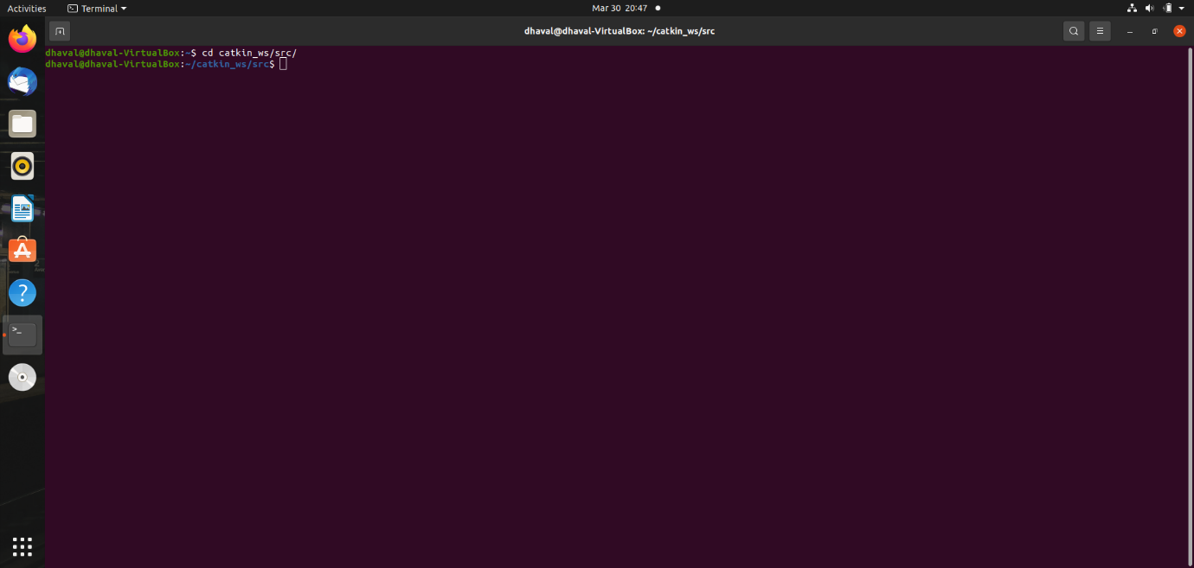

* Now use the below command to create a catkin package named beginner_tutorials.

$ catkin_create_pkg beginner_tutorials std_msgs rospy roscpp

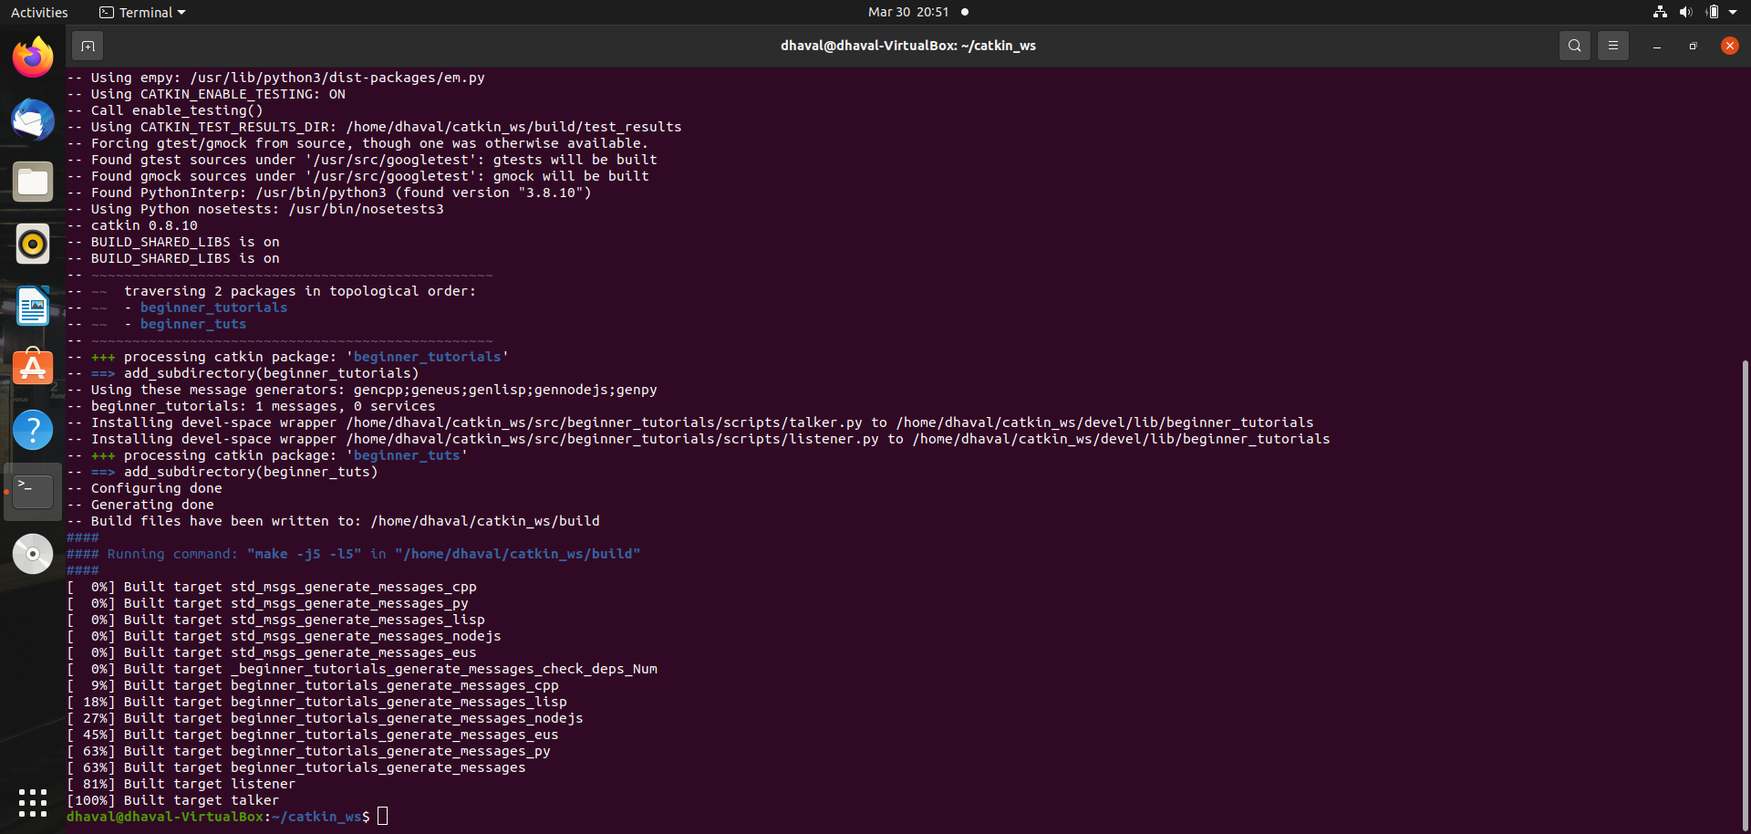

* Now to build the package and workspace go to catkin_ws folder and execute catkin_make.

$ catking_make

* Now, to add the workspace to our ROS environment we need to source the generated setup file.

$ source devel/setup.bash

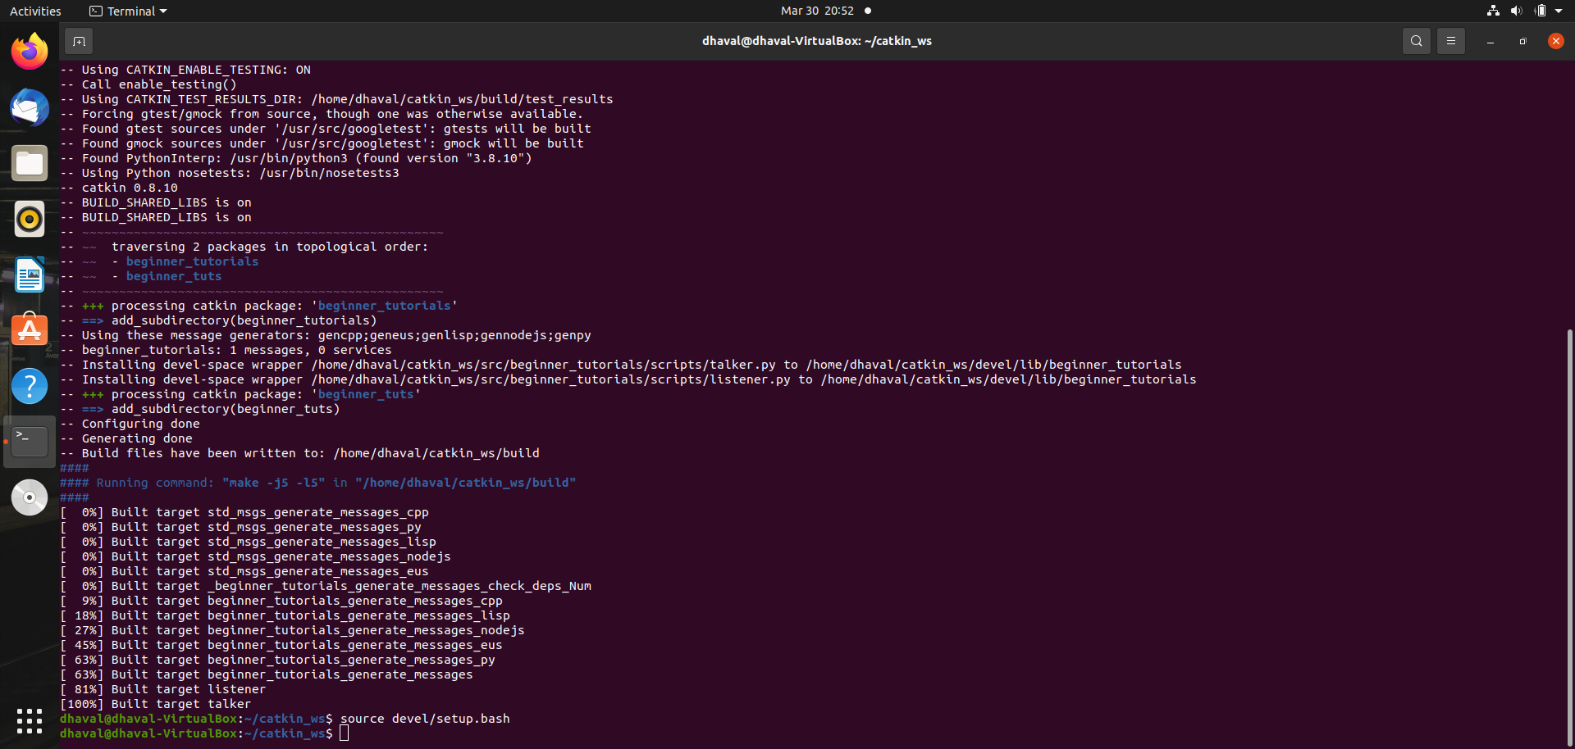

* Simple launch file

We will write a simple launch file in our beginner_tutorials package. Content of the file is given below.

**<launch>**

**<node** pkg="turtlesim" name="sim" type="turtlesim_node"**/>**

**</launch>**

Now we will launch this launch file by running following command.

$ roslaunch beginner_tutorials launchfile.launch

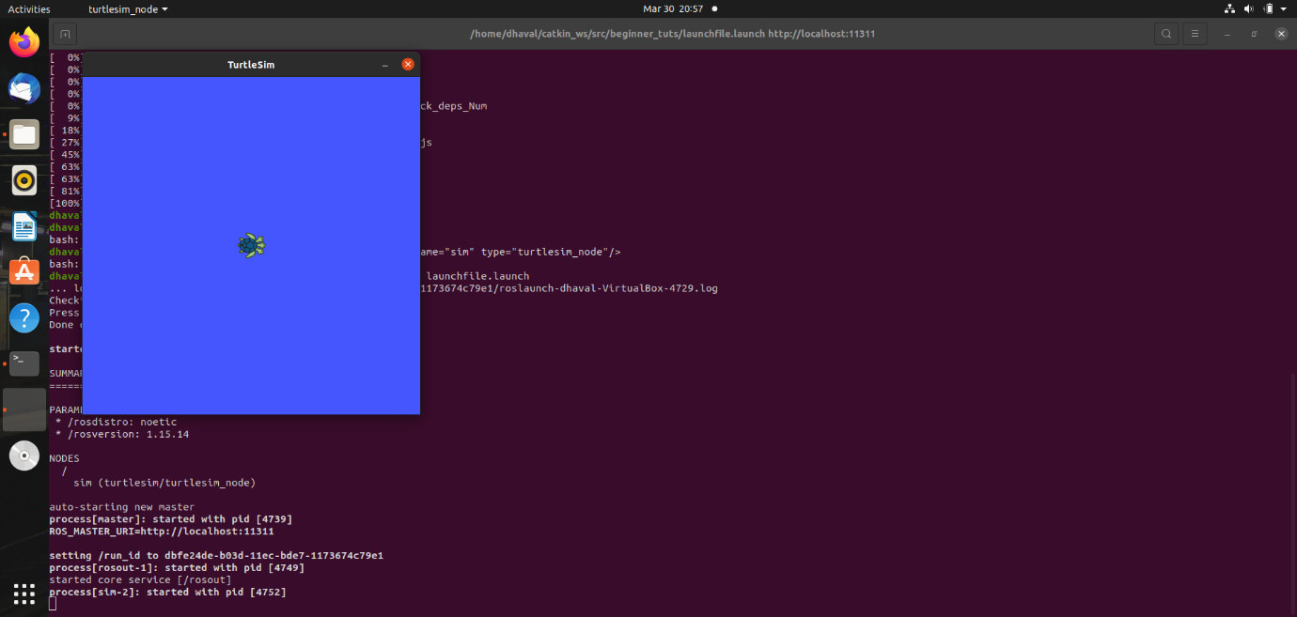

* Launch file with teleop key which can control through keyboard

We will write a simple launch file which includes teleop key in our beginner_tutorials package. Content of the file is given below.

**<launch>**

**<node** pkg="turtlesim" name="sim" type="turtlesim_node**"/>**

**<node** pkg="turtlesim" name="teleop_key" type="turtle_teleop_key"**/>**

**</launch>**

Now we will launch this launch file by running following command.

$ roslaunch beginner_tutorials launchfile.launch

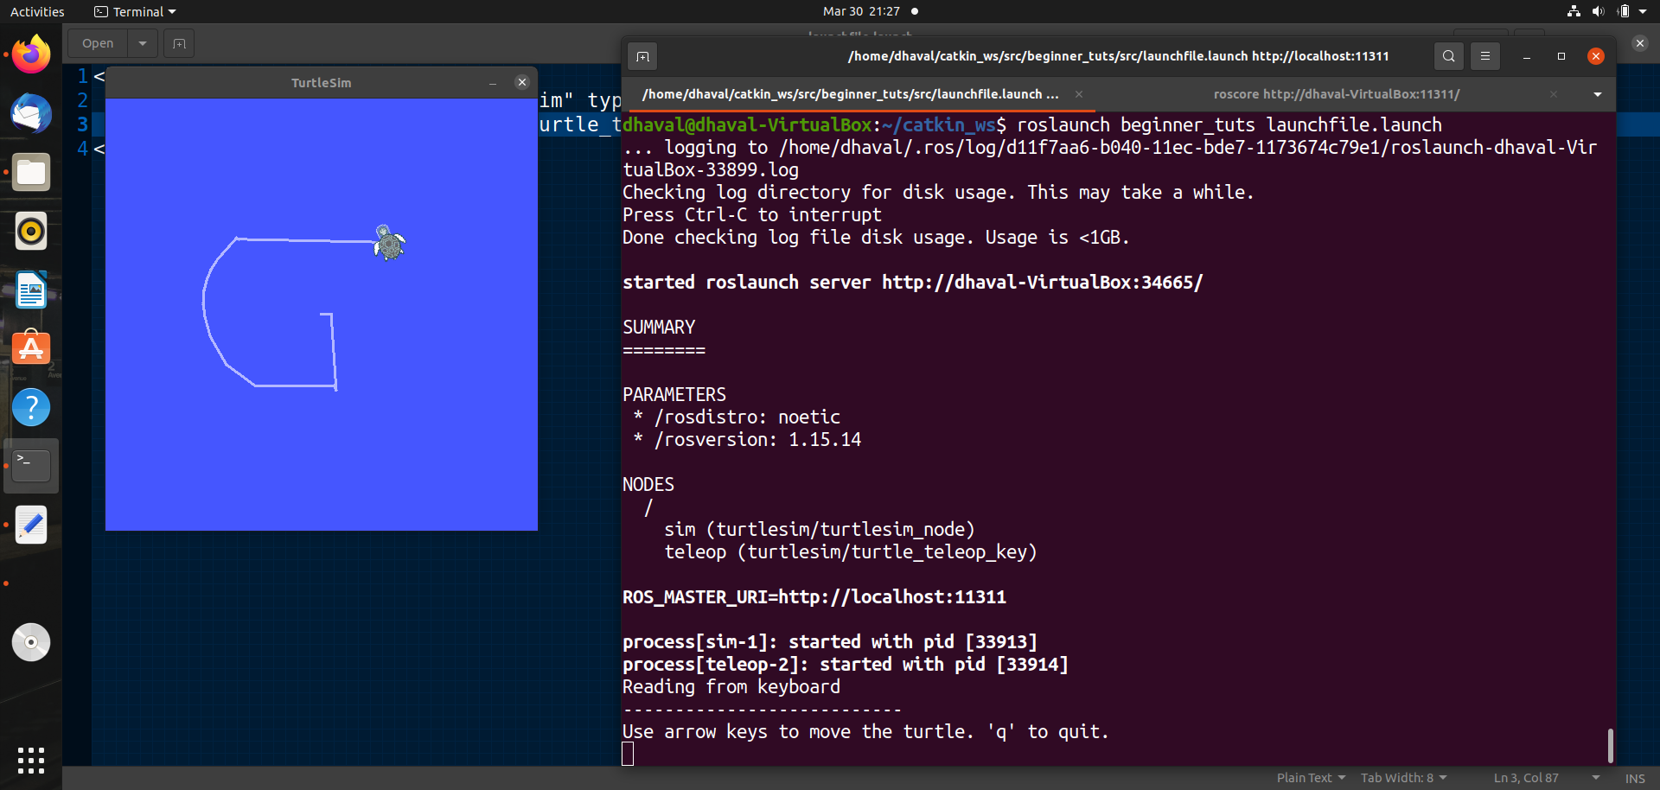

* Launch file with teleop key which can control through keyboard

To make turtlesim node moves via python file and control through keyboard, we will write a simple launch file in our beginner_tutorials package. Content of the file is given below.

**<launch>**

**<node** pkg="turtlesim" name="sim" type="turtlesim_node"**/>**

**<node** pkg="turtlesim" name="teleop_key" type="turtle_teleop_key"**/>**

**<node** pkg="beginner_tutorials" name="turtlesim_cleaner" type="turtlesim_cleaner.py" output="screen"**/>**

**</launch>**

Now we will launch this launch file by running following command.

$ roslaunch beginner_tutorials launchfile.launch

