**IE 410 – INTRODUCTION TO ROBOTICS**

**Lab-8 report**

**Turtlebot3 and simulation**

**Team M410:**

201901011 – HIMANSHU DUDHATRA

201901024 – DHAVALSINH RAJ

201901100 – SHUBHAM PATEL

201901145 – GARGEY PATEL

* **Installing turtlebot3**

Run following commands to install turtlebot3

$ cd ~/catkin_ws/src/

$ git clone <https://github.com/ROBOTIS-GIT/turtlebot3_msgs.git>

$ git clone <https://github.com/ROBOTIS-GIT/turtlebot3.git>

$ cd ~/catkin_ws && catkin_make

After, add following line in our .bashrc file export TURTLEBOT3_MODEL=burger

Now run the following commands

$ source ~/.bashrc

$ cd ~/catkin_ws/src/

$ git clone <https://github.com/ROBOTIS-GIT/turtlebot3_simulations.git>

$ cd ~/catkin_ws && catkin_make

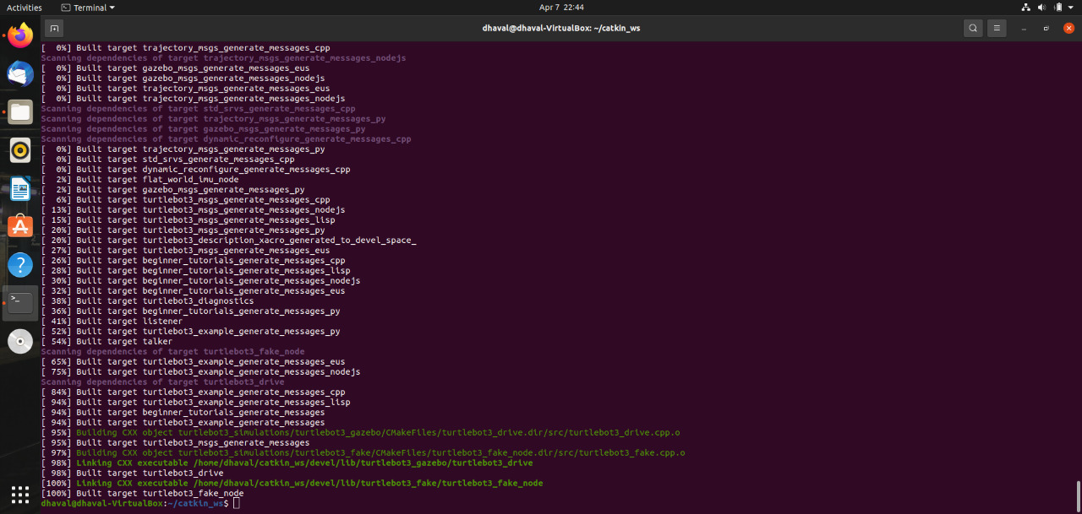

* **Simulate turtlebot3 using RViz**

Run the following command to simulate turtlebot3 using RViz.

$ roslaunch turtlebot3_fake turtlebot3_fake.launch

If you want to control turtlebot3 using your keyboard run the following command.

$ roslaunch turtlebot3_teleop turtlebot3_teleop_key.launch

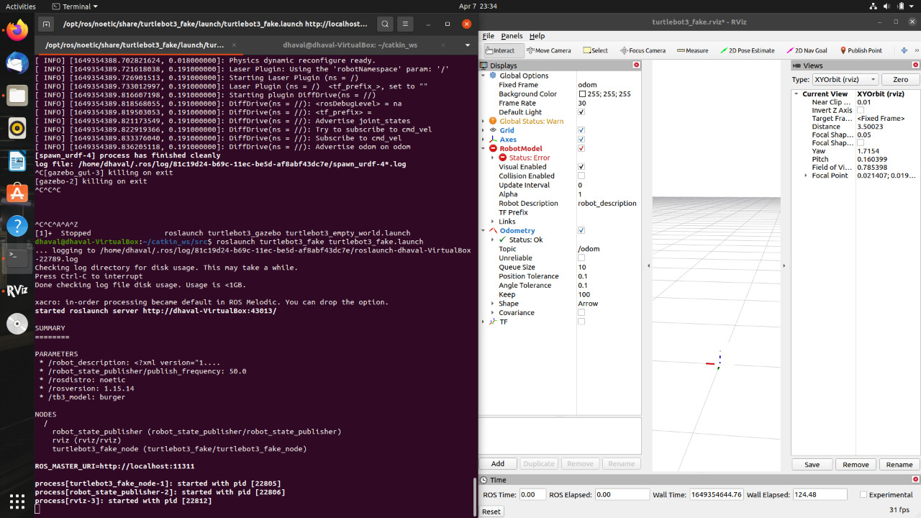

* **Simulate turtlebot3 using Gazebo**

Run the following command to simulate turtlebot3 using Gazebo.

$ roslaunch turtlebot3_gazebo turtlebot3_empty_world.launch

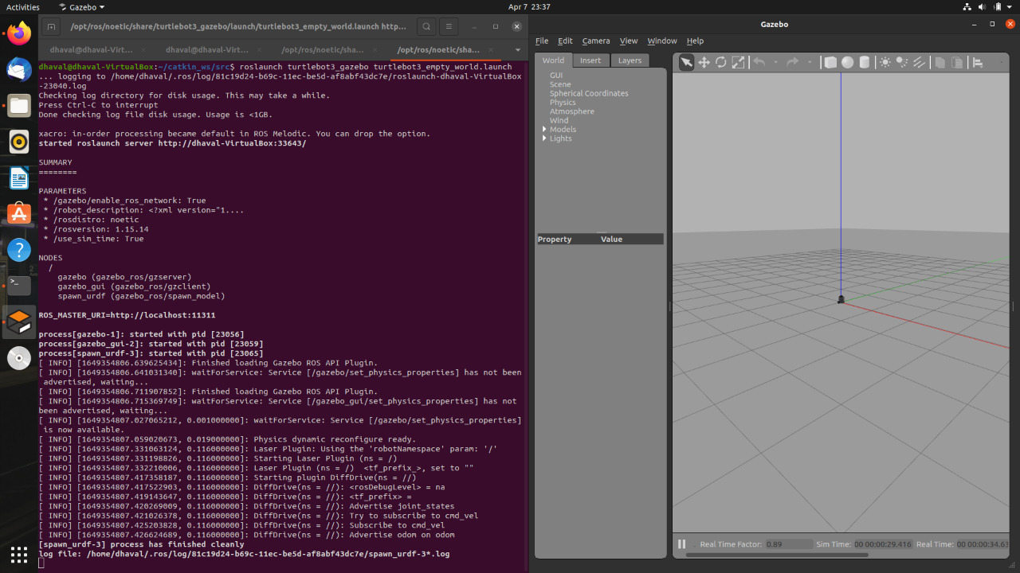

* **Managing simulation environment of turtlebot3**

Let’s look at our turtlebot3 in a different environment. This environment is often used for testing SLAM and navigation algorithms. Simultaneous localization and mapping (SLAM)

concerns the problem of a robot building or updating a map of an unknown environment while simultaneously keeping track of its location in that environment.

$ roslaunch turtlebot3_gazebo turtlebot3_world.launch

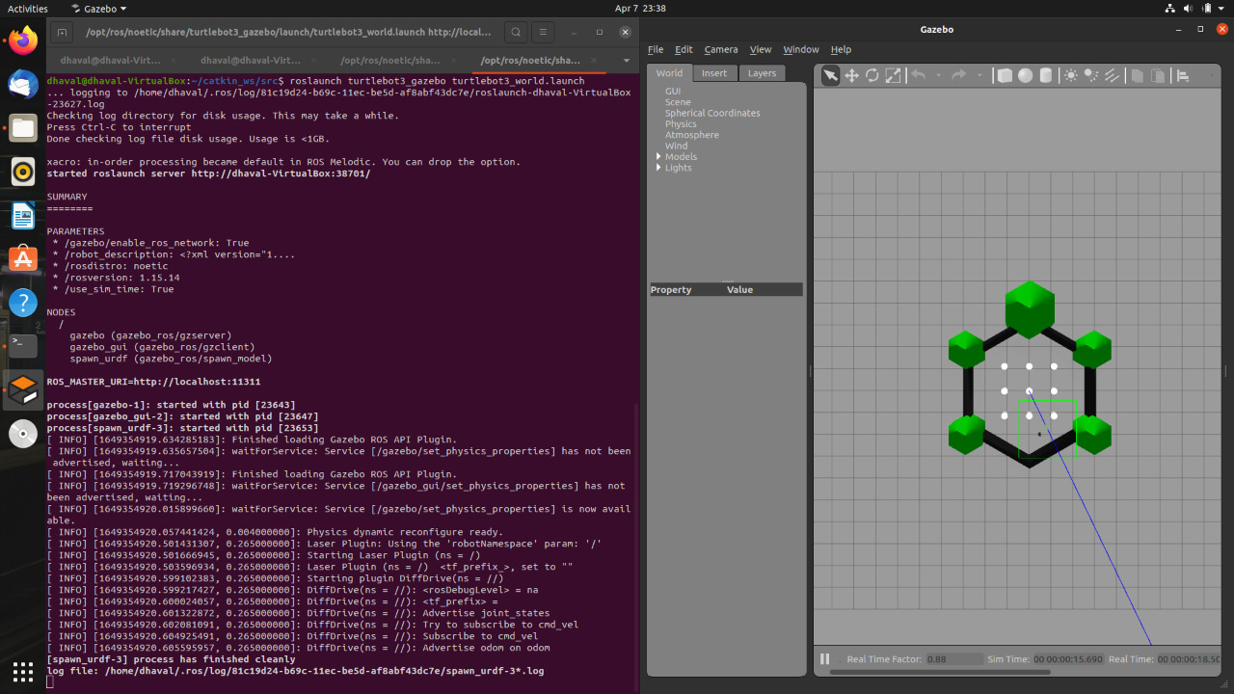

Type this command and wait a few minutes for the environment to load to stimulate turtlebot3 inside a house.

$ roslaunch turtlebot3_gazebo turtlebot3_house.launch

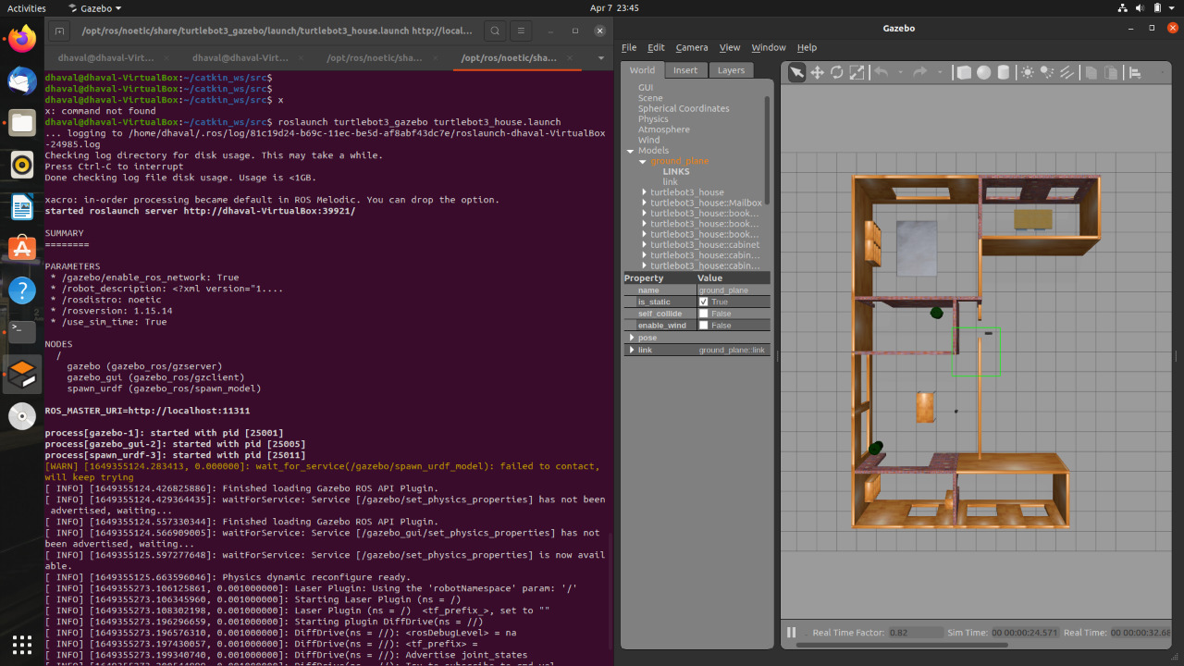

To move the turtlebot with your keyboard, use this command in another terminal tab:

$ roslaunch turtlebot3_teleop turtlebot3_teleop_key.launch

* **Simulating SLAM with TurtleBot3**

Install the SLAM module in a new terminal window.

$ sudo apt install ros-melodic-slam-gmapping

$ roslaunch turtlebot3_gazebo turtlebot3_world.launch

$ roslaunch turtlebot3_slam turtlebot3_slam.launch slam_methods:=gmapping

$ roslaunch turtlebot3_gazebo turtlebot3_simulation.launch





