**IT 314 - Lab 2**

Ayush Prajapati – 201901099

Shubham Patel – 201901100

**Time Management Software**

1. Adding all user stories in Taiga.

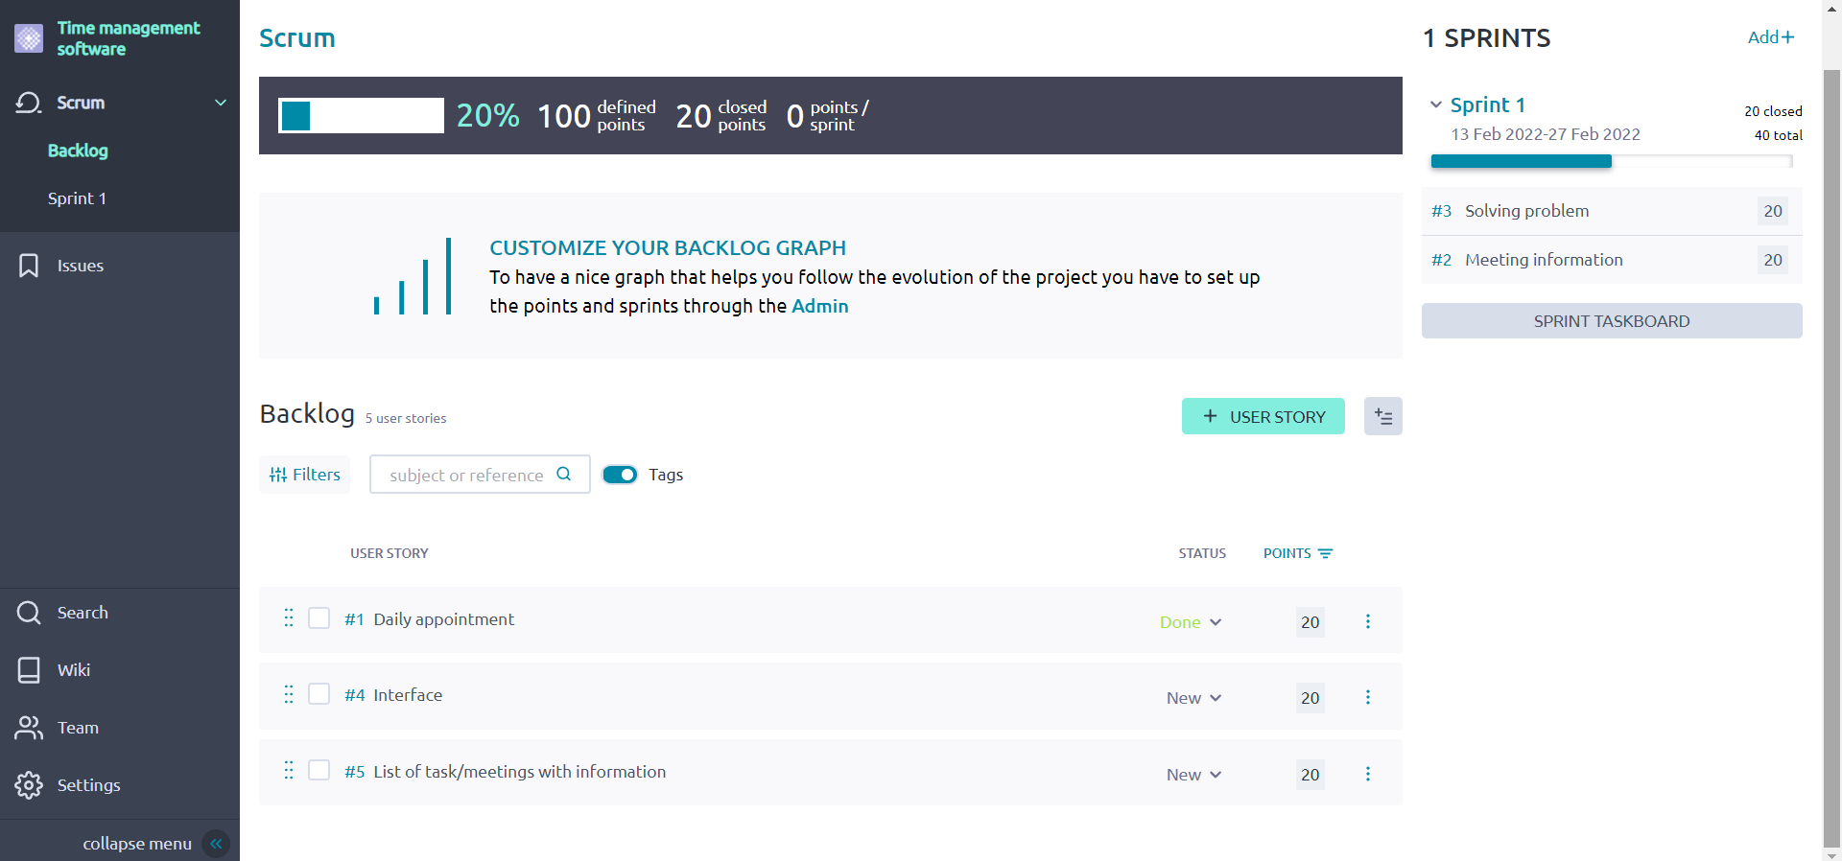

1. Adding tasks to all user stories in Taiga.

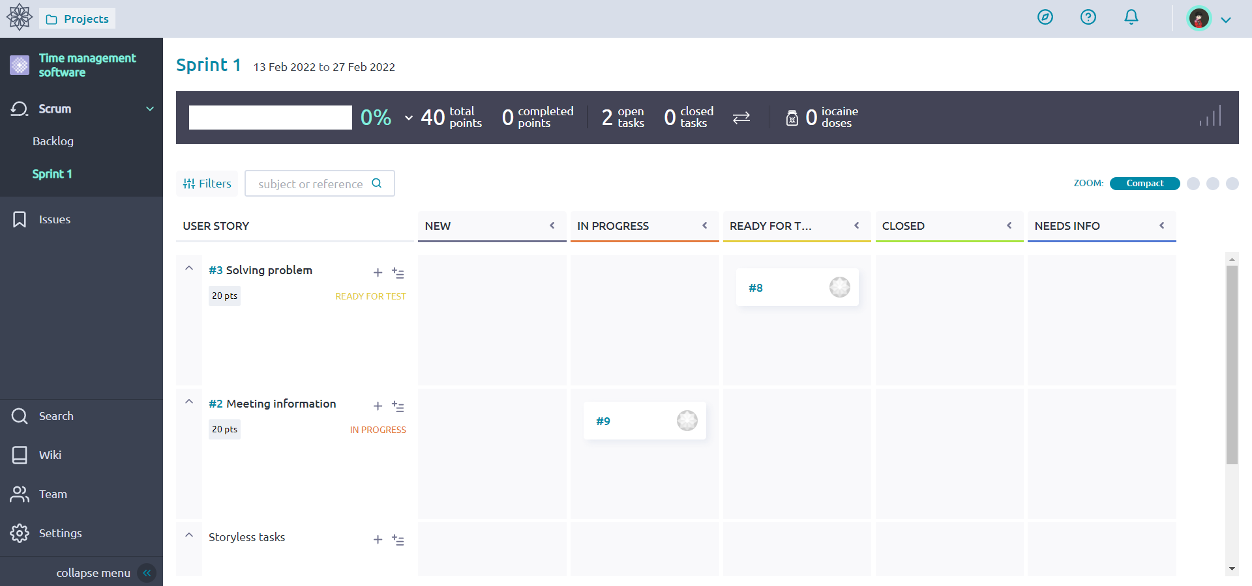

1. Burn out chart.

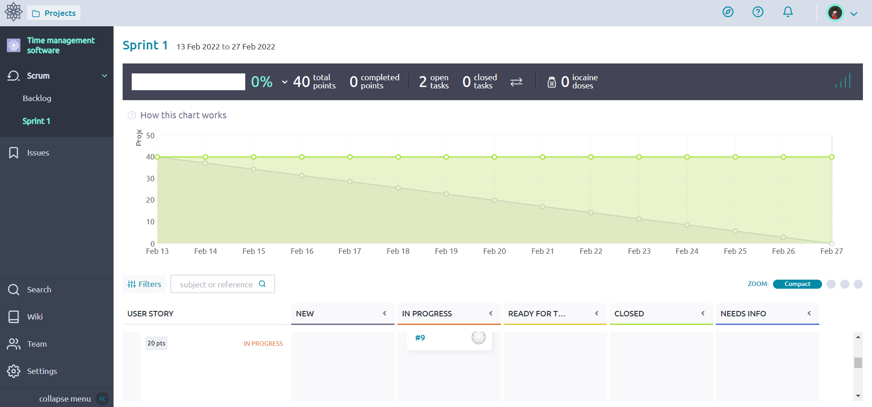

1. Adding issues.

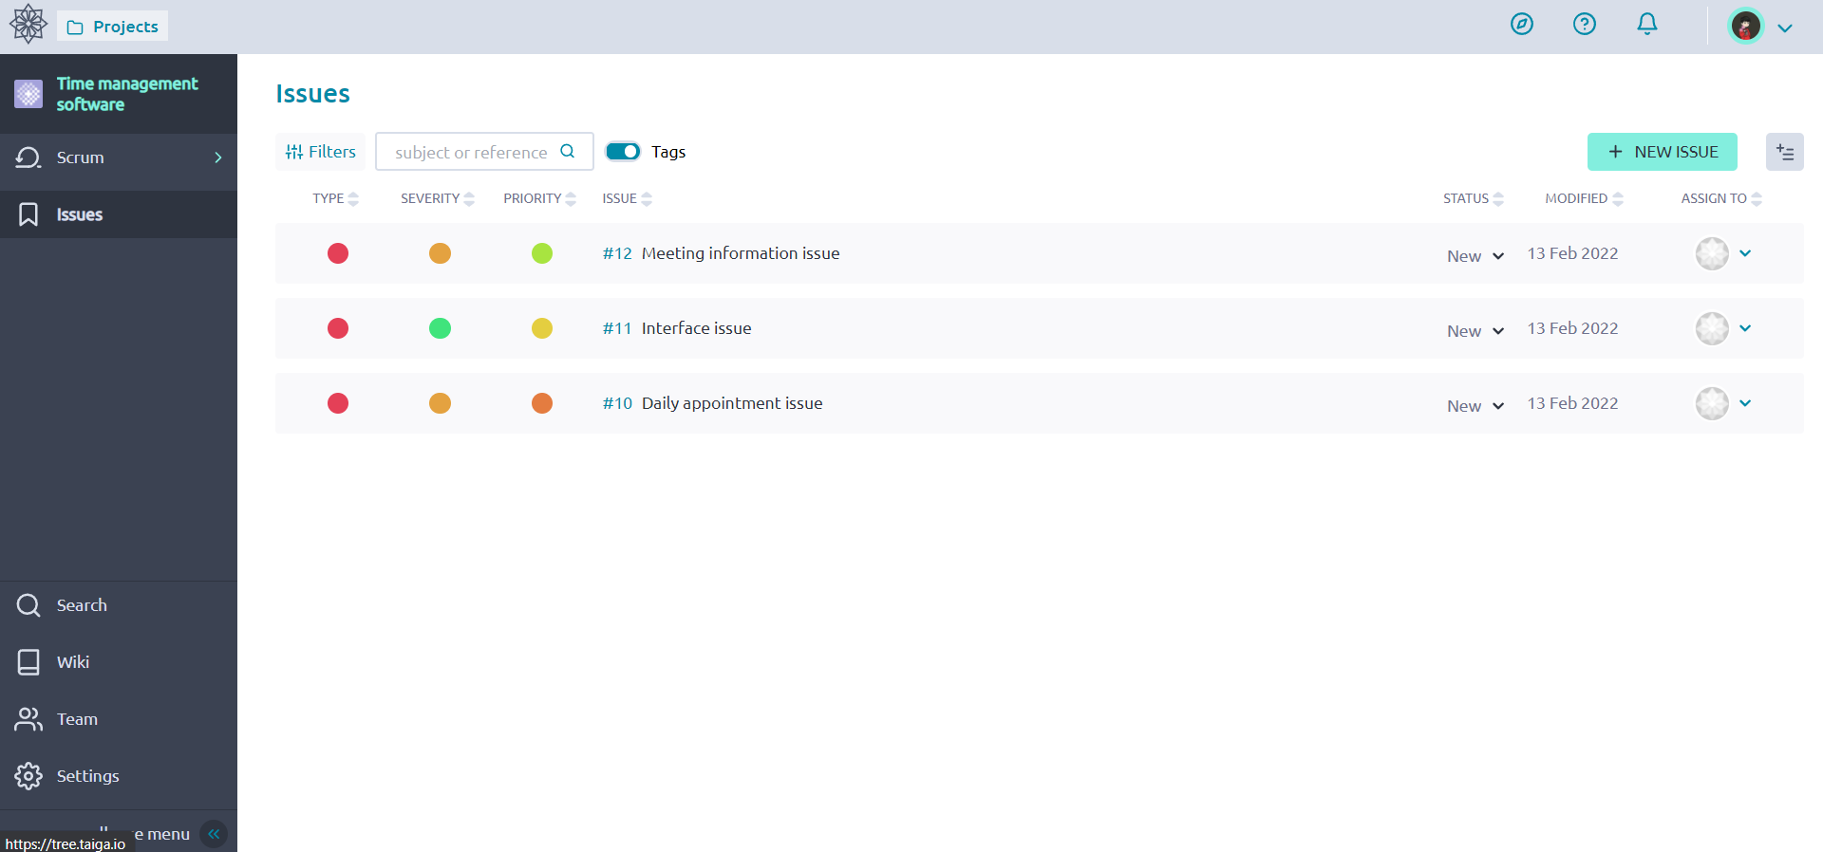

**Restaurant Automation System**

1. Adding all user stories in Taiga.

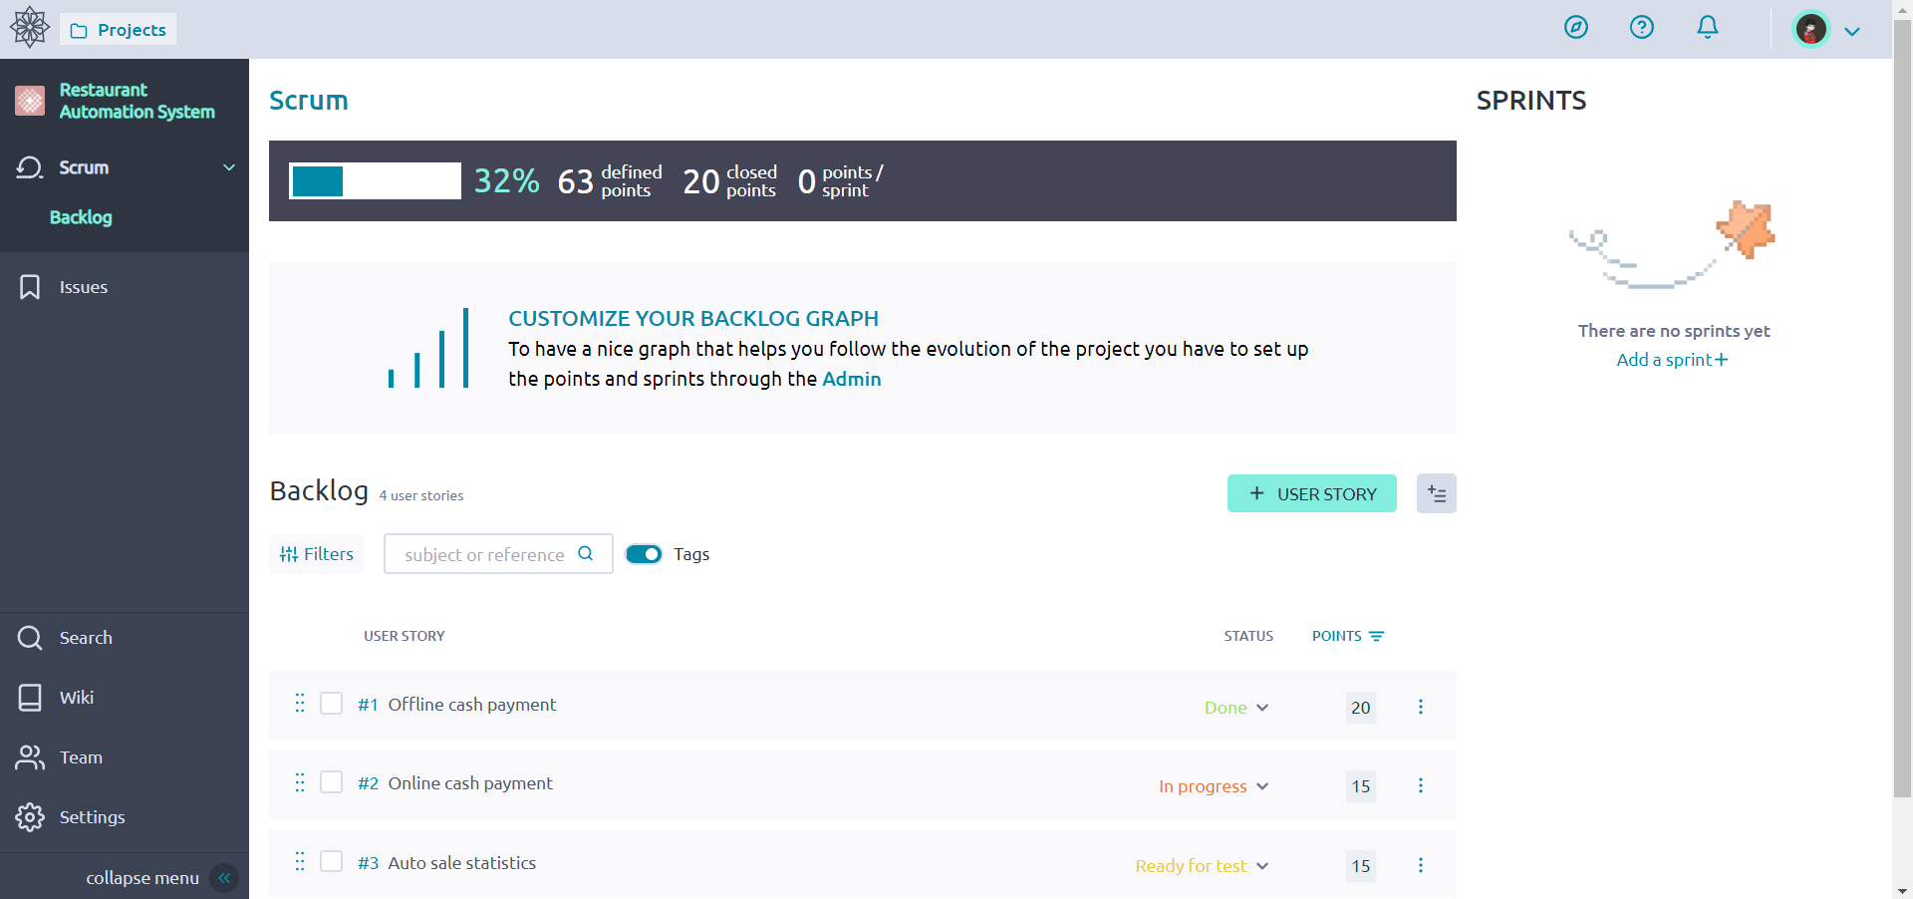

1. Adding tasks to all user stories in Taiga.

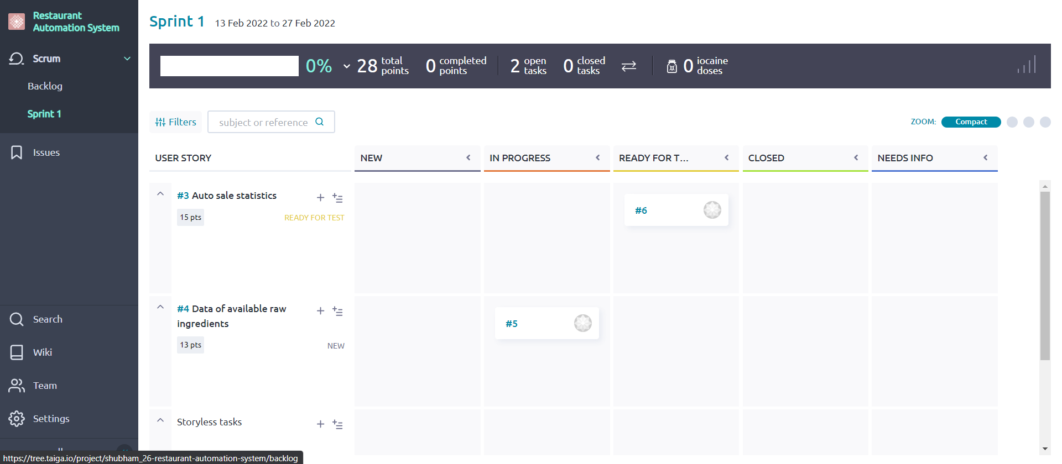

1. Burn out chart.

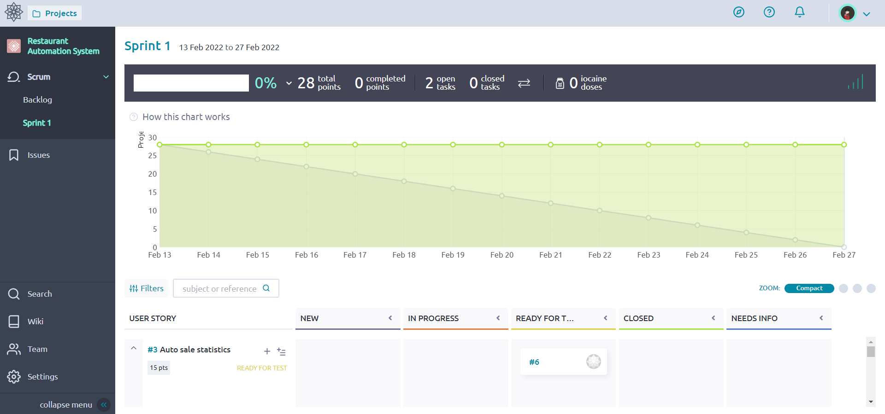

1. Adding issues.

