**IT 314 - Lab 3**

201901099 – Ayush Prajapati

201901100 – Shubham Patel

**Hotel Automation Software**

* HAS.reqif

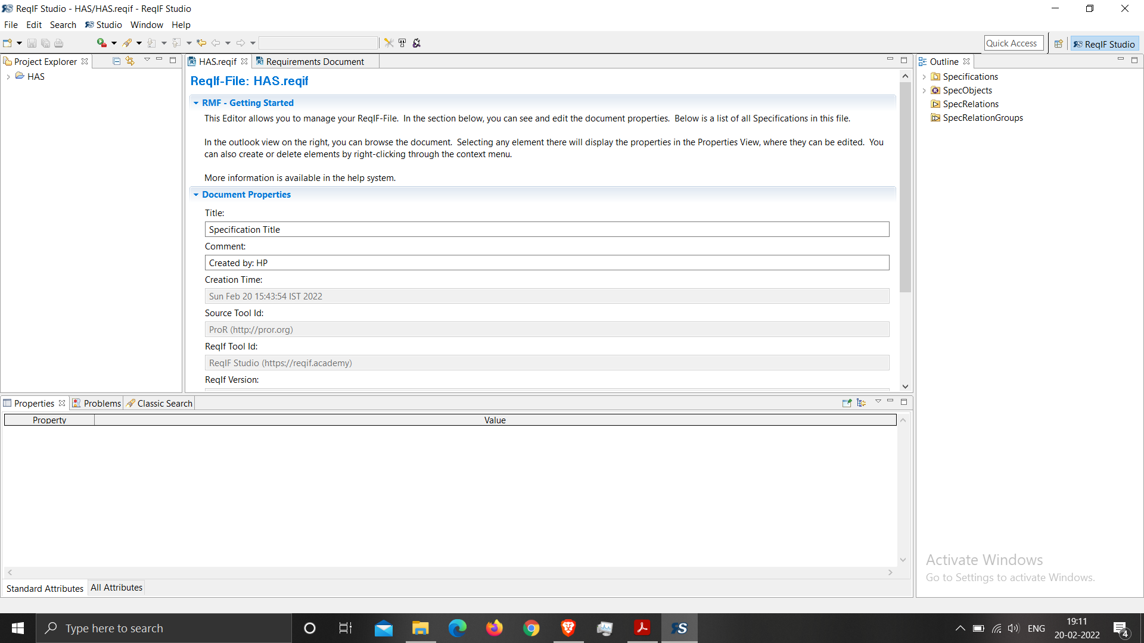

**Medical Shop Automation**

* MSA.reqif

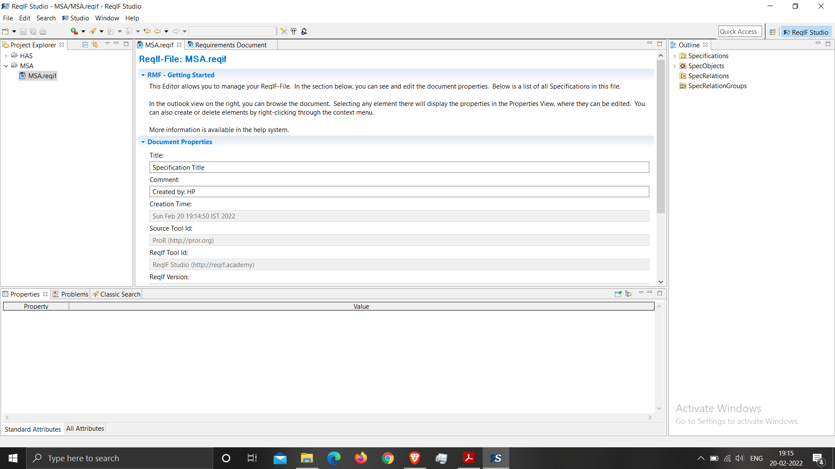

* Datatype configuration and Configure columns are same for both.

Datatype configuration:

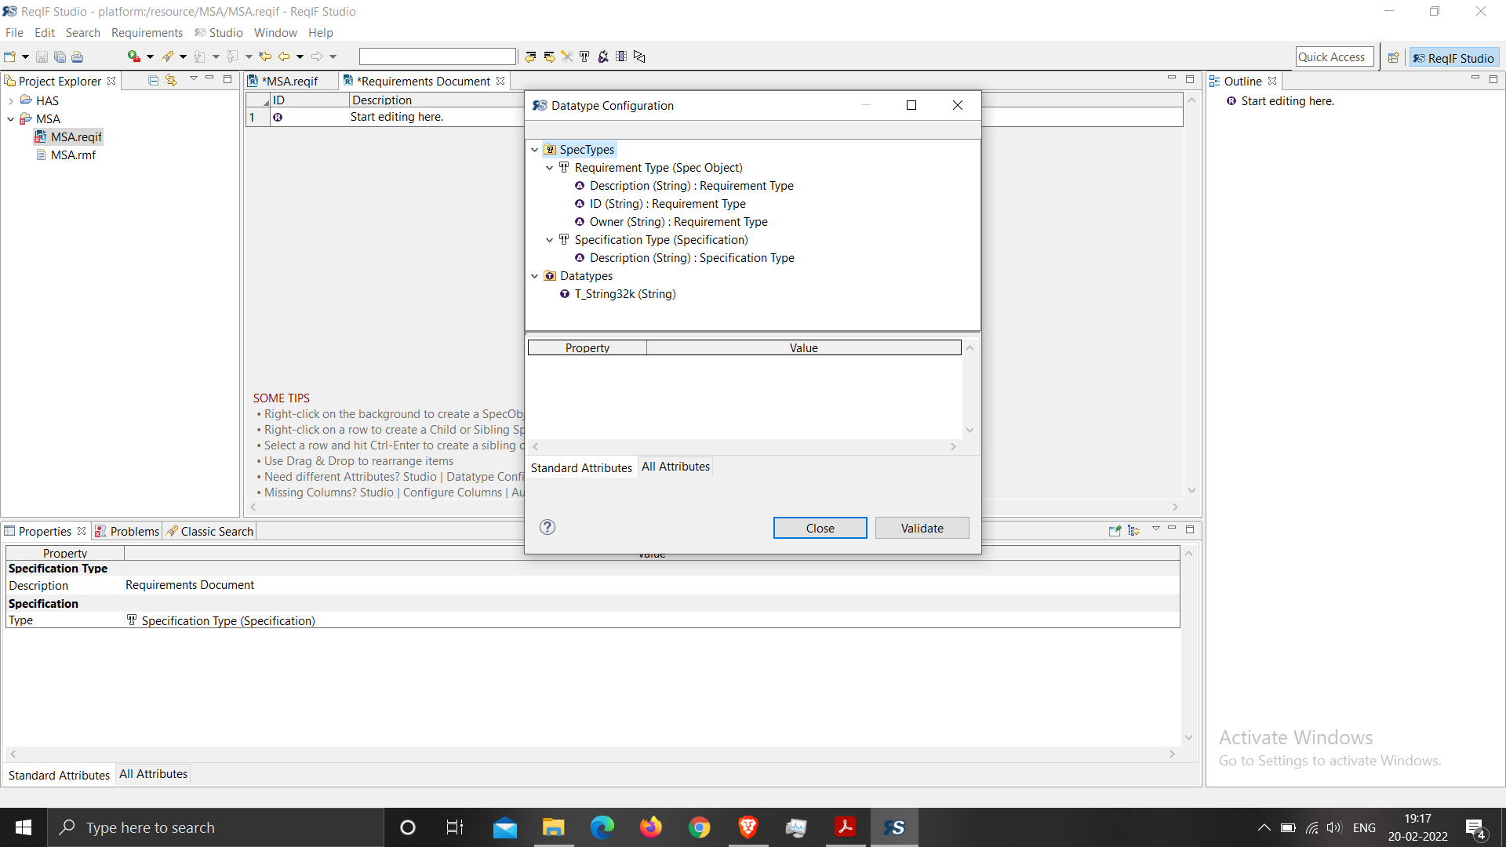

Configure columns:

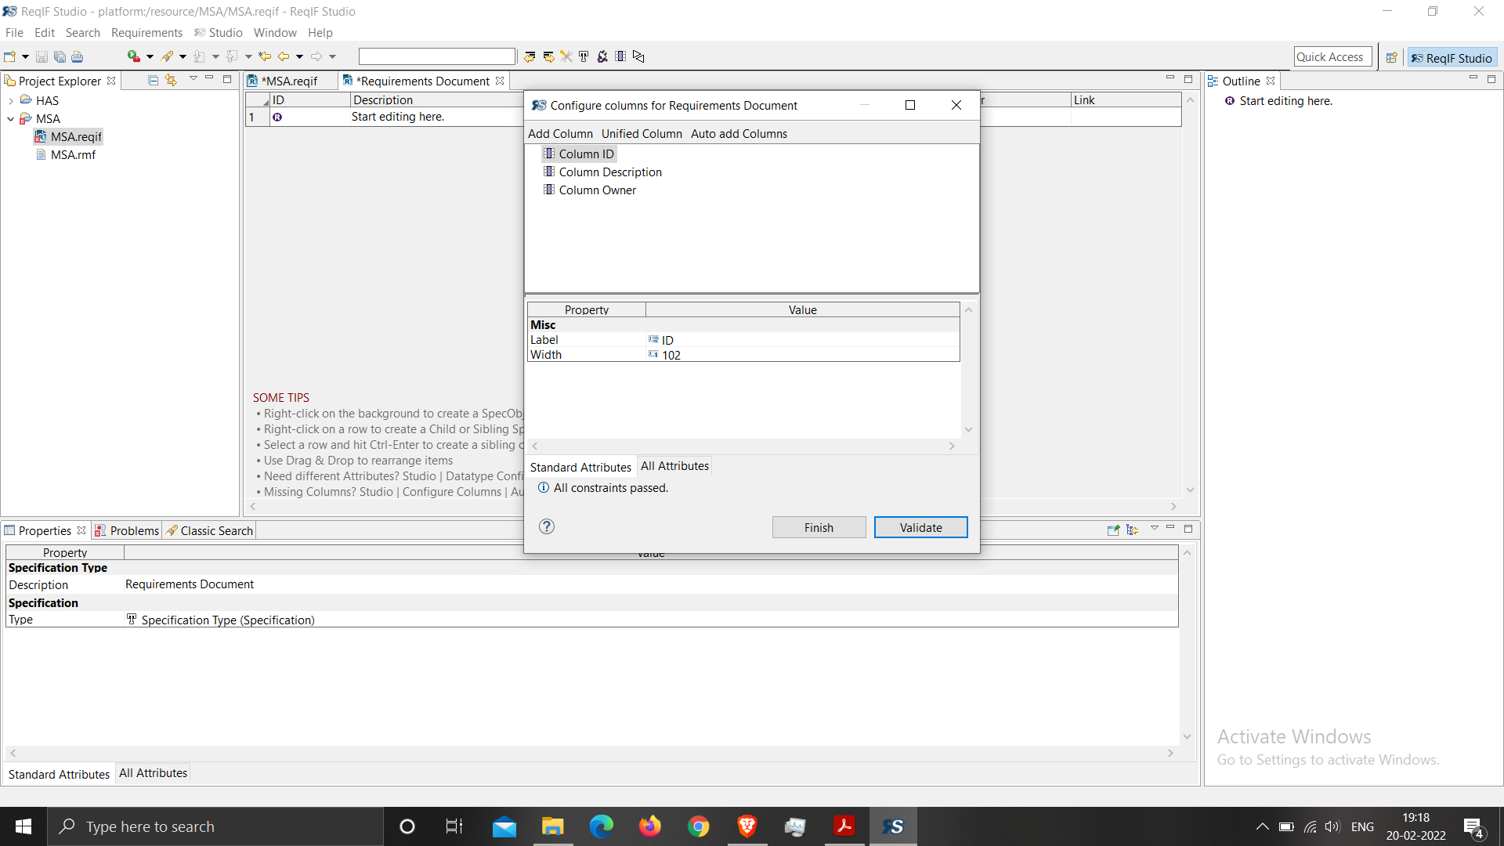

**Hotel Automation Software**

* Requirement Document (ReqIF Studio)

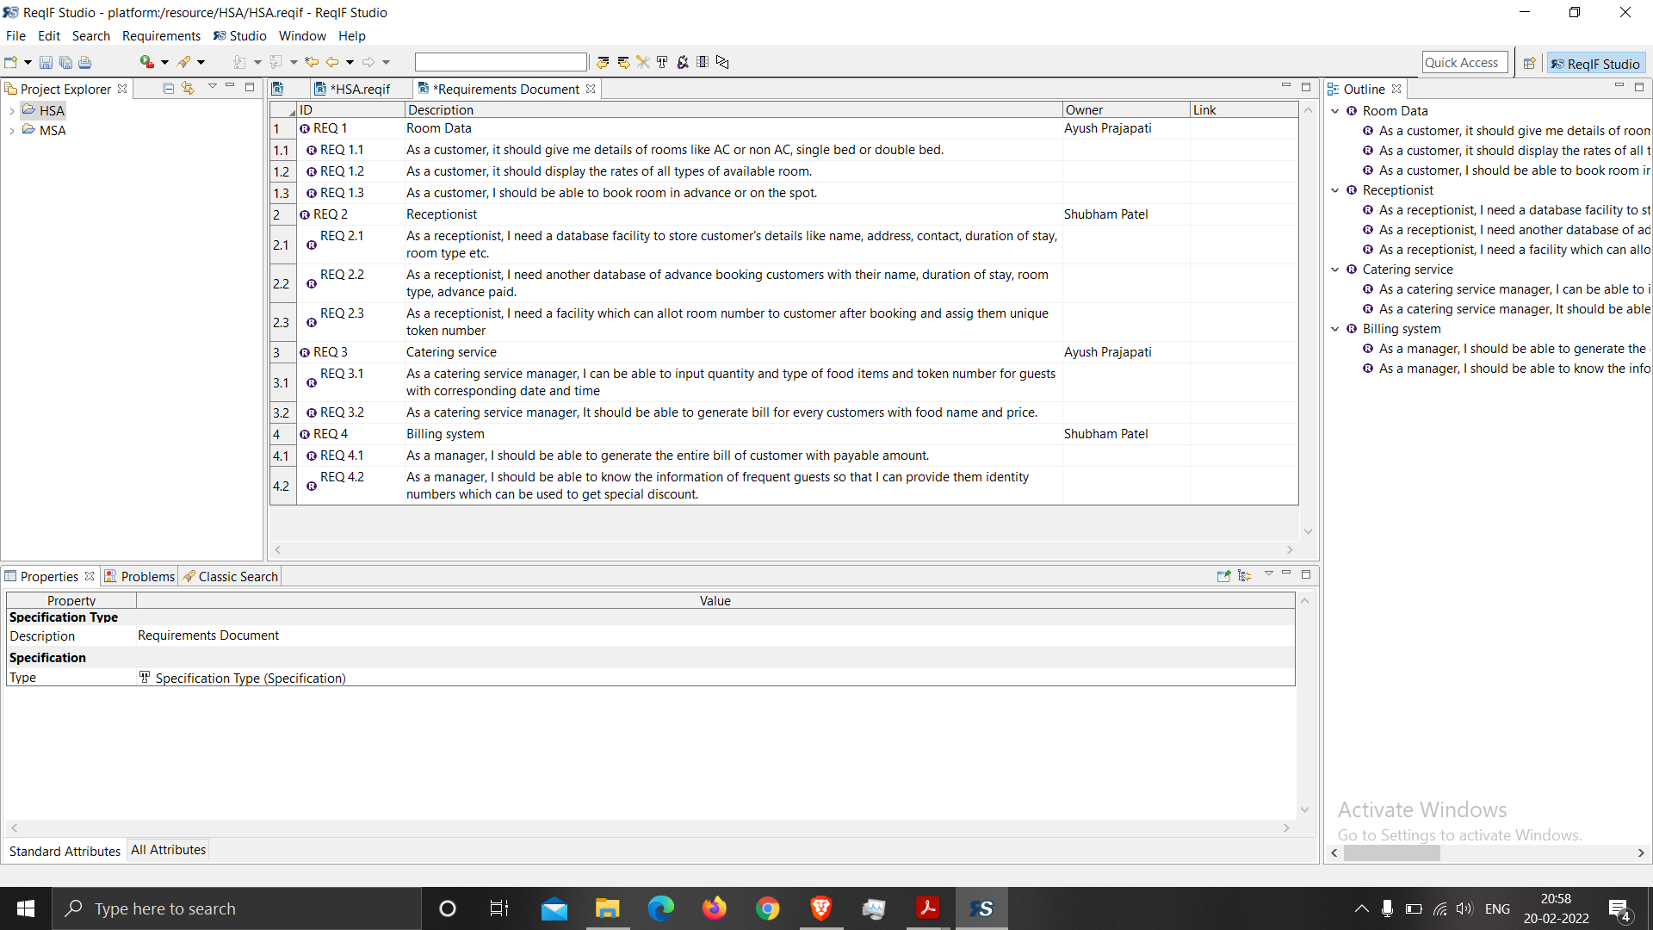

* Requirement Document (HTML Page)

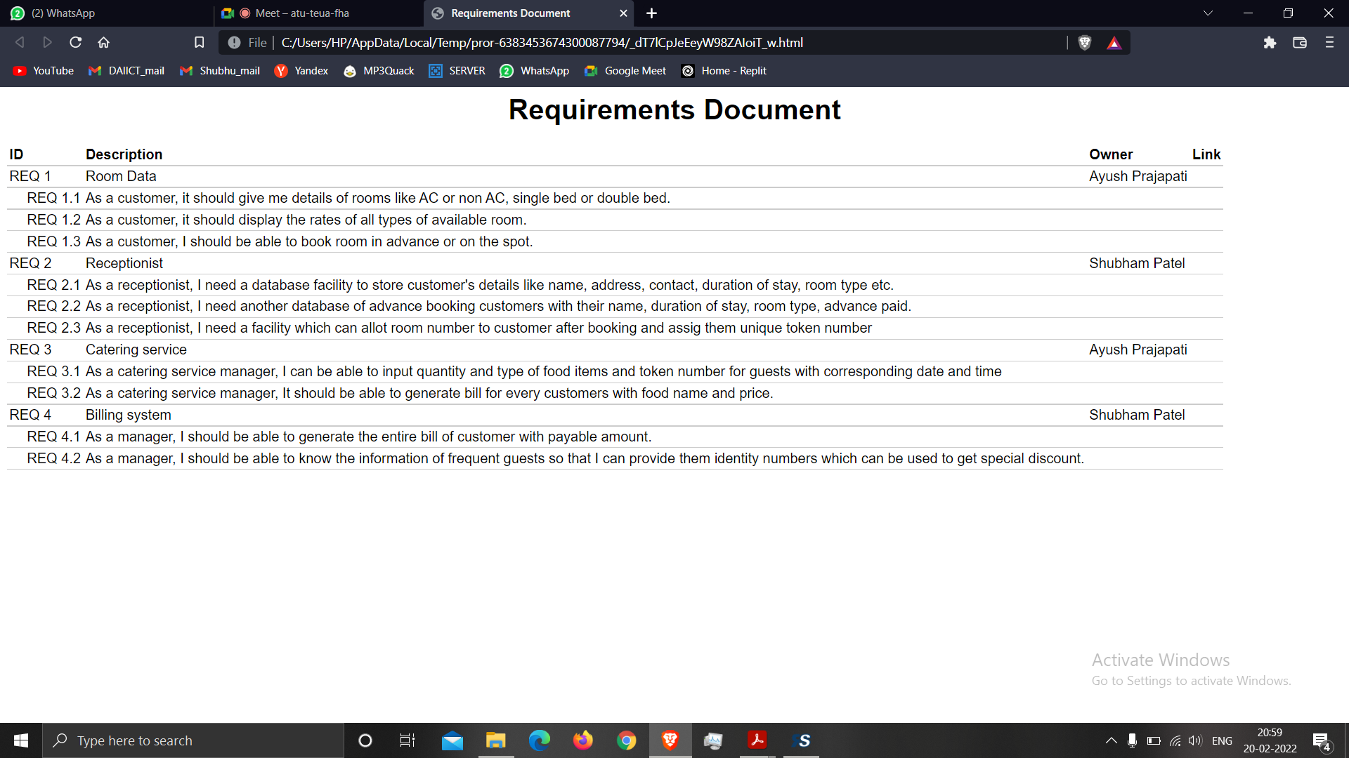

**Medical Shop Automation**

* Requirement Document (ReqIF Studio)

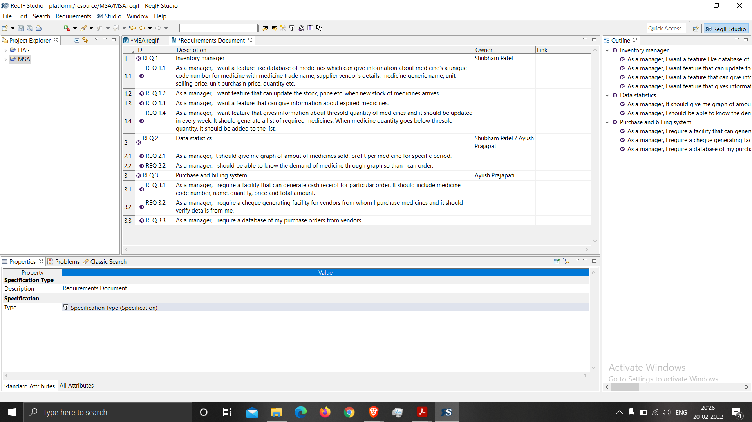

* Requirement Document (HTML Page)

