**IT314: Software Engineering**

**Group 15:**

201901057 – Shivam Patel

201901011 – Himanshu Dudhatra

201901024 – Dhavalsinh Raj

201901030 – Bhuminkumar Patel

201901056 – Smit Patel

201901100 – Shubham Patel

**Lab 05: DFD Modeling**

**Hotel Automation System**

* **DFD: Level 0**

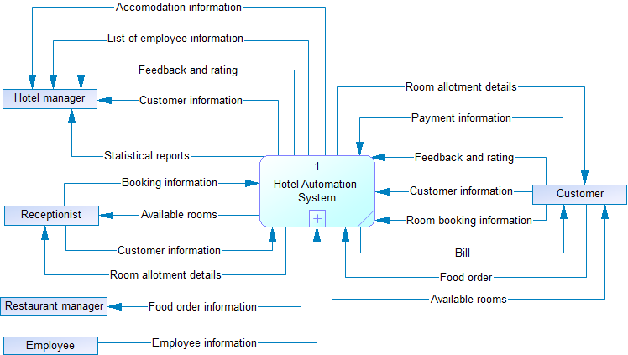

* **DFD: Level 1**

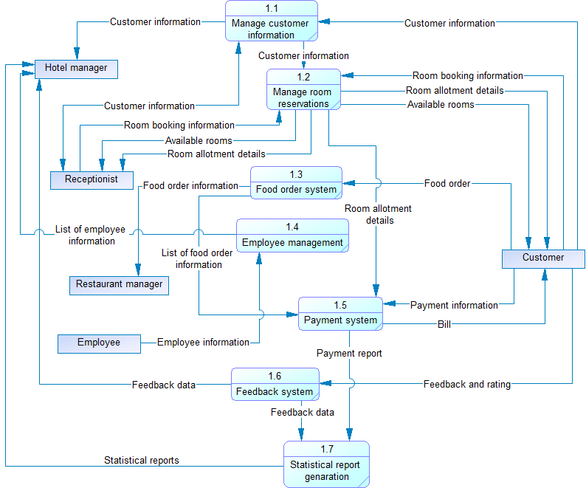

* **DFD: Level 2**

