**IT314 – SOFTWARE ENGINEERING**

**Lab 9 – UI / UX Design**

**Group 15:**

201901011 – Himanshu Dudhatra

201901024 – Dhaval Raj

201901030 – Bhuminkumar Patel

201901056 – Smit Patel

201901057 – Shivam Patel

201901100 – Shubham Patel

1.

* This is the **Home** page of our application. When any external entity opens the application, this page will be appeared.
* There is a logo of application.
* There are 3 features: **User Login**, **Employee Login** and **Manager Login**.
* User can login through **User Login** button and it will redirect user to page 9(**User login** page).
* Employee can login through **Employee Login** button and it will redirect user to page 8(**Employee login** page).
* Manager can login through **Manager Login** button and it will redirect user to page 2(**Manager login** page).
* We formed group for all 3 buttons **User Login**, **Employee Login**, **Manager Login** and header.

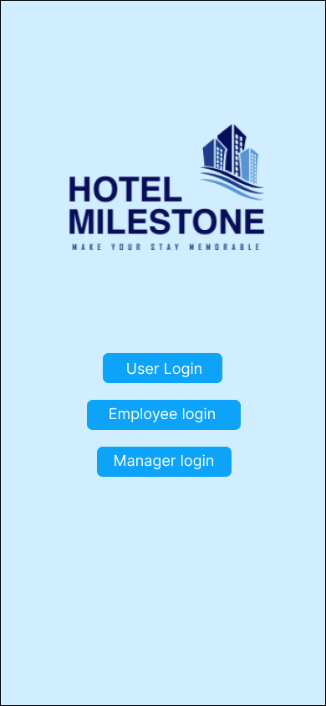

2.

* This is **Manager Login** page.
* Manager can enter his/her identification code in the text box and then press **Login** button. Then it will redirect to page 3(**Manager home** page).
* **Back** button will redirect to page 1(**Home** page).
* We formed group for text box, **Login** button and header.

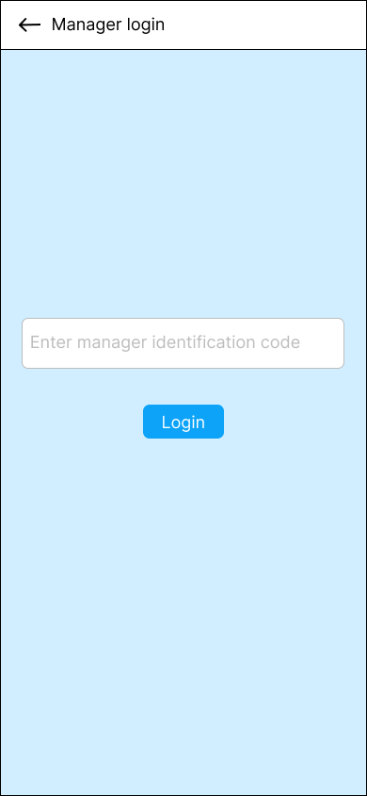

3.

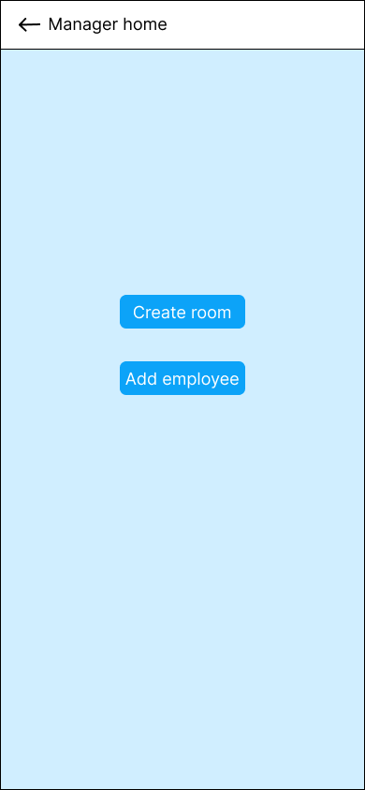

* This is **Manager home** page.
* Manager can create room by using **Create Room** button and add employee by using **Add Employee** button.
* **Create Room** button will redirect to page 4(**Create Room** page).
* **Add employee** button will redirect to page 6(**Add Employee** page).
* **Back** button will redirect to page 2(**Manager login** page).
* We formed group for both buttons **Create Room** and **Add Employee** and header.

4.

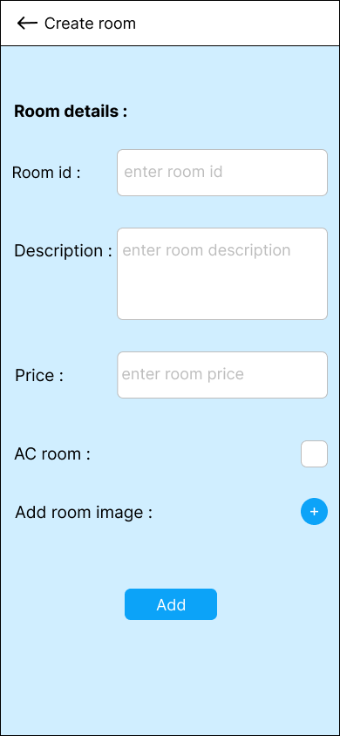

* This is **Create Room** page.
* Manager can fill new Room details like **Room id**, **Room Description**, **Room Price**, **AC Room or not** by check button and **Add room image** by using PLUS sign. Then he/she can press **Add** button to create new room.
* **Add** button will redirect to page 5(**Add room confirmation** page).
* **Back** button will redirect to page 3(**Manager home** page).
* We formed group for all details like **Room id**, **Room Description**, **Room Price**, **AC Room** with respective text box and also for **Add** button.

5.



* This is **Add room confirmation** page.
* After pressing **Add** button on **Create Room** page, new room will be created and manager will see the confirmation message.
* **Home** button will redirect to page 3(**Manager home** page).
* We formed group for **Home** button.

6.

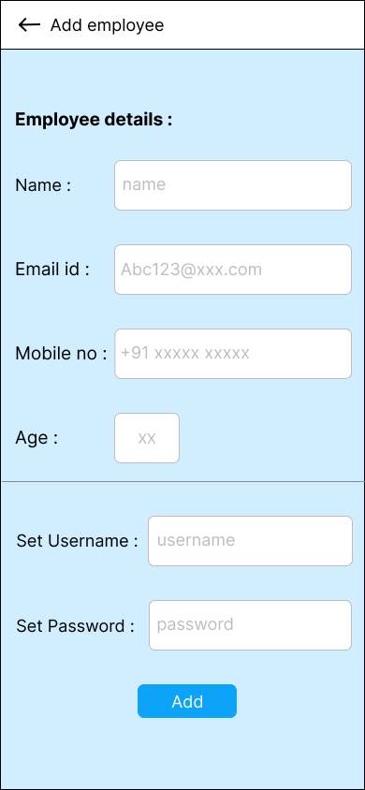

* This is **Add Employee** page.
* Manager can fill new employee details like **Name**, **Email id**, **Mobile number** and **Age**. Manager can set **Username** and **Password** for employee. Then he/she can press **Add** button to add new employee.
* **Add** button will redirect to page 7(**Add employee confirmation** page).
* **Back** button will redirect to page 3(**Manager home** page).
* We formed group for all details like **Name**, **Email id**, **Mobile number**, **Age**, **Set Username**, **Set Password** with respective text box and also for **Add** button.

7.



* This is **Add employee confirmation** page.
* After pressing **Add** button on **Add employee** page, new entry of employee will be done and manager will see the confirmation message.
* **Home** button will redirect to page 3(**Manager home** page).
* We formed group for **Home** button.

8.

* This is **Employee Login** page.
* Employee can enter his/her **username** and **password** in the text box and then press **Login** button.
* **Back** button will redirect to page 1(**Home** page).
* We formed group for all text box and **Login** button and header.

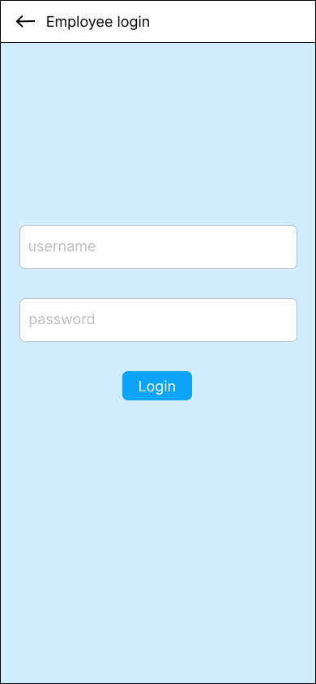

9.

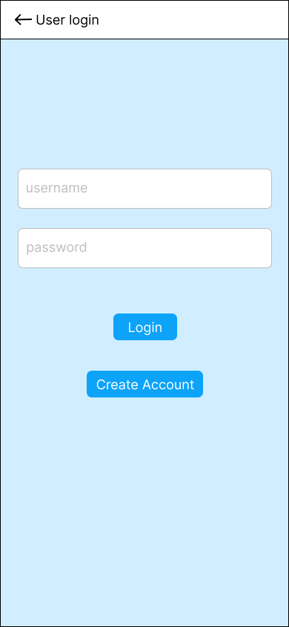

* This is **User Login** page.
* Existing user can enter his/her **username** and **password** in the text box and then press **Login** button and it will redirect to page 12(**Room list** page).
* If user is new, then he/she can press **Create Account** button to create new account and it will redirect to page 10(**Create account** page).
* **Back** button will redirect to page 1(**Home** page).
* We formed group for all text box and **Login**, **Create Account** button and header.

10.

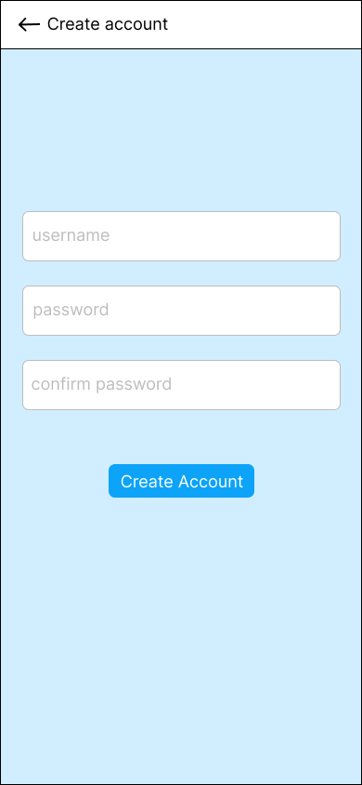

* This is **Create account** page.
* New user can enter his/her **username**, **password**, again **password** for confirmation then press **Create Account** button and it will redirect to page 11(**Create account confirmation** page).
* **Back** button will redirect to page 1(**Home** page).
* We formed group for all text box, **Create Account** button and header.

11.



* This is **Create account confirmation** page.
* After pressing **Create Account** button on **Create account** page, new account for user will be created and user will see the confirmation message.
* **Login** button will redirect to page 9(**User Login** page).
* We formed group for **Login** button.

12.

* This is **Room list** page.
* After pressing **Login** button on **User login** page, user will redirect to this page for booking room.
* This page contains details of available rooms along with **room number**, **description**, **rate** etc.
* User will press **Book now** button to book room and it will redirect to page 13(**Booking details** page).
* **Back** button will redirect to page 9(**User login** page).
* **Refresh** button will refresh room list and stay on this page.
* **Logout** button will redirect to page 9(**User login** page).
* We formed group for particular room details, **Book now** buttons and header.

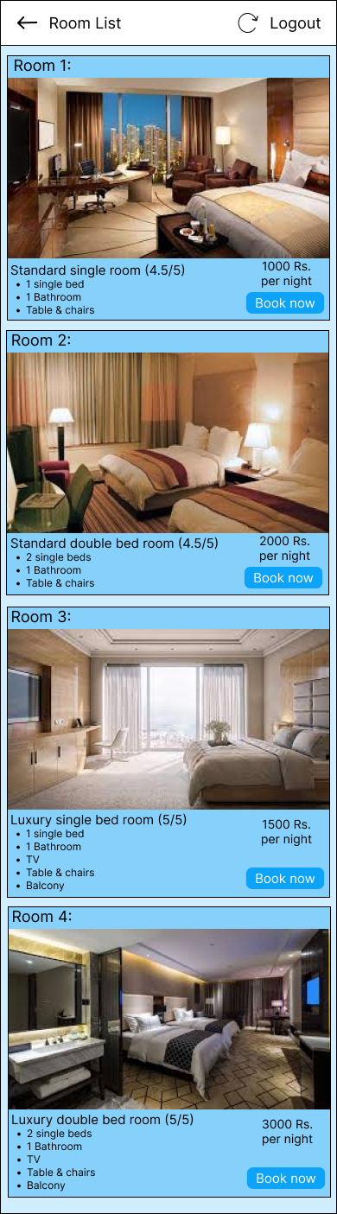

13.

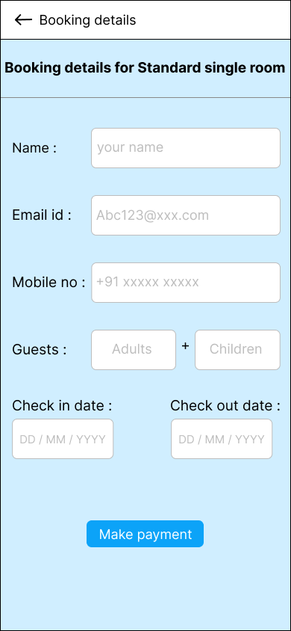

* This is **Booking details** page.
* After pressing **Book now** button on **Room list** page, user will redirect to this page.
* User need to enter details like **Name**, **Email id**, **Mobile number**, **Guests (Adults** and **Children)**, **Check in date**, **Check out date**.
* For payment, user need to press **Make Payment** button and it will redirect to page 14(**Payment details** page).
* **Back** button will redirect to page 12(**Room list** page).
* We formed group for all details with respective text box, **Make payment** button and header.

14.

* This is **Payment details** page.
* After pressing **Make payment** button on **Booking details** page, user will redirect to this page.
* User can see the rate of selected room on top. User need to enter details like **Credit/Debit card number**, **Expiry month**, **Expiry date**, **CVV code**, **Name on the card** for further payment process.
* For further payment process, user need to press **Pay** button and it will redirect to page 15(**Authenticate Payment** page).
* **Back** button will redirect to page 13(**Booking details** page).
* We formed group for all details with respective text box, **Pay** button and header.

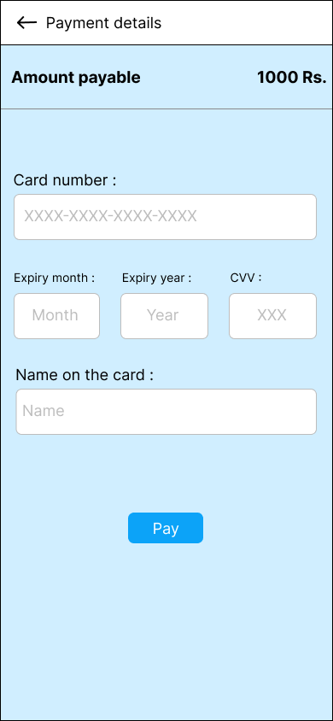

15.

* This is **Authenticate payment** page.
* After pressing **Pay** button on **Payment details** page, user will redirect to this page.
* User can see **merchant name**, **transaction amount** and **credit/debit card number**.
* In **Authentication** section, user will see that OPT has sent to his/her registered phone number.
* For further payment process, user need to enter 6 digit OPT and then press **Pay** button and it will redirect to page 16(**Booking confirmation** page).
* User can see some important notice about activating credit/debit card at the bottom of the page.
* **Back** button will redirect to page 14(**Payment details** page).
* We formed group for all text boxes with respective sections, **Pay** button and header.

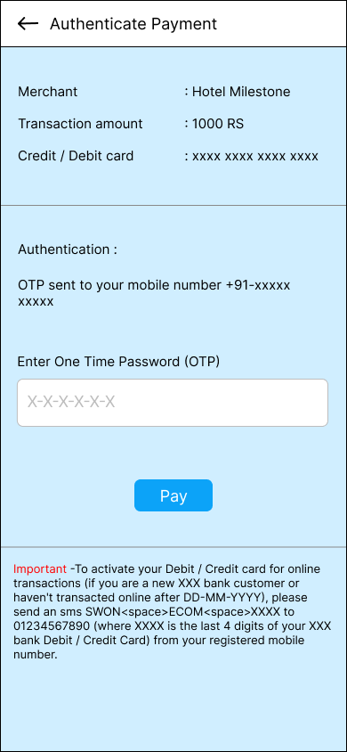

16.

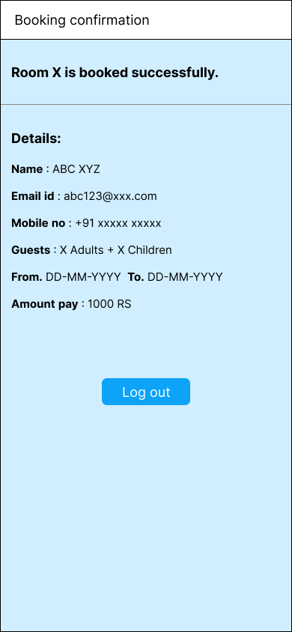

* This is **Booking confirmation** page.
* After pressing **Pay** button on **Authenticate payment** page and successful payment, user will redirect to this page.
* User can see his/her **booked room number** and details like **name**, **email** **id**, **mobile** **number**, **guests**, **check in and check out dates**, **amount pay**.
* **Log out** button will redirect to page 9(**User Login** page).
* We formed group for all text box section, **Log out** button and header.

**Prototyping between pages:**

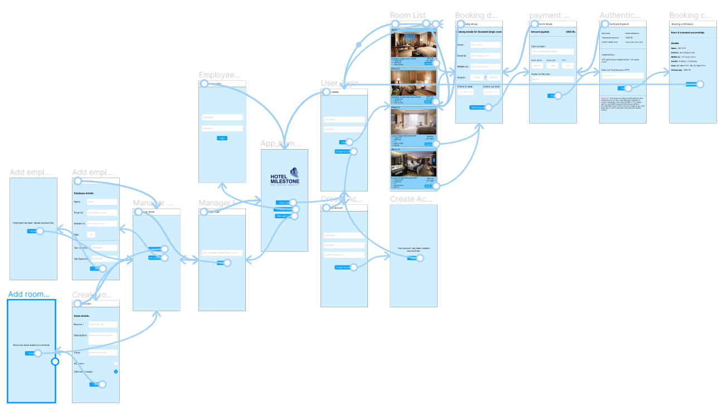

**Importance of UI/UX in software products.**

* The primary goal of any business is to increase its sales and increase the growth of the business. UX/UI design plays an essential role in achieving this goal. The UX/UI design of the application improves the user experience and customer satisfaction that ultimately helps increase the number of users of the specific application.
* The UI and UX design help to win the consumers’ confidence and make them use your application or website providing them what they are looking for. The number of consumers you are getting on your application can measure the success of the great UI and UX.
* For a start-up or a small venture, the importance of UI and UX design becomes even more crucial as the first impression lasts long and using UI and UX designing can make or break the brand recognition.