**IT441 COMPUTER GRAPHICS**

QUIZ #1

MAX MARKS: 4 x 3 = 12 TIME ALLOWED: 40 MINUTES

Q1. From the origin (0,0) to endpoint (10,M), a line is to be drawn using the mid-point line drawing algorithm. Determine the pixel which will be selected by the algorithm in the column given by coordinate x = 2.

How to provide answer: Y coordinate value of pixel.

SOLUTION (to be computed for various values of M)

d = 2*M – 10;

x = 0; y = 0; /* putPixel(x,y); */

/* for column x = 1 */

if d <= 0 {

d += 2M; x++; /* EAST */

}

else {

d += 2(M-10); x++; y++; /* NORTHEAST */

}

/* putPixel(x,y); */



/* for column x = 2 */

if d <= 0 {

x++; /* EAST */

}

else {

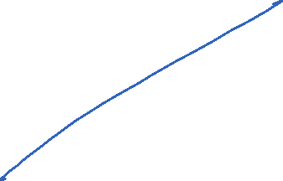

x++; y++; /* NORTHEAST */

}

/* putPixel(x,**y**); */



Q2. A line segment extends between world coordinates (-1,0) and (19,20). A clip rectangle is specified by bottom left point (0,0) to top right point (15,M), in world coordinates. Determine the end-points of the clipped line segment.

How to provide answer: Coordinates of the two points, (a,b) and (c,d).

SOLUTION

It is easily seen that the line segment has slope = 1, and that it satisfies the straight line equation: y = x + 1. Assume that the origin (0,0) is at the bottom left of the clip area.

1. At the left edge of the clip rectangle, x = 0. Therefore the specified line segment intersects the left edge at the point (0,1).

2. At the top edge of the clip rectangle, y = M. Therefore the line segment intersects the top edge at the point (M-1,M).

So the two required end-points are: (0,1) and (M-1,M).



Q3. A 2D object is located with its centroid at point (M, 2*M). Calculate the homogenized transformation matrix which will rotate this object ABOUT ITS CENTROID by angle q degrees, where sin(q) = 0.6, cos(q) = 0.8.

How to provide answer: [ a11, a12, a13 ; a21, a22, a23 ; a31, a32, a33 ].

SOLUTION STEPS: Translate the centroid to the origin, rotate, translate back. Homogenized answer matrix: The first one below. To be multiplied by student.

Q4. A 2D object is located with its centroid at point (M, 2*M). Calculate the homogenized transformation matrix which will scale this object ABOUT ITS CENTROID by scale factors Sx = 0.4 and Sy = 0.6.

How to provide answer: [ a11, a12, a13 ; a21, a22, a23 ; a31, a32, a33 ].

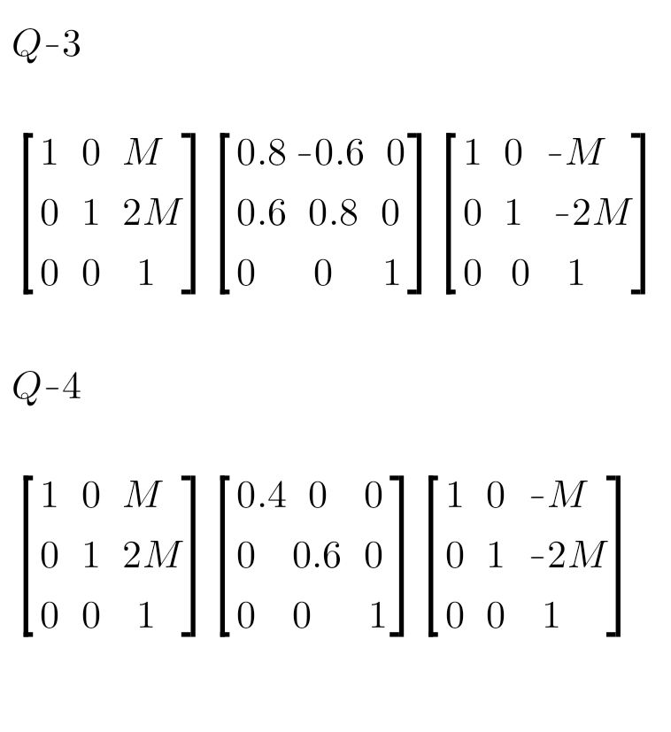SOLUTION STEPS: Translate the centroid to the origin, scale, translate back. Homogenized answer matrix: The second one below. To be multiplied by student.