**IT441 – QUIZ #2**

Maximum marks: 12 Time allowed: 40 minutes.

Q-1. A cuboid of width 4M, height 3M and depth 2M is situated with its centre at the origin of the 3D coordinate system, and edges parallel to X, Y, Z axes. See Figure 1. Find the volume of the portion of the cuboid defined by:

x > 0, y > 0, z > 0.

Q-2. In the 3D space defined by X, Y, Z axes, the linear equation:

x + M*y + z = M

defines a plane. Find the unit vector normal to this plane.

Q-3. You are given a polyhedron which is a truncated pyramid, whose base is a 3*M sided polygon. Find the number of edges in this polyhedron.

[NOTE: For reference and understanding, Figure 2 shows a truncated pyramid with a base which is a 16 sided polygon.]

Q-4. Figure 3 gives the 4x4 matrix MH which defines the Hermite family of cubic curves in parametric form, with 0 < t < 1. In a given instance, the x-component Gx of the geometry vector is given by [ 0 M 2 2 ]T. Find x(0.5).

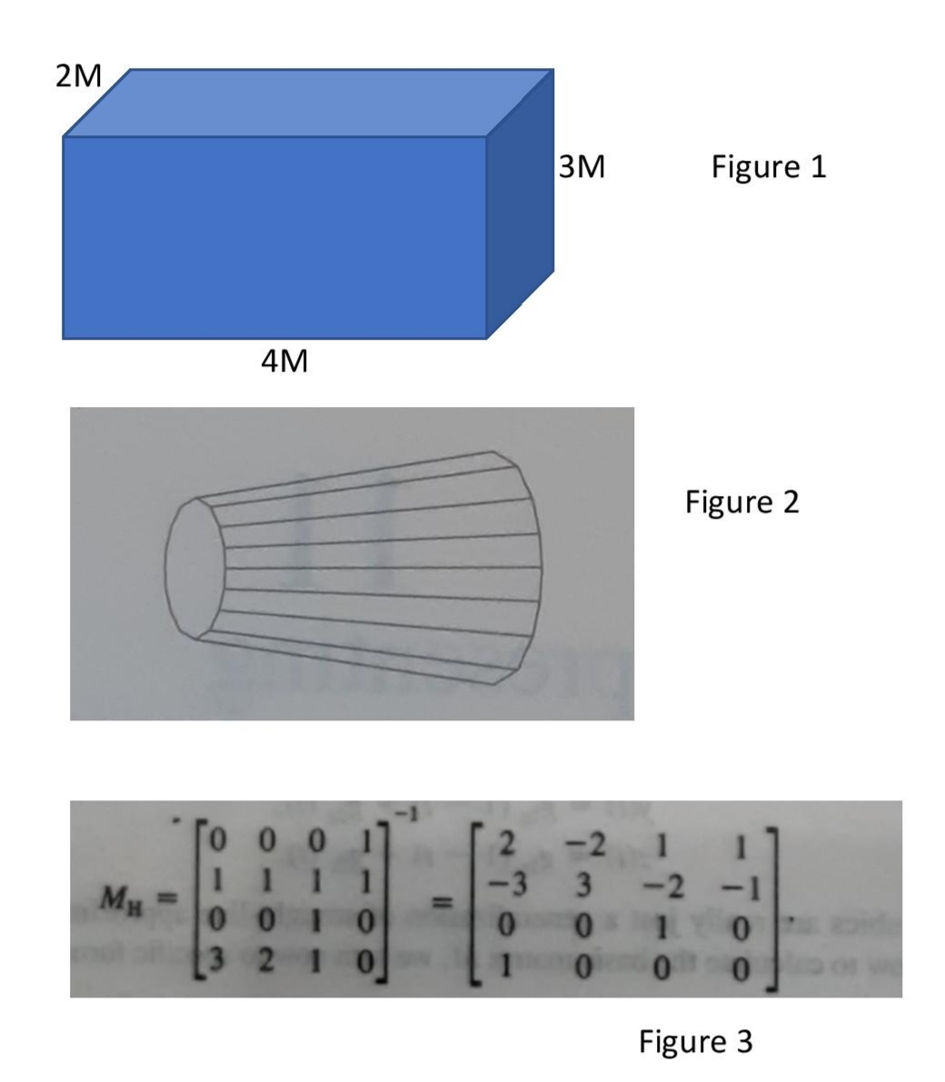

2M

3M Figure 1

4M

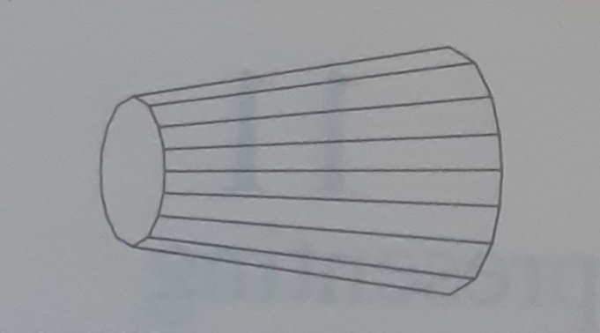

Figure 2

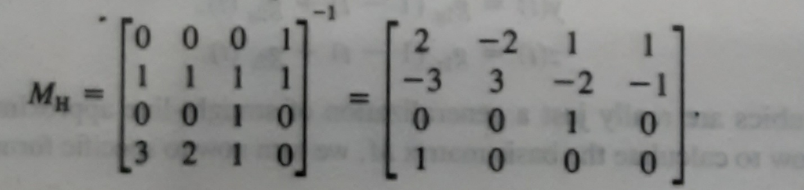

Figure 3