IE 410 – INTRODUCTION TO ROBOTICS

Lab-9 report

Team M410:

201901011 – HIMANSHU DUDHATRA
201901024 – DHAVALSINH RAJ
201901100 – SHUBHAM PATEL
201901145 – GARGEY PATEL

- Run following commands

$ source catkin_ws/devel/setup.bash
$ roslaunch turtlebot3_navigation turtlebot3_navigation.launch map_file:=$Home/map.yaml

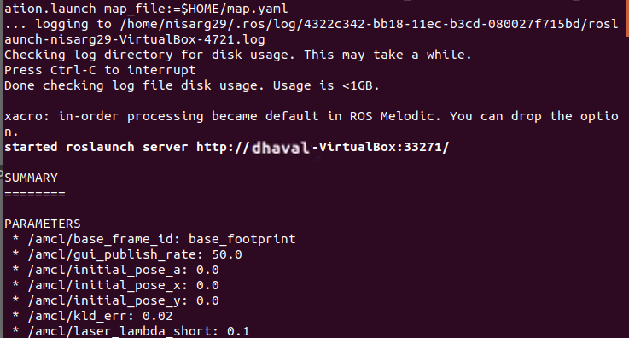

- To control turtlebot3 by keyboard, run following command

$ roslaunch turtlebot3_teleop turtlebot3_teleop_key.launch

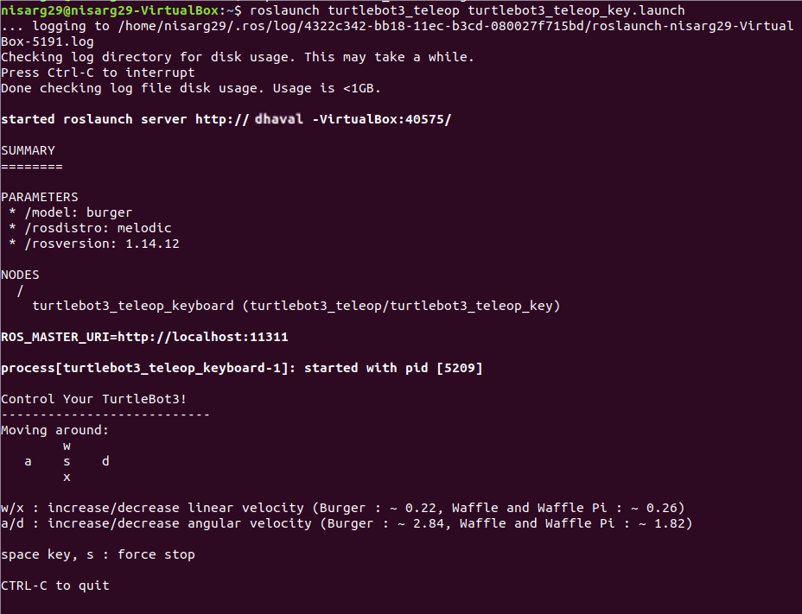

Moving robot using keys:

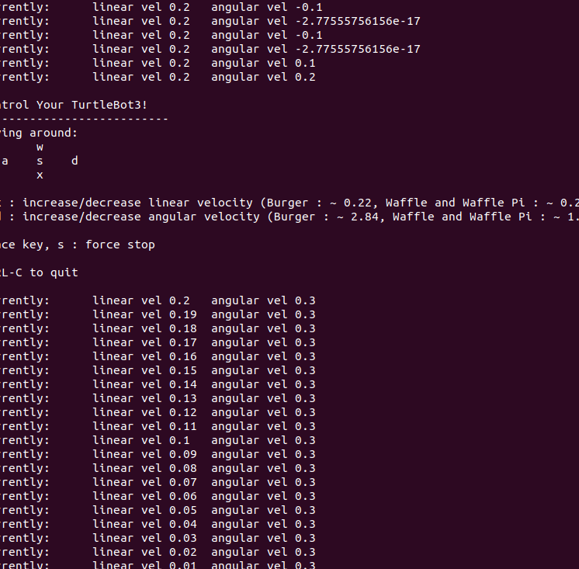

- Retrieving map using turtlebot3_slam.launch

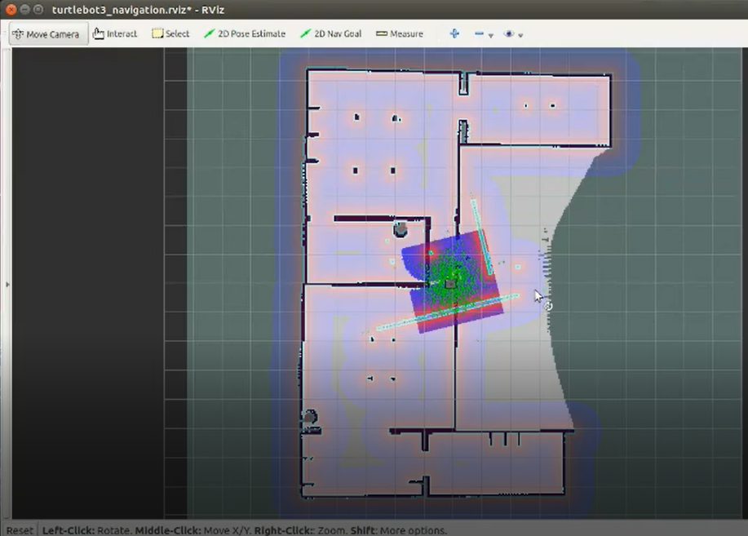
Local map:

Planner map:

Cost map:

