Steps to create and launch server on your local machine.
1.check for node version:- node -v
2. After that follow these steps:

A-)npm -v
B-)npm install http -server g

3.This will create a local server if everything goes well,then open your deafult browser and issue the following commands:-

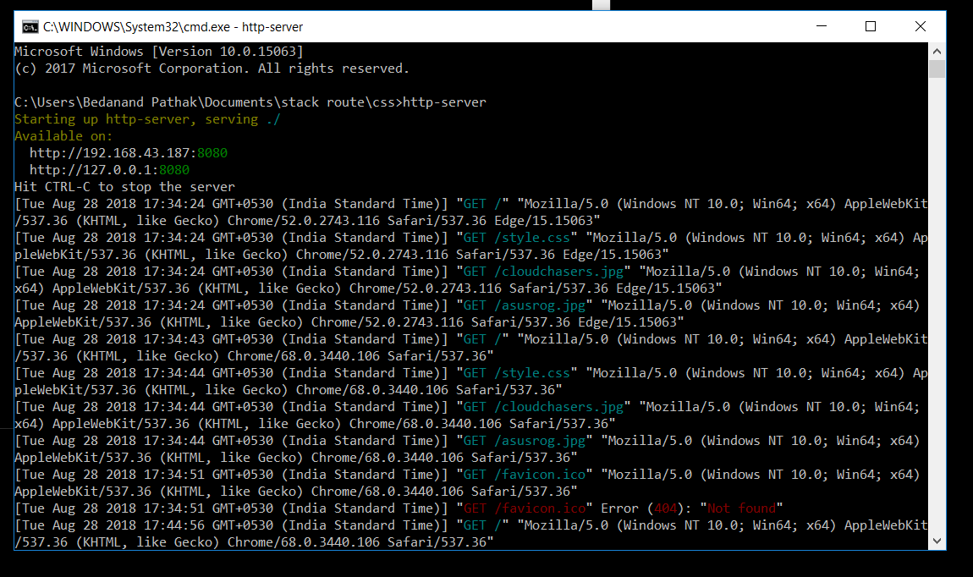
4.In my case the address of local host machine is at port 8080:
so go to your browser and type:
localhost:8080
This will launch your live server.

