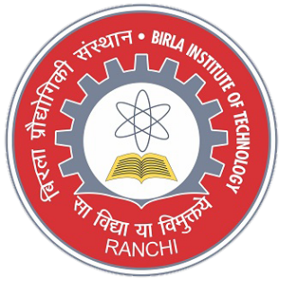**SHUBHAM PATIDAR**

Gender : Male Linguistic Proficiency: English, Hindi

Master Of Computer Application Date of Birth: 20/07/1997

Birla Institute of Techn­­ology Email: shubhampatidar1802@gmail.com

Ranchi (Mesra), India Contact: +91 7566662151

**Educational Qualification:**

|  |  |  |  |  |
| --- | --- | --- | --- | --- |
| **Degree/ Examination** | **Year of Passing** | **School/Institute** | **Board/University** | **Percentage/ CGPA** |
| MCA | 2022* | Birla Institute of Techn­­ology  Ranchi (Mesra), India | Birla Institute of Techn­­ology  Ranchi (Mesra), India | 8. 25 |
| BCA | 2019 | School of computer science  and technology ,indore | Devi Ahilya Vishwavidyalaya  Indore | 64.44 |
| Class XII | 2016 | Bright Career Public Higher Secondary School,  Boda | Madhya Pradesh Board of Secondary Education | 82.40 |
| Class X | 2014 | Bright Career Public Higher Secondary School,  Boda | Madhya Pradesh Board of secondary Education | 87.20 |

**Project Work:**

* **Project – Online Medical Services:**

1. **This website developed to help people for avail medical facilities online.**
2. **Our motto is to serve patient with different diseases by providing them online medical store ,**

**Health article , doctors.**

1. **It has been developed using HTML,CSS as front-end and used php MySQL database as backend.**

**Areas of Interest:**

* Data Structure and Algorithms
* Object Oriented Programming Concepts
* Database Management Systems

**Technical Skills/ Certifications:**

* Programming Languages : C, C++, Structured Query Language (SQL)

**Academic Achievements and Co-Curricular Activities:**

* Secured **AIR-49** in **BIT’19 MCA** National Level MCA Entrance Examination.

**Extracurricular Activities:**

**Positions of Responsibility:**

**Social Activities:**

**Cultural and Sport Activities:**