### ****Project Title****: DTDC Courier Insights: A Comprehensive SQL-Based Logistics Analysis

**Primary Objective:** To perform in-depth consignment analysis using MySQL by leveraging a courier service dataset and focusing on:

* Operational efficiency
* Consignment cost structure
* Financial metrics
* Geo-Logistics Optimization
* Exception & Risk Management
* Client behavior

**Dataset Source:** Dataset used for this project is available publicly on kaggle. Link: [DTDC Courier Dataset](https://www.kaggle.com/datasets/ravindrasinghrana/dtdc-courier-dataset)

**Tools:**

* MySQL
* Kaggle DTDC Courier Dataset

**Schema Diagram:**

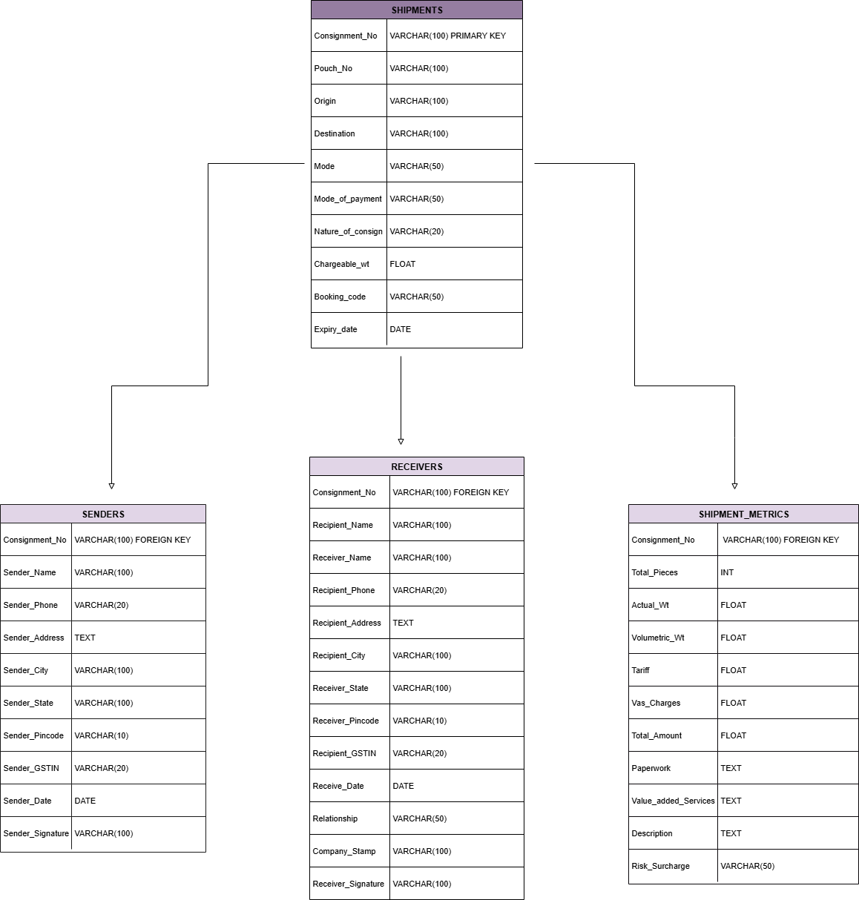

**Questions:**

* **Operational efficiency:**
  1. What is the average turnaround time and standard deviation per mode of transport?

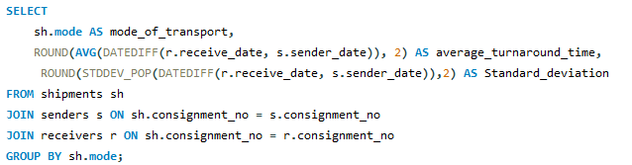

**O/P:**

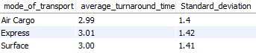

**Analysis:**

Between all mode of transports average turnaround time is consistent to approx 3 days. **Air Cargo**, expected to be the fastest, leads marginally — but not significantly. **Express** and **Surface** are performing **on par** with air cargo. **Low Standard Deviation** across all three modes (1.4–1.42) suggests that **turnaround times are consistent** and there is **no major variance** between best- and worst-case delivery times.

* 1. How many consignments were handled per day?

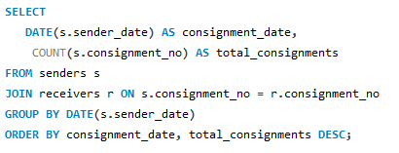

**O/P:**

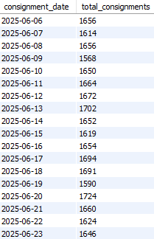

**Analysis:**

Consistent Volume: Shipment volumes hover tightly around 1,650–1,700 per day. This indicates a stable operational workload — useful for staffing and fleet planning. No sudden surge (like 2,000+) or dip (like <1,500). This suggests steady demand, possibly due to good distribution of client orders or B2B contracts.

* 1. Max and min number of consignments handled per day.

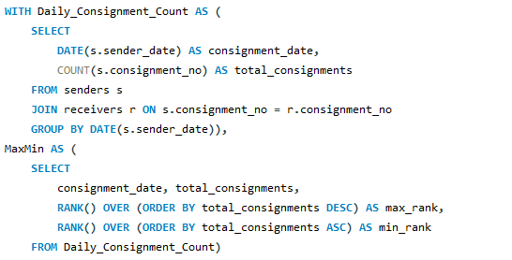

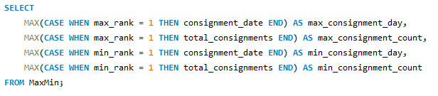

**O/P:**



**Analysis:**

The gap of **171 consignments** shows an **approx 10% fluctuation** between the busiest and lightest days. This is moderate — not extreme, but **should still be factored into planning.**

* 1. Number of days where number of consignments are above average.

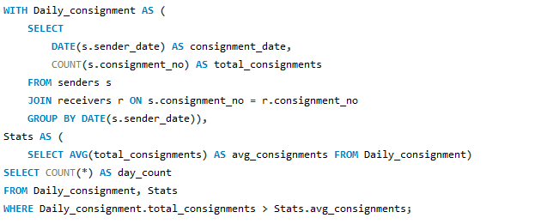

**O/P:**



**Analysis:**

**Average consignment volume** is only exceeded on **23%** of the days. This suggests that **consignment load is concentrated on a few high-volume days**, while the rest of the period sees relatively **lower or below-average activity.**

* 1. Which top 5 booking codes experience higher delivery times across cities?

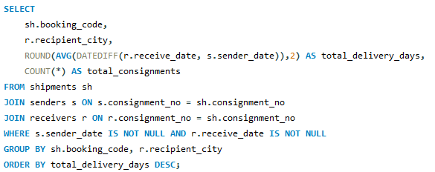

**O/P:**

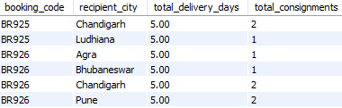

**Analysis:**

Specific booking codes like BR926 delaying deliveries could be flagged for review.

* 1. Identify count of shipments where the delivery gap is unusually high compared to similar routes.

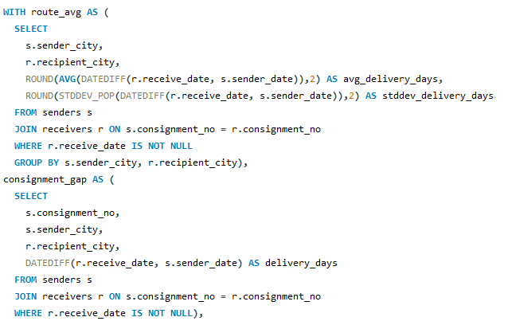

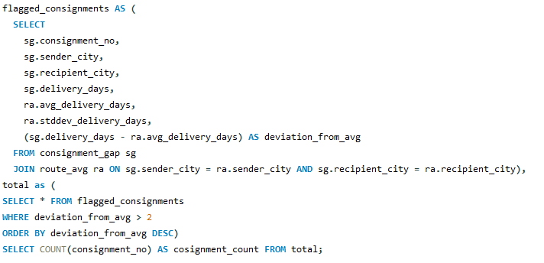

**O/P:**



**Analysis:**

Out of 49629 consignments 3799 consignments have high delivery gap. Outliers could reveal delays due to poor route planning.

* **Geo-Logistics Optimization:**
  1. Segment by mode of transport and routes, which route suffers most delays in terms of delivery gap and volume of consignments.

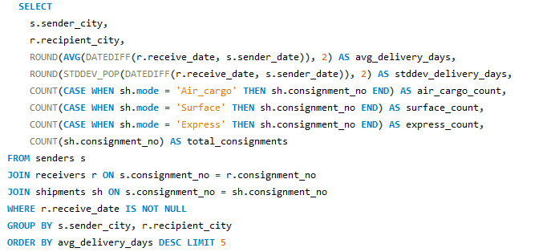

**O/P:**

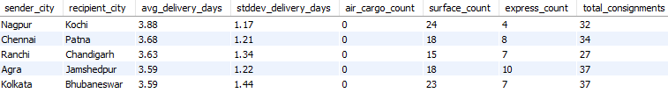

**Analysis:**

Higher delivery gap is observed in mode of transport 80% in surface and 20% in express. Routes which observe higher delivery gaps are Nagpur - Kochi, Chennai - Patna, Ranchi - Chandigarh, Agra - Jamshedpur, Kolkata - Bhubaneshwar. Volume of consignments on each route range around 25-40

* 1. Which top 5 routes operate with the lowest cost-per-kg (high efficiency)?

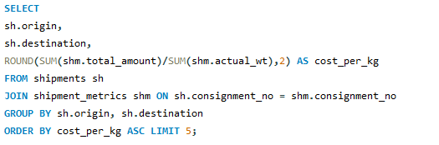

**O/P:**

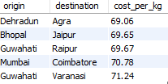

**Analysis:**

**High-efficiency lanes like Dehradun - Agra, Bhopal - Jaipur, Guwahati – Raipur, Mumbai – Coimbatore and Guwahati - Varanasi** worth expanding.

* 1. Which top 5 routes operate with the highest cost-per-kg (Low efficiency)

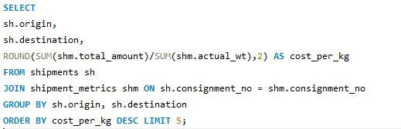

**O/P:**

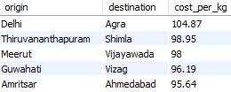

**Analysis:**

Flag routes like Delhi – Agra, Thiruvananthapuram – Shimla, Meerut – Vijayawada, Guwahati – Vizag and Amritsar - Ahmedabad for **pricing revision**

* 1. Which routes have the highest consignment volume and weight?

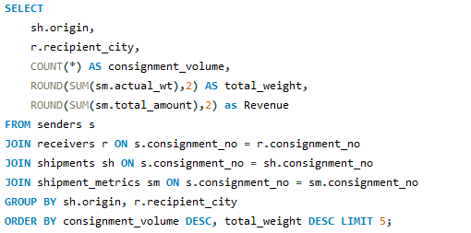

**O/P:**

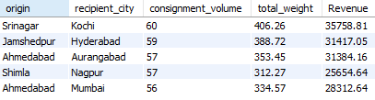

**Analysis:**

Routes with high shipment volume also show **high total weight**, implying major **bulk consignments** rather than lightweight or document parcels.

* **Consignment Cost Structure:**
  1. What is the average cost per kg by mode?

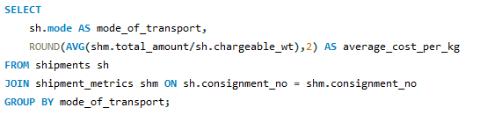

**O/P:**

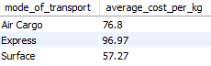

**Analysis:**

**Express is the most expensive mode per kg** most likely due to faster delivery expectations. **Air Cargo is mid-tier in cost mostly** used for faster but **moderately priced** consignments. Surface is most cost efficient may be because per-unit transport cost is lower despite longer delivery time

* 1. Which cities consistently incur higher VAS charges?

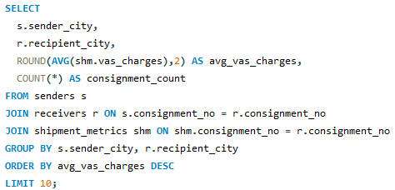

**O/P:**

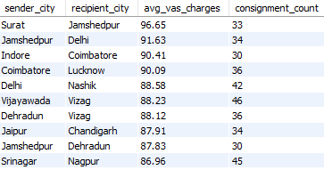

**Analysis:**

Routes involving **Tier 2 and 3 cities** (e.g., Jamshedpur, Indore, Coimbatore, Dehradun) are frequently on this list. Possible reasons: Infrastructure gaps requiring extra services.

* 1. Find % of total revenue spent on VAS.

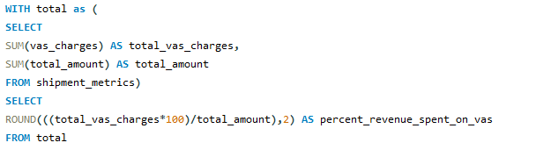

**O/P:**



**Analysis:**

13.23% of total revenue is used for vas charges. This margins refers to higher level upgrades to the basic services already booked by the logistics provider

* **Financial Metrics:**
  1. What is the total % revenue generated from each sender state and mode combination?

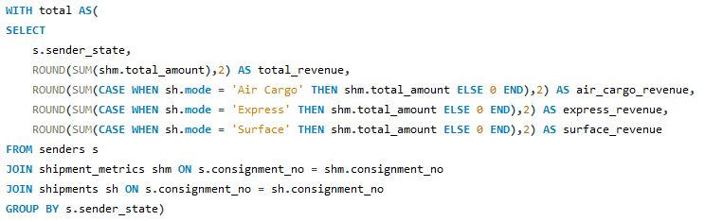

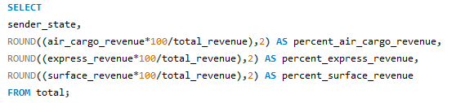

**O/P:**

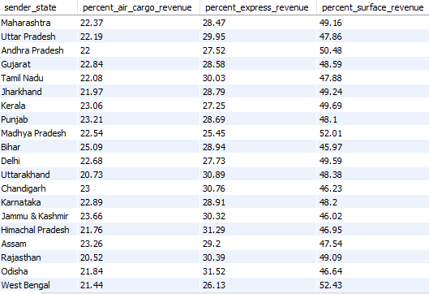

**Analysis:**

This suggests **surface is the most relied upon mode** operationally, possibly due to cost efficiency and nature of consignments (high volume, non-urgent).

* 1. Total revenue, VAS charge margin and profitability index of each mode of transport and correlation with volume of consignments.

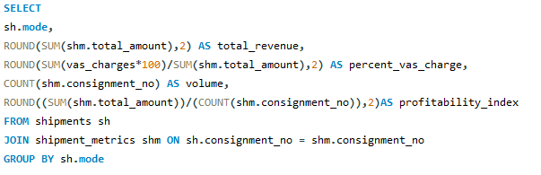

**O/P:**

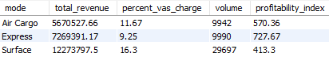

**Analysis:**

Major contribution to revenue is done by surface mode of transport with highest observed volume of shipments. Vas charge margin from revenue is highest in Surface. Profitability index is highest in express mode of transport 727 per consignment.

* 1. Identify top 5 senders state contributing highest total revenue across all consignments, their vas charge margin and profitability index.

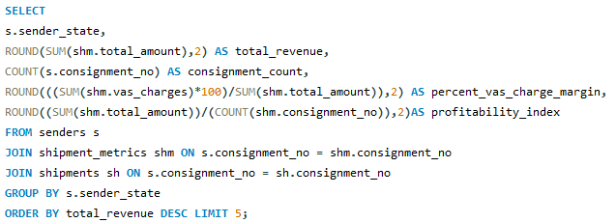

**O/P:**

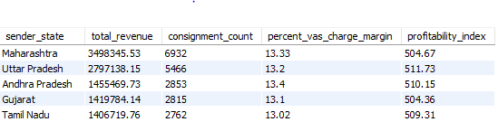

**Analysis:**

Major volumes of high revenue orders are received from Maharashtra and Uttar Pradesh. Profitability index is consistent through all top 5 states in range 500-510 per consignment.

* **Exception & Risk Management**:
  1. Count Consignments where chargeable_wt deviates significantly > 2kg from actual_wt.

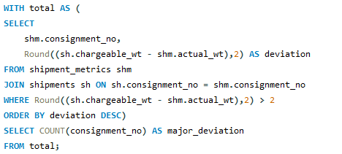

**O/P:**



**Analysis:**

**34.28%** of consignments have a significant weight deviation. **Data inconsistencies** observed in data in form of incorrect weight capture during booking.

* 1. Which routes and mode combinations generate high revenue but have low consignment volume?

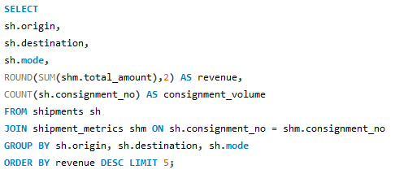

**O/P:**

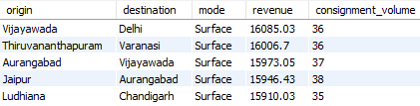

**Analysis:**

Mostly in surface mode of transportation high revenue at low consignment volume is observed. Vijayawada –Delhi, Thiruvananthapuram – Varanasi, Aurangabad – Vijayawada, Jaipur – Aurangabad, Ludhiana-Chandigarh are routes where we observed consistent revenue of Rs.16,000.

* **Client Behavior:**
  1. Top 10 clients by revenue or volume.

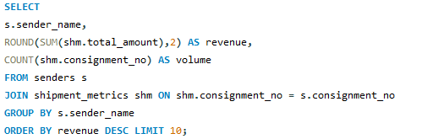

**O/P:**

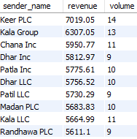

**Key Insights and Findings:**

**1. Operational Efficiency**

* Turnaround Time across all transport modes averages ~3 days, with minimal variance (SD: 1.4–1.6), highlighting process consistency and reliability.
* Daily consignment volume is in between 1,600–1,700. Despite being stable, only 14 out of 60 days (Approx. 23%) exceed average volume, indicating uneven peak demand.
* Difference in consignments between peak and low demand days is of approx.10%. this leads to scope for improvement.
* All routes show standard deviation within 1.4–1.6, but with volumes ranging from 30–50, there is potential to optimize volume on high-variance lanes.
* Booking Codes like BR926 appear frequently in delayed orders — recommending audit or redesign of these product-service packages.

**2. Consignment Cost Structure**

* Highest average cost per kg is found in express mode of transportation which is mainly due to faster speed and service expectations. Where as in surface mode it is found lowest may be due to bulk and non-urgent parcel characteristics.
* High efficiency routes are Dehradun–Agra, Guwahati–Varanasi and Mumbai–Coimbatore.
* Low efficiency routes: Delhi–Agra, Meerut–Vijayawad needs new strategies to optimize efficient.
* 13.23% of total revenue is allocated to VAS — a substantial margin that demands closer review for cost trimming strategies.

**3. Delivery Performance**

* Delivery gaps predominantly seen in Surface mode (80%) and cities like Kochi, Patna, Chandigarh, Jamshedpur, Bhubaneswar.
* 3,799 out of 49,629 consignments show significant delay anomalies — emphasizing a need for route-wise root cause analysis and monitoring.

**4. Financial Metrics**

* Surface dominates with ~50% of total revenue (₹1.2 Cr), aided by large volumes (30,000+ consignments).
* Express scores the highest Profitability Index (₹727 per consignment) due to premium services.
* Maharashtra and Uttar Pradesh lead in revenue and consignment count. Profitability remains consistent (~₹500–510 per consignment) across top-performing states.

**5. Geo-Logistics Optimization**

* Route Profitability Matrix reveals low-volume, high-revenue route-mode combinations, e.g., Vijayawada–Delhi via Surface. These are ideal candidates for capacity and revenue-maximization strategies.
* Tier-2/3 Cities like Jamshedpur and Dehradun report higher VAS charges, possibly due to lack of automation or limited hub access — signaling a geo-infrastructure gap.

**6. Exception & Risk Management**

* 34.28% of consignments have a greater than 2kg deviation between chargeable and actual weight. Indicates potential mislabeling or volumetric packaging inefficiencies.
* 3,799 shipments flagged for excessive delivery deviation. These represent revenue leakages, client dissatisfaction, and reputational risk.

**7. Client Behavior**

* Top Clients like Keer PLC and Kala Group maintain volume regularity.
* Clients like Keer PLC and Kala Group require segmentation and engagement strategies (e.g., discounts for loyalty, bundled services) to increase retention rate.

**Conclusion:**

* Operational workflows are stable, to add more efficiency in operations route-level optimization, booking code auditing, and volume balancing should be done.
* In mode of transportations surface dominates in volume and revenue. But express mode yields superior per-unit profitability. This creates an opportunity to up sell value-driven consignments.
* Cost and delay hotspots in Tier-2 routes show underlying infrastructure issues.
* A significant portion of revenue is driven by a limited number of high-performing origin-destination routes and key clients. Need to focus on improving routes and customers with average performance to make the business more stable and grow faster
* Exception handling needs a stronger data governance framework, especially around weight misreporting and unusual delivery gaps.

**How to Use This Project:**

* 1. Clone or download this repository.
* 2. Load the dataset into your MySQL environment.
* 3. Run the queries from the `DTDC_Analysis.sql` file.
* 4. Interpret the results to generate business insights.