Design of the Assignment

Class Design:

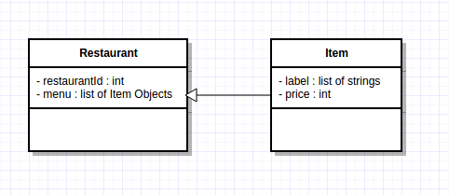

Data Structures:

1) Hash Map : is used to store to data of restaurants. The id of restaurant is used as Key and corresponding object of restaurant class is used as value.

Hash Map (or Dictionary) : [ Key, Value ] : [ restaurantId, Object of Restaurant Class]

2) Set : is used to find common items between menu of user and menu of restaurant while discarding the duplicate inputs

3) List (or Array) :
- is used to hold list of suitable restaurant objects which contain the menu requirement given by user.
- also used to hold the flag for each food item in user menu to check if the food item is present in the restaurant menu or not.

Algorithm :

1) Parse CSV using csv library to generate Map of restaurants (restaurantDict)

2) for each restaurant in restaurantDict :

- check if restaurant contains all food items from user menu by finding intersection between user menu and restaurant menu using Sets

- set menuFlag for each user item found in restaurant menu

- if all indexes of menu flag are set, seperate out that restaurant in a new list called suitableRestaurants

3) for each restaurant in suitableRestaurant:

- find all possible combinations of restaurant menu items. (a brute force solution)

- keep track of minimum price using max_price variable

- for each combination, check if this combination contains all user items.

- if the combination contains all user items, check if price of this combination is less than max price. If it is, replace the max_price with current price.

- in similar way, for all combinations find the minimum price for combination offering all user items.

- create a combo (tuple) of restaurant id and minimum price for each restaurant offering all user items.

- find out the best restaurant (with minimum price) from list of such combos.

Test Cases :

1) run : python solution.py sample_data.csv burger tofu_log

output : 2 11.5

2) run : python solution.py sample_data.csv wine_spritzer

output : 4 2.5

3) run : python solution.py sample_data.csv abc

output : Nil

4) run : python solution.py sample_data.csv extreme_fajita jalapeno_poppers extra_salsa

output : 6 6.0

