**NAME : Darshan Badgujar**

**ROLL NO: 2 BATCH : T1**

**Experiment No: 5 & 6**

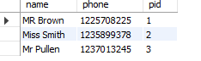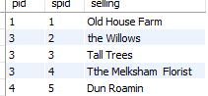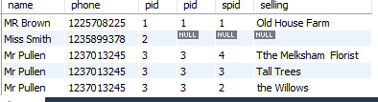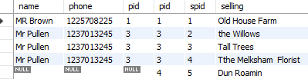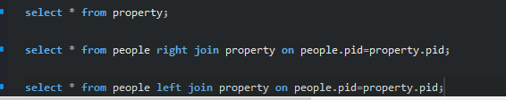

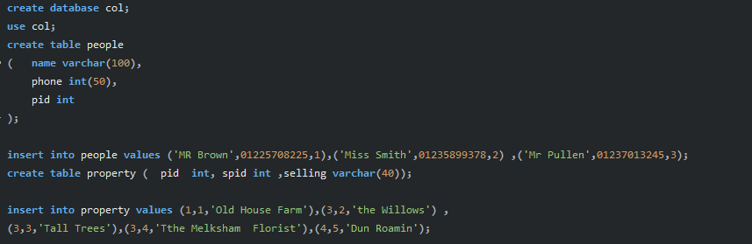

psvkm@svkm-HP-200-G3-AiO:~$ sudo mysql

[sudo] password for svkm:

Welcome to the MySQL monitor. Commands end with ; or \g.

Your MySQL connection id is 14

Server version: 8.0.28-0ubuntu0.20.04.3 (Ubuntu)

Copyright (c) 2000, 2022, Oracle and/or its affiliates.

Oracle is a registered trademark of Oracle Corporation and/or its

affiliates. Other names may be trademarks of their respective

owners.

Type 'help;' or '\h' for help. Type '\c' to clear the current input statement.

**mysql> create database payment;**

Query OK, 1 row affected (0.10 sec)

**mysql> use payment;**

Database changed

mysql> create table payments(customernumber int , checknumber varchar(40),amount int);

Query OK, 0 rows affected (0.68 sec)

**mysql> insert into payments values** (141,'JE105477',12000),(120,'MH45611',800),(135,'EF78955',500) ;

Query OK, 3 rows affected (0.09 sec)

Records: 3 Duplicates: 0 Warnings: 0

**mysql> select customernumber,amount from payments where amount = (select max(amount) from payments);**

+----------------+--------+

| customernumber | amount |

+----------------+--------+

| 141 | 12000 |

+----------------+--------+

1 row in set (0.01 sec)

**mysql> create view customerdetails as select customernumber,amount** **from payments;**

Query OK, 0 rows affected (0.11 sec)

mysql> select * from customerdetails;

+----------------+--------+

| customernumber | amount |

+----------------+--------+

| 141 | 12000 |

| 120 | 800 |

| 135 | 500 |

+----------------+--------+

3 rows in set (0.01 sec)

mysql>

create database col;

use col;

create table people

{

name varchar(100),

phone int(50),

pid int )

};

insert into people values (‘MR Brown', 01225708225,1), ('Miss Smith', 01235899378,2), ('Mr Pullen’, 01237013245,3);

create table property (pid int, spid int, selling varchar(40));

insert into property values (1,1, 'Old House Farm’), (3, 2, 'the Willows'), (3,3, 'Tall Trees'), (3,4, 'Tthe Melksham Florist'), (4,5, 'Dun Roamin');

select * from property;

select * from people right join property on people.pid=property.pid;

select from people left join property on people.pid=property.pid;