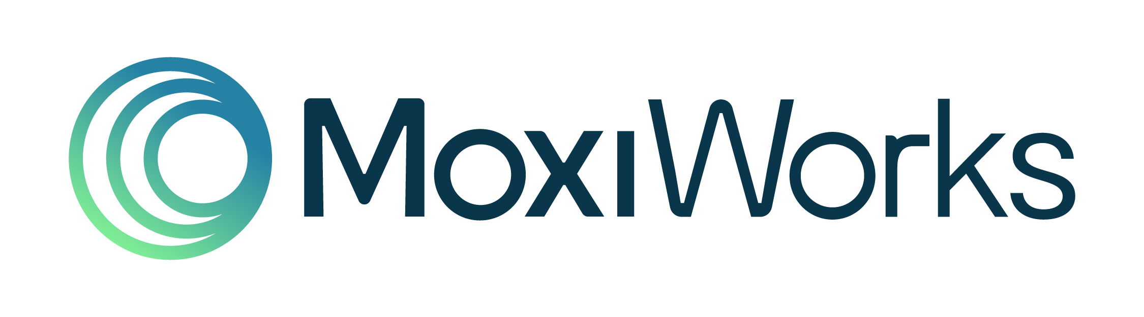

Job Title: - Automation QA Engineer (Cypress)
Location: Pune (Fully onsite)
Team: Engineering
Employment type: Full-Time
Experience: 3-5 Years

About MoxiWorks
MoxiWorks is the leading real estate technology platform powering more than 800 brokerages and over 400,000 agents across North America. Our open platform connects CRM, marketing, websites, presentations, and transaction tools — along with a deep ecosystem of partners and MLS data sources — to help real estate professionals run their businesses end-to-end. Our Pune office plays a central role in building and scaling the integrations that move data across our platform and the wider real estate ecosystem.

About the Role
We are looking for an Automation QA Engineer to join the Rise engineering team and own quality across our web and mobile platforms. You will design, build, and maintain test suites across a modern TypeScript monorepo, working closely with frontend and backend engineers to ship with confidence.
Rise is a real estate CRM built on a Turborepo monorepo — you will work across a Vite/React web app, a React Native mobile app, a GraphQL API layer, and a Cypress-based E2E suite.

Key Responsibilities
- Design, write, and maintain automated E2E tests using Cypress following best practices (e.g., Page Object Model)
- Review pull requests to ensure adequate test coverage and code quality
- Triage CI failures on Buildkite, reproduce issues locally, and collaborate with engineers to resolve them
- Identify, track, and help reduce flaky tests
- Work closely with developers to incorporate testing early in the development lifecycle
- Contribute to improvements in test infrastructure (test data setup, shared utilities, CI pipelines)
- Support sprint planning by providing QA estimates and highlighting potential risk areas
- Leverage AI tools (e.g., Claude) to improve productivity in testing and debugging
- Contribute to process improvement by identifying recurring implementation issues and helping refine internal workflows, documentation, and checklists

Required Skills
- Proficiency in Cypress for E2E testing (assertions, intercepts, custom commands, fixtures)
- Strong hands-on experience with JavaScript / TypeScript for writing and maintaining test code
- Familiarity with React applications and testing UI behavior
- Basic understanding of GraphQL and mocking API responses in tests
- Experience working with CI/CD systems (e.g., Buildkite, GitHub Actions, or similar)
- Proficiency with Git (branching, pull requests, rebasing)
- Experience writing clear test plans, test cases, and bug reports with reproducible steps
- Understanding of cross-browser and responsive testing
- Strong understanding of testing fundamentals (test design, edge cases, negative scenarios)
- Ability to debug test failures and analyze logs effectively

Required Soft Skills
- Communication — you work across time zones with engineers in the US; async written communication matters as much as meetings
- Ownership — you treat the test suite as a product; you don't just file bugs, you follow them to closure
- Pragmatism — you balance coverage with speed; you know when a unit test is enough and when E2E is essential
- Curiosity — the codebase is large and evolving; you read code you didn't write and ask good questions
- Attention to detail — you catch edge cases that engineers miss under deadline pressure
- Collaboration — you give clear, constructive feedback in code reviews without gatekeeping

Benefits
- Competitive salary
- Health insurance
- Hybrid work policy

Growth Opportunities
- Work on scalable, SaaS products with real-world impact on thousands of users
- Gain hands-on experience with modern technologies, architecture, and best engineering practices
- Collaborate with cross-functional teams including Product, Design, and Customer Success
- Continuous learning through mentorship, feedback cycles, and access to learning resources

