Predicting Churn for Bank Customers

Team: error 404
AIMT Group 1
Lambton College
Toronto, Canada

Abstract— This proposal outlines a data visualization project to predict customer churn for a bank using the Predicting Churn for Bank Customers dataset from Kaggle. The project will be focused on delivering clear and insightful visualizations using various static and dynamic charts to communicate the business problem and demonstrate the proposed solution.
Keywords—Data Visualization, Bank Customers, Churn Prediction, Kaggle

Introduction
Customer churn is a frequent issue for banks, resulting in substantial revenue losses and a detrimental effect on company development. Identifying the variables that cause client churn and creating practical ways to keep customers is critical for any bank's performance. This project will address this issue using data visualization methods and machine learning. Using the Predicting Churn for Bank Customers dataset, we will evaluate different customer characteristics and determine the main variables causing customer churn. By creating informative visualizations, we will present a solution to the customer churn problem and demonstrate its effectiveness in retaining customers.

Motivation
The dataset for this project is collected from UCI Machine Learning Repository. This repository consists of 4 databases from Cleveland, Switzerland, Hungary, and VA Long beach, and among these, I have taken Cleveland Data. This dataset consists of 302 rows and 14 attributes, as given

About the dataset
The dataset for this project is collected from UCI Machine Learning Repository. This repository consists of 4 databases from Cleveland, Switzerland, Hungary, and VA Long beach, and among these, I have taken Cleveland Data. This dataset consists of 302 rows and 14 attributes, as given below:
- Age: Age in years
- Sex: 1 for male; 0 for female
- cp: chest pain type; Value=1: typical angina Value=2: atypical angina, Value=3: non-anginal pain, Value=4: asymptomatic
- trestbps: resting blood pressure (in mm Hg)
- chol: person's cholesterol measurement in mg/dl
- fbs:(fasting blood sugar>120 mg/dl) (1=true,0= false)
- restecg: resting electrocardiographic results
- thalach: maximum heart rate achieved
- exang: exercise-induced angina (1 = yes; 0 = no)
- oldpeak: ST depression induced by exercise relative to rest
- slope: the slope of the peak exercise ST segment if Value=1: upsloping if Value=2: flat if Value=3: downsloping
- ca: number of major vessels (0-3) colored by flourosopy
- thal: if Value = 3: normal if Value = 6: fixed defect if Value = 7: reversable defect
- num: diagnosis of heart disease; if Value = 0: absent, if Value = 1,2,3,4: Present

Data Preparation

Querying the Data
The first step is to query the dataset by loading the .data file. It consists of 14 feature columns, including the num column, which shows whether heart disease is present or not.
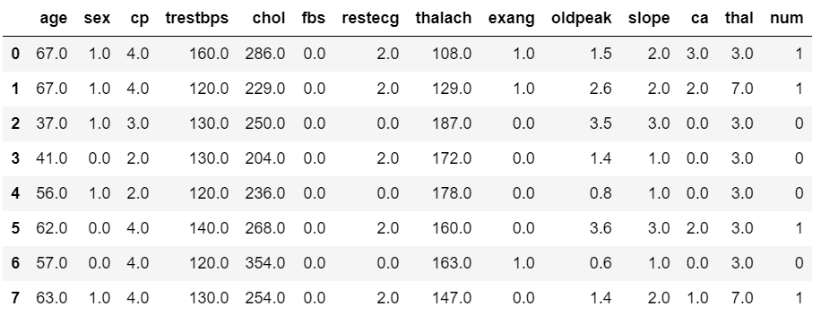
- Cleveland Heart Disease Dataset

Assigning Column Header
Since this dataset has no column header, assigning the column header according to the attribute description given in the UCI dataset.

Missing Values Handling
The first step of this process is to check whether there are any null values in the dataset. This dataset does not contain null values but consists of columns: ca and thal with irrelevant '?' values. As these columns have categorical data, missing values are handled by imputation using mode. 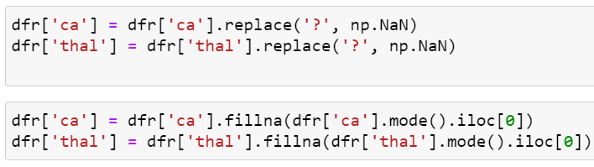
- Handling missing values
Here, a num column has five values 0, 1, 2, 3 and 4, where 0 represents the heart disease is absent, and a value greater than 0 means heart disease is present. Therefore, replacing the values > 0 with value 1. Now, this dataset does not have any missing values or errors.

Outlier Removal
Feature columns selected for outlier removal are chol, trestbps, thalach, and old peak, as other columns have categorical values and are normal. Here are a few things that I got after describing the dataset. The patient’s age is between 29 and 77, so there are no outliers. Chest Pain(cp) ranges between 1 to 4. trestbps column values range between 94-200 mm HG, which is normal. Chol column value range between 126-564 mg/dl, which is also normal. thalach column value is also normal as it ranges between 71-202. Although all the values are normal in the dataset, I will demonstrate two methods to remove outliers.

Outlier Removal using Mean and Standard Deviation:
Applying the mean and three standard deviations, nine outliers are detected from the four columns.
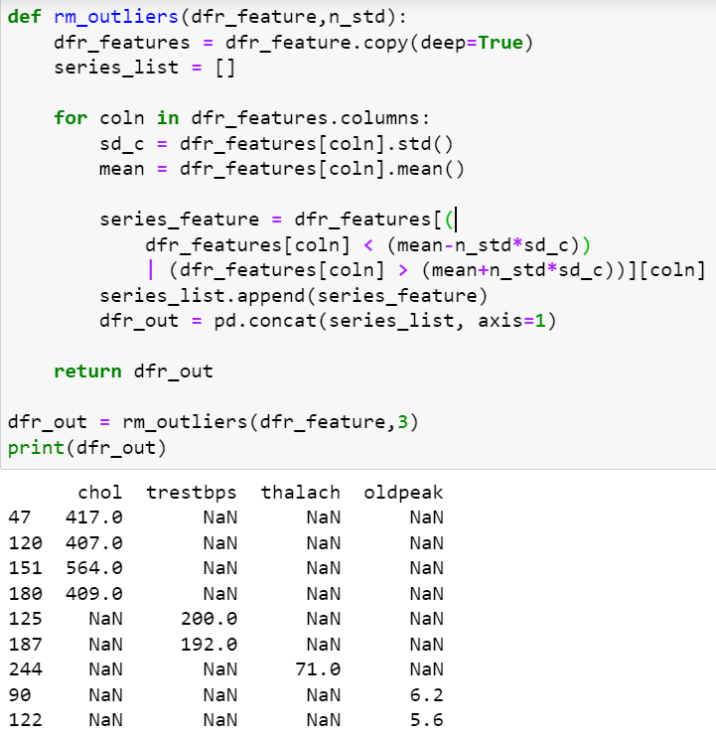
- Outliers and their removal code using mean and sdv

Outlier Removal using Median and IQR:
In this process, median, quartiles and inter-quartile range values are used to find outliers where the data that lies below (Q1 – 1.5 * IQR) and above (Q1 +1.5 * IQR) are considered outliers and are removed from the dataset.

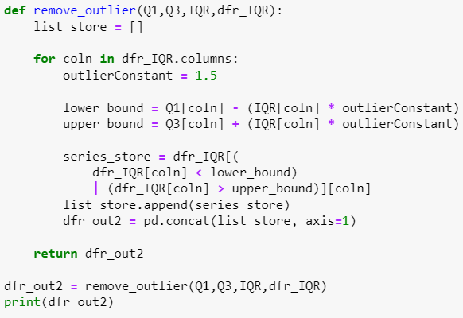
- Outliers removal code using Median and IQR
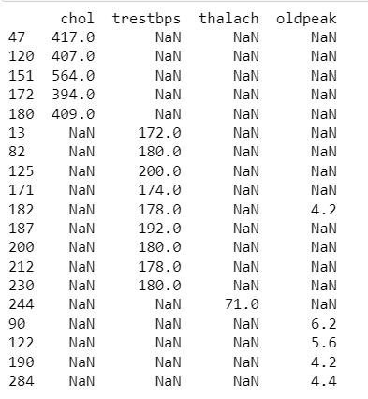
- Outliers detected by using Median and IQR
Here, 19 outliers are detected, most of them from the trestbps column, representing a person's resting blood pressure. After removing outliers, the total shape of the data frame is 283 rows and 14 columns.

Feature Engineering

Correlation Matrix:
Correlation is a statistical measure that expresses the degree of relationship between variables. The correlation matrix is simply a table that shows the correlation between a set of variables. It is used to determine which pair of variables are closely related. It may be positive or negative. A positive correlation occurs when both variables are in the same direction. Similarly, a negative correlation occurs when two variables are in opposite directions or inversely proportional. Here, a correlation heatmap is used to plot the 2D correlation matrix to visualize the strength of relationships between numerical variables.

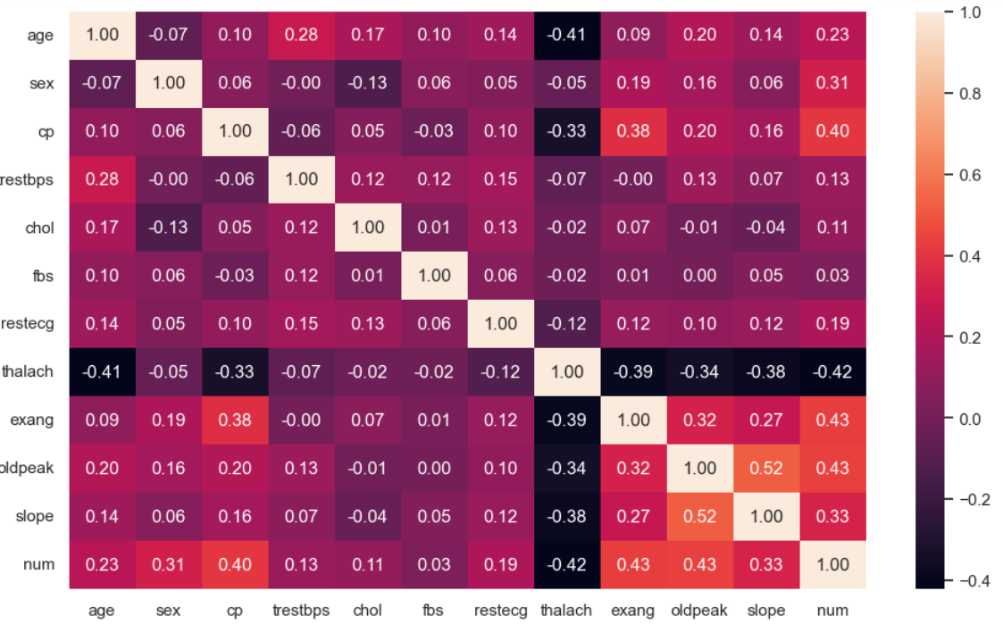
- Correlation Matrix Heatmap
From this heatmap, it can be seen that none of the features is strongly correlated with the num variable, which is the target. So, I will select all the feature columns for training the model.

Data Visualization
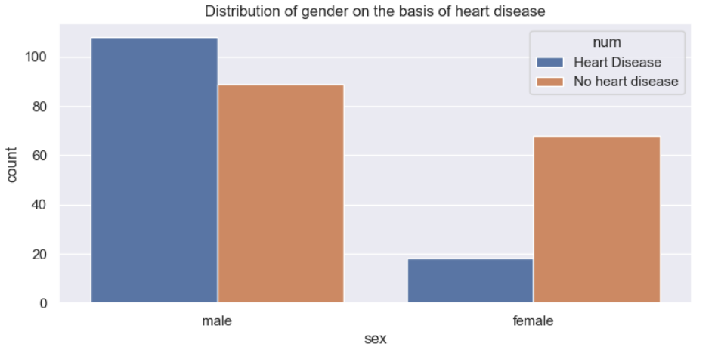
- Male vs Female based on Heart disease
Based on this dataset distribution based on gender, males are more prone to heart disease than women.
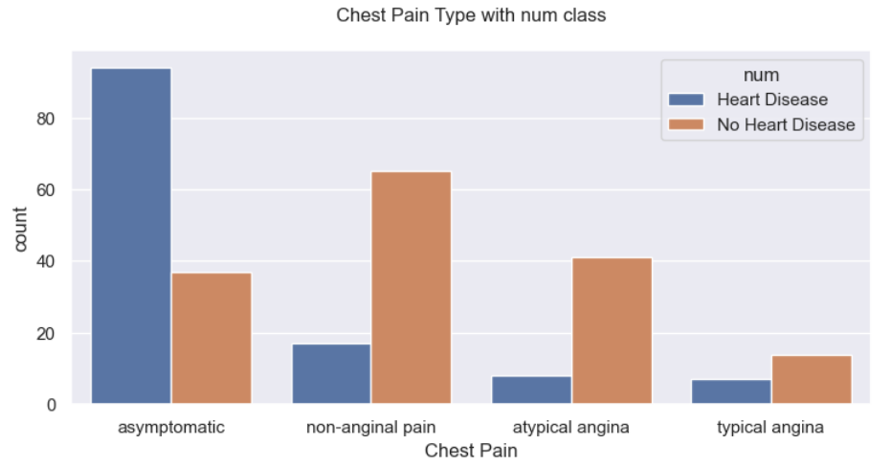
- Types of chest pain based on Heart disease
It consists of 4 types of chest pain: asymptomatic, non-anginal, atypical, and typical angina. According to this dataset distribution, most people with asymptomatic pain are found to have heart disease.
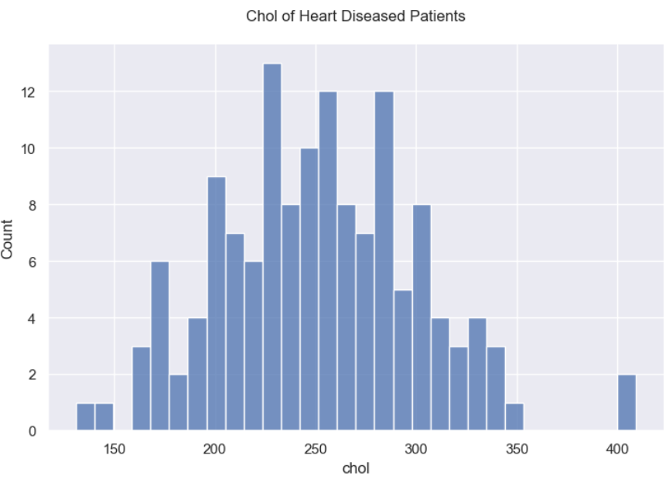
- Cholesterol of the patients having heart disease

Data Modelling

Train-Test Split:
Data is split into 20% test data and 80% train data, and Standard Scaler is used for the standardization of the features

Supervised Algorithm:
Logistic Regression is used for predictive analysis, where we estimate the probability of whether the event is occurring or not. Here, I am going to predict whether heart disease is present or not based on a set of independent variables.

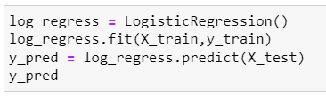
- Logistic Regression model

Performance Evaluation

Confusion Matrix:
The Confusion Matrix is used for the performance measurement of the logistic regression algorithm [2]. It consists of a table with predicted and actual values, which consist of 4 different combinations.

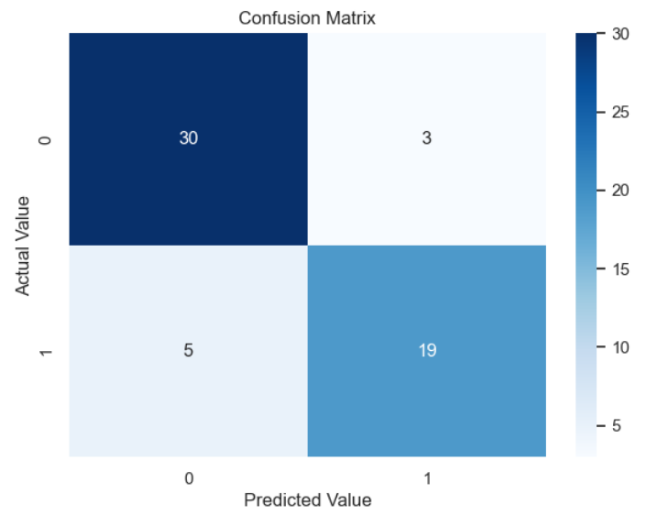

- Visual Representation of Confusion Matrix
Hence, From the confusion matrix of the Logistic Regression model, it can be seen that the True positive value is 30, the True negative value is 19, the False positive value is 3, and the false negative value is 5.

Measuring Performance:
The model’s performance is now measured by finding accuracy, precision, recall and the F1- Score.
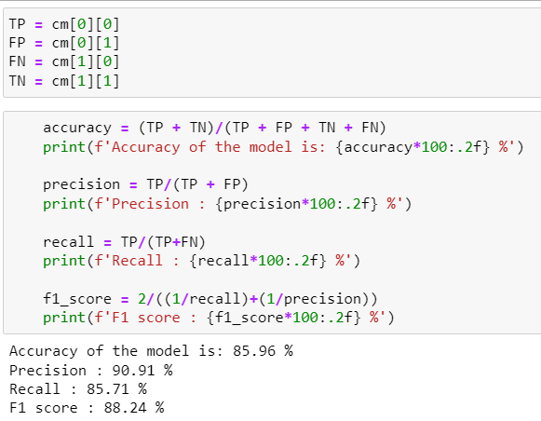
- Performance Measure
Here, the accuracy of the Logistic Regression model is 85.96 %, Precision is 90.91 %, Recall is 85.71 %, and the F1 score is 88.24 %

Unsupervised Algorithm
For an unsupervised machine learning algorithm, K-means clustering is used to find different clusters using the features of the dataset column. Initially, using the Elbow method, the Cluster Sum of squares (WCSS) is calculated for the number of clusters.
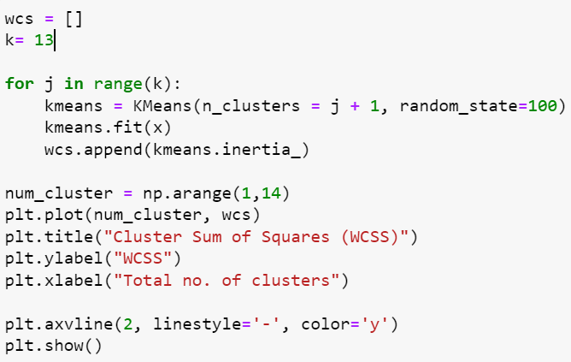
- Cluster Sum of Squares Code (WCSS)
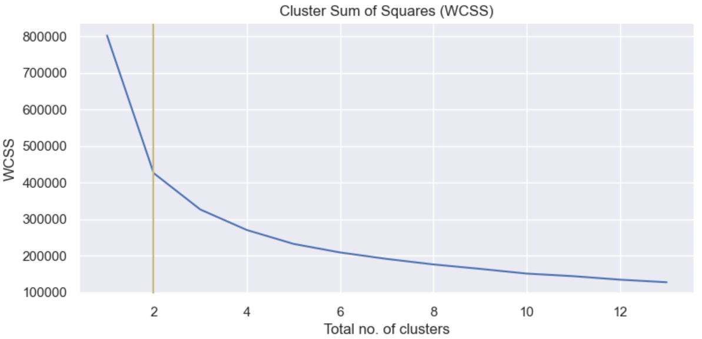
- Visualization for WCSS
Using the elbow method, the above figure depicts that two numbers of clusters look suitable for the k-means clustering algorithm. Plotting different graphs using the number of clusters identified by the algorithm.
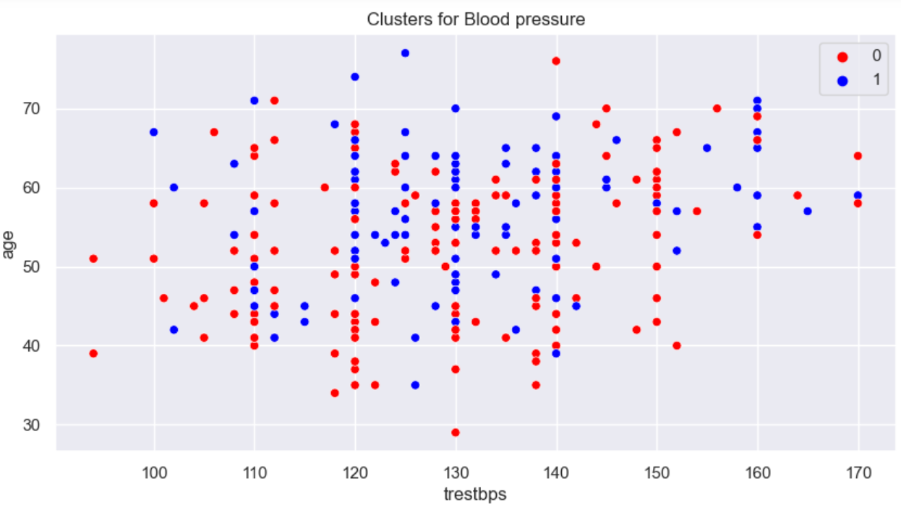
- Clusters for feature trestbps
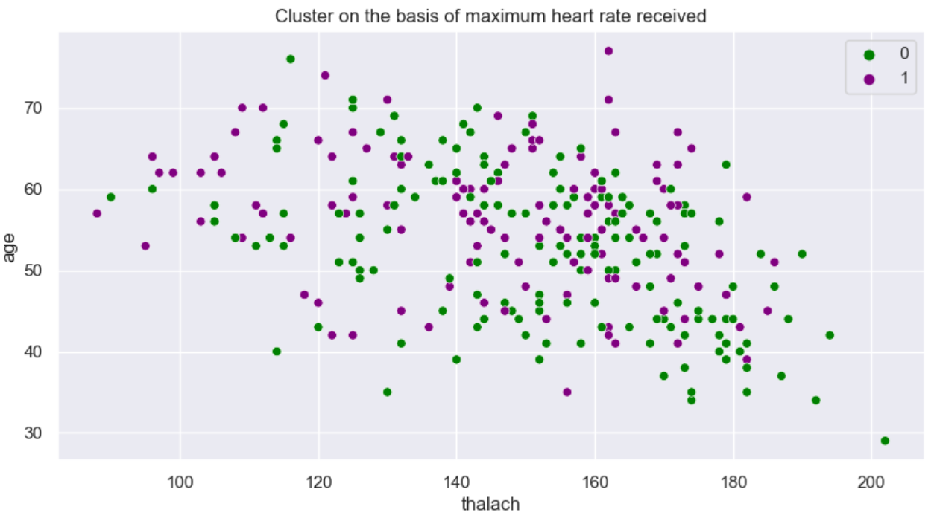
- Cluster for feature thalach
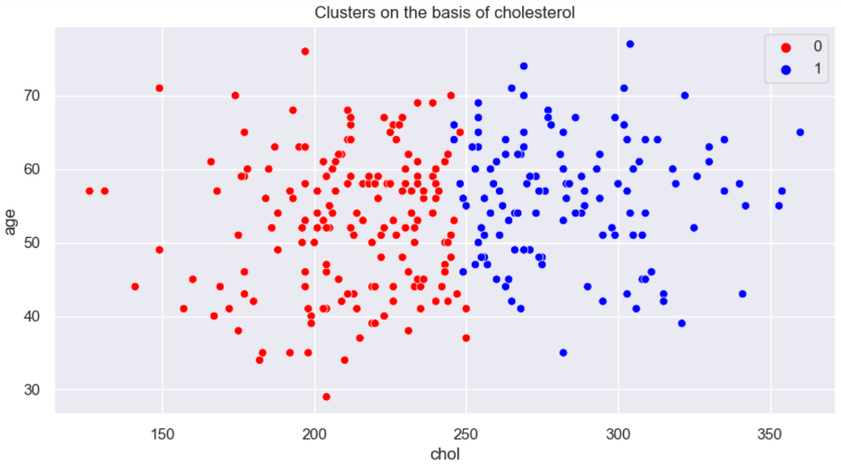
- Two Clusters for feature chol
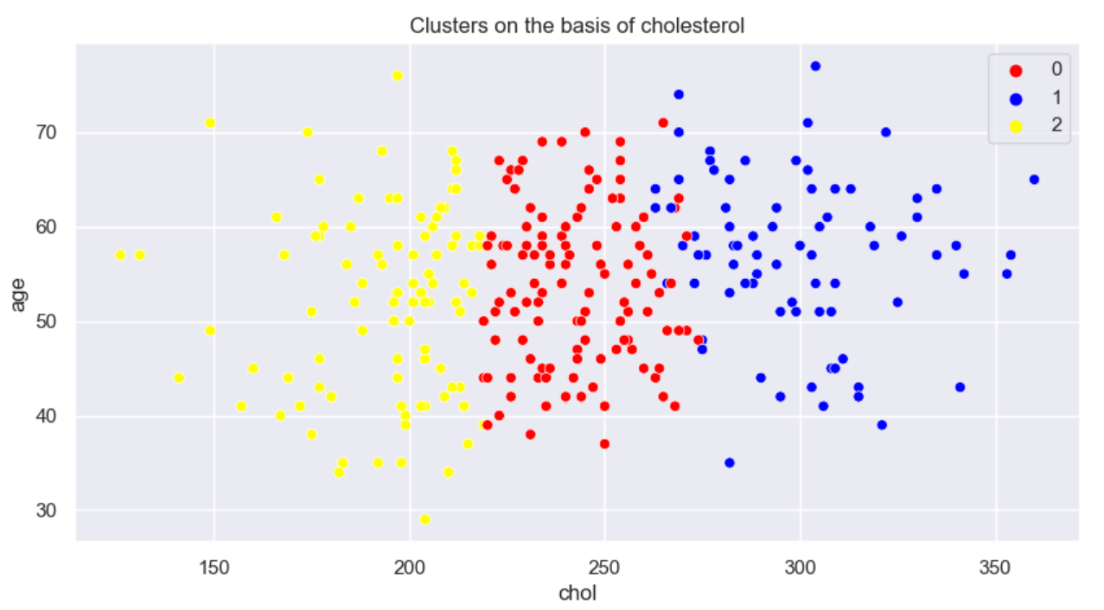
- Three Clusters for feature chol
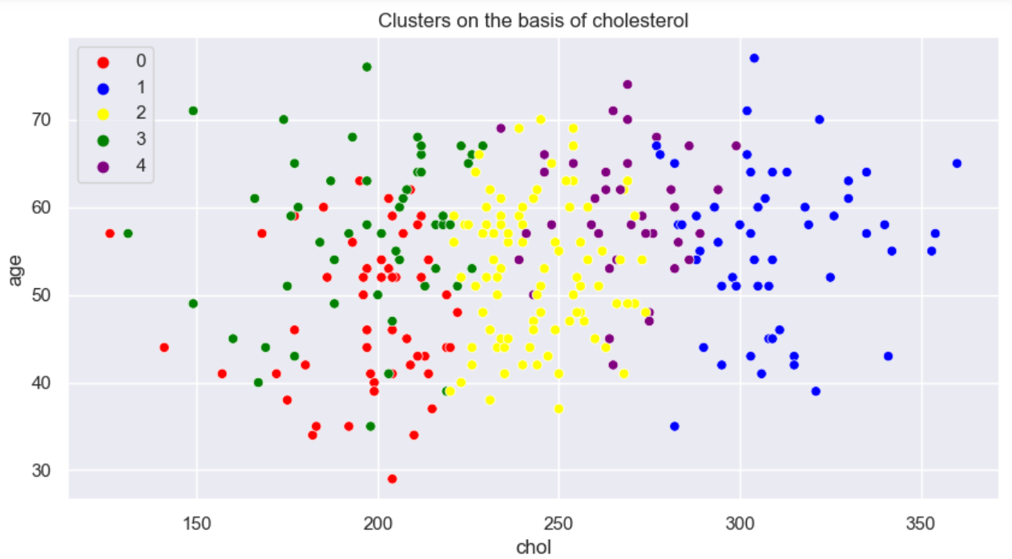
- Five Clusters for feature chol

Conclusion
To conclude, initially, the dataset from the UCI machine learning repository was preprocessed by cleaning, removing outliers, and selecting the features before training. For the supervised machine learning algorithm, since this is prediction, so logistic regression algorithm is used where the model gave 85.96% accuracy with an F1-score of 88.24%. Secondly, the k-means clustering algorithm is used for the unsupervised method, where different numbers of clusters are identified for three features: cholesterol, blood pressure and maximum heart rate. By data visualization, it can be seen that males are more prone to heart disease than females.

Acknowledgment
I want to express my special thanks to prof. Mohammad Islam, as well as Lambton College, for providing me with the opportunity to implement supervised and unsupervised Machine Learning Algorithms on Heart Disease Prediction Dataset.

References
- “Heart Disease Facts | Cdc.Gov.” Centers for Disease Control and Prevention, 7 Feb. 2022, www.cdc.gov/heartdisease/facts.htm.
- S. Narkhede, Understanding Confusion Matrix, May 2018 DOI: https://towardsdatascience.com/understanding-confusion-matrix-a9ad42dcfd6

