**Libraries**

tkinter -Requires for GUI

sudo apt-get install python-tk

time - for delay purpose

already exist

serial- for serial data read

already exist

**special function**

**bind for button- (Use snipping tool for screen shot)**

It is used to access any key on “Keyboard” or “Mouse”. We does not requires to generate GUI button. Here is the example of bind…

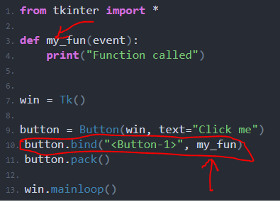

Here “<Button-1>” refers to the left click. If we want to call the function on clicking the right click then we had to use “<Button-2>”.

**Invoke() -**

It is used to press GUI button automatically.

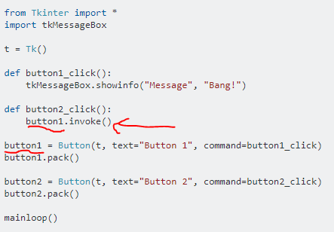

Here we have to press only second button and first button also execute with it. If you do not have tkMessageBox then remove that and also remove tkMessageBox.showinfo("Message", "Bang!") from button1_click() and print Anything you want and test the example.

**Place( ) –**

Used for page editing. In pack( ) all blocks are assigned with default place one by

one. And in grid( ) we can go by row and column. But in place( ) we can give x and

y values by our self.

**Insert data in blocks from one window to another –**



Here we created block for data as entry. If we have to fill data automatically

we need to insert data in it when we get the data.



Here when **fat** get value **e3.delete** clears the block and **e3.insert** get the fat

value into block.

**dpu.after(2000,luck)**

This is very important line in **Python GUI** while we transit from one GUI page

to another. Here is 2000 is delay and luck is the function to be called.

And here don’t use “**()”**  while calling luck function as “luck()”. Use only

Function name. It does not give any error but it will stuck on first page

Until called function execute completely.