Initialize Node

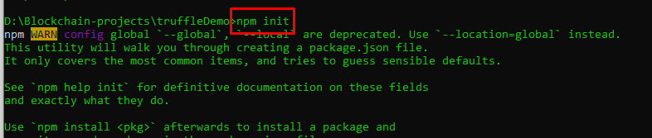

Install Truffle and Web3js

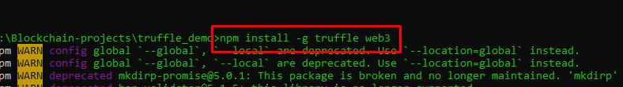

For using react with truffle

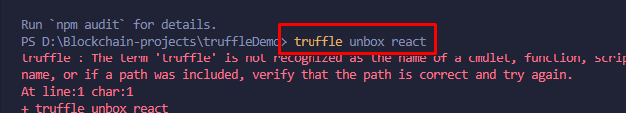

Uncomment Network & compiler

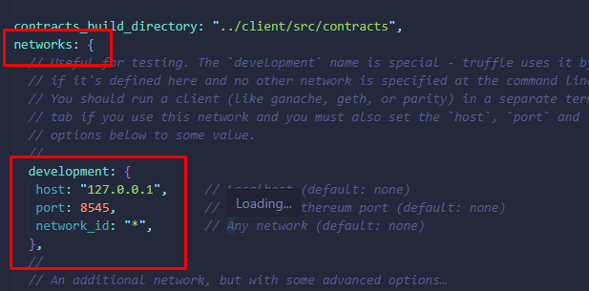

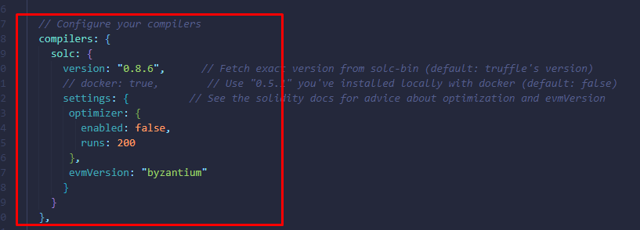

Write the contract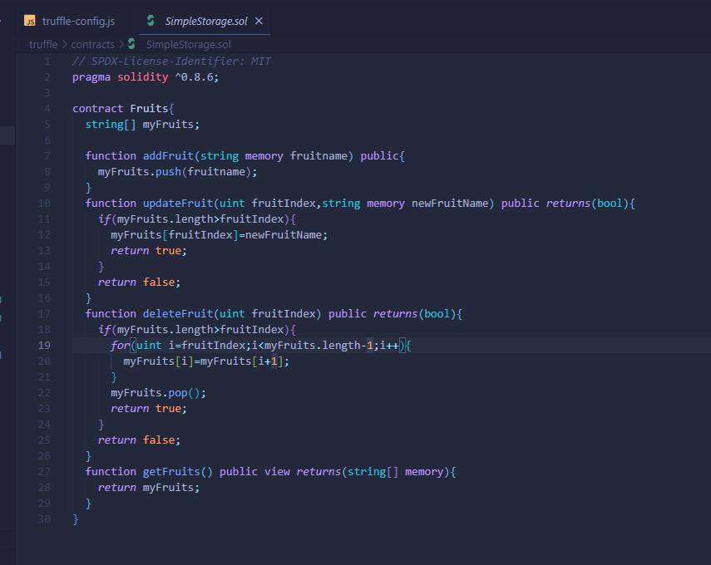

Write Migration file

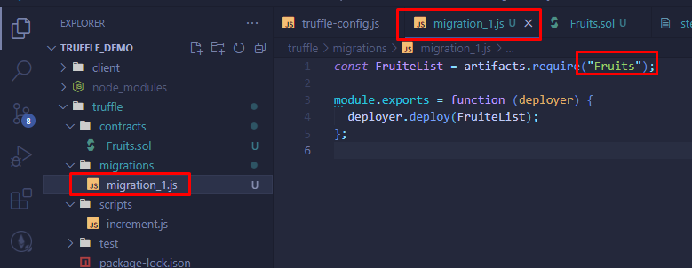

Opening truffle develop environment

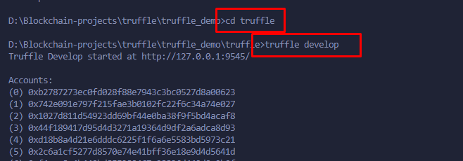

Compile & migrate the contract

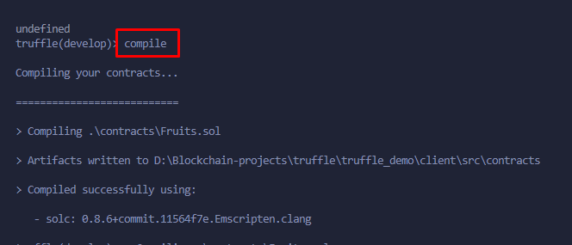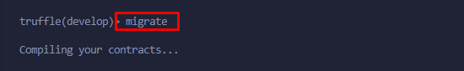

Move to truffle folder and Install the Web3 in Truffle packages

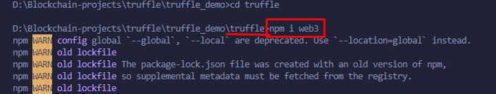

Wring Migration Contract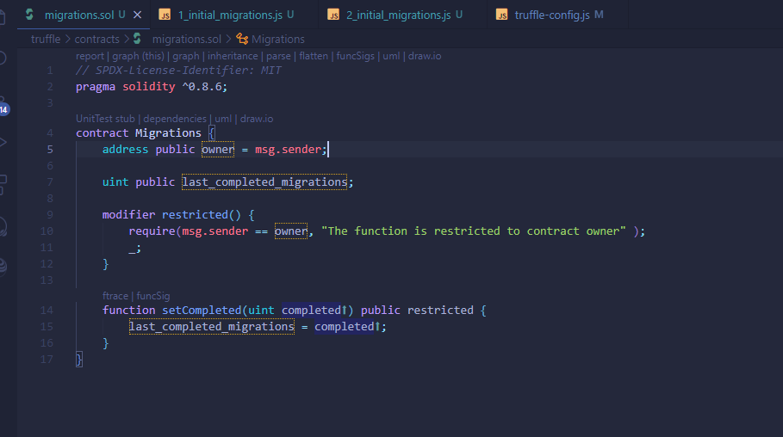

Deployment scripts for Migration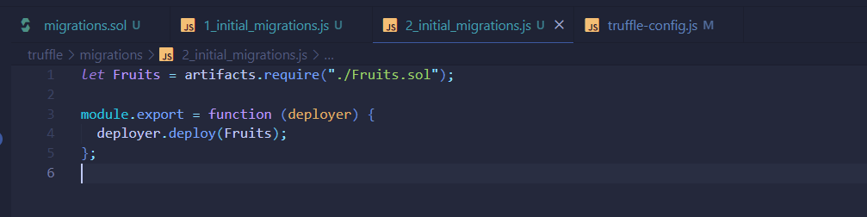

Deployment scripts for Fruits

Installing Truffle for Vs code 

Open the Ganache now

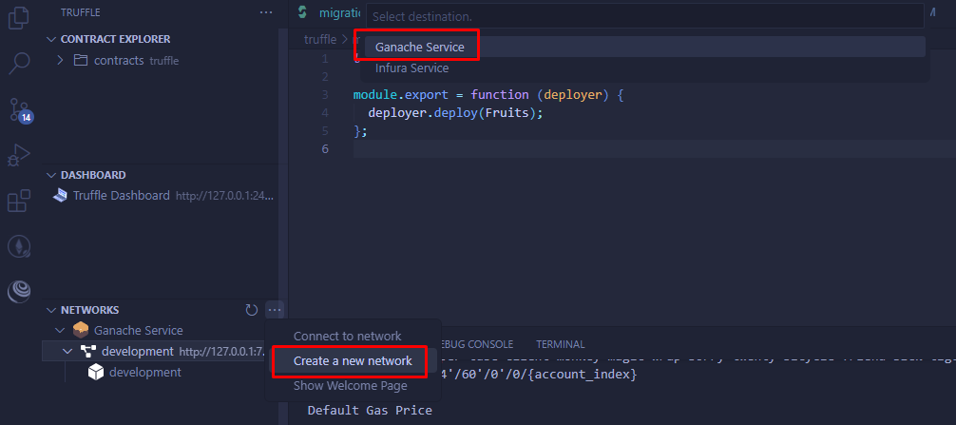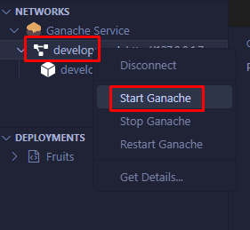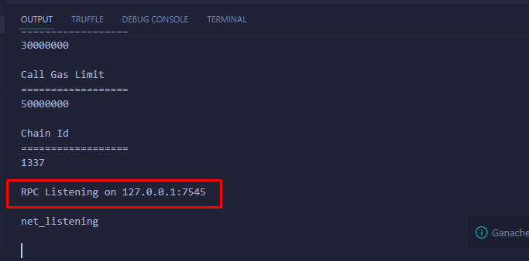

Open Command Prompt

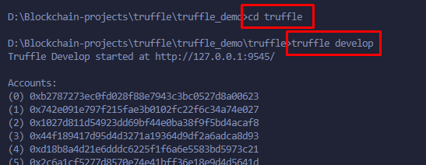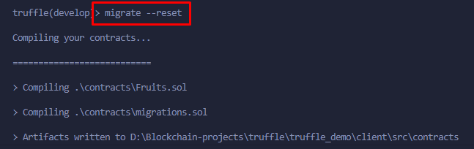

Lets write Test File