**Welcome to address book MySQL simulation!**

**UC1 Create address book service database –**

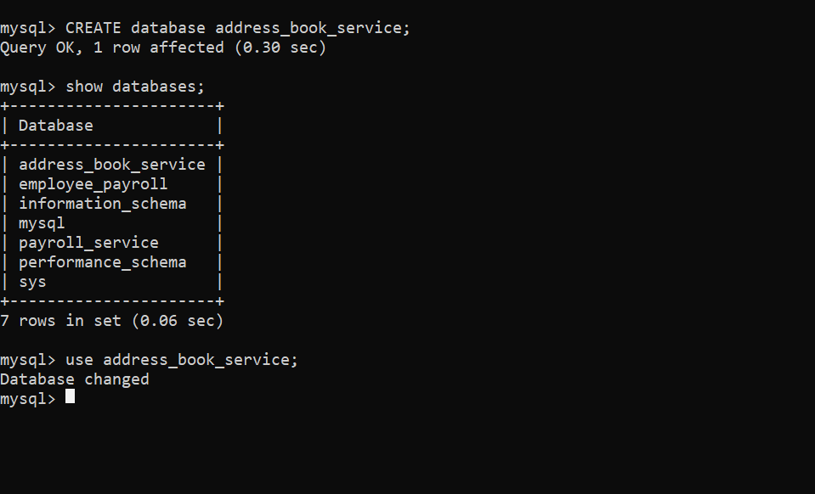

**UC2 Create table personal details in address book service database with given parameters –**

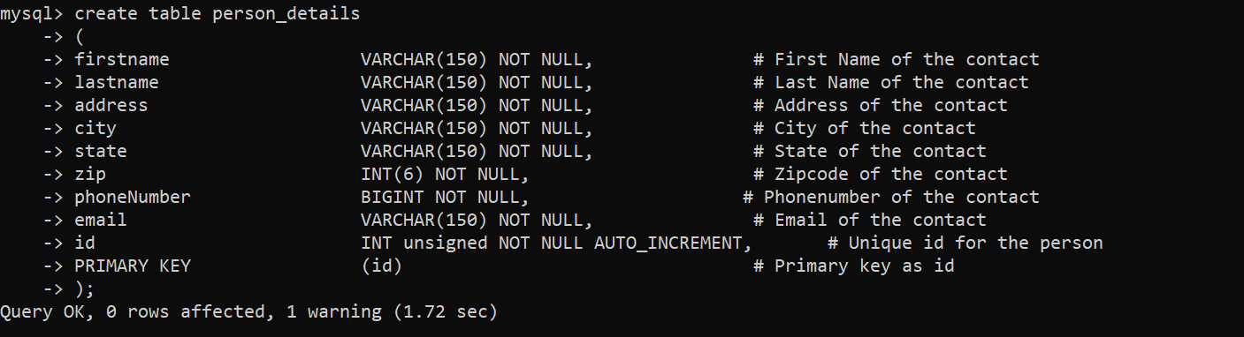

**UC3 Create new contacts in personal details of address book service –**

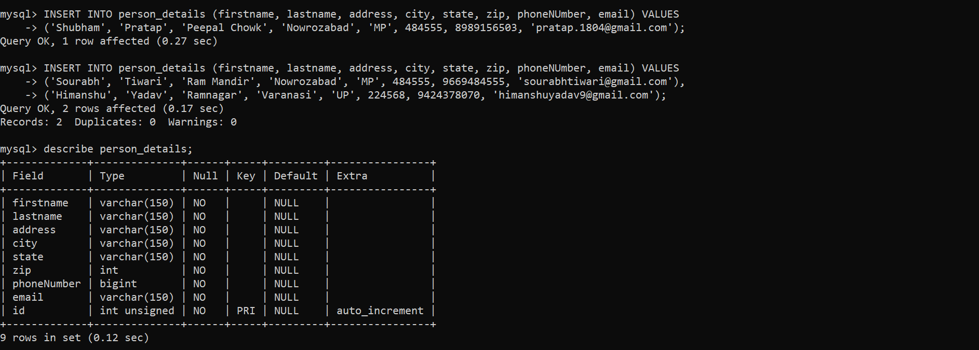

**UC4 Update contact details using first name –**

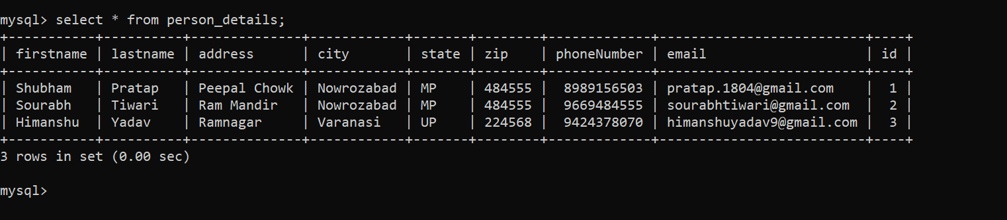

**UC5 Delete person details using contact’s first name –**

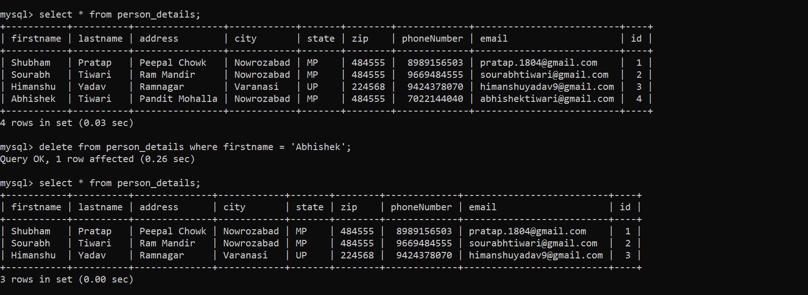

**UC6 Retrieve person’s details using city or state –**

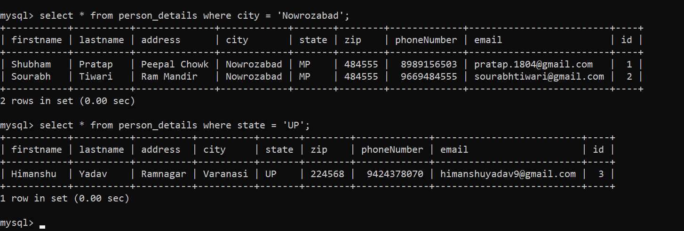

**UC7 Size of the address book using city or state –**

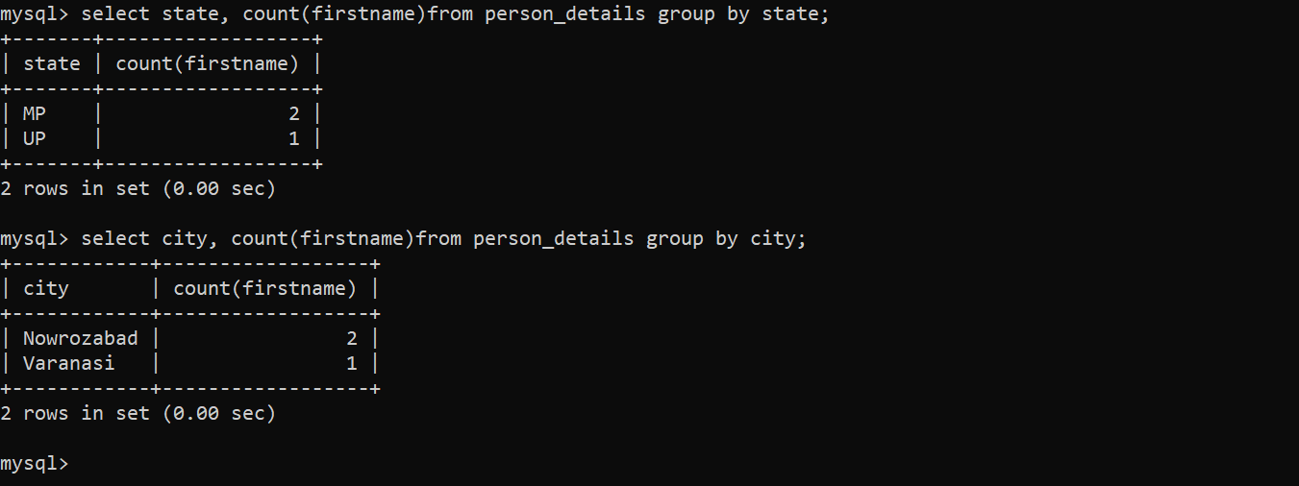

**UC8 Sort contacts lexicographically for a given city –**

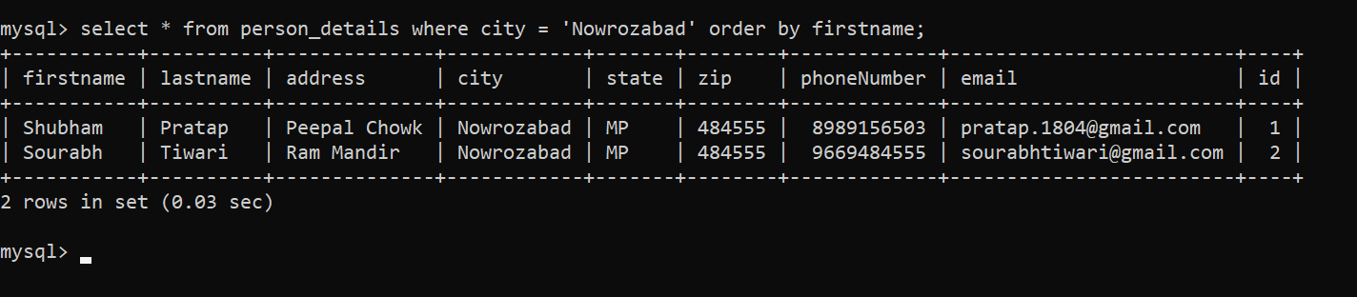

**UC9 Identify each contact with address book name and type –**

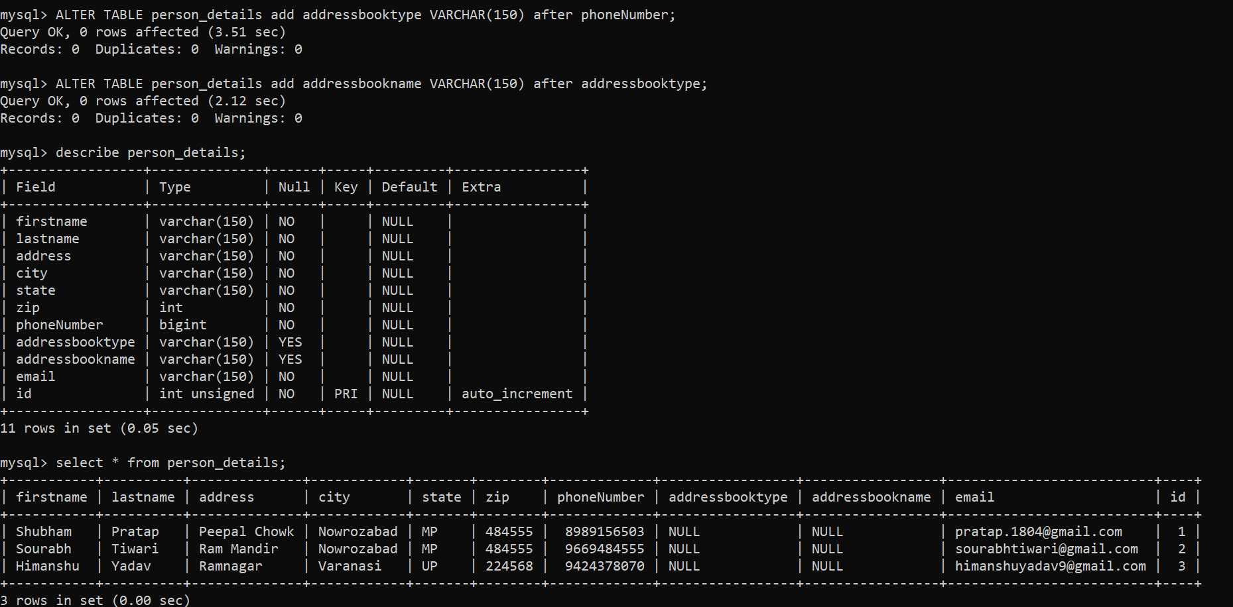

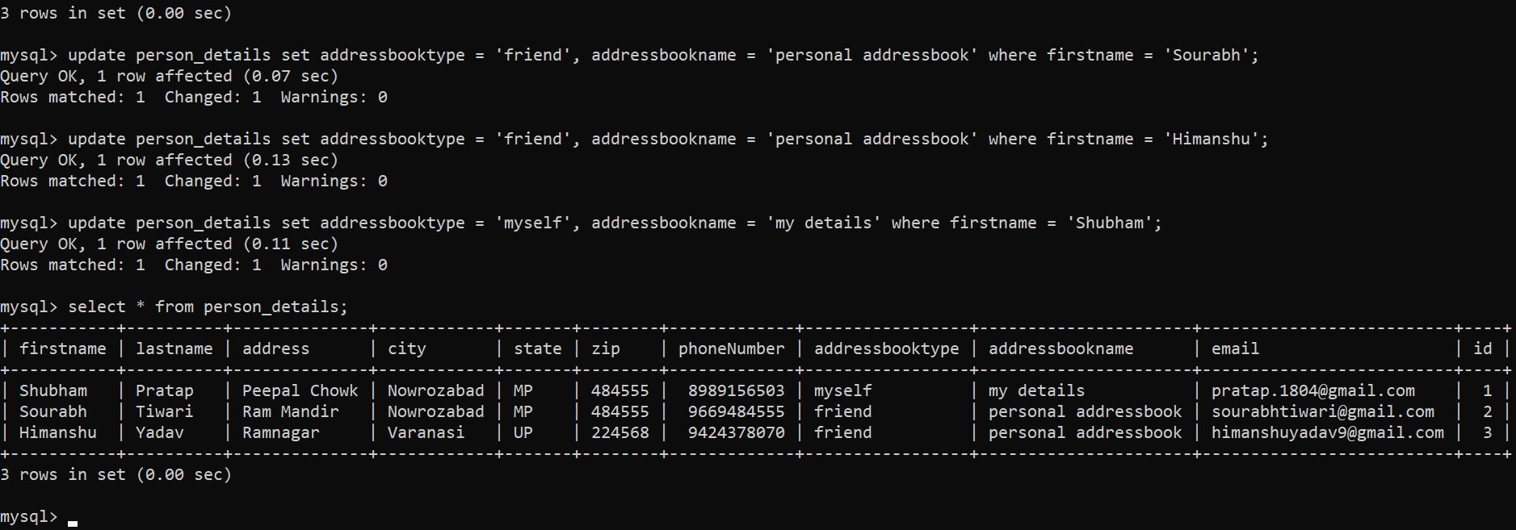

**UC10 Number of contact group by address book type –**

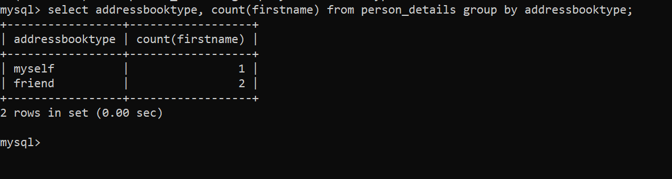

**UC11 Add person to both family and friends –**

