Welcome to Java JDBC simulation program!

**UC1 – Create payroll service database-**

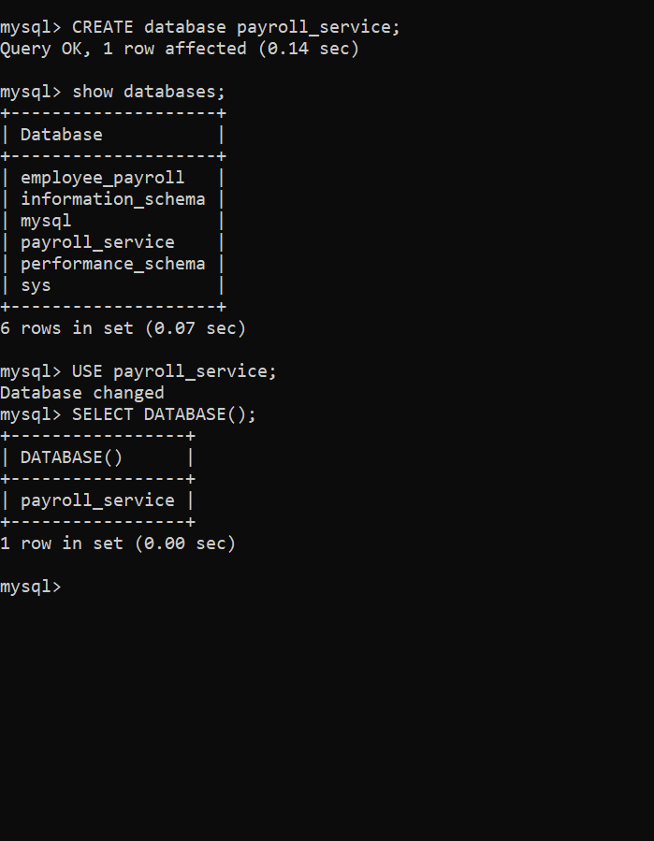

**UC2 – Employee payroll table in payroll service database to manage employee payrolls-**

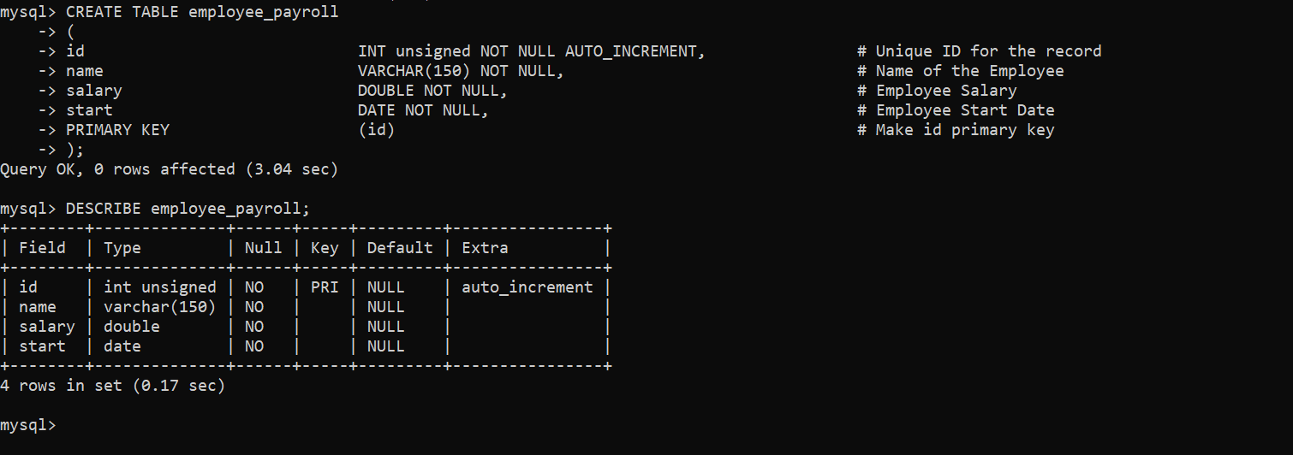

**UC3- Created employee payroll data in payroll service and performing INSERT INTO as part of the CURD operation-**

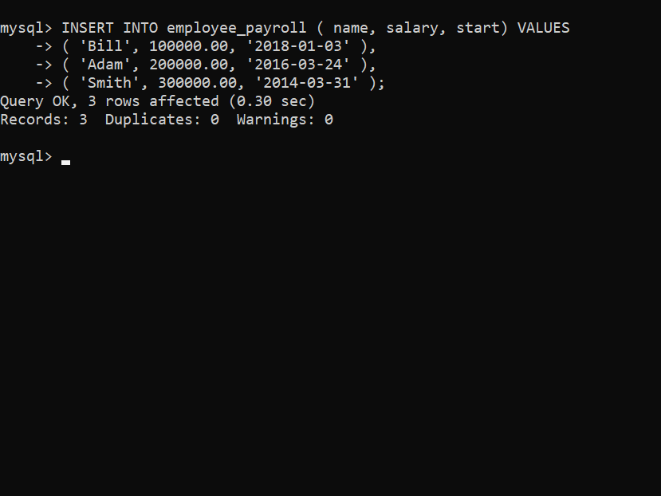

**UC4 – Retrieved all added data from employee payroll data in the payroll service database**

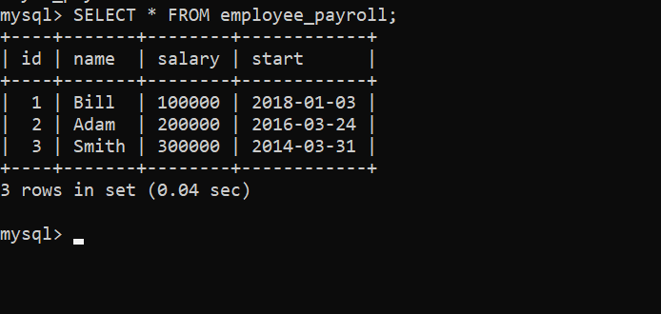

**UC5 – Retrieved salary data from the particular employee ‘Bill’ as well as employees who have joined after a particular date-**

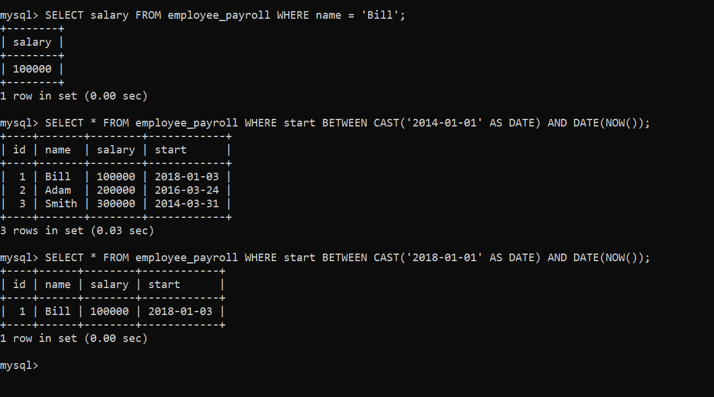

**UC6 – Added gender in the employee payroll table in payroll service database and updated gender for 3 entries-**

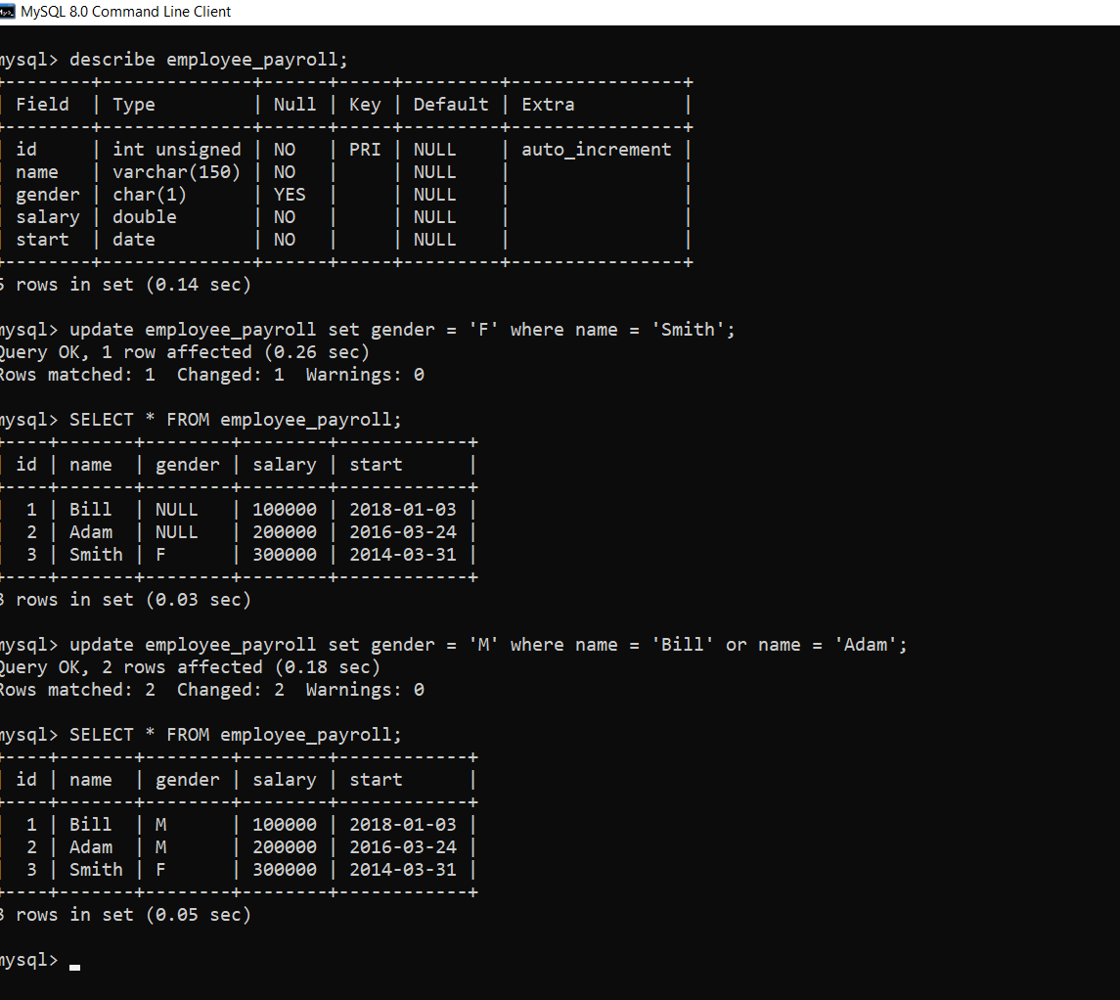

**UC7 -Ability to find sum, average, minimum, maximum and number of male and female employees-**

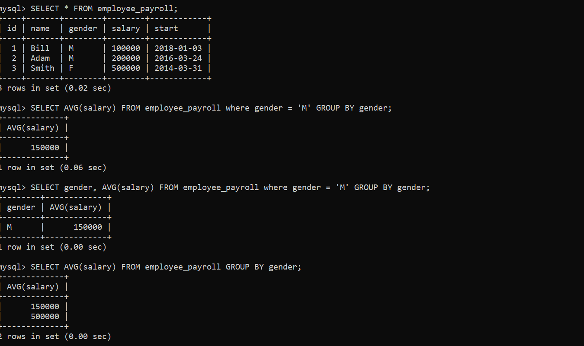

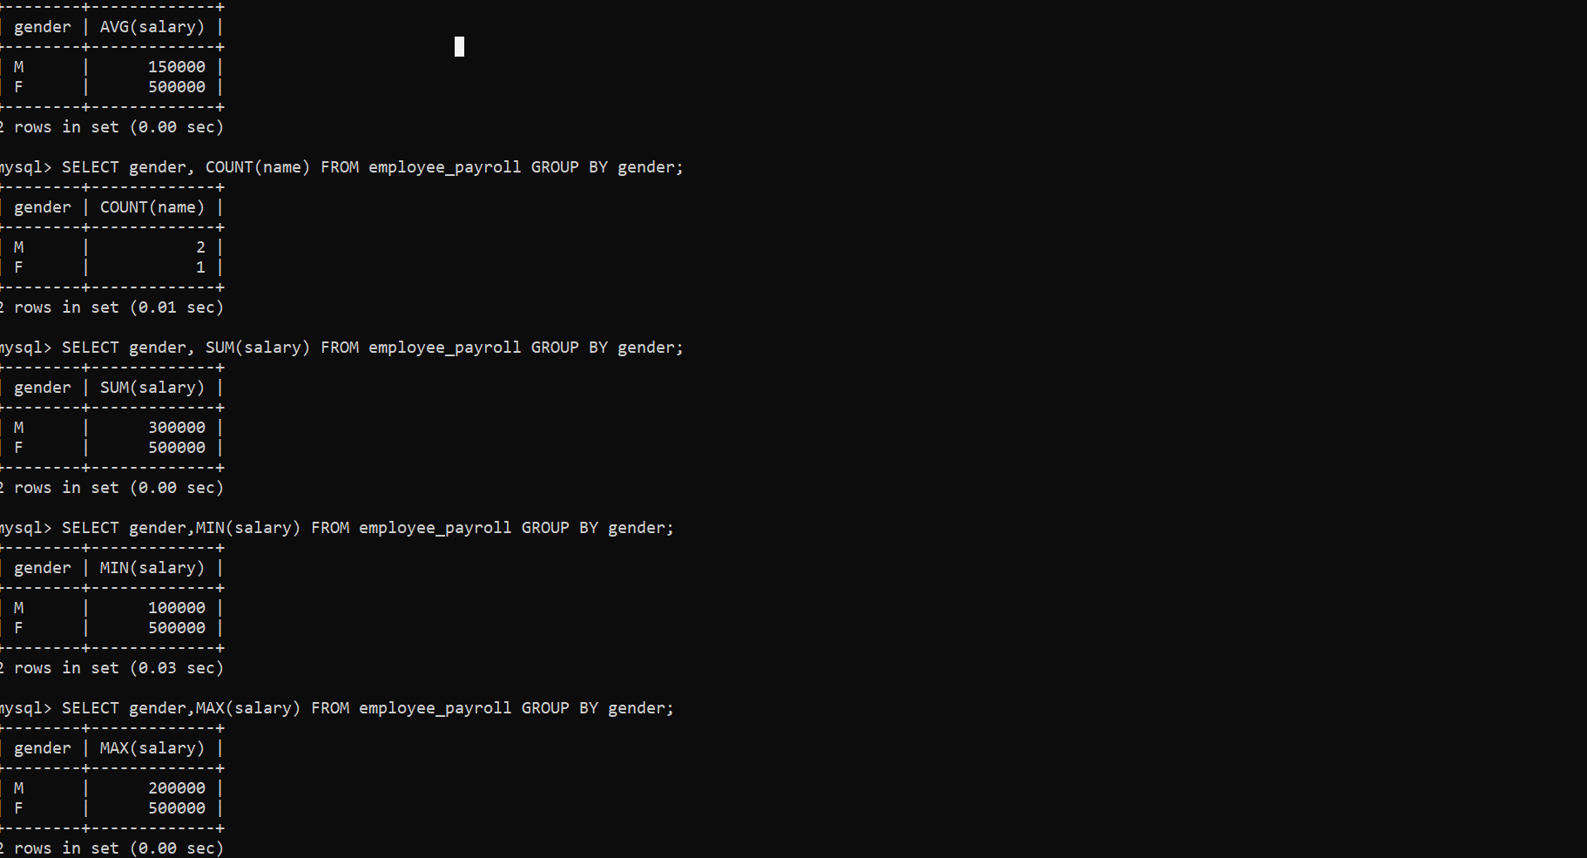

**UC8 Extend employee payroll to have information such as phone number, address and department-**

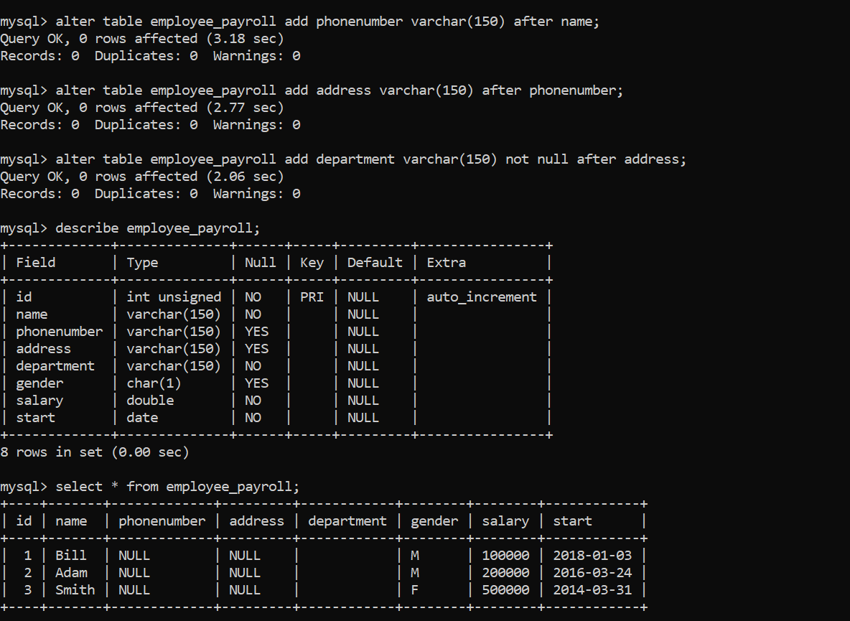

**UC9 Extend employee payroll to have more columns such as basic pay, deductions, taxable pay, tax and net pay-**

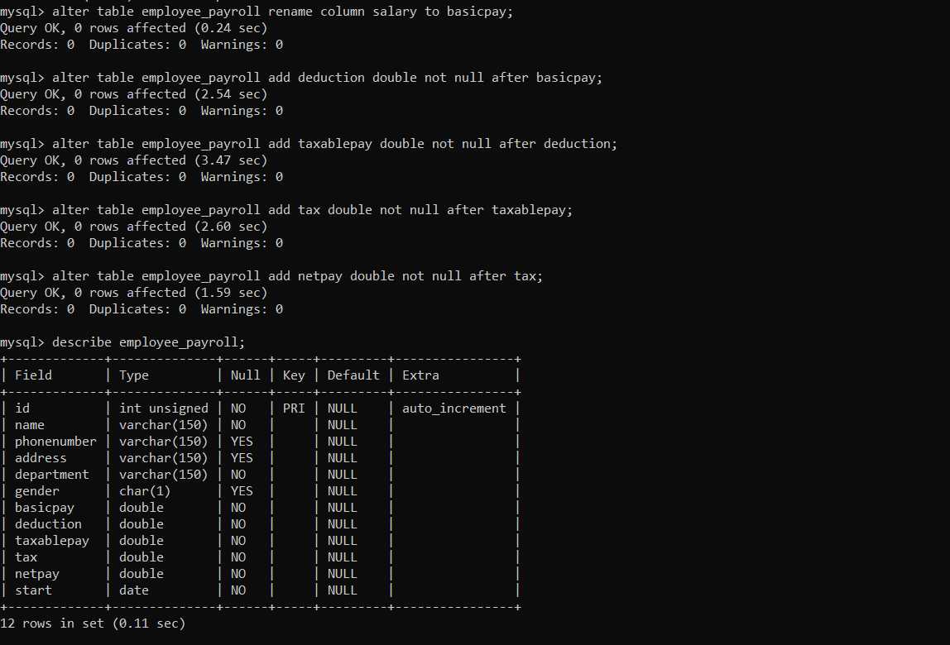

**UC10 Make Bill as a part of both marketing and sales department-**

