**LOVELY PROFESSIONAL UNIVERSITY**

**ACADEMIC TASK NO. 1**

**Mittal School of Business (MSOB) Faculty of Marketing**

**Name: Shubham Prakash Reg. No.: 11915803**

Name of the faculty member: Dr. MOHD FARHAN

Course Code: MGN909  **Course Title:** DATA ANALYSIS USING SPSS Max. Marks: 30 Marks

Date of Allotment: **19.08.2020** Date of Submission: **29.08.2020**

**ASSIGNMENT 1**

1. First we need to import data into SPSS to perform our desired Analysis.

To import data into our SPSS we follow these commands:

File Tab>>Open option>>Data Option>>Select the data file from Download directory.

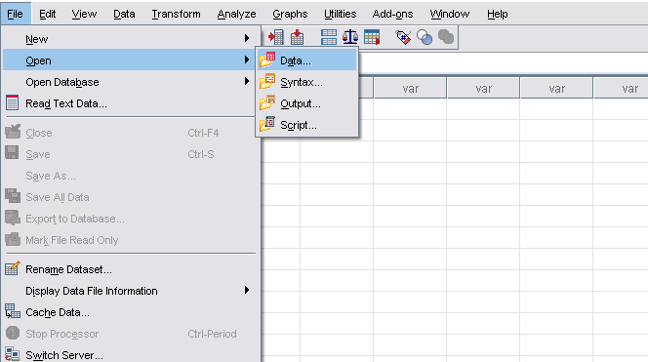Step 1: Download the file from Sample Excel Spreadsheet – Microsoft go.microsoft.com › fwlink

Step 2: Open SPSS and click to File tab on top left side.

Step 3: Select the Open option from the drop down menu.

Step 4: Select Data option and Directory selection pop-up window will open.

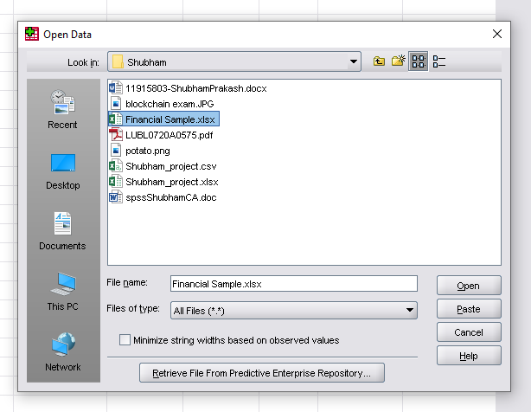Step 5: Select Data file from Download directory or where the data file is present and remember to change the filetype to All files. And click Open.

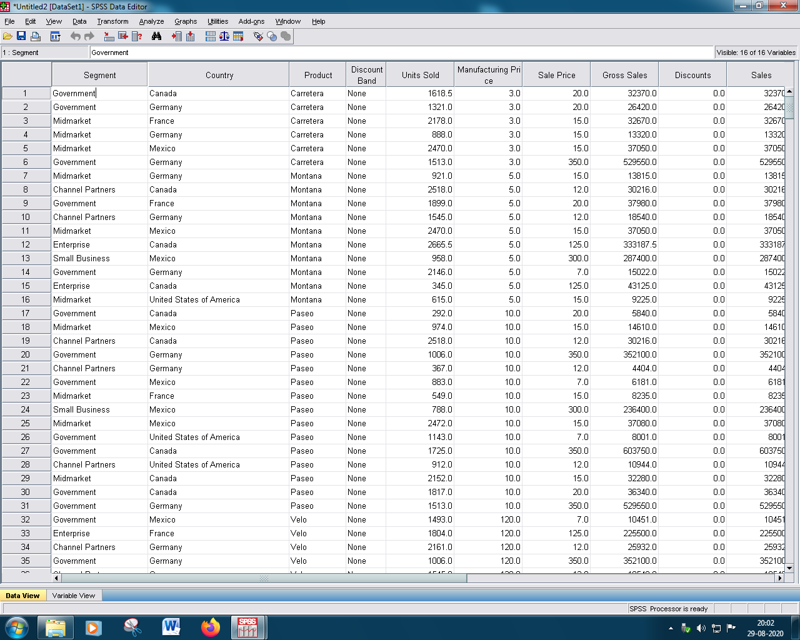Here, we can see that the desired data has been imported into the SPSS.

2. Generating frequencytables of Segments.

* For generating the Frequency tables we need to Select the Analyze tab, and then select Descriptive Stats. then select Frequencies option from the drop down menu.
* 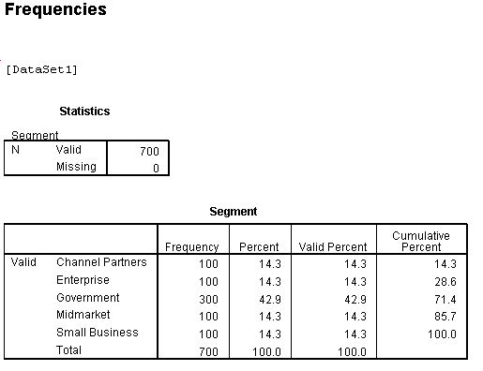Analyze tab>> Descriptive Stats >> Frequencies>>Select Variable >> Check Display Table>>OK

Here, we can see that Govt. has th highest Frequency, Percent & Valid Percent.

And Total Frequency is 700.

* Generating frequencytables of products.

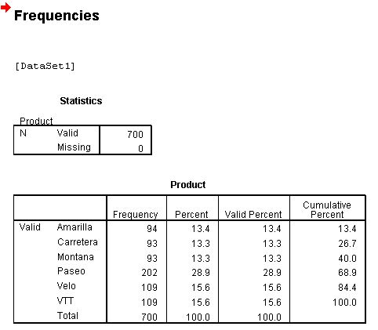

Here, we can see that Paseo has the highest frequency of 202, and total frequency of all is 700.

* Generating frequencytables of Country

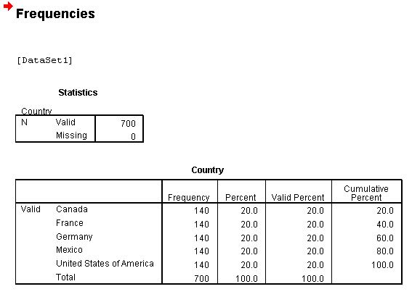

Here, we can see that all countries have same frequency and total frequency of them is 700.

* Generating frequencytables of Price.

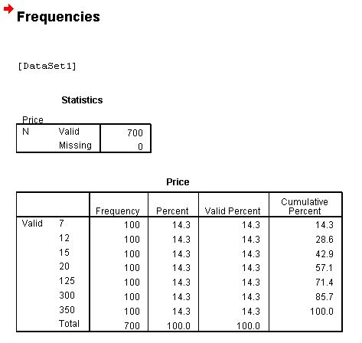

Here, Sale Price frequency is same and the total frequency is 700.

* Generating frequencytables of Year.

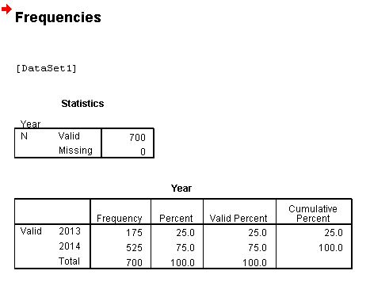Here, we can clearly see that in 2014 frequency was highest as compared to 2013.

3.Generating Bar diagram for country wise sale (with data labels).

* + - To create bar diagram/graph of country wise sale, we need to select the Graphs tab, then select the Char Builder, then select Bar graph and choose the type of graph which is required, then select the variables(country in x-axis & sales in y-axis) required for x and y- axis of the Bar graph.
    - Graph tab >> Char Builder >>Select Bar graph >>select Variables >> click OK.
    - And to label it double click on the generated bar graph then select the Elements tab then select Show Data Labels.

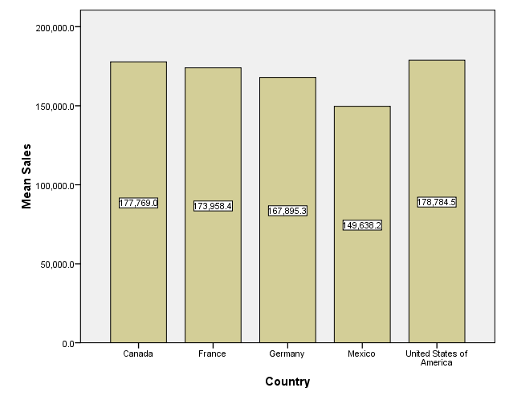

Here, we can see that USA has highest sales of 178,784.5 and Mexico has lowest sales of 149,638.2 in all.

4. Generating pie chart of countries (with data labels).

* To create Pie chart of countries, we need to select the Graphs tab, and then select the Char Builder, then select Pie Chart and then select the variable (country) required for the pie chart.
* Graph tab >> Char Builder >>Select Pie Chart >>select Variable >> click OK.
* And to label it double click on the generated Pie chart and then select the Elements tab then select Show Data Labels.

.

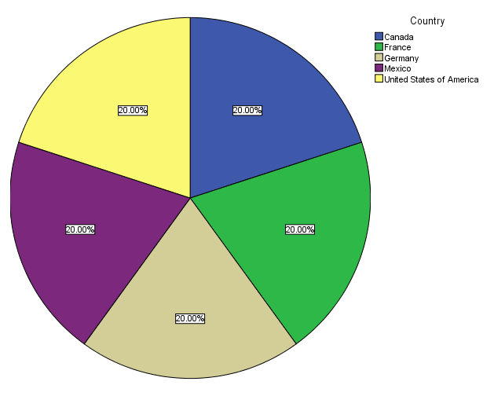

Here, we can see that all 5 countries have equal shares of 20%.

* + 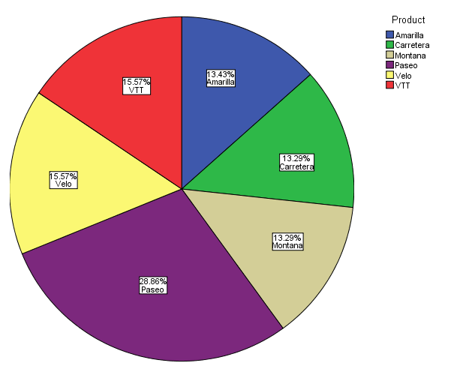Generating pie chart of Products
* Here we can clearly see that Paseo has the highest share of 28.86% and Montana and Carretera lowest of 13.29%.

**5.** Generating histogram of Unit Sold with normal curve.

* To create Histogram of Unit Sold, we need to select the Graphs tab, and then select the Char Builder, then select Histogram and then select the variable (Unit sold) required for the Histogram, then select the Elements Properties, check the Display Normal Curve option box and click OK.
* Graph tab >> Char Builder >>Select Histogram >>select Variable >>Select Element Properties >> Check Display Normal Curve>>click OK.

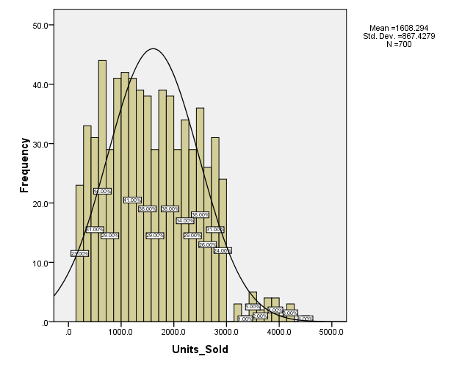

Here, we can see that the frequency distribution slope is in peak at between 100 – 200 units and declining, showing uniform distribution.

Thanking You

By: Shubham Prakash