Lab Practical #01:
Study of basic networking commands and IP configuration.
Practical Assignment #01:
- Perform and explain various networking commands listed below:
  - ipconfig
  - ping
  - getmac
  - systeminfo
  - traceroute / tracert
  - netstat
  - nslookup
  - hostname
  - pathping
  - arp

ipconfig

Description:
Displays all current TCP/IP network configuration values and refreshes DHCP and DNS settings.
No. | Option | Description
1 | /all | Displays full configuration information.
2 | /release | Releases the IP address for the specified adapter.
3 | /renew | Renews the IP address for the specified adapter.
4 | /flushdns | Clears the DNS Resolver cache.
5 | /displaydns | Displays the contents of the DNS Resolver cache.

Implementation:

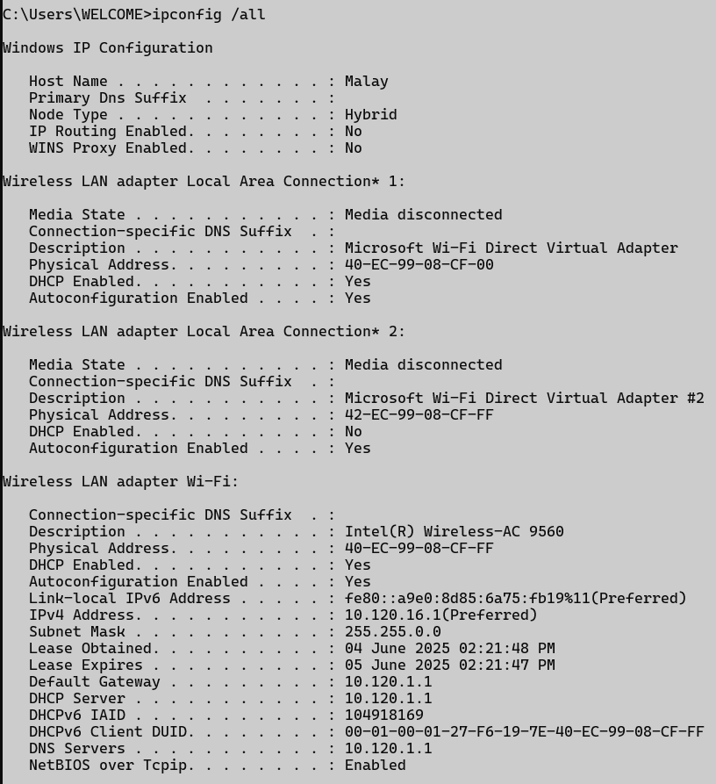

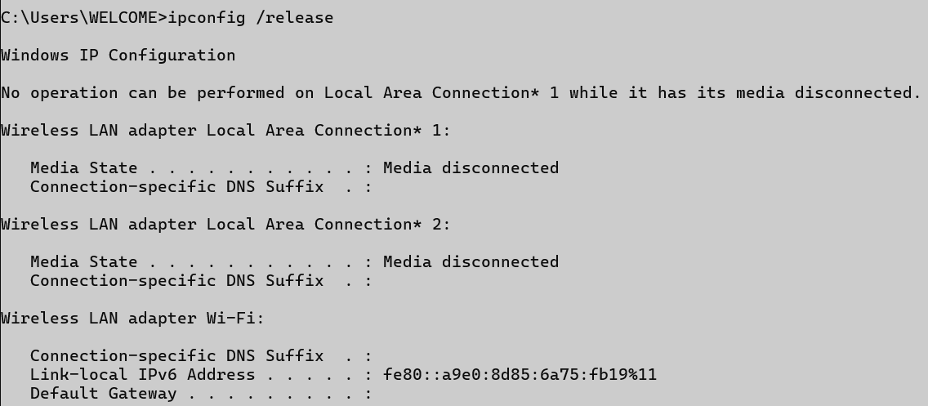
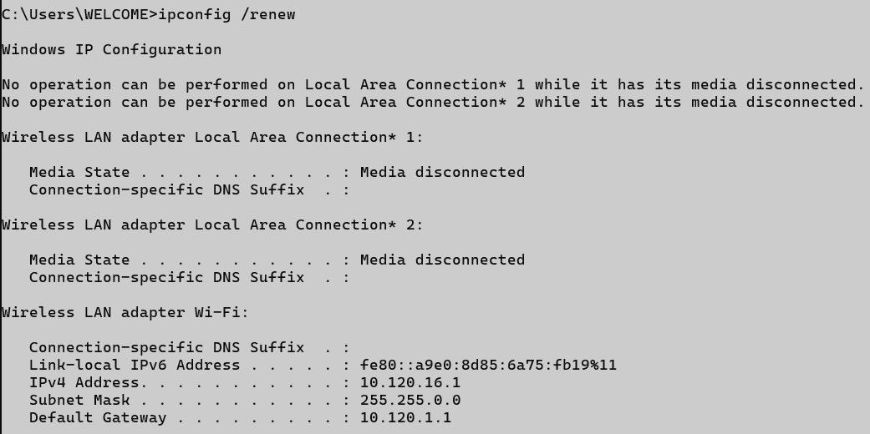

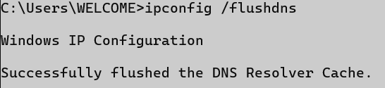
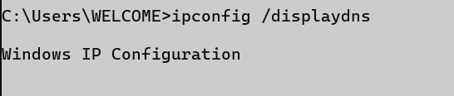

ping

Description:
Sends ICMP Echo Request messages to verify if a host is reachable over the network.
No. | Option | Description
1 | -t | Pings the target until stopped manually.
2 | -n count | Specifies the number of Echo Request messages to send.
3 | -l size | Sends packets with a custom byte size.
4 | -4 | Forces using IPv4.
5 | -a | Resolve addresses to hostnames.

Implementation:

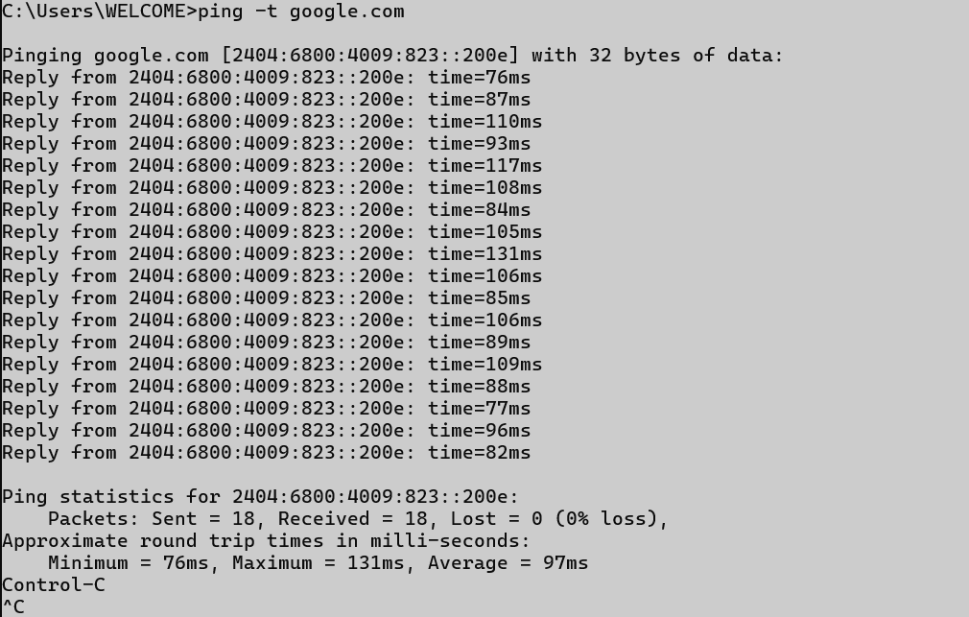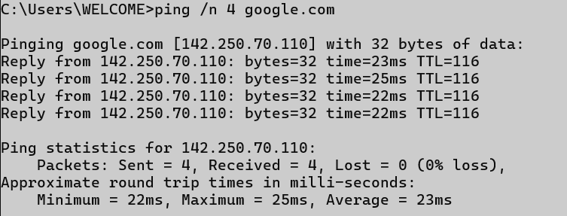

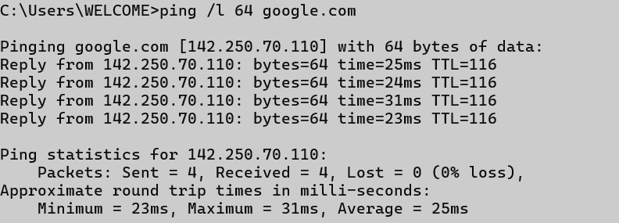
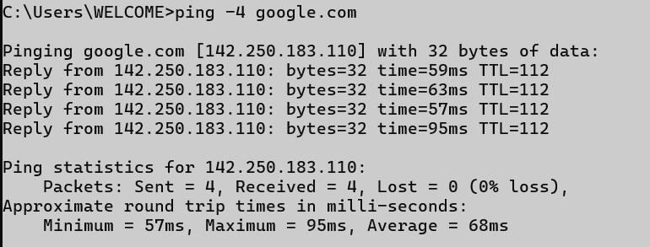
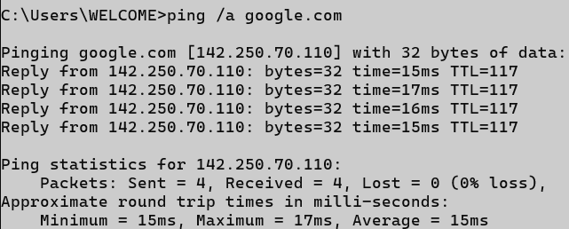

getmac

Description:
Displays the MAC address of the system’s network interfaces.
No. | Option | Description
1 | /v | Shows verbose output with more details.
2 | /fo table | Displays output in table format.
3 | /fo list | Displays output in list format.
4 | /fo csv | Displays output in CSV format.
5 | /nh | Hides the column headers in the output.

Implementation:

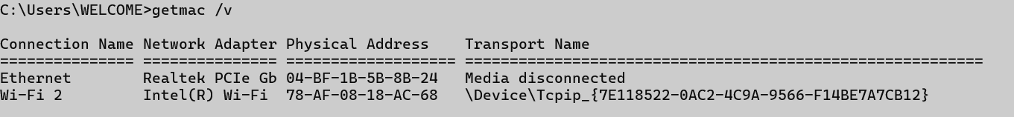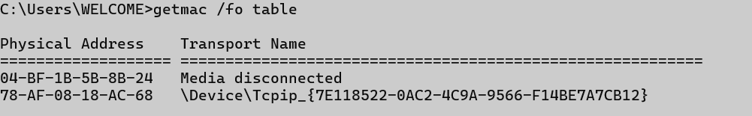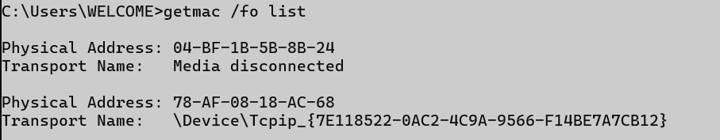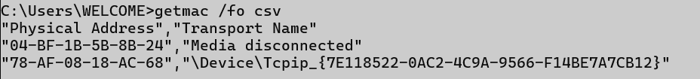


systeminfo

Description:
Provides detailed configuration information about the computer and its OS.
No. | Option | Description
1 | (no option) | Shows all system information.
2
3
4
5

Implementation:

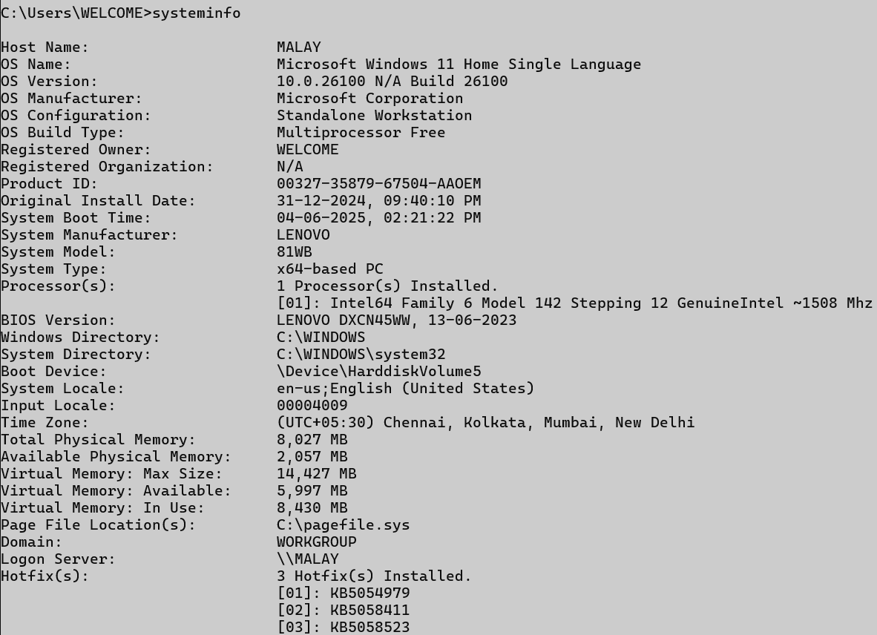

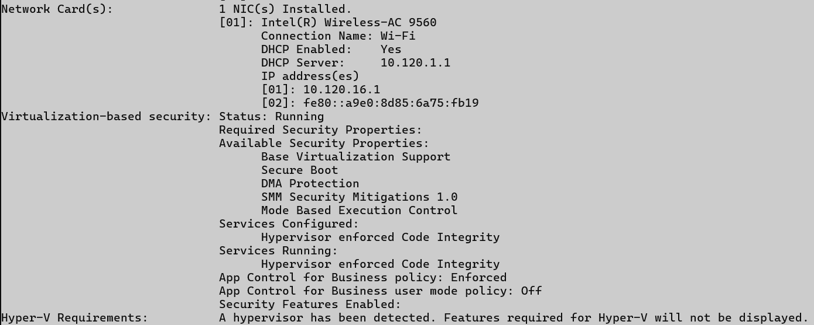

traceroute / tracert

Description:
Traces the path that packets take to reach a network host.
No. | Option | Description
1 | -d | Prevents resolving IPs to hostnames.
2 | -h <max> | Sets the maximum number of hops.
3 | -w <timeout> | Sets the timeout in milliseconds.
4 | -4 | Forces using IPv4.
5 | -6 | Forces using IPv6.

Implementation:

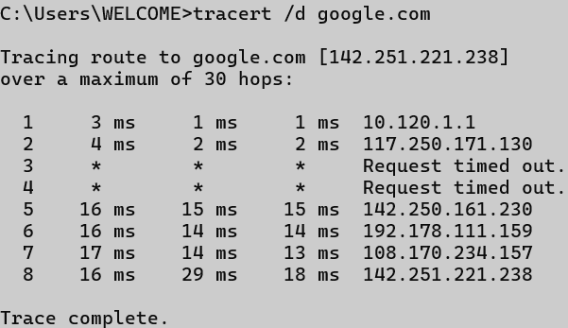

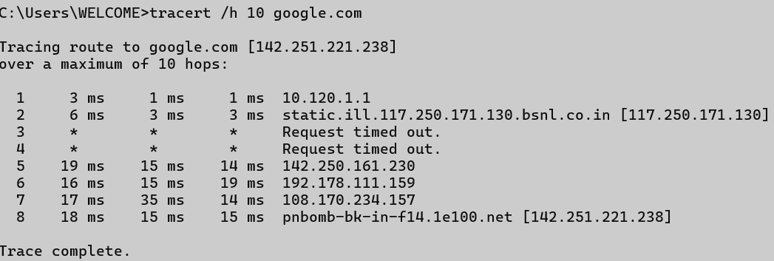

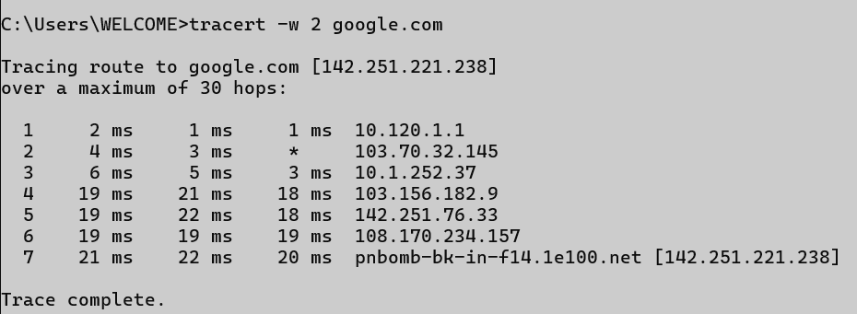
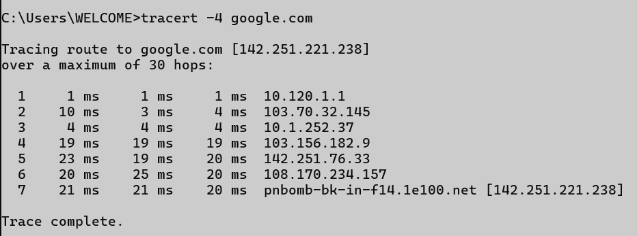
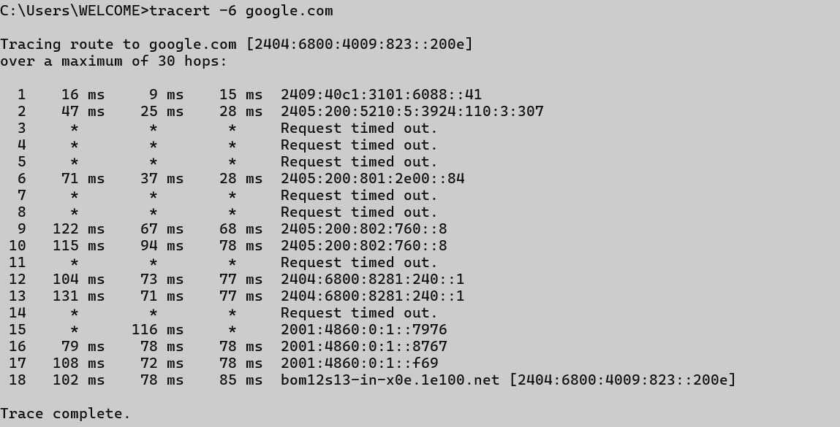

netstat

Description:
Displays network connections, routing tables, interface stats, etc.
No. | Option | Description
1 | -a | Displays all connections and listening ports.
2 | -n | Displays addresses and port numbers numerically.
3 | -o | Displays owning process ID associated with each connection.
4 | -e | Displays Ethernet statistics.
5 | -s | Displays per-protocol statistics.

Implementation:

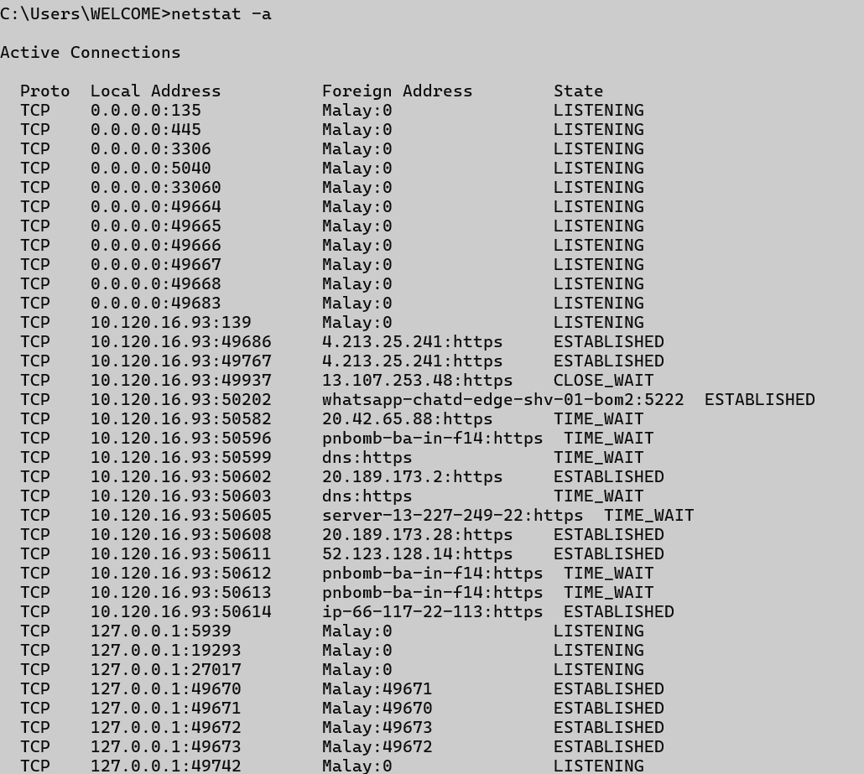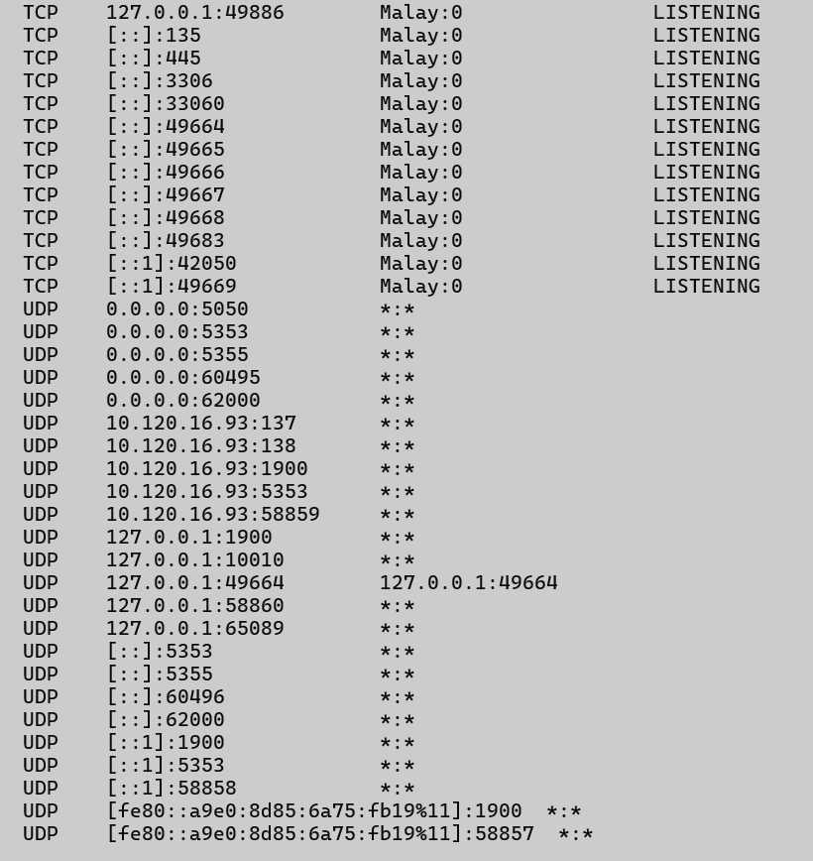
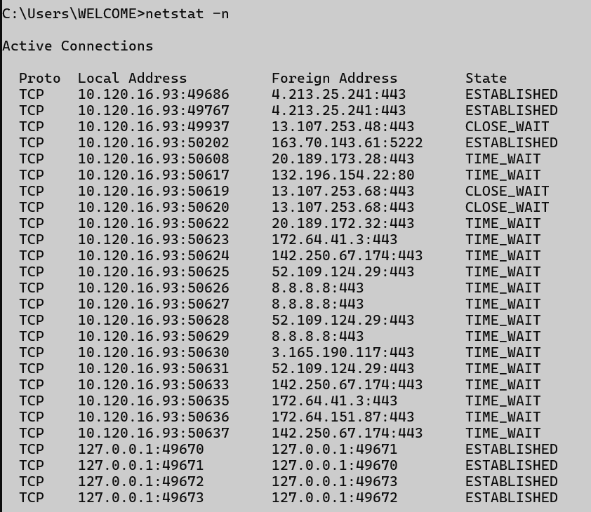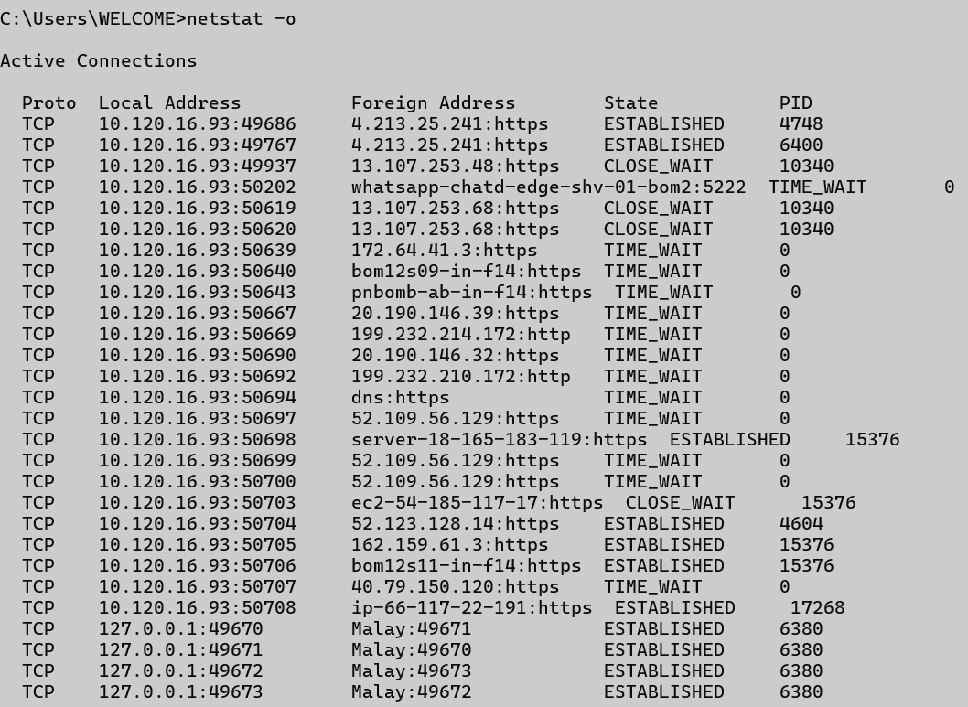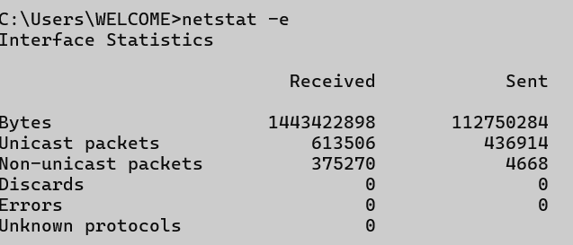
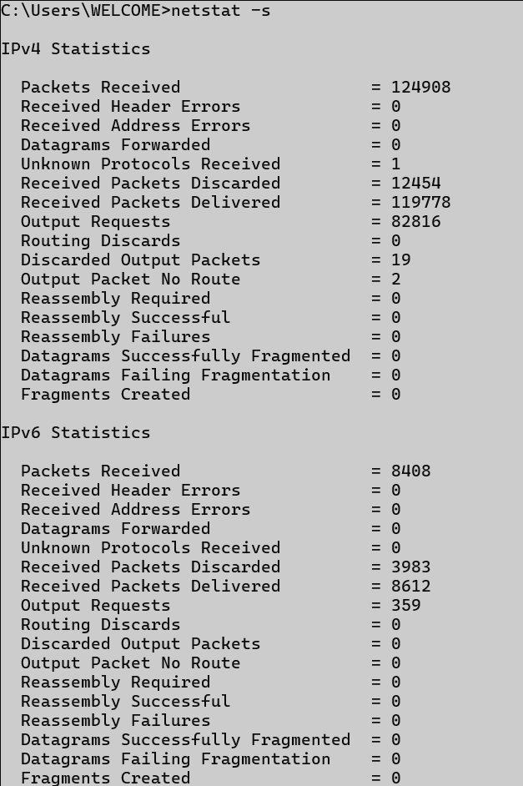

nslookup

Description:
Queries the DNS to obtain domain name or IP address mapping.
No. | Option | Description
1 | <domain> | Retrieves IP address for the domain.
2 | <IP> | Retrieves domain name for the given IP (reverse lookup).
3 | set type=MX | Retrieves Mail Exchange records.
4 | set type=NS | Retrieves Name Server records.
5 | server <IP> | Specifies DNS server for the query.

Implementation:
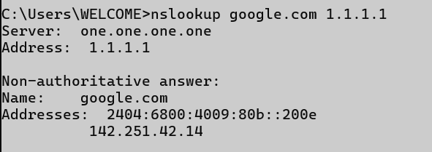
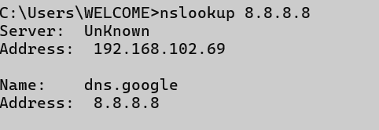
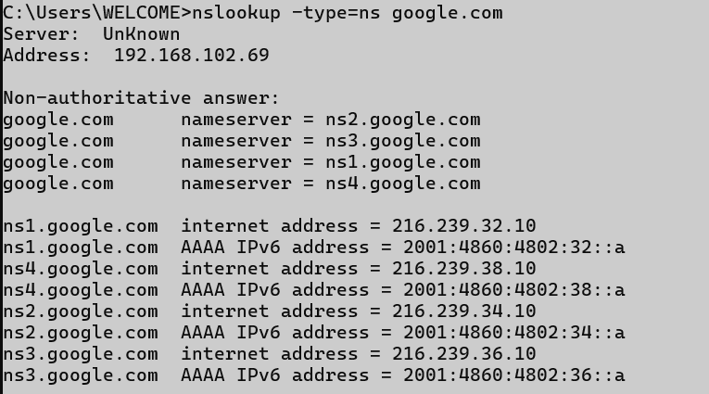
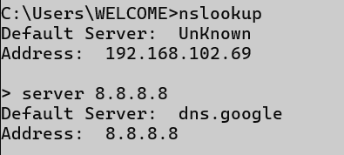

hostname

Description:
Displays the current name of the computer.
No. | Option | Description
1 | (no option) | Prints current hostname.
2
3
4
5

Implementation:

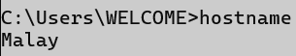

pathping

Description:
Combines the functions of ping and tracert to provide information on packet loss at each hop.
No. | Option | Description
1 | -n | Prevents resolving hostnames.
2 | -h <max> | Sets maximum number of hops.
3 | -g <host-list> | Specifies loose source route along host list.
4 | -p <ms> | Wait time between pings.
5 | -q <num> | Number of queries per hop.

Implementation:

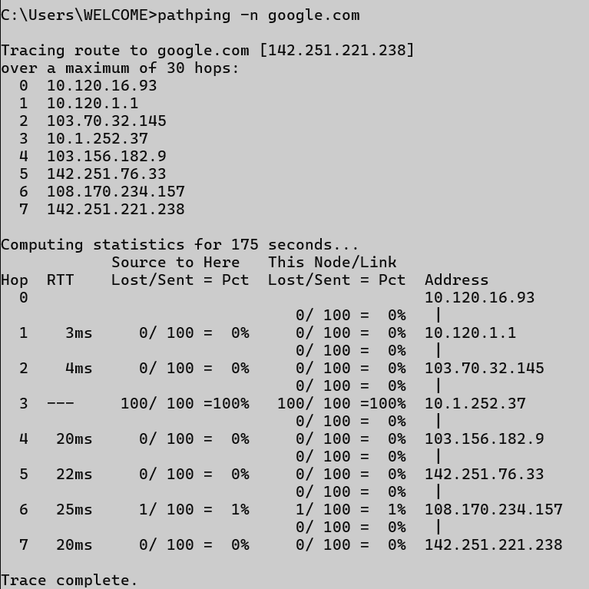
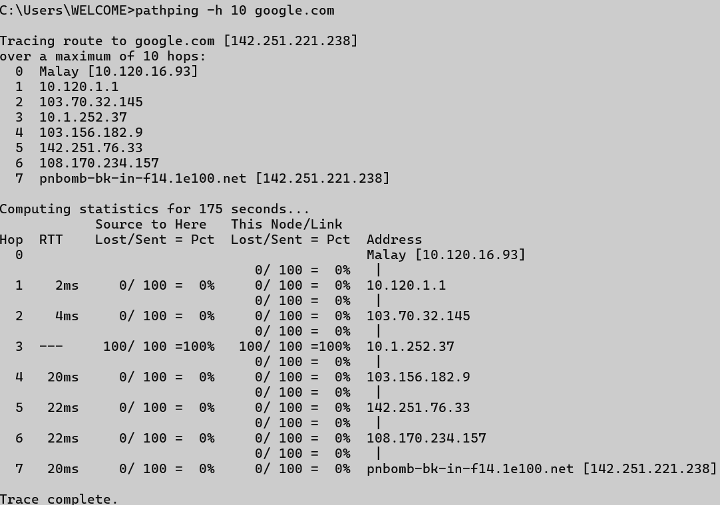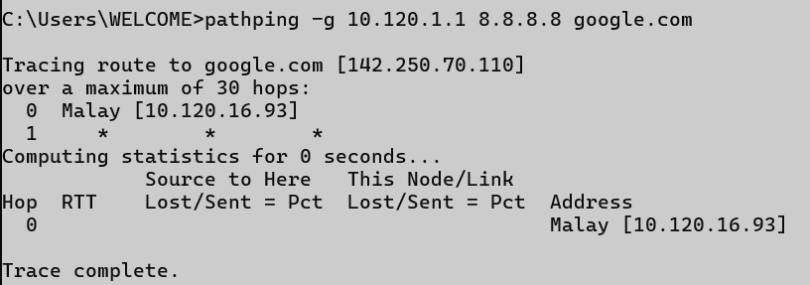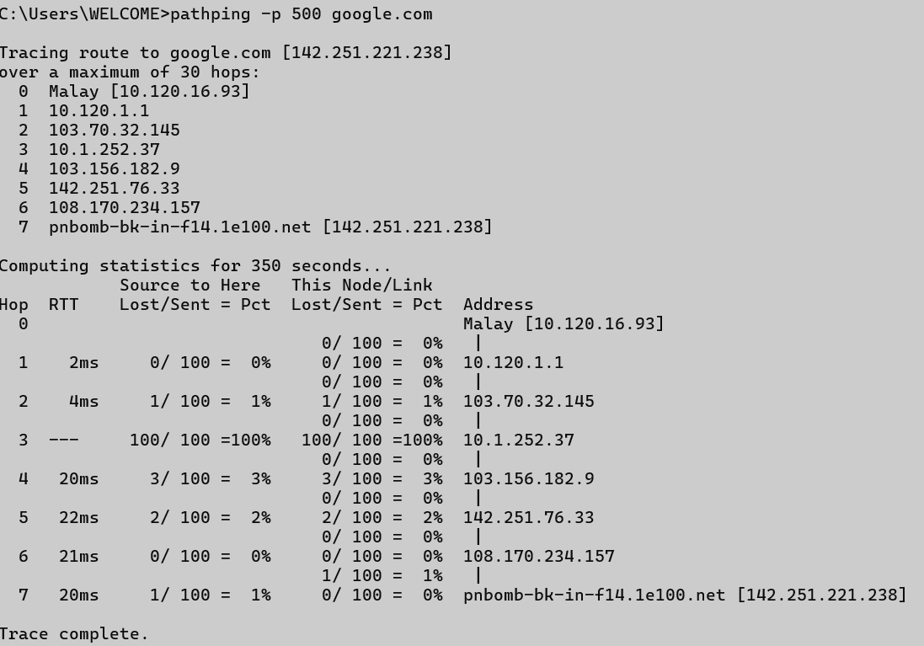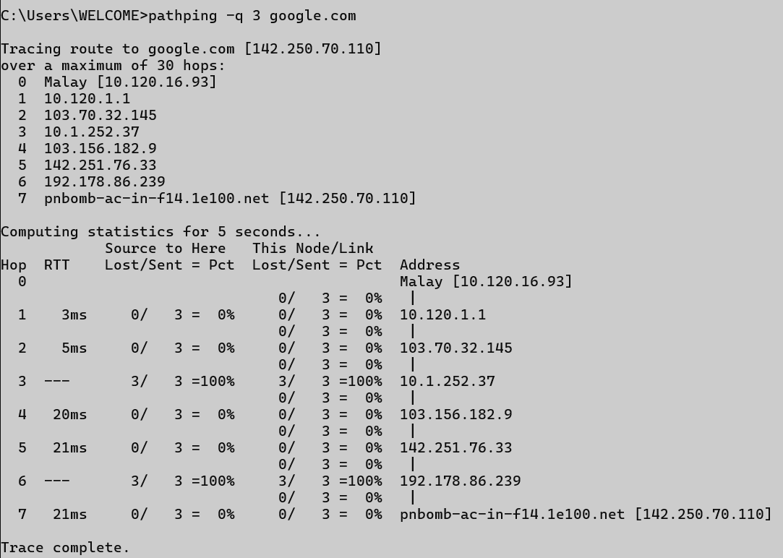

arp

Description:
Displays and modifies the ARP (Address Resolution Protocol) cache.
No. | Option | Description
1 | -a | Displays current ARP entries.
2 | -g | Displays current ARP entries (same as -a).
3 | -d <IP> | Deletes ARP entry for the specified IP address.
4 | -s <IP> <MAC> | Adds a static ARP entry.
5 | -v | Shows verbose output.

Implementation:

