Lab Practical #8:
Study & Survey of Institute organization network infrastructure.
Practical Assignment #8:
- Identify type of network in your institute. Draw a design of network in your institute (Any Lab/Floor/Building).
Lab No: C- 302
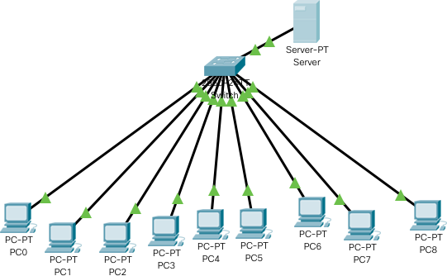
Topology: Star Topology

- List how many network devices and types of cable used and give its details.

Network Devices:
- Router
  - Connects different networks and routes data packets between them, such as between a local network and the internet.
- Switch
  - Connects multiple devices within the same network and directs data to the correct destination device.
- Firewall
  - Provides network security by monitoring and controlling incoming and outgoing traffic based on predetermined rules.
- Access Point (AP)
  - Provides wireless network connectivity for devices to connect to a wired network.
- Network Interface Card (NIC)
  - Hardware installed in devices to enable network connectivity.
- Modem
  - Modulates and demodulates signals for internet access over telephone lines or other communication mediums.
- Load Balancer
  - Distributes network or application traffic across multiple servers to ensure reliability and performance.

Types of Cables:

- Ethernet Cable (Twisted Pair - Cat5e, Cat6, Cat6a)
  - Used for wired network connections; twisted pairs reduce interference and support high-speed data transfer.
- Fiber Optic Cable
  - Uses light to transmit data at very high speeds over long distances with minimal signal loss.
- Coaxial Cable
  - Used in some legacy network setups; carries data via electrical signals within a single conductor surrounded by shielding.
- Console Cable (RJ45 to Serial)
  - Used to connect network devices like switches and routers to a computer for configuration.

