Industrial Internship Report on
”PASSWORD MANAGER”
Prepared by
SHUBHAM VERMA

Executive Summary
This report presents the details of the Industrial Internship program conducted by Upskill Campus and The IoT Academy in collaboration with the industrial partner UniConverge Technologies Pvt. Ltd. (UCT). The internship was designed to provide practical exposure to real-world industrial problems and their solutions.
The internship focused on a project/problem statement assigned by UCT, which was to be completed within a duration of six weeks, including both implementation and documentation. During this period, I worked on the project titled “Password Manager”, which aims to securely store, manage, and retrieve user credentials using Python and encryption techniques.
The project involves developing a system that allows users to store passwords in an encrypted format, generate strong passwords, and access them securely when required. This solution addresses the common challenge of managing multiple passwords while ensuring data security and privacy.
This internship provided me with a valuable opportunity to gain hands-on experience in solving industrial-level problems and implementing practical solutions. It helped me enhance my technical knowledge, improve problem-solving skills, and understand the real-world application of concepts learned during academic studies.
Overall, the internship was a highly enriching and rewarding experience that contributed significantly to my personal and professional growth.

TABLE OF CONTENTS
1 Preface 3
2 Introduction 4
2.1 About UniConverge Technologies Pvt Ltd 4
2.2 About upskill Campus 8
2.3 Objective 9
2.4 Reference 9
2.5 Glossary 10
3 Problem Statement 11
4 Existing and Proposed solution 12
5 Proposed Design/ Model 13
5.1 High Level Diagram (if applicable) 13
5.2 Low Level Diagram (if applicable) 13
5.3 Interfaces (if applicable) 13
6 Performance Test 14
6.1 Test Plan/ Test Cases 14
6.2 Test Procedure 14
6.3 Performance Outcome 14
7 My learnings 15
8 Future work scope 16

Preface

The six-week industrial internship program provided me with a valuable opportunity to gain practical exposure to real-world problems and their solutions. During this period, I worked on the project titled “Password Manager”, which focuses on securely storing and managing user credentials using Python and encryption techniques.
In today’s digital era, internships play a crucial role in career development. They bridge the gap between theoretical knowledge and practical implementation, helping students understand industry standards, tools, and workflows. This internship helped me enhance my technical skills, problem-solving abilities, and professional mindset.
The problem statement for my project was to design a secure and efficient system that allows users to store, generate, and retrieve passwords safely. With the increasing number of online platforms, managing multiple passwords has become challenging, and this project aims to provide a reliable solution.
I am grateful to Upskill Campus (USC) and UniConverge Technologies Pvt. Ltd. (UCT) for providing me with this excellent opportunity. The internship program was well-structured, including proper guidance, regular tasks, and deadlines that helped in systematic learning and project development. The program was planned in a way that each week focused on different aspects such as understanding the problem, designing the solution, implementation, testing, and final reporting.
Throughout this internship, I gained hands-on experience in Python programming, encryption techniques, file handling, and project development. I also improved my analytical thinking, debugging skills, and ability to work independently on real-world problems. This experience has significantly contributed to my personal and professional growth.
I would like to express my sincere gratitude to my mentors, instructors, and everyone who supported me during this internship. Their guidance and encouragement played a vital role in the successful completion of this project. I would also like to thank my friends and family for their continuous support and motivation.
Finally, I would like to advise my juniors and peers to take internships seriously, stay consistent, and focus on learning rather than just completing tasks. Real growth comes from practical experience, and such opportunities should be utilized to the fullest.

Introduction

About UniConverge Technologies Pvt Ltd
A company established in 2013 and working in Digital Transformation domain and providing Industrial solutions with prime focus on sustainability and RoI.
For developing its products and solutions it is leveraging various Cutting Edge Technologies e.g. Internet of Things (IoT), Cyber Security, Cloud computing (AWS, Azure), Machine Learning, Communication Technologies (4G/5G/LoRaWAN), Java Full Stack, Python, Front end etc.

- UCT IoT Platform ()
UCT Insight is an IOT platform designed for quick deployment of IOT applications on the same time providing valuable “insight” for your process/business. It has been built in Java for backend and ReactJS for Front end. It has support for MySQL and various NoSql Databases.
- It enables device connectivity via industry standard IoT protocols - MQTT, CoAP, HTTP, Modbus TCP, OPC UA
- It supports both cloud and on-premises deployments.
It has features to
• Build Your own dashboard
• Analytics and Reporting
• Alert and Notification
• Integration with third party application(Power BI, SAP, ERP)
• Rule Engine

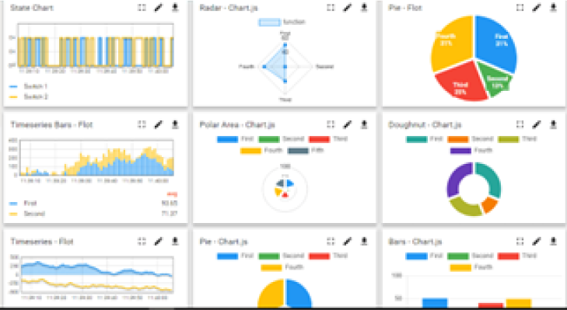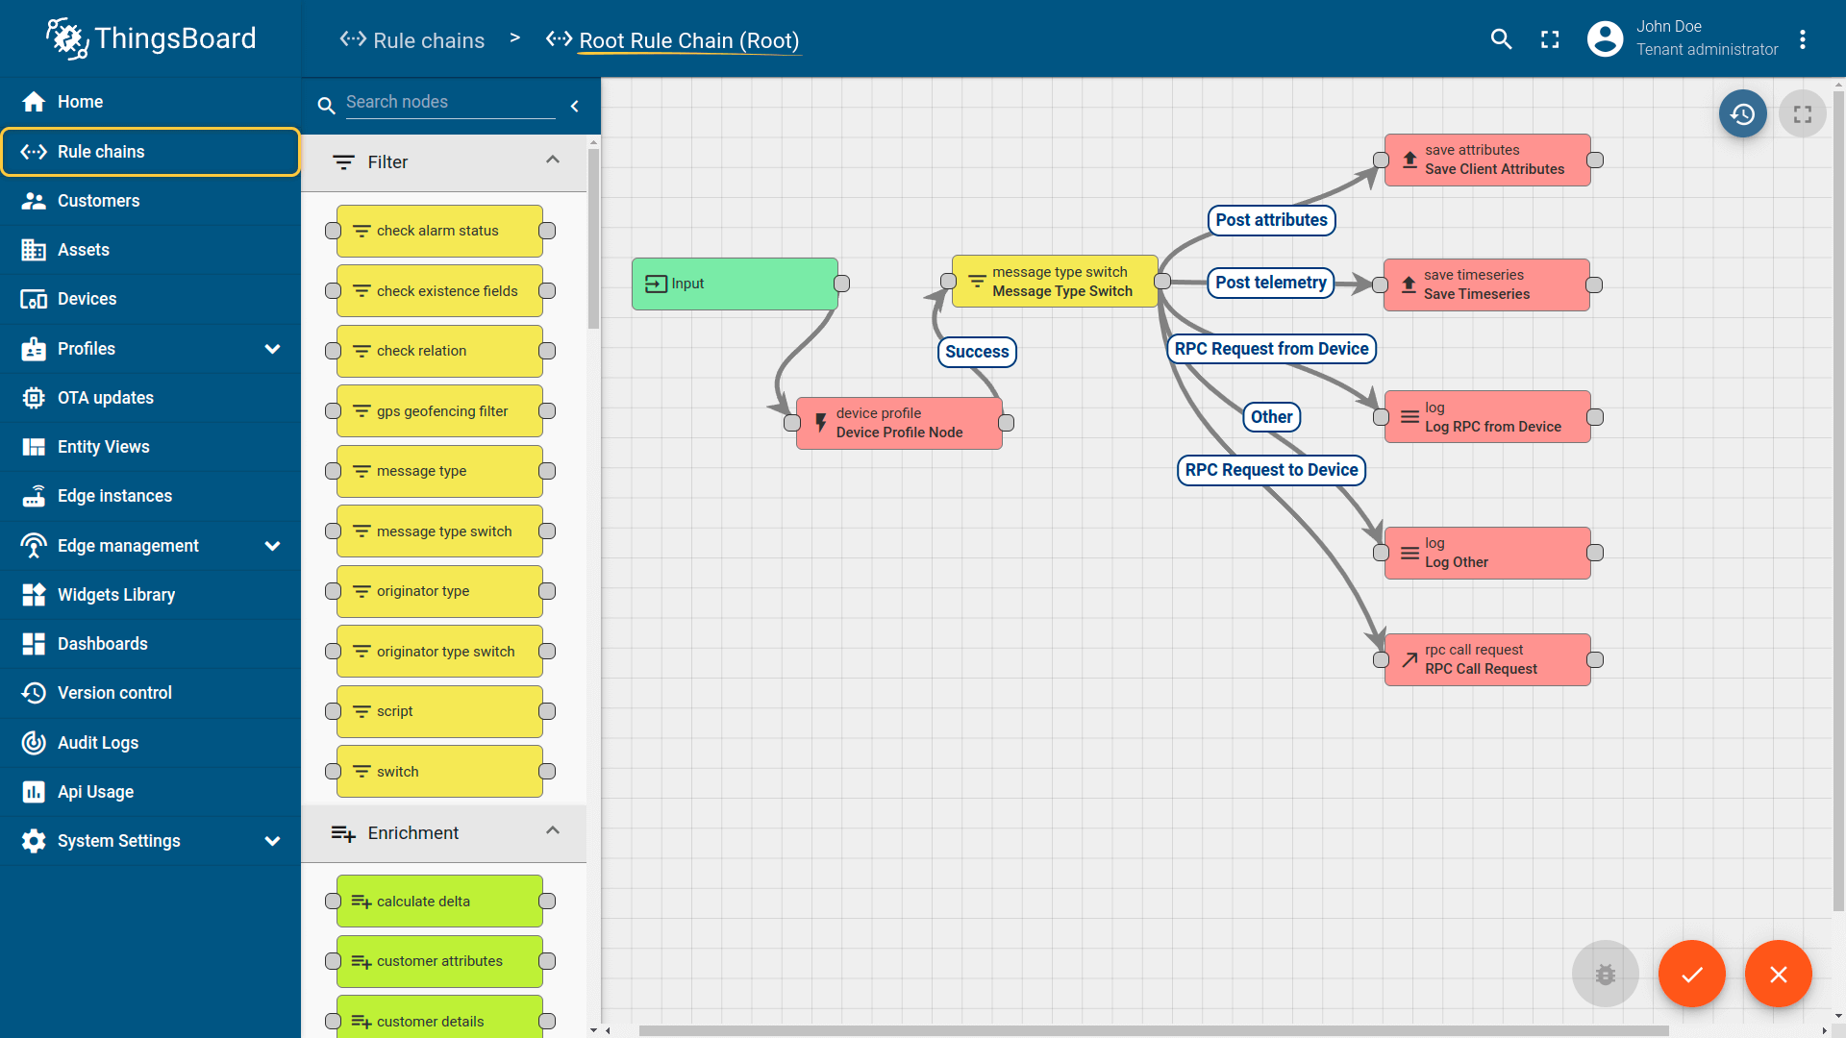

- Smart Factory Platform ()
Factory watch is a platform for smart factory needs.
It provides Users/ Factory
- with a scalable solution for their Production and asset monitoring
- OEE and predictive maintenance solution scaling up to digital twin for your assets.
- to unleased the true potential of the data that their machines are generating and helps to identify the KPIs and also improve them.
- A modular architecture that allows users to choose the service that they what to start and then can scale to more complex solutions as per their demands.
Its unique SaaS model helps users to save time, cost and money.
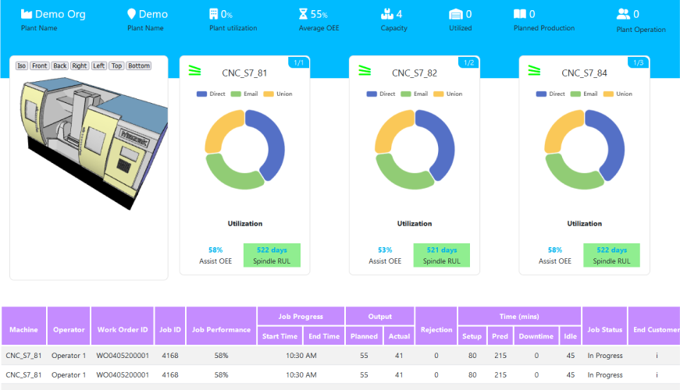

-  based Solution
UCT is one of the early adopters of LoRAWAN teschnology and providing solution in Agritech, Smart cities, Industrial Monitoring, Smart Street Light, Smart Water/ Gas/ Electricity metering solutions etc.
- Predictive Maintenance
UCT is providing Industrial Machine health monitoring and Predictive maintenance solution leveraging Embedded system, Industrial IoT and Machine Learning Technologies by finding Remaining useful life time of various Machines used in production process.
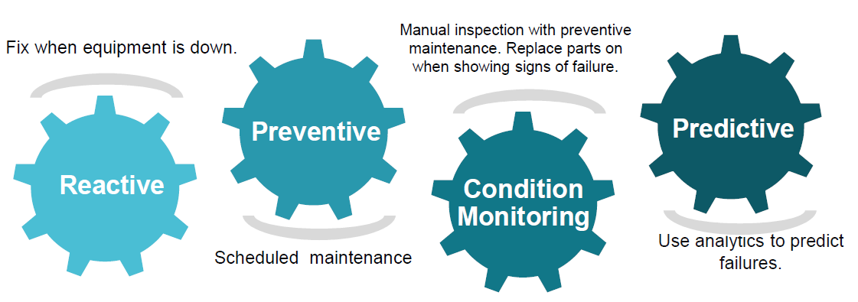

About upskill Campus (USC)
upskill Campus along with The IoT Academy and in association with Uniconverge technologies has facilitated the smooth execution of the complete internship process.
USC is a career development platform that delivers personalized executive coaching in a more affordable, scalable and measurable way.




Seeing need of upskilling in self paced manner along-with additional support services e.g. Internship, projects, interaction with Industry experts, Career growth Services
https://www.upskillcampus.com/
upSkill Campus aiming to upskill 1 million learners in next 5 year

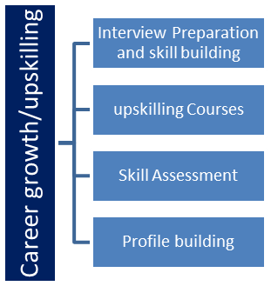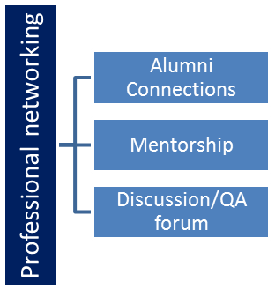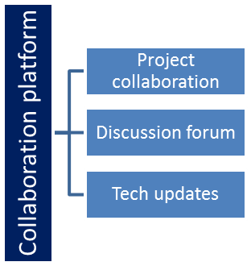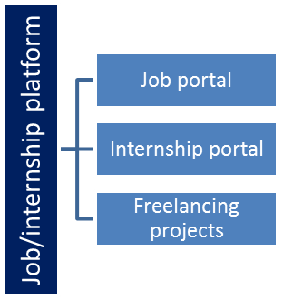

The IoT Academy
The IoT academy is EdTech Division of UCT that is running long executive certification programs in collaboration with EICT Academy, IITK, IITR and IITG in multiple domains.

Objectives of this Internship program
The primary objectives of this internship program were to gain practical knowledge and hands-on experience in a real-world working environment. The internship was designed to bridge the gap between theoretical learning and industrial application, enabling students to understand how concepts are implemented in actual scenarios.
The key objectives of this internship program are as follows:
- To gain practical experience of working in the industry and understand professional work culture.
- To develop the ability to solve real-world problems using technical knowledge and logical thinking.
- To improve job prospects by acquiring relevant industry skills and experience.
- To enhance understanding of the field of study and its real-life applications.
- To achieve personal growth by improving communication skills, teamwork, and problem-solving abilities.

Reference
The following resources were referred to during the development of the project and preparation of this report:
- Official Python Documentation – https://docs.python.org/3/
- Cryptography Library Documentation (Fernet) – https://cryptography.io/
- JSON Documentation – https://www.json.org/
- Online tutorials and technical blogs related to Python and Encryption
- Study materials and guidance provided during the internship program by Upskill Campus and UCT

Glossary
Term | Description
Encryption | Process of converting data into a secure format to prevent unauthorized access
Decryption | Process of converting encrypted data back to its original form
Password Manager | A software application used to store and manage passwords securely
Fernet | A symmetric encryption method used for secure data handling in Python
JSON | JavaScript Object Notation, a format used for storing and exchanging data
Authentication | The process of verifying the identity of a user
Database | A structured collection of data stored electronically
User Interface (UI) | The part of the application through which users interact

Problem Statement

In the assigned problem statement, the objective was to design and develop a secure and efficient system for managing user passwords. In today’s digital world, individuals use multiple online platforms such as social media, banking, email, and other services, each requiring a unique password. Managing these multiple passwords becomes difficult and often leads users to adopt unsafe practices such as using weak passwords, reusing the same password across platforms, or storing passwords in insecure locations.
Such practices increase the risk of cyber threats including data breaches, hacking, and unauthorized access. Therefore, there is a strong need for a reliable system that can securely store and manage user credentials while ensuring ease of access.
The problem focuses on creating a Password Manager application that allows users to:
- Store their passwords securely using encryption techniques
- Generate strong and unique passwords
- Retrieve stored passwords safely when required
The challenge in this project was to ensure data security, confidentiality, and usability while maintaining a simple and user-friendly interface. The system must protect sensitive information from unauthorized access and provide a seamless experience to the user.
This project aims to address these issues by developing a secure password management system using Python and encryption methods, thereby providing a practical solution to a common real-world problem.

Existing and Proposed solution

- 4.1 Existing Solutions
Currently, users adopt various methods to manage their passwords. Some of the common existing solutions include:
- Manual Storage Methods:
Many users write their passwords in notebooks or store them in plain text files. This method is highly insecure as anyone with access can easily read the passwords.
- Browser-based Password Managers:
Modern web browsers provide built-in password-saving features. Although convenient, these may not always be secure if the system is compromised, and they lack advanced customization.
- Third-party Password Managers:
Applications like password management tools are available that offer encryption and cloud storage. However, some of these tools require paid subscriptions, internet dependency, and may raise concerns about data privacy.

- Limitations of Existing Systems
Despite the availability of these solutions, they have several limitations:
- Lack of strong security in manual methods
- Risk of data breaches in browser-based storage
- Dependency on internet and third-party services
- Limited control over data privacy
- Complexity and cost in advanced tools

- 4.2 Proposed Solution
To overcome these limitations, the proposed solution is to develop a Password Manager using Python that provides a secure, efficient, and user-friendly way to manage passwords.
The system includes the following features:
- Secure Storage: Passwords are stored in encrypted form using strong encryption techniques (Fernet).
- Password Generation: Ability to generate strong and random passwords.
- Easy Retrieval: Users can safely retrieve stored passwords when needed.
- Local Storage: Data is stored locally, ensuring full control and privacy.
- Simple Interface: Easy-to-use interface for better user experience.

- 4.3 Value Addition
The proposed system offers several improvements over existing solutions:
- Enhanced security through encryption techniques
- No dependency on internet or external services
- Full control of user data (privacy-focused approach)
- Lightweight and easy to use
- Cost-effective (no subscription required)
- Customizable features as per user requirements

This solution aims to provide a reliable and secure password management system that addresses real-world challenges effectively while maintaining simplicity and usability.

Code submission (Github link)
https://github.com/shubhamraghuvanshi2424/password-manager

Report submission (Github link) :

Proposed Design/ Model

The proposed design of the Password Manager system focuses on providing a secure, efficient, and user-friendly solution for managing user credentials. The design follows a structured flow that includes input, processing, storage, and output stages. The system is divided into multiple components that work together to ensure proper functionality and data security.

- 5.1 Design Flow
The overall working of the system can be explained in the following stages:
1. Start (User Interaction):
The process begins when the user opens the application. The user is provided with options such as storing a new password, generating a password, or retrieving an existing password.
2. Input Stage:
The user enters required details such as:
- Website/Application name
- Username/Email
- Password (or chooses auto-generate option)
3. Processing Stage:
Once the input is provided, the system processes the data:
- If the user selects password generation, a strong random password is created
- The entered/generated password is then encrypted using a secure encryption algorithm (Fernet)
4. Storage Stage:
The encrypted password along with other details is stored in a structured format (JSON file or database). This ensures that even if data is accessed, it remains unreadable without decryption.
5. Retrieval Stage:
When the user wants to access saved credentials:
- The system fetches encrypted data
- Decrypts it using the stored key
- Displays the original password securely
6. Output Stage:
The system shows the requested information (decrypted password or generated password) to the user in a readable format.
7. End Process:
The operation is completed, and the system waits for the next user action.

- 5.2 System Components
The system is divided into the following modules:
- User Interface Module: Handles interaction between user and system
- Password Generator Module: Generates strong and random passwords
- Encryption Module: Encrypts and decrypts sensitive data
- Storage Module: Stores encrypted data in files/database
- Retrieval Module: Fetches and displays stored credentials

- 5.3 Design Characteristics
- Security: Uses encryption to protect sensitive data
- Efficiency: Fast processing and retrieval
- Scalability: Can be extended with GUI or cloud integration
- User-Friendly: Simple and easy-to-use design

- 5.4 Final Outcome
The final outcome of this design is a fully functional Password Manager system that:
- Securely stores user credentials
- Protects data from unauthorized access
- Provides quick and easy access to stored passwords
- Enhances overall user security and experience

High Level Diagram (if applicable)

Figure 1: High Level Diagram of the System
The high-level diagram represents the overall structure of the Password Manager system and shows how different components interact with each other at a broader level.
In this system, the User interacts with the Application Interface, which acts as the main control unit. The application processes user requests such as storing, generating, and retrieving passwords. The input data is then passed to the Encryption Module, where sensitive information is encrypted before storage.
The encrypted data is stored in a Database/JSON File, ensuring data security and privacy. When the user requests stored information, the data is retrieved from storage, decrypted, and displayed to the user.
- Main Components in High Level Diagram:
- User
- Application Interface
- Encryption/Decryption Module
- Storage System (JSON/Database)
👉 Diagram idea (draw this in Word/PDF):
User → Application → Encryption → Database
↑ ↓
Output ← Decryption ← Retrieval

Low Level Diagram (if applicable)
The low-level diagram provides a detailed internal working of the system, showing how each module operates and interacts at a deeper level.
In the Password Manager system, the process starts with user input, followed by validation. If the user selects password generation, the Password Generator Module creates a strong password. The data is then passed to the Encryption Function, which converts it into a secure format.
The encrypted data is stored in a structured format using a File Handling Module (JSON). During retrieval, the system fetches the encrypted data, applies the Decryption Function, and returns the original password to the user.
- Modules in Low Level Diagram:
- Input Handler
- Password Generator
- Encryption Function
- File Handling (JSON Storage)
- Decryption Function
- Output Display
👉 Diagram idea:
Input → Validation → (Generator) → Encryption → File Storage
↓
Retrieval ← Decryption ← Data Fetch ← Database

Interfaces (if applicable)
The system includes multiple interfaces and internal structures that enable smooth communication between different components.
- 1. User Interface (UI)
The user interface allows users to:
- Enter website, username, and password
- Generate strong passwords
- Retrieve stored credentials
It is designed to be simple and user-friendly.

- 2. Data Flow (DFD Concept)
The data flow in the system follows this path:
User Input → Processing → Encryption → Storage
Storage → Retrieval → Decryption → Output
This ensures that sensitive data is always encrypted during storage and only decrypted when required.

- 3. Flowchart (System Workflow)
Start
↓
Enter Details
↓
Generate Password? → Yes → Generate
↓
Encrypt Data
↓
Store Data
↓
Retrieve Request?
↓
Decrypt Data
↓
Display Output
↓
End

- 4. Protocols Used
- No external communication protocol is required (offline system)
- Internal logic is based on:
  - File handling
  - Encryption algorithms (Fernet)

- 5. Memory and Data Handling
- Data is stored in JSON format
- Encryption ensures that:
  - Data is unreadable without a key
  - Memory usage is optimized
- Efficient file handling ensures quick read/write operations

- 6. System Behavior (State Concept)
The system works in different states:
- Input State
- Processing State
- Encryption State
- Storage State
- Retrieval State
- Output State

Performance Test

The performance testing of the Password Manager system is an essential part of the project as it demonstrates the practical applicability of the solution in real-world scenarios rather than just being a theoretical implementation.
In this project, several constraints were identified and analyzed to evaluate system performance and reliability.

- 8.1 Identified Constraints
The following constraints were considered during system design and testing:
- Memory Usage:
The system should efficiently store encrypted data without consuming excessive memory.
- Processing Speed:
Encryption and decryption operations should be fast to ensure smooth user experience.
- Security (Accuracy of Encryption):
The encryption algorithm must accurately secure and retrieve data without loss or corruption.
- Scalability:
The system should handle multiple password entries without performance degradation.
- Reliability:
The system must consistently perform operations like storing and retrieving data without failure.

- Handling of Constraints in Design
The system design incorporates the following measures:
- Used Fernet encryption, which is secure and efficient
- Implemented JSON-based storage for lightweight data handling
- Optimized file handling to reduce read/write time
- Designed modular structure to improve scalability and maintainability

- 8.1 Test Plan / Test Cases
The following test cases were designed to validate system performance:
Test Case ID | Description | Input | Expected Output
TC-01 | Store Password | Valid user data | Data stored successfully
TC-02 | Retrieve Password | Existing entry | Correct password displayed
TC-03 | Encryption Check | Plain password | Encrypted output
TC-04 | Decryption Check | Encrypted data | Original password
TC-05 | Password Generation | Request | Strong random password
TC-06 | Invalid Retrieval | Non-existing entry | Error message

- 8.2 Test Procedure
The testing process was carried out in the following steps:
- The application was executed in a local environment.
- Various inputs were provided to test different functionalities.
- Password storage functionality was tested by entering multiple credentials.
- Retrieval function was tested to verify correct decryption.
- Encryption and decryption outputs were verified manually.
- Multiple entries were added to check system performance under load.

- 8.3 Performance Outcome
The results obtained from testing are as follows:
- The system successfully stored and retrieved encrypted passwords without any data loss.
- Encryption and decryption operations were performed quickly with minimal delay.
- Memory usage remained low due to efficient JSON storage.
- The system handled multiple entries effectively without performance issues.
- All test cases passed successfully, confirming system reliability.

- Limitations & Recommendations
Although the system performs well, some limitations exist:
- Currently supports only local storage
- No multi-user authentication
- Limited scalability for very large datasets
- Future Improvements
- Integration with cloud storage for better scalability
- Implementation of database systems (MySQL, MongoDB)
- Addition of GUI for better user experience
- Multi-user authentication and access control

My learnings

The internship program was a highly enriching experience that provided me with both technical knowledge and practical exposure to real-world problem-solving. Working on the Password Manager project helped me understand how theoretical concepts are applied in actual software development.
During this internship, I gained strong hands-on experience in Python programming, especially in areas such as file handling, data structures, and modular coding. I learned how to design and implement a complete project from scratch, including planning, development, testing, and documentation.
One of the most important learnings was understanding the concept of data security and encryption. By implementing encryption techniques (Fernet), I gained practical knowledge of how sensitive data can be protected from unauthorized access. This has increased my awareness of cybersecurity practices and their importance in modern applications.
I also improved my problem-solving skills by breaking down complex problems into smaller, manageable tasks and finding efficient solutions. Debugging errors and optimizing the code further enhanced my analytical thinking and patience.
In addition to technical skills, this internship helped me develop important soft skills such as time management, consistency, and self-discipline. Completing tasks within deadlines and maintaining regular progress improved my ability to work in a structured manner.
Furthermore, I gained experience in project documentation and report writing, which is an essential part of professional work. I learned how to present technical information in a clear and organized way.
Overall, this internship has played a significant role in my career growth. It has boosted my confidence, strengthened my technical foundation, and prepared me for future opportunities in the software development field. The knowledge and experience gained during this program will be highly beneficial in my academic journey as well as in my professional career.

Future work scope

Although the Password Manager project has been successfully developed and meets its primary objectives, there are several enhancements and advanced features that can be implemented in the future to improve its functionality, scalability, and user experience.
One of the major improvements can be the development of a Graphical User Interface (GUI) using frameworks such as Tkinter or PyQt. This will make the application more interactive and user-friendly compared to the current text-based interface.
Another important enhancement is the integration of cloud storage. Currently, the system stores data locally using JSON files, but in the future, it can be extended to store encrypted data on cloud platforms. This will allow users to access their passwords from multiple devices securely.
The system can also be improved by implementing database support such as MySQL or MongoDB instead of JSON files. This will enhance scalability and performance, especially when handling a large amount of data.
Adding multi-user authentication is another valuable feature. Currently, the system is designed for a single user, but future versions can include login systems with username and master password authentication for better security.
Further improvements can include:
- Integration of biometric authentication (fingerprint or face recognition)
- Implementation of two-factor authentication (2FA) for enhanced security
- Auto-fill feature for websites and applications
- Password strength analysis and security recommendations
- Mobile application development for Android/iOS platforms
Additionally, advanced encryption techniques and security protocols can be incorporated to make the system more robust against cyber threats.

- Final Statement
These future enhancements will transform the current Password Manager into a more powerful, secure, and industry-level application capable of meeting modern user requirements and security standards.

