Hadoop Map Reduce Report

Shubham Rai

scr130130

# Objectives

The purpose of this report is to observe the characteristics of the HDFS under different settings. To do this work on a simple sanitized data obtained from <http://www.police.uk/data>, I’ve written a MapReduce program to compute the total number of crime incidents of each crime type in each region. I considered following definitions for a region:

* The crime location is defined by a coordinate system (East, North). East and North are defined by 6 digit numbers.
* Region definition 1: Using only the first digits of the coordinate system.
* Region definition 2: Using the first three digits of the coordinate system.
* There are different types of crime viz. Anti social behavior, Burglary, Drugs, Robbery, etc.

# Implementation

All the tasks were carried out in both Single node cluster as well as multimode cluster.

Task carried out in Multi node cluster were with 1 master and 3 slaves.

Slave 1: 10.176.128.21

Slave 2: 10.176.128.22

Slave 3: 10.176.128.23

There are 1341 files in the UK crime data corpus.

The distribution of the files on the cluster is shown below with a replication factor of 2

Blocks on each Data Node:

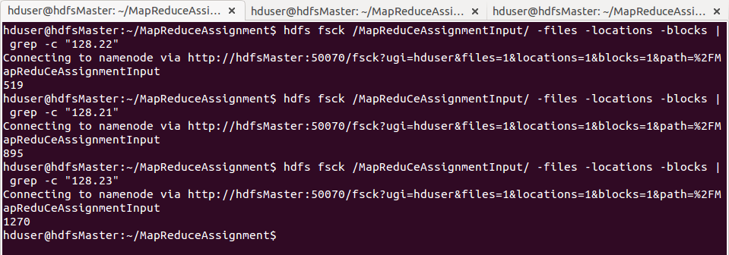

From the above image we can gather that the 895 were in 10.176.128.21:50010 machine, 519 in 10.176.128.22:5001 machine and 1270 in 10.176.128.23:50010 machine.

**1. Small input file**

|  |  |
| --- | --- |
| **Name** | **Size (Kbs)** |
| 2013-05-kent-street.csv | 1749.366 |

For the first case, where the input file is a single text file of size 1.7 mb, the corresponding block on host file-system is

Output

Running on Single Node Cluster

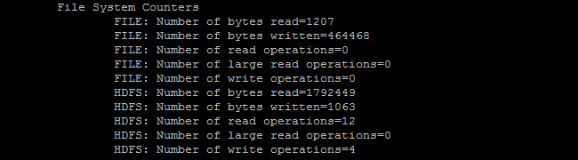

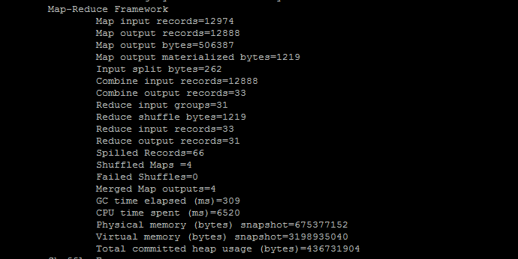

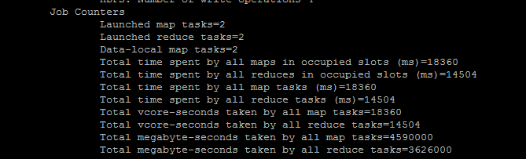

Running on Multi Node Cluster

FSCK started by hduser (auth:SIMPLE) from /[10.176.128.33](http://10.176.128.33/) for path /MapReduCeAssignmentInput/2013-05-kent-street.csv at Fri Nov 06 12:31:30 CST 2015  
/MapReduCeAssignmentInput/2013-05-kent-street.csv 1749366 bytes, 1 block(s):  OK  
0. BP-171612301-10.176.128.33-1445550968862:blk_1073743433_2609 len=1749366 repl=2 [DatanodeInfoWithStorage[[10.176.128.22:50010](http://10.176.128.22:50010/),DS-1c1bd347-7bbc-4d10-84ed-00a953e5287b,DISK], DatanodeInfoWithStorage[[10.176.128.23:50010](http://10.176.128.23:50010/),DS-e449ade6-2a47-4d49-bffc-875c318a1fbb,DISK]]  
  
Status: HEALTHY

Total size:    1749366 B  
 Total dirs:    0  
 Total files:    1  
 Total symlinks:        0  
 Total blocks (validated):    1 (avg. block size 1749366 B)  
 Minimally replicated blocks:    1 (100.0 %)  
 Over-replicated blocks:    0 (0.0 %)  
 Under-replicated blocks:    0 (0.0 %)  
 Mis-replicated blocks:        0 (0.0 %)  
 Default replication factor:    2  
 Average block replication:    2.0  
 Corrupt blocks:        0  
 Missing replicas:        0 (0.0 %)  
 Number of data-nodes:        3  
 Number of racks:        1

|  |  |  |
| --- | --- | --- |
| **DataNode** | **Name** | **Size(Kbs)** |
| DatanodeInfoWithStorage[10.176.128.22:50010] | blk_1073743433_2609 | 1749.366 |

**Map-Reduce Framework**

|  |  |
| --- | --- |
| Map input records | 12974 |
| Map output records | 12888 |
| Map output bytes | 506387 |
| Map output materialized bytes | 1151 |
| Input split bytes | 124 |
| Combine input records | 12888 |
| Combine output records | 31 |
| Reduce input groups | 31 |
| Reduce shuffle bytes | 1151 |
| Reduce input records | 31 |
| Reduce output records | 31 |
| Spilled Records | 62 |
| Shuffled Maps | 2 |
| Failed Shuffles | 0 |
| Merged Map outputs | 2 |
| GC time elapsed (ms) | 25 |
| Total committed heap usage (bytes) | 529465344 |

**File System Counters**

FILE: Number of bytes read=27257  
 FILE: Number of bytes written=853512  
 FILE: Number of read operations=0  
 FILE: Number of large read operations=0  
 FILE: Number of write operations=0  
 HDFS: Number of bytes read=5248098  
 HDFS: Number of bytes written=1608  
 HDFS: Number of read operations=24  
 HDFS: Number of large read operations=0  
 HDFS: Number of write operations=9

**Shuffle Errors**

BAD_ID=0  
CONNECTION=0  
IO_ERROR=0  
WRONG_LENGTH=0  
WRONG_MAP=0  
WRONG_REDUCE=0

**2.** **Large Consolidated File**

|  |  |
| --- | --- |
| **Name** | **Size (Kbs)** |
| largeFile.csv | 2183975593 |

For the second case, where the input file is a single consolidated large text file of size 2.1 gb, the corresponding block on host file-system is:

Output

hduser@hdfsMaster:~/MapReduceAssignment$ hdfs fsck /MapReduCeAssignmentInput/largeFile.csv  -files -locations -blocks  
Connecting to namenode via [http://hdfsMaster:50070/fsck?ugi=hduser&files=1&locations=1&blocks=1&path=%2FMapReduCeAssignmentInput%2FlargeFile.csv](http://hdfsmaster:50070/fsck?ugi=hduser&files=1&locations=1&blocks=1&path=%2FMapReduCeAssignmentInput%2FlargeFile.csv)

FSCK started by hduser (auth:SIMPLE) from /[10.176.128.33](http://10.176.128.33/) for path /MapReduCeAssignmentInput/largeFile.csv at Fri Nov 06 13:13:50 CST 2015  
/MapReduCeAssignmentInput/largeFile.csv [2183910057](tel:2183910057) bytes, 17 block(s):  OK  
0. BP-171612301-10.176.128.33-1445550968862:blk_1073743509_2694 len=134217728 repl=2 [DatanodeInfoWithStorage[[10.176.128.21:50010](http://10.176.128.21:50010/),DS-21425df4-64d0-43d5-bfe9-f29941619356,DISK], DatanodeInfoWithStorage[[10.176.128.22:50010](http://10.176.128.22:50010/),DS-1c1bd347-7bbc-4d10-84ed-00a953e5287b,DISK]]  
1. BP-171612301-10.176.128.33-1445550968862:blk_1073743510_2695 len=134217728 repl=2 [DatanodeInfoWithStorage[[10.176.128.23:50010](http://10.176.128.23:50010/),DS-e449ade6-2a47-4d49-bffc-875c318a1fbb,DISK], DatanodeInfoWithStorage[[10.176.128.21:50010](http://10.176.128.21:50010/),DS-21425df4-64d0-43d5-bfe9-f29941619356,DISK]]  
2. BP-171612301-10.176.128.33-1445550968862:blk_1073743511_2696 len=134217728 repl=2 [DatanodeInfoWithStorage[[10.176.128.23:50010](http://10.176.128.23:50010/),DS-e449ade6-2a47-4d49-bffc-875c318a1fbb,DISK], DatanodeInfoWithStorage[[10.176.128.22:50010](http://10.176.128.22:50010/),DS-1c1bd347-7bbc-4d10-84ed-00a953e5287b,DISK]]  
3. BP-171612301-10.176.128.33-1445550968862:blk_1073743512_2697 len=134217728 repl=2 [DatanodeInfoWithStorage[[10.176.128.21:50010](http://10.176.128.21:50010/),DS-21425df4-64d0-43d5-bfe9-f29941619356,DISK], DatanodeInfoWithStorage[[10.176.128.22:50010](http://10.176.128.22:50010/),DS-1c1bd347-7bbc-4d10-84ed-00a953e5287b,DISK]]  
4. BP-171612301-10.176.128.33-1445550968862:blk_1073743513_2698 len=134217728 repl=2 [DatanodeInfoWithStorage[[10.176.128.22:50010](http://10.176.128.22:50010/),DS-1c1bd347-7bbc-4d10-84ed-00a953e5287b,DISK], DatanodeInfoWithStorage[[10.176.128.23:50010](http://10.176.128.23:50010/),DS-e449ade6-2a47-4d49-bffc-875c318a1fbb,DISK]]  
5. BP-171612301-10.176.128.33-1445550968862:blk_1073743514_2699 len=134217728 repl=2 [DatanodeInfoWithStorage[[10.176.128.22:50010](http://10.176.128.22:50010/),DS-1c1bd347-7bbc-4d10-84ed-00a953e5287b,DISK], DatanodeInfoWithStorage[[10.176.128.21:50010](http://10.176.128.21:50010/),DS-21425df4-64d0-43d5-bfe9-f29941619356,DISK]]  
6. BP-171612301-10.176.128.33-1445550968862:blk_1073743515_2700 len=134217728 repl=2 [DatanodeInfoWithStorage[[10.176.128.22:50010](http://10.176.128.22:50010/),DS-1c1bd347-7bbc-4d10-84ed-00a953e5287b,DISK], DatanodeInfoWithStorage[[10.176.128.23:50010](http://10.176.128.23:50010/),DS-e449ade6-2a47-4d49-bffc-875c318a1fbb,DISK]]  
7. BP-171612301-10.176.128.33-1445550968862:blk_1073743516_2701 len=134217728 repl=2 [DatanodeInfoWithStorage[[10.176.128.23:50010](http://10.176.128.23:50010/),DS-e449ade6-2a47-4d49-bffc-875c318a1fbb,DISK], DatanodeInfoWithStorage[[10.176.128.21:50010](http://10.176.128.21:50010/),DS-21425df4-64d0-43d5-bfe9-f29941619356,DISK]]  
8. BP-171612301-10.176.128.33-1445550968862:blk_1073743517_2702 len=134217728 repl=2 [DatanodeInfoWithStorage[[10.176.128.23:50010](http://10.176.128.23:50010/),DS-e449ade6-2a47-4d49-bffc-875c318a1fbb,DISK], DatanodeInfoWithStorage[[10.176.128.21:50010](http://10.176.128.21:50010/),DS-21425df4-64d0-43d5-bfe9-f29941619356,DISK]]  
9. BP-171612301-10.176.128.33-1445550968862:blk_1073743518_2703 len=134217728 repl=2 [DatanodeInfoWithStorage[[10.176.128.22:50010](http://10.176.128.22:50010/),DS-1c1bd347-7bbc-4d10-84ed-00a953e5287b,DISK], DatanodeInfoWithStorage[[10.176.128.21:50010](http://10.176.128.21:50010/),DS-21425df4-64d0-43d5-bfe9-f29941619356,DISK]]  
10. BP-171612301-10.176.128.33-1445550968862:blk_1073743519_2704 len=134217728 repl=2 [DatanodeInfoWithStorage[[10.176.128.21:50010](http://10.176.128.21:50010/),DS-21425df4-64d0-43d5-bfe9-f29941619356,DISK], DatanodeInfoWithStorage[[10.176.128.22:50010](http://10.176.128.22:50010/),DS-1c1bd347-7bbc-4d10-84ed-00a953e5287b,DISK]]  
11. BP-171612301-10.176.128.33-1445550968862:blk_1073743520_2705 len=134217728 repl=2 [DatanodeInfoWithStorage[[10.176.128.21:50010](http://10.176.128.21:50010/),DS-21425df4-64d0-43d5-bfe9-f29941619356,DISK], DatanodeInfoWithStorage[[10.176.128.23:50010](http://10.176.128.23:50010/),DS-e449ade6-2a47-4d49-bffc-875c318a1fbb,DISK]]  
12. BP-171612301-10.176.128.33-1445550968862:blk_1073743521_2706 len=134217728 repl=2 [DatanodeInfoWithStorage[[10.176.128.23:50010](http://10.176.128.23:50010/),DS-e449ade6-2a47-4d49-bffc-875c318a1fbb,DISK], DatanodeInfoWithStorage[[10.176.128.21:50010](http://10.176.128.21:50010/),DS-21425df4-64d0-43d5-bfe9-f29941619356,DISK]]  
13. BP-171612301-10.176.128.33-1445550968862:blk_1073743522_2707 len=134217728 repl=2 [DatanodeInfoWithStorage[[10.176.128.22:50010](http://10.176.128.22:50010/),DS-1c1bd347-7bbc-4d10-84ed-00a953e5287b,DISK], DatanodeInfoWithStorage[[10.176.128.21:50010](http://10.176.128.21:50010/),DS-21425df4-64d0-43d5-bfe9-f29941619356,DISK]]  
14. BP-171612301-10.176.128.33-1445550968862:blk_1073743523_2708 len=134217728 repl=2 [DatanodeInfoWithStorage[[10.176.128.21:50010](http://10.176.128.21:50010/),DS-21425df4-64d0-43d5-bfe9-f29941619356,DISK], DatanodeInfoWithStorage[[10.176.128.23:50010](http://10.176.128.23:50010/),DS-e449ade6-2a47-4d49-bffc-875c318a1fbb,DISK]]  
15. BP-171612301-10.176.128.33-1445550968862:blk_1073743524_2709 len=134217728 repl=2 [DatanodeInfoWithStorage[[10.176.128.23:50010](http://10.176.128.23:50010/),DS-e449ade6-2a47-4d49-bffc-875c318a1fbb,DISK], DatanodeInfoWithStorage[[10.176.128.22:50010](http://10.176.128.22:50010/),DS-1c1bd347-7bbc-4d10-84ed-00a953e5287b,DISK]]  
16. BP-171612301-10.176.128.33-1445550968862:blk_1073743525_2710 len=36426409 repl=2 [DatanodeInfoWithStorage[[10.176.128.21:50010](http://10.176.128.21:50010/),DS-21425df4-64d0-43d5-bfe9-f29941619356,DISK], DatanodeInfoWithStorage[[10.176.128.23:50010](http://10.176.128.23:50010/),DS-e449ade6-2a47-4d49-bffc-875c318a1fbb,DISK]]  
  
Status: HEALTHY  
 Total size:    [2183910057](tel:2183910057) B  
 Total dirs:    0  
 Total files:    1  
 Total symlinks:        0  
 Total blocks (validated):    17 (avg. block size 128465297 B)  
 Minimally replicated blocks:    17 (100.0 %)  
 Over-replicated blocks:    0 (0.0 %)  
 Under-replicated blocks:    0 (0.0 %)  
 Mis-replicated blocks:        0 (0.0 %)  
 Default replication factor:    2  
 Average block replication:    2.0  
 Corrupt blocks:        0  
 Missing replicas:        0 (0.0 %)  
 Number of data-nodes:        3  
 Number of racks:        1

|  |  |  |
| --- | --- | --- |
| **DataNode** | **Name** | **Size(Kbs)** |
| DatanodeInfoWithStorage[10.176.128.21:50010] | blk_1073743509_2694 | 134217.728 |
| DatanodeInfoWithStorage[10.176.128.23:50010] | blk_1073743510_2695 | 134217.728 |
| DatanodeInfoWithStorage[10.176.128.23:50010] | blk_1073743511_2696 | 134217.728 |
| DatanodeInfoWithStorage[10.176.128.21:50010] | blk_1073743512_2697 | 134217.728 |
| DatanodeInfoWithStorage[10.176.128.22:50010] | blk_1073743513_2698 | 134217.728 |
| DatanodeInfoWithStorage[10.176.128.22:5001] | blk_1073743514_2699 | 134217.728 |
| DatanodeInfoWithStorage[10.176.128.22:50010] | blk_1073743515_2700 | 134217.728 |
| DatanodeInfoWithStorage[10.176.128.23:50010] | blk_1073743516_2701 | 134217.728 |
| DatanodeInfoWithStorage[10.176.128.23:50010] | blk_1073743517_2702 | 134217.728 |
| DatanodeInfoWithStorage[10.176.128.22:50010] | blk_1073743518_2703 | 134217.728 |
| DatanodeInfoWithStorage[10.176.128.21:50010] | blk_1073743519_2704 | 134217.728 |
| DatanodeInfoWithStorage[10.176.128.21:50010] | blk_1073743520_2705 | 134217.728 |
| DatanodeInfoWithStorage[10.176.128.23:50010] | blk_1073743521_2706 | 134217.728 |
| DatanodeInfoWithStorage[10.176.128.22:50010] | blk_1073743522_2707 | 134217.728 |
| DatanodeInfoWithStorage[10.176.128.21:50010] | blk_1073743523_2708 | 134217.728 |
| DatanodeInfoWithStorage[10.176.128.23:50010] | blk_1073743524_2709 | 134217.728 |
| DatanodeInfoWithStorage[10.176.128.21:50010] | blk_1073743525_2710 | 36426.409 |

Block Distribution of Large consolidated File

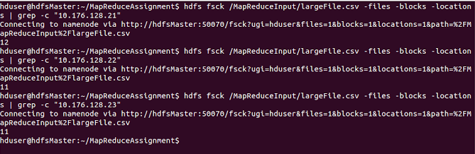

The average block size is 128MB, and the 2.1GB file was divided into 17 blocks across the datanodes. The replication factor was 1.

In our case the replication factor was 2 which produced 34 blocks, 12 were in 10.176.128.21:50010 machine, 11 in 10.176.128.22:5001 machine and 11 in 10.176.128.23:50010 machine.

**Map-Reduce Framework**

|  |  |
| --- | --- |
| Map input records | 15669890 |
| Map output records | 15576983 |
| Map output bytes | 575119894 |
| Map output materialized bytes | 202284 |
| Input split bytes | 1938 |
| Combine input records | 15576983 |
| Combine output records | 5614 |
| Reduce input groups | 568 |
| Reduce shuffle bytes | 202284 |
| Reduce input records | 5614 |
| Reduce output records | 568 |
| Spilled Records | 11228 |
| Shuffled Maps | 34 |
| Failed Shuffles | 0 |
| Merged Map outputs | 34 |
| GC time elapsed (ms) | 3358 |
| Total committed heap usage (bytes) | 3353280512 |

**File System Counters**

FILE: Number of bytes read=1157387

FILE: Number of bytes written=7759225

FILE: Number of read operations=0

FILE: Number of large read operations=0

FILE: Number of write operations=0

HDFS: Number of bytes read=24806094843

HDFS: Number of bytes written=30521

HDFS: Number of read operations=440

HDFS: Number of large read operations=0

HDFS: Number of write operations=25

**Shuffle Errors**

BAD_ID=0  
CONNECTION=0  
IO_ERROR=0  
WRONG_LENGTH=0  
WRONG_MAP=0  
WRONG_REDUCE=0

**3. Multiple files of small size**

For the third case, where the input multiple files of small size which totals to 173 mb

|  |  |
| --- | --- |
| **Name** | **Size (Kbs)** |
| smallSizeManyFiles | 181893.897 |

Output

Running on Single Node Cluster

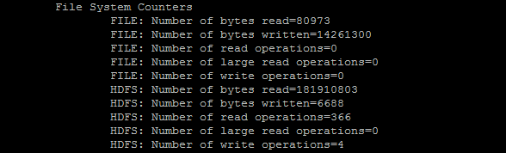

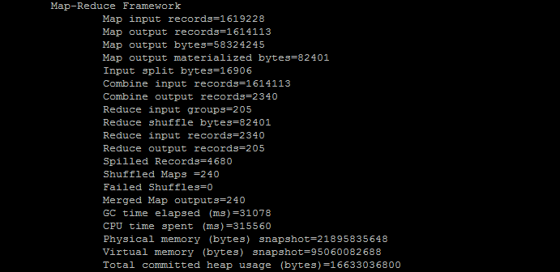

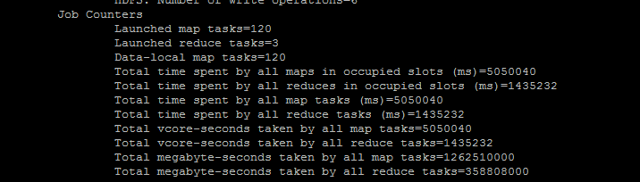

Running on Multi Node Cluster

hduser@hdfsMaster:~/MapReduceAssignment$ hdfs fsck /MapReduCeAssignmentInput/smallSizeManyFiles  -files -locations -blocks  
Connecting to namenode via [http://hdfsMaster:50070/fsck?ugi=hduser&files=1&locations=1&blocks=1&path=%2FMapReduCeAssignmentInput%2FlargeFile.csv](http://hdfsmaster:50070/fsck?ugi=hduser&files=1&locations=1&blocks=1&path=%2FMapReduCeAssignmentInput%2FlargeFile.csv)

15/11/06 17:35:15 INFO reduce.MergeManagerImpl: Merged 120 segments, 38805 bytes to disk to satisfy reduce memory limit  
15/11/06 17:35:15 INFO reduce.MergeManagerImpl: Merging 1 files, 38571 bytes from disk  
15/11/06 17:35:15 INFO reduce.MergeManagerImpl: Merging 0 segments, 0 bytes from memory into reduce  
15/11/06 17:35:15 INFO mapred.Merger: Merging 1 sorted segments  
15/11/06 17:35:15 INFO mapred.Merger: Down to the last merge-pass, with 1 segments left of total size: 38537 bytes  
15/11/06 17:35:15 INFO mapred.LocalJobRunner: 120 / 120 copied.  
15/11/06 17:35:16 INFO mapred.Task: Task:attempt_local126779413_0001_r_000001_0 is done. And is in the process of committing  
15/11/06 17:35:16 INFO mapred.LocalJobRunner: 120 / 120 copied.  
15/11/06 17:35:16 INFO mapred.Task: Task attempt_local126779413_0001_r_000001_0 is allowed to commit now  
15/11/06 17:35:16 INFO output.FileOutputCommitter: Saved output of task 'attempt_local126779413_0001_r_000001_0' to hdfs://hdfsMaster:54310/MapreduceOutputMultipleShubham/_temporary/0/task_local126779413_0001_r_000001  
15/11/06 17:35:16 INFO mapred.LocalJobRunner: reduce > reduce  
15/11/06 17:35:16 INFO mapred.Task: Task 'attempt_local126779413_0001_r_000001_0' done.  
15/11/06 17:35:16 INFO mapred.LocalJobRunner: Finishing task: attempt_local126779413_0001_r_000001_0  
15/11/06 17:35:16 INFO mapred.LocalJobRunner: reduce task executor complete.  
15/11/06 17:35:16 INFO mapreduce.Job: Job job_local126779413_0001 completed successfully  
15/11/06 17:35:16 INFO mapreduce.Job: Counters: 35

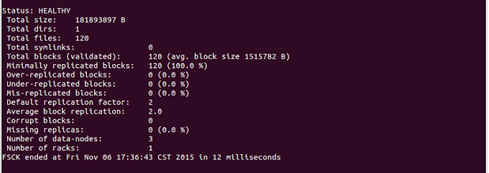

Since there are 120 splits, I won’t be listing all the spits on the 3 data nodes.

Block Distribution of Multiple small Files

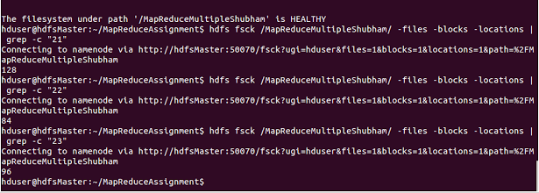

The average block size is 128MB, and the 173 mB file was divided into 120 blocks across the datanodes. The replication factor was 1.

In our case the replication factor was 2 which gives: 128 were in 10.176.128.21:50010 machine, 84 in 10.176.128.22:5001 machine and 96 in 10.176.128.23:50010 machine.

**Map-Reduce Framework**

|  |  |
| --- | --- |
| Map input records | 1619228 |
| Map output records | 1614113 |
| Map output bytes | 58324245 |
| Map output materialized bytes | 82401 |
| Input split bytes | 15706 |
| Combine input records | 1614113 |
| Combine output records | 2340 |
| Reduce input groups | 205 |
| Reduce shuffle bytes | 82401 |
| Reduce input records | 2340 |
| Reduce output records | 205 |
| Spilled Records | 4680 |
| Shuffled Maps | 240 |
| Failed Shuffles | 0 |
| Merged Map outputs | 240 |
| GC time elapsed (ms) | 10547 |
| Total committed heap usage (bytes) | 21937995776 |

**File System Counters**

FILE: Number of bytes read=32718227

FILE: Number of bytes written=41911470

FILE: Number of read operations=0

FILE: Number of large read operations=0

FILE: Number of write operations=0

HDFS: Number of bytes read=16040282768

HDFS: Number of bytes written=10116

HDFS: Number of read operations=15375

HDFS: Number of large read operations=0

HDFS: Number of write operations=128

**Shuffle Errors**

BAD_ID=0  
CONNECTION=0  
IO_ERROR=0  
WRONG_LENGTH=0  
WRONG_MAP=0  
WRONG_REDUCE=0

# Error handling

The execution engine stops the failed map tasks whenever there are any execution errors like unhandled exceptions.

If the User enters invalid region, the program will communicate to the user to enter the valid region.

# Distribution of tasks

Since the HDFS follows the data locality principle, the map tasks are run on datanodes where the blocks are situated. Additional map tasks were created to handle the load. The task distribution was found to be similar to the block distribution.

# Conclusion

As we go on to input the different files of various sizes, depending upon the size of total input Map-Reducer will split the input chunks into one or more parts. For the shown input pattern, we have three cases:

* + Small input file : 1 split of the input
  + One large file : 17 splits of the total input
  + Multiple files : 120 splits of the total input

Several variables related to Map-Reduce framework can be obtained using log files:

* Reduce shuffle bytes: the shuffled map output on the reducer, which was obtained through the Task Tracker using the intermediate files of Map phase.
* Spilled Records: When the buffer memory gets filled and no space is left for new records, old records are written to the disk.
* Map output bytes: Output from the map phase.
* Combine input records: Records merged by the combiner during the map phase.
* Reduce input records: Number of values associate to the keys from the mapper phase
* Reduce input groups: The number of unique keys fed to reducer from mappers.
* Reduce output records: The number of records combined by all reducers.
* Combine output records: No of records combined during the reduce phase.

As per the observation, Apache Hadoop behaves the way it is described in various white papers. It has implemented features like replication, and is fault tolerant. The distribution of files, jobs were as expected. Hadoop does achieve parallelism.