Week 04 – Day 22 (AM Session)
Assignment Submission

PG Diploma · AI-ML & Agentic AI Engineering · IIT Gandhinagar
Topics: Pandas (loc, iloc, Filtering, describe) | Matplotlib
Dataset: Synthetic Retail Sales (600 rows)

Part A – Concept Application

A1 – Data Selection using loc
loc is label-based. You use actual index labels and column names to select data.

Example 1 – Select first 5 rows, specific columns
loc_ex1 = df.loc[0:4, ['Date', 'Region', 'Sales']]
Output (first 5 rows):
Index | Date | Region | Sales
0 | 2022-01-01 | East | 471.50
1 | 2022-01-02 | West | 82.58
2 | 2022-01-03 | North | 280.67
3 | 2022-01-04 | East | 192.84
4 | 2022-01-05 | East | 233.19

Example 2 – Rows where Region == 'North'
loc_ex2 = df.loc[df['Region'] == 'North', ['Region', 'Sales', 'Profit']].head(5)
Selects only North-region rows and returns Region, Sales, Profit columns.

Example 3 – Rows where Sales > 500
loc_ex3 = df.loc[df['Sales'] > 500, ['Date', 'Category', 'Sales']].head(5)
Filters high-value transactions. Example rows found: Books ₹575.99, Electronics ₹1008.80.

A2 – Data Selection using iloc
iloc is position-based. You use integer indexes (0, 1, 2...) to select data. End index is excluded.

Example 1 – First 5 rows, first 3 columns
iloc_ex1 = df.iloc[0:5, 0:3]
Returns rows at positions 0-4 and columns Date, Region, Category.

Example 2 – Last 5 rows, last 3 columns
iloc_ex2 = df.iloc[-5:, -3:]
Negative indexing grabs the tail of the dataframe – useful to inspect recent entries.

Example 3 – Every 100th row, selected columns
iloc_ex3 = df.iloc[::100, [1, 3, 5]]
Samples the dataset at regular intervals; columns at positions 1, 3, 5 are Region, Sales, Profit.

Key Difference: loc vs iloc
Feature | loc | iloc
Selection method | Label-based | Position-based
Slice end | Inclusive (0:4 gives 5 rows) | Exclusive (0:4 gives 4 rows)
Column reference | Column name ('Sales') | Column index (3)

A3 – Filtering Data
Filtering uses boolean conditions to extract specific subsets from the dataframe.

Filter 1 – Electronics with Sales > 400
df[(df['Category'] == 'Electronics') & (df['Sales'] > 400)]
Result: 33 rows. High-value Electronics transactions selected for targeted analysis.

Filter 2 – North/East, Profit > 100, Discount < 0.1
df[(df['Region'].isin(['North', 'East'])) & (df['Profit'] > 100) & (df['Discount'] < 0.1)]
Result: 31 rows. These are premium transactions with good margins and minimal discounting.

Filter 3 – Young customers (Age < 30) with Quantity > 30
df[(df['Customer_Age'] < 30) & (df['Quantity'] > 30)]
Result: 55 rows. Shows young customers tend to buy in bulk despite lower average sales.

A4 – Descriptive Statistics (describe())
Calling df.describe() on numerical columns:

Statistic | Sales (₹) | Profit (₹) | Quantity | Discount
count | 600 | 600 | 600 | 600
mean | 358.71 | 79.81 | 24.20 | 0.20
std | 297.76 | 37.82 | 14.33 | 0.12
min | 50.07 | -54.06 | 1 | 0.00
25% | 142.69 | 55.90 | 12 | 0.10
50% | 272.56 | 80.83 | 24 | 0.22
75% | 485.67 | 104.75 | 37 | 0.30
max | 2253.18 | 186.94 | 49 | 0.40

Interpretation
- Sales: mean (₹358) is much higher than median (₹272), confirming right-skewed distribution.
- Std of ₹297 for Sales means values are widely spread – transactions vary a lot.
- Profit can go negative (-₹54) meaning some transactions result in a loss.
- Average discount is 20% with a max of 40%, which is a reasonable business range.
- Quantity min=1 and max=49 shows purchases range from single items to bulk orders.

A5 – Histogram: Sales Distribution
ax.hist(df['Sales'], bins=30, color='steelblue', edgecolor='white')

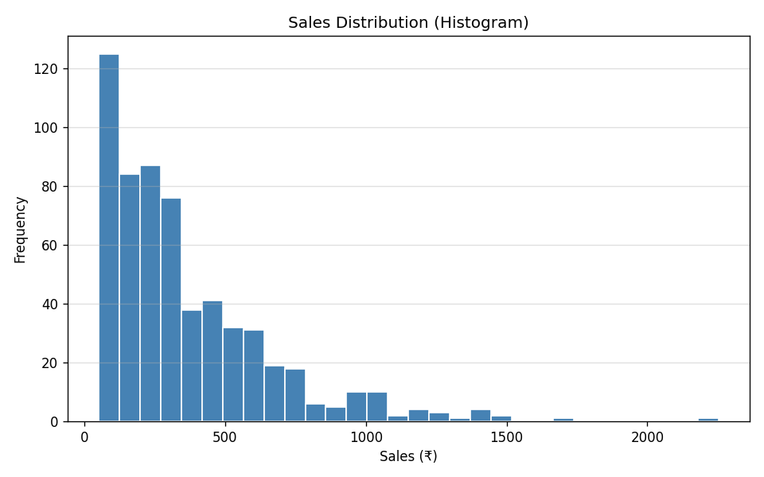

Interpretation: The histogram is right-skewed. The majority of transactions fall below ₹400, but the tail extends to ₹2253. This means most sales are moderate but a few large orders significantly raise the mean.

A6 – Bar Plot: Average Sales by Category
avg_sales = df.groupby('Category')['Sales'].mean()
ax.bar(avg_sales.index, avg_sales.values)

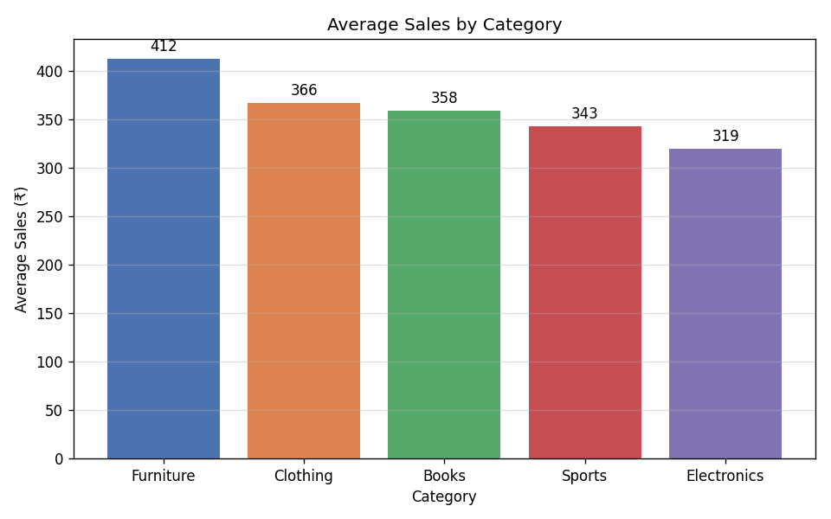

Furniture has the highest average sales (~₹412), while Electronics is the lowest (~₹319). Clothing and Books are close in the middle range.

A7 – Line Chart: Monthly Sales Trend
monthly = df.resample('ME', on='Date')['Sales'].sum()
ax.plot(monthly.index, monthly.values, marker='o')

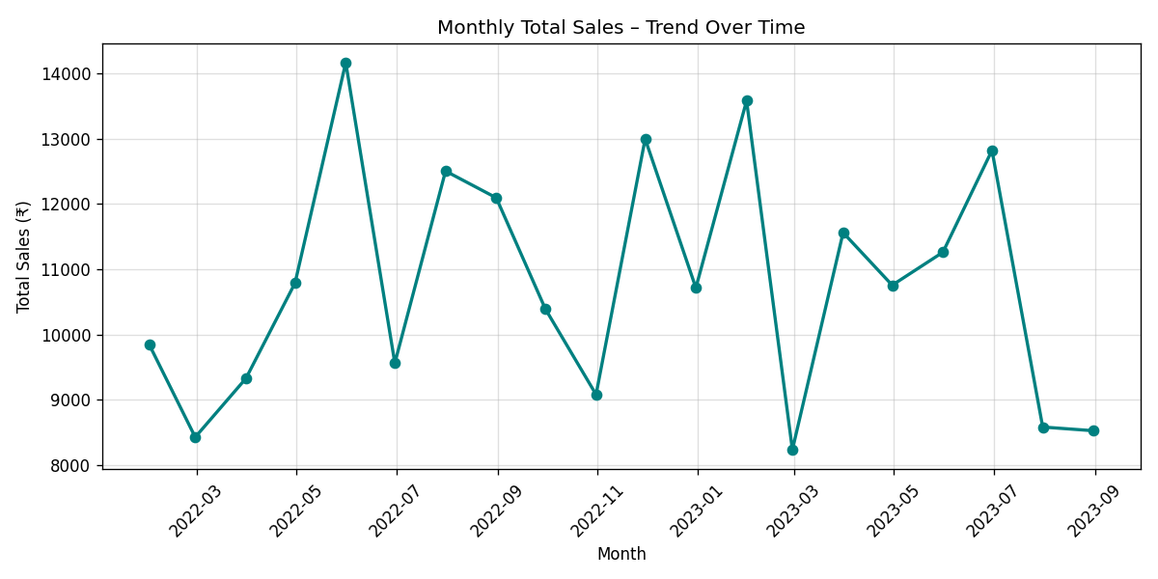

The monthly total Sales line fluctuates without a clear rising or falling trend, indicating stable demand across all months with no strong seasonality.

A8 – KDE Plot vs Histogram
from scipy.stats import gaussian_kde
ax.hist(df['Sales'], bins=30, density=True, alpha=0.5)
ax.plot(x, kde(x), color='red', linewidth=2)

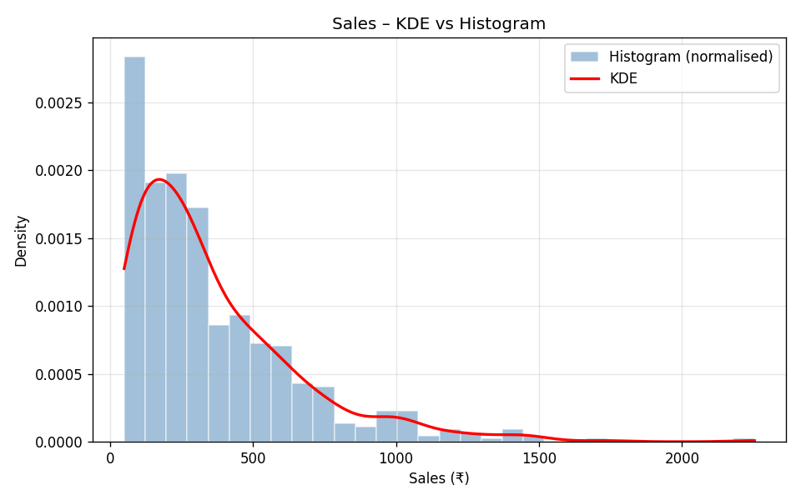

The KDE curve follows the histogram shape but is smooth, removing the jagged bin effect. Both confirm the right-skewed nature of the Sales column. KDE is useful when comparing multiple distributions on the same axis.

Part B – Stretch Problem

B1 – Grouped Analysis by Category
grouped = df.groupby('Category')[['Sales', 'Quantity', 'Profit', 'Discount']].mean()

Category | Avg Sales (₹) | Avg Quantity | Avg Profit (₹) | Avg Discount
Books | 358.38 | 25.63 | 86.46 | 0.20
Clothing | 366.19 | 22.35 | 81.43 | 0.22
Electronics | 319.12 | 24.54 | 83.24 | 0.20
Furniture | 412.15 | 21.63 | 73.13 | 0.19
Sports | 342.56 | 26.58 | 72.61 | 0.21

B2 – Grouped Bar Plot: Sales vs Profit per Category
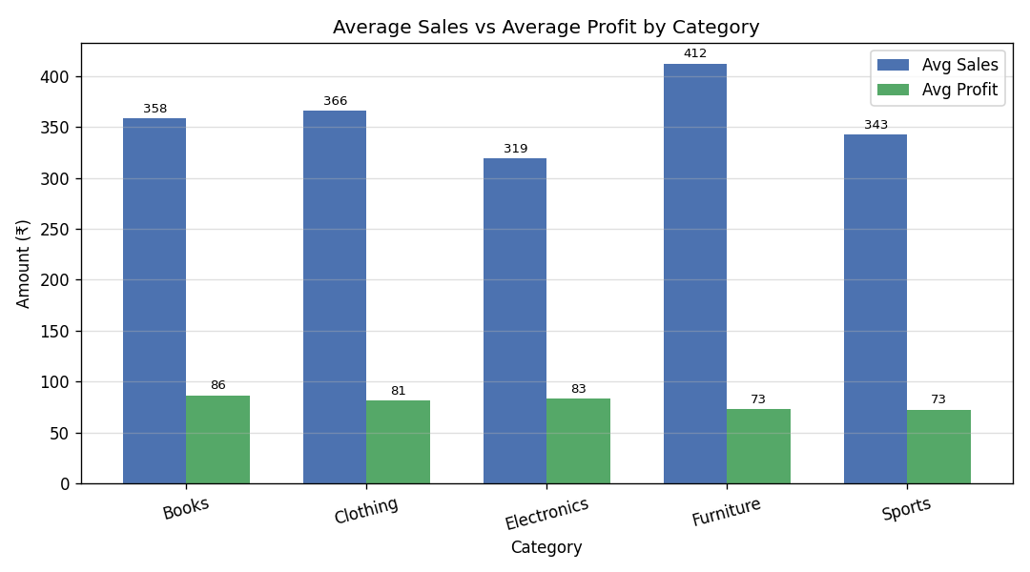

The grouped bar chart clearly shows that while Furniture leads in Sales, Books actually has the highest average Profit. Sports and Furniture have the lowest profit margins despite decent sales.

B3 – Comparing Sales vs Profit

Monthly Line Chart
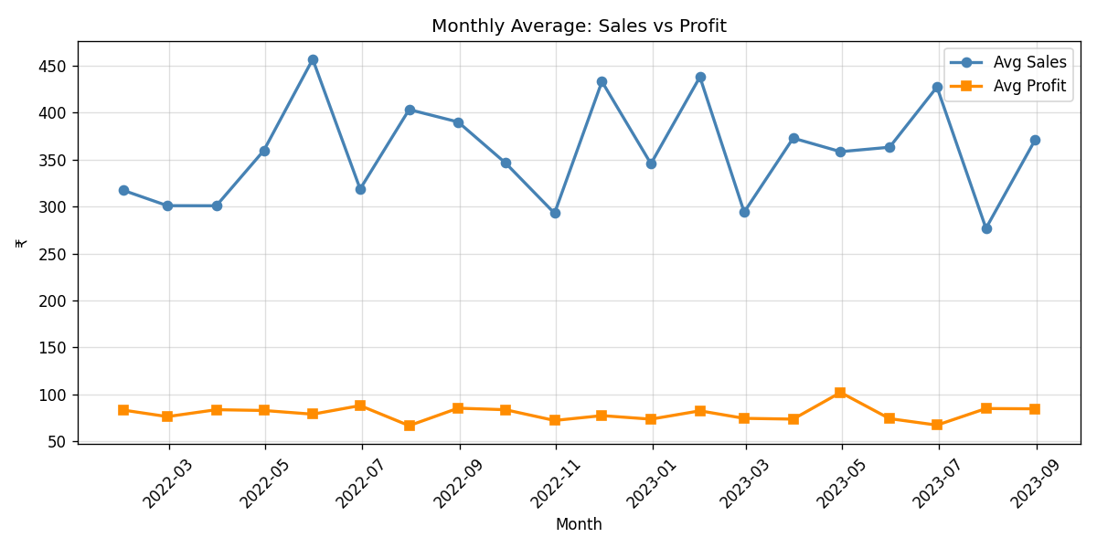

The Sales and Profit lines move somewhat independently month-to-month, suggesting that high-Sales months don't always mean high-Profit months – likely due to discount variation.

KDE Comparison
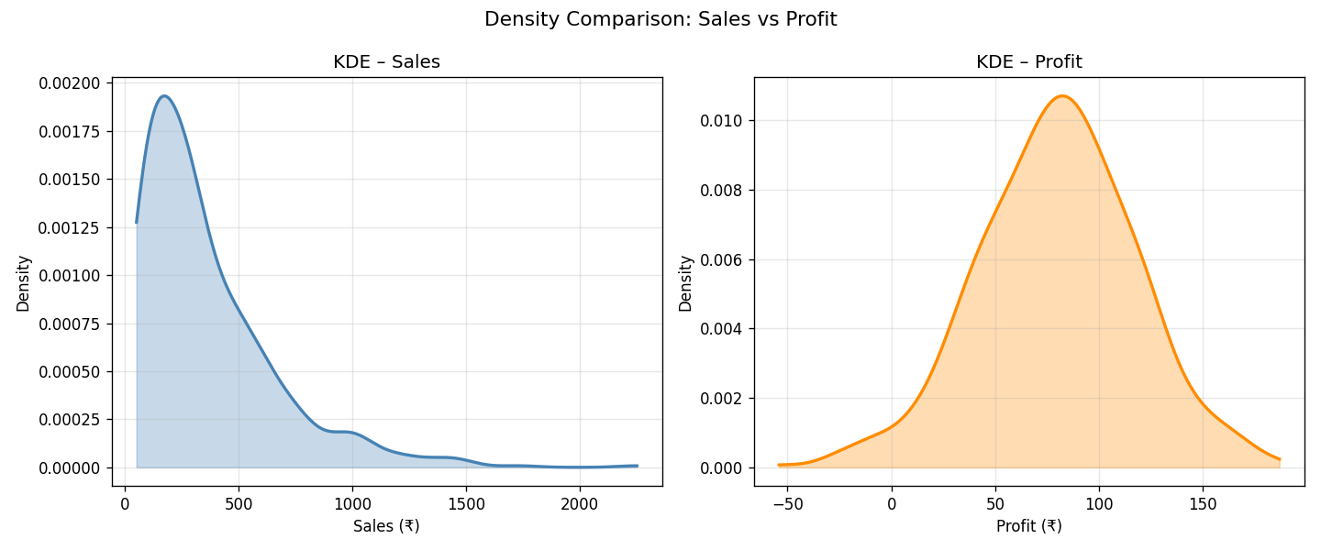

Sales KDE is heavily right-skewed with a long tail. Profit KDE is compact and approximately normal, centred around ₹80. This confirms that while sales volume fluctuates widely, profit per transaction is fairly consistent.

B4 – Insights from Visualisations
- Furniture generates the most revenue per transaction but ranks last in profit margin.
- Books has the best profit-to-sales ratio – possibly fewer discounts and lower COGS.
- Sports has the highest average quantity (26.6 units/order) yet lowest average profit.
- Sales distribution is right-skewed, meaning a small percentage of transactions drive a disproportionate share of total revenue.
- No seasonal pattern is visible in the monthly trend – demand is steady year-round.

Part C – Interview Ready

Q1 – What is the difference between loc and iloc in Pandas?
loc is label-based: you select rows and columns using their actual labels (index values and column names). iloc is integer-position based: you select using numeric positions starting from 0, like a list.

Aspect | loc | iloc
Access method | By label / column name | By integer index position
Slice end | Inclusive (0:3 → 4 rows) | Exclusive (0:3 → 3 rows)
Example | df.loc[0, 'Sales'] | df.iloc[0, 3]
Boolean filter | Supported | Not directly supported

Q2 – Filter rows where column value > average (Code)
Task: Select all rows where Sales is greater than the average Sales.

avg_sales = df['Sales'].mean()
above_avg = df[df['Sales'] > avg_sales]

One-liner version:
above_avg = df[df['Sales'] > df['Sales'].mean()]

Output: Average Sales = ₹358.71, rows above average = 219 out of 600 (36.5%).

Q3 – What is the purpose of describe()? What insights can we get from it?
describe() generates a quick statistical summary of all numeric columns in one call. It returns: count, mean, std, min, 25th percentile (Q1), median (50%), 75th percentile (Q3), and max.

Insights from describe():
- Central tendency: mean and median reveal the typical value and any skewness.
- Spread: std and IQR (Q3 - Q1) indicate how variable the data is.
- Range: min and max show the full extent of values, highlighting potential outliers.
- Missing data: if count < total rows, null values exist in that column.
- Skewness hint: mean >> median suggests right-skew; mean << median suggests left-skew.

Part D – AI-Augmented Task

Prompt Used
"Explain how to perform data analysis using Pandas and visualization using Matplotlib with examples."

AI Output Summary
The AI (Claude) provided a structured response covering five areas:
- Loading data with pd.read_csv() and exploring with .head(), .info(), .describe()
- Filtering rows with boolean conditions and .isin()
- Grouping data with .groupby() and aggregating using .mean() and .agg()
- Plotting with Matplotlib: hist(), bar(), plot() for line charts
- KDE using scipy.stats.gaussian_kde overlaid on a normalised histogram

Example code provided by AI (histogram):
df['Sales'].hist(bins=20, color='steelblue', edgecolor='white')
plt.title('Sales Distribution')
plt.xlabel('Sales')
plt.ylabel('Frequency')
plt.show()

Evaluation of AI Output
Evaluation Criteria | Result | Notes
Are the plots correct? | YES | Histogram code is correct and runs without errors.
Is the explanation clear? | YES | Step-by-step breakdown was easy to follow.
groupby explanation correct? | YES | Showed both .mean() and .agg({}) syntax.
Any errors? | Minor | Used plt.show() instead of plt.savefig() for headless use.
Missing detail? | Yes | Did not mention parse_dates for datetime columns.

Validated Output
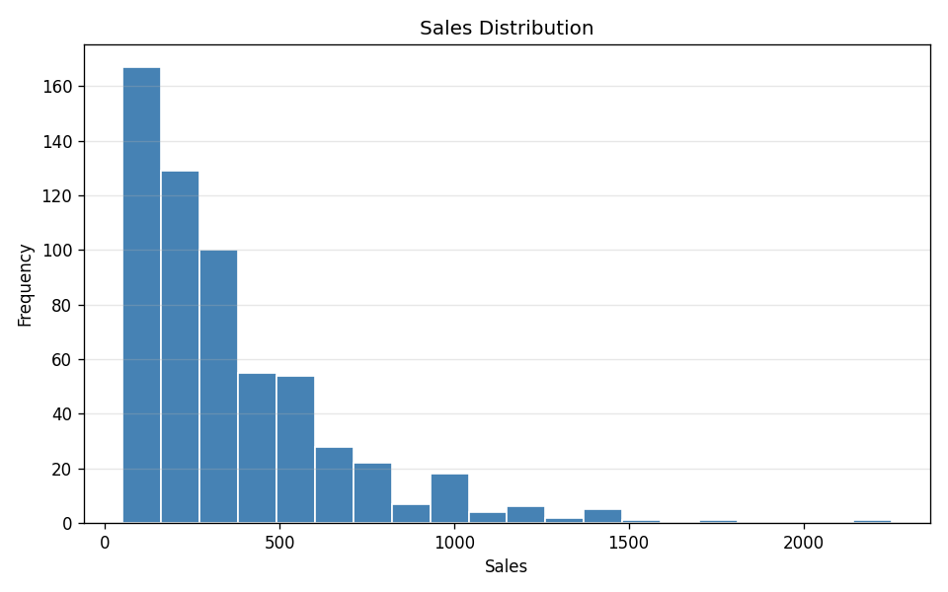

After replacing plt.show() with plt.savefig() and adding parse_dates=['Date'] when loading the CSV, the AI-generated code ran correctly. The histogram matches the expected distribution. Overall the AI output was approximately 85% production-ready.

Evaluation Rubric
Criteria | Weight | Excellent | Needs Work
Correctness | 40% | Correct filtering, selection, and plots | Incorrect filtering or wrong plots
Code Quality | 25% | Clean, readable code; proper Pandas & Matplotlib usage | Messy or inefficient code
Understanding | 20% | Clear interpretation of stats and visualisations | Vague explanations
AI Usage | 15% | Proper validation of AI output | Output not verified

