PROJECT 5
The Retail Oracle
Predictive Cart Intelligence

Anticipating Consumer Needs Through Sequential Behavior

Industry: FMCG / Retail / Supply Chain
Duration: 2 Sprints (10 Working Days)
Format: MVP / Proof of Concept

Futurense AI Clinic
April 2026

THE FRAMEWORK

How Enterprise Teams Attack a Data Problem
Before you read the project-specific brief, understand the general sequence. Every enterprise ML engagement, whether at a bank, a logistics company, or a government agency, moves through the same fundamental stages. The details change. The rhythm does not.
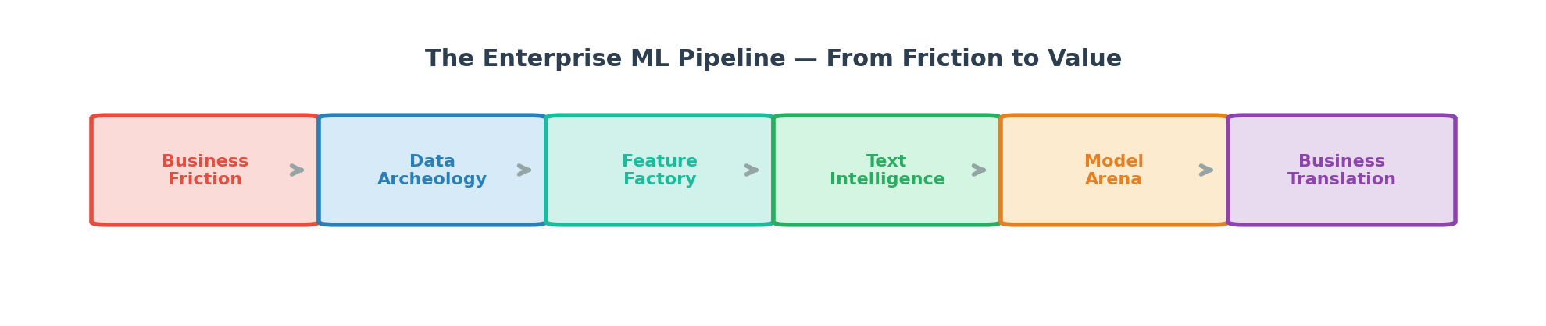
It starts with understanding the business friction: what is costing the organization money, time, or trust? Then comes data archeology: profiling, joining, cleaning, and understanding the mess you have been handed. The feature factory is where raw data becomes predictive signal. Text intelligence is where unstructured language gets quantified. The model arena is where hypotheses are tested. And the final stage, the one most teams skip and the one that separates juniors from seniors, is business translation: converting a statistical result into a recommendation that a non-technical stakeholder can act on.
In the real world, nobody gives you a clean CSV and a list of instructions. They give you a problem and a mess. Start with the mess.
THE SITUATION ROOM

The Business Friction
A grocery delivery platform ships millions of orders per week. Their supply chain is optimized for average demand, not actual demand. When organic bananas spike on Tuesday in Mumbai, the warehouse runs out by noon and customers switch to a competitor. When a new product launches and nobody orders it, perishable inventory goes to waste.
The recommendation engine is the other lever. If the platform can predict which products a returning customer will reorder, it can pre-populate their cart, reducing the time from app-open to checkout. Every second saved increases the probability of conversion. Every relevant suggestion increases basket size.
This is not a recommendation problem in the Netflix sense. Nobody dies if you suggest the wrong movie. In grocery, a missed prediction means someone's dinner plan falls apart, and they order from the shop next door.

THE DATA YOU INHERIT

The Data Landscape
You are working with one of the largest publicly available retail transaction datasets: over 3 million grocery orders from 200,000 users, spanning 50,000 products organized into aisles and departments.
The scale is the first challenge. The prior orders table alone has over 32 million rows. Most laptops will struggle to load this into memory. You will need to think about data engineering before data science: chunked reading, downcasting data types, sampling strategies, or feature pre-computation.
The temporal structure is the second challenge. Orders are sequential. A user's 5th order depends on their 1st through 4th. The products they reorder, the time between orders, the day of week they typically shop, the items they tried once and never bought again: all of this is signal, and all of it requires careful feature engineering to extract.
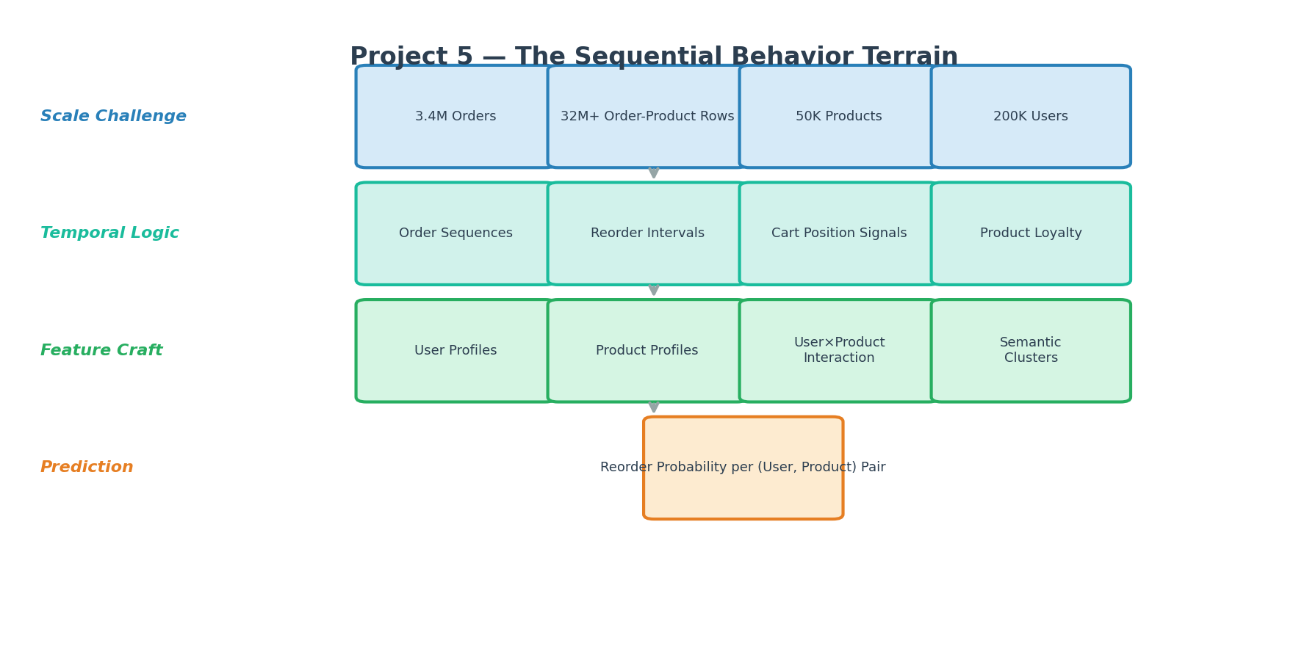
Instacart Market Basket Analysis Competition Data

THE INTELLECTUAL TERRAIN

What the Business Needs You to Think About

The Feature Engineering Challenge
This project is won or lost on feature engineering. The modeling is almost secondary. The data in its raw form is a sequence of transactions. The features you derive from those transactions are what the model actually learns from.
Think about features at three levels. User-level: shopping frequency, basket diversity, day-of-week preferences, organic affinity. Product-level: overall popularity, reorder rate, position in cart. User-product interaction level: how many times has this specific user bought this specific product? How long since their last purchase of it? Is it part of their "routine" or a one-time experiment?
What defines a "loyal" product for a user? Is it the product they buy every single order? Or the product they buy every other order but have never skipped? The definition you choose shapes the feature, and the feature shapes the model.

The Scale Problem
32 million rows of order-product pairs. If you try to compute features naively, you will either run out of memory or wait hours. Enterprise data scientists learn to think in terms of efficient groupby operations, vectorized computations, and strategic sampling.
If you need to sample, how do you choose which users to include? Random sampling? Stratified by order count? What biases does each approach introduce? The sampling decision is itself a modeling decision.

Where Text Meets Structure
Product names and aisle names are your text data. "Organic Whole Milk" and "Whole Milk" and "Organic 2% Reduced Fat Milk" are different strings that a human would group together. Your model sees them as completely unrelated unless you engineer that relationship.
Can you extract semantic features from product names? Keywords like "organic," "gluten-free," "low-fat," "sugar-free" encode dietary preferences. Do health-conscious shoppers have different reorder patterns than others? Is this a feature worth engineering?
Think about product similarity. Two products in different aisles might be substitutes. Two products in the same aisle might be complements. Can text similarity help your model understand these relationships?

How This Gets Built in the Real World
Retail prediction systems at companies like Instacart, Amazon Fresh, and BigBasket typically operate at the (user, product) pair level. For each user and each candidate product, the system computes a reorder probability. The top-N products with the highest probability are surfaced in the "buy it again" section. Feature engineering pipelines compute user profiles, product profiles, and interaction profiles in batch, updated on a cadence. The model is typically gradient-boosted trees because of their speed, interpretability, and ability to handle the feature heterogeneity inherent in this domain.

OPERATING STANDARDS

The Operating Model
These standards apply regardless of which project you are working on. They are non-negotiable. In enterprise data science, the quality of your process is evaluated as rigorously as the quality of your model.

Engineering Hygiene: Git & GitHub
In industry, code that is not version-controlled does not exist. Your GitHub repository is not a submission folder. It is the living history of how your team thinks, collaborates, and iterates.
If your commit history shows one giant commit on the last day, you have demonstrated the opposite of professional engineering practice.
Consider what a senior engineer reviewing your repository would look for. They would look at branch naming conventions that reflect intent. They would look at commit messages that tell a story. They would look at pull requests that show peer review happened before code was merged. They would look at a README that lets a stranger set up and run your project in under five minutes.
Your repository structure should separate concerns: raw data stays untouched, processing code lives in modules, notebooks are for exploration and storytelling, and documentation explains decisions made along the way. Think about what belongs in .gitignore and why.

Operating Rhythm: Agile Practices
You are running a two-sprint engagement. Not because this is an academic exercise, but because every enterprise data science project operates in sprints.
Sprint 1 is your discovery and foundation phase. The business problem needs to be understood, the data needs to be profiled, the architecture needs to be sketched, and a baseline needs to prove the problem is tractable. Sprint 2 is where engineering maturity shows. Features get refined, text intelligence gets integrated, models get compared rigorously, and the solution gets translated back into business language.
Daily standups are not status reports. They are coordination mechanisms. Three questions, answered by each member, taking no more than two minutes each: What did I close? What am I picking up? What is in my way?
Track your work visibly. GitHub Issues and a Kanban board are the minimum. When a task moves from "In Progress" to "Done," there should be a commit, a review, and an updated document to prove it.

The Co-Pilot Protocol: AI & GenAI Tools
AI tools are permitted. They are not your replacement. They are your accelerator. The distinction matters.
The test is simple: if you cannot explain every line of code in your pipeline during a live walkthrough, the code is not yours, regardless of who or what wrote it.
Use AI to clarify concepts, debug errors, generate boilerplate, and refactor messy code. Document every significant AI interaction in a PROMPTS.md file in your repository. Log the tool, the prompt, and how you validated or modified the output. This is not bureaucracy. Companies like Google, Deloitte, and McKinsey now require AI usage documentation on internal projects.
Before you paste your dataset schema into any AI tool, ask yourself: if this were real client data, would you be comfortable sending it to a third-party API? Treat every dataset as company-confidential. Describe your schema; do not upload your data.
The strongest prompt engineers are specific. Instead of asking "help me with ML," they describe the shape of their data, the business constraint, and the specific technical decision they are stuck on. Iterate on your prompts. The first answer is generic. The third is gold.

Design Thinking: HLD & LLD
Enterprises do not start coding on Day 1. They design. Your team must produce two artifacts before any model training begins.
The High-Level Design is your architecture story. One to two pages. It answers: What is the business problem and who cares? Where does the data come from and how does it connect? What does the pipeline look like from raw files to predictions? What metric will you optimize, and why that one instead of another? What assumptions are you making, and what could break them?
The Low-Level Design is your engineering blueprint. It specifies: every feature you intend to use, its type, its source, and your strategy for missing values. It documents your text processing pipeline. It lists your model hypotheses and your evaluation strategy.
Both documents must exist in your repository under /docs before any modeling work begins. A team that skips design and jumps to code is a team that will rewrite everything in Week 2.

Stakeholder Communication: Presentations
The Weekend Checkpoint
This is not a polish exercise. It is a progress demonstration. Show what the data revealed during exploration. Show the data quality problems you discovered and the decisions you made. Show your architecture diagram. Show a baseline model and its honest metrics. Show what is blocking you and what your plan is for the second sprint.
The Final Presentation
Present as if you are in a room with the VP of Data Science at the company whose problem you are solving.
Start with the business context. Why does this problem cost money? Then tell the data story. What surprised you? What insight drove your feature engineering? Walk through your technical approach at a level where a technical manager can follow. Show results with proper evaluation, not just accuracy. Translate your best model into a business recommendation. End with a retrospective: what worked, what didn't, what you would do differently.
Every team member must speak. If one person presents everything, the team loses credibility. In enterprise consulting, this is disqualifying.

Working as a Team
The commit history is your evidence of collaboration. If one member has 90% of the commits, the team has a problem, not a star.
Divide by verticals, not by sequence. One person should not "do EDA" while others wait. Parallel work on data integration, text processing, and model architecture is how real teams operate. Pair programming accelerates learning and reduces bugs. Two people on the same problem produce better output than two people on separate problems.
When two people disagree on an approach, the resolution is not debate. It is experiment. Implement both, compare results, and let the data decide. Document the comparison in your notebook.
Hold each other accountable early. A blocker raised on Day 3 is manageable. A blocker revealed on Day 9 is a project failure.

Solution Maturity
Your work will be evaluated on the maturity of your approach, not just the accuracy of your model.
A student-level submission runs a model and reports a number. A practitioner-level submission includes proper exploration, documented decisions, and multiple model comparisons. An engineer-level submission has modular code, pipeline architecture, justified feature engineering, and meaningful NLP integration. A consultant-level submission translates model outputs into business recommendations, performs error analysis, identifies edge cases, and discusses deployment considerations.
Aim for engineer-level. Impress us with consultant-level.

