create table Customer123(

customerid int primary key,

firstname varchar(30),

lastname varchar(20),

city varchar(30),

state varchar(30)

);

insert into Customer123

values

(10101,'John','Gray','Lynden','Washington'),

(10298,'Leroy','Brown','Pinetop','Arizona'),

(10299,'Elroy','Keller','Snoqualmie','Washington'),

(10315,'Lisa','Jones','Oshkosh','Wisconsin'),

(10325,'Ginger','Schultz','Pocatello','Idaho'),

(10329,'kelly','Mendoza','Kailua','Hawaii'),

(10330,'Shawn','Dalton','Cannon Beach','Oregon'),

(10338,'Michael','Howell','Tillamook','Oregon'),

(10339,'Anthony','Sanchez','Winslow','Arizona'),

(10408,'Elroy','Cleaver','Globe','Arizona');

create table Items_ordered(

customerid int ,

order_date date,

item varchar(30),

quantity int,

price dec(7,2)

);

insert into Items_ordered

values

(10330,'1999-06-30','Pogo stick',1,28),

(10101,'1999-06-30','Raft',1,58),

(10298,'1999-07-19','Skateboard',1,33),

(10101,'1999-07-02','Life Vest',4,125),

(10299,'1999-07-06','Parachute',1,1250),

(10339,'1999-07-27','Umbrella',1,4.50),

(10449,'1999-08-13','Unicycle',1,180.79),

(10439,'1999-08-14','Ski Poles',2,25.50),

(10101,'1999-08-18','Rain Coat',1,18.30);

1.

select c.customerid,c.firstname,c.lastname,i.order_date,i.item,i.price from

customer123 as c join Items_ordered as i on(c.customerid=i.customerid);

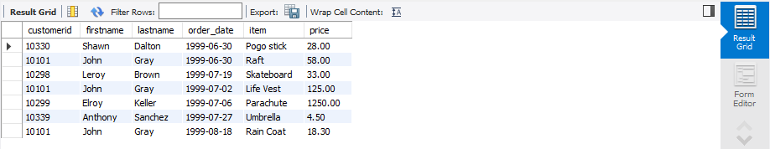

2.

select c.customerid,c.firstname,c.lastname,i.order_date,i.item,i.price,c.state from

customer123 as c join Items_ordered as i on(c.customerid=i.customerid) order by c.state desc ;

