Design and Performance Comparison Report on
Pipelined ALU vs Non-Pipelined ALU

By

SHUBHAM KUMAR SAH
(2341019010)

Bachelor of Technology
Electronics and Communication Engineering

Institute of Technical Education and Research

SIKSHA ‘O’ ANUSANDHAN
Bhubaneswar, Odisha

Abstract

An Arithmetic Logic Unit (ALU) is a fundamental building block in a digital electronics system which is responsible for performing arithmetic and logical operations. In a high-speed digital electronics system where performance is a critical factor and pipelining technique is commonly used to improve performance of ALU. This report presents the design, implementation and comparison of a non-pipelined ALU and a pipelined ALU using Verilog HDL (Hardware Descriptive Language). The design was synthesized and implemented to get Timing report, Utilization report and Power report for further comparison. The result show that the pipelining improves timing performance at the cost of additional hardware resources and latency.

Content

Sl. No. | Chapters | Page no.
1. | INTRODUCTION | 4
2. | METHODOLOGY | 4
3. | IMPLEMENTATION | 5
4. | SCHEMATIC | 5
5. | RESULTS AND ANALYSIS | 10
6. | CONCLUSION | 10
7. | REFERENCES

CHAPTER 1: INTRODUCTION
  - Arithmetic Logic Unit (ALU)

An Arithmetic Logic Unit (ALU) is a combinational digital circuit that performs arithmetic operations such as addition, subtraction, multiplication, division, and logical operations such as AND, OR, NAND, NOR, XOR, and XNOR. The ALU is a core component of microprocessors and microcontrollers.

  - Need for Performance Optimization

As clock frequencies increase, combinational logic delay becomes a limiting factor. Large combinational circuits result in timing violations and reduced maximum clock frequency. To overcome this, pipelining is introduced to divide long combinational paths into multiple stages.

  - Objective of the Project

- To design a non-pipelined ALU in Verilog
- To design a pipelined ALU in Verilog
- To compare timing, utilization and power performance
- To analyse advantages and disadvantages

CHAPTER 2: METHODOLOGY
2.1 Non-Pipelined ALU Design
The non-pipelined ALU is designed as a single-stage combinational block. Inputs are directly processed, and the result is produced in one clock cycle. This design has minimum hardware components but suffers from long combinational delays.
2.1.1 Architecture
- Inputs: A, B, Control signal
- Operators: Addition, Subtraction, Multiplication, Division, AND, OR, NAND, NOR, XOR, XNOR
- Output: Result

2.2 Pipelined ALU Design
The non-pipelined ALU is designed as a single-stage combinational block. Inputs are directly processed, and the result is produced in one clock cycle. This design has minimal hardware overhead but suffers from long combinational delays.
2.2.1 Pipeline Stages
- Stage 1: Input Registering
- Stage 2: Operation Execution
- Stage 3: Output Registering
Pipelining increases throughout because multiple operations can be performed simultaneously in different stages.

CHAPTER 3: IMPLEMENTATION
3.1 Design Tools
- Language: Verilog
- Synthesis and Implementation: Xilinx Vivado
- Target Platform: FPGA (Field Programmable Gate Array)
3.2 Verilog Implementation
Both pipelined and non-pipelined ALU design were coded in Verilog. Testbenches were created to verify functionality using simulation.
3.3 Constraints
Clock constraints were applied using XDC files to define clock period and timing representations. For fair comparison, the same clock constraints were used for both designs.

CHAPTER 4: SCHEMATIC
4.1 Synthesis Schematic Diagram
Fig. 1: Schematic Diagram after Synthesis
4.1 Synthesis Schematic Diagram
Fig. 2: Schematic Diagram after Synthesis
CHAPTER 5: RESULTS AND ANALYSIS
5.1 Timing Analysis
Timing reports were generated after synthesis and implementation.
5.1.1 Non-Pipelined ALU Timing Summary
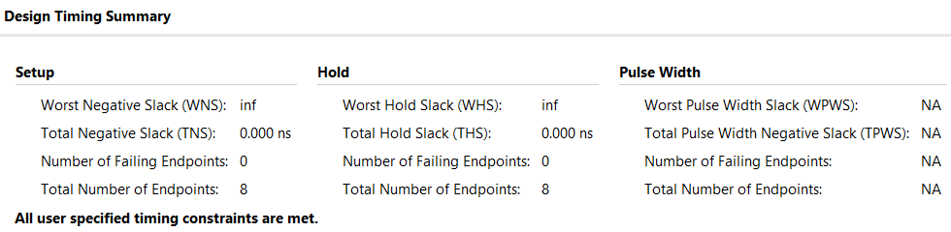
Fig. 3: Timing Summary after Synthesis
- It indicated that the design could not meet the specified clock frequency due to large number of combinational delays.
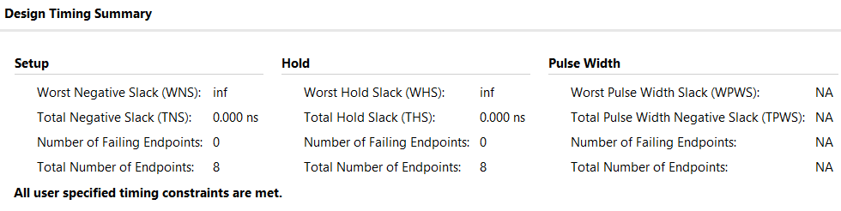
Fig. 4: Timing Summary after Implementation

5.1.2 Pipelined ALU Timing Summary
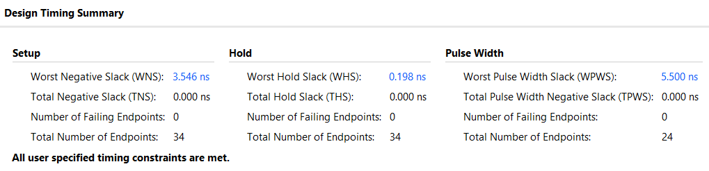
Fig. 5: Timing Summary after Synthesis
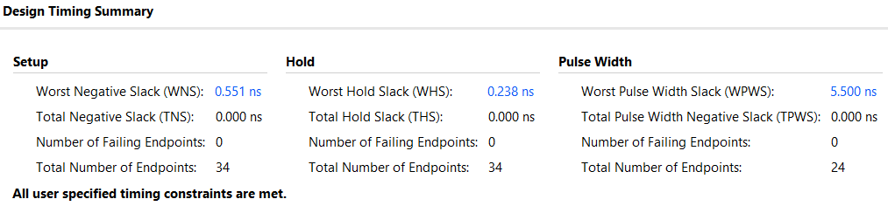
Fig. 6: Timing Summary after Implementation
- This shows that the pipelined ALU successfully meets timing constraints.

5.2 Power Analysis
Power estimation reports were generated using Vivado.
5.2.1 Non-Pipelined ALU Power
- High power dynamics due to large number of combinational switches.
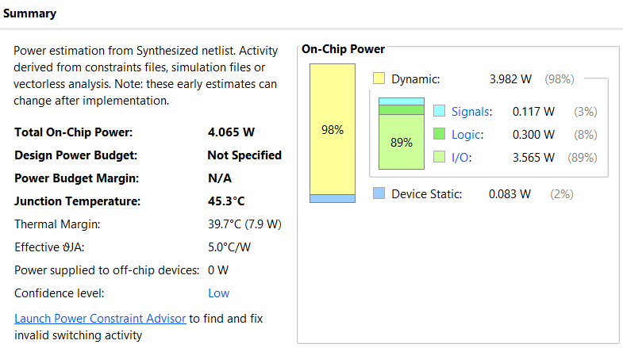
Fig. 7: Power Summary after Synthesis
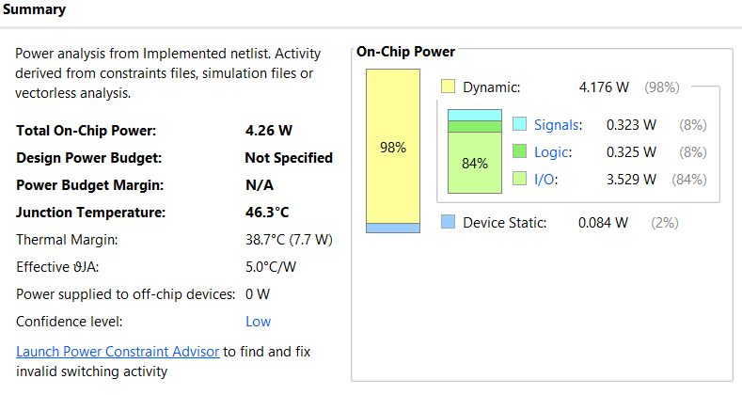
Fig. 8: Power Summary after Implementation

5.2.2 Pipelined ALU Power
- Slightly higher static power due to additional registers
- Reduced dynamic power per stage
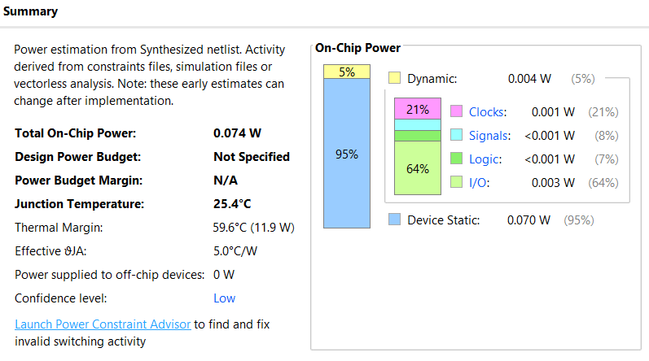
Fig. 9: Power Summary after Synthesis

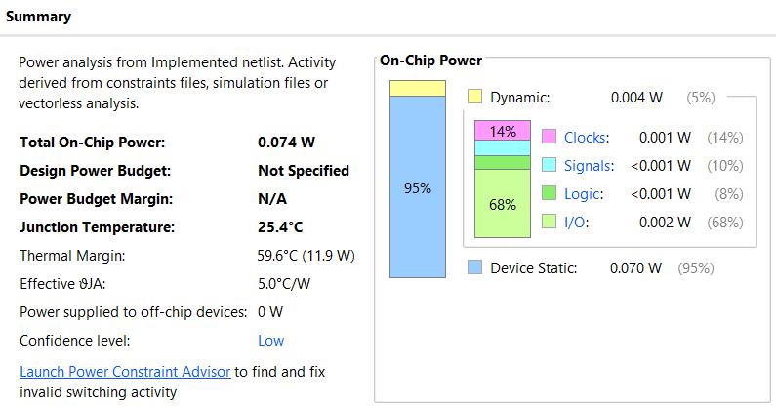
Fig. 10: Power Summary after Implementation

5.3 Resource Utilization
Pipelined ALU uses more flip-flops and registers in comparison to non-pipelined ALU. However, LUT uses may remain similar depending on operation.
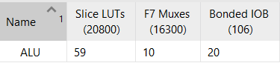
Fig. 11: Resource Utilization Summary after Synthesis for Non-Pipelined ALU

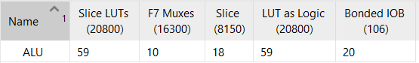
Fig. 12: Resource Utilization Summary after Implementation for Non-Pipelined ALU

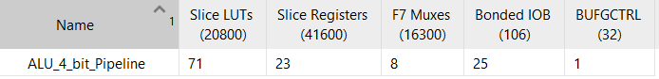
Fig. 13: Resource Utilization Summary after Synthesis for Pipelined ALU
Fig. 14: Resource Utilization Summary after Implementation for Pipelined ALU

CHAPTER 6: CONCLUSION
This project demonstrated the design and comparison of pipelined and non-pipelined ALU architectures. The results show that pipelining is an effective technique for improving clock frequency and throughput. The non-pipelined ALU is simpler and consumes fewer resources but fails to meet high-speed timing constraints. Future work can include multi-stage pipelining.

CHAPTER 7: REFERENCES
- Carl Hamacher, Zvonko Vranesic, Safwat Zaky, Naraig Manjikian, Computer Organization and Embedded Systems
- Xilinx Vivado User Guide

