TECHNICAL SPECIFICATIONS DOCUMENT

CRUD OPERATION ON TABLE

Undertaken at
Location Guru Solutions


Created By Under Guidance Of
Shubham Sapate Mr.Mayur Mate

Content

1.Introduction
2.Software Requirment Specification
3.Snapshot
4.Functionality
5.Coding
6.References

1. INTRODUCTION

If you’ve ever worked with a database, you’ve likely worked with CRUD operations. CRUD operations are often used with SQL.Since SQL is pretty prominent in the development community, it’s crucial for developers to understand how CRUD operations work.

The Definition of CRUD
Within computer programming, the acronym CRUD stands for create, read, update and delete. These are the four basic functions of persistent storage. Also, each letter in the acronym can refer to all functions executed in relational database applications and mapped to a standard HTTP method, SQL statement or DDS operation.
It can also describe user-interface conventions that allow viewing, searching and modifying information through computer-based forms and reports. In essence, entities are read, created, updated and deleted. Those same entities can be modified by taking the data from a service and changing the setting properties before sending the data back to the service for an update. Plus, CRUD is data-oriented and the standardized use of HTTP action verbs.

2. SOFTWARE REQUIREMENT SPECIFICATION

“Software Requirment Specification for performing CRUD operation”

1.Interfaces :

Software interface: vscode editor,CROME browser

Programming Language: HTML,CSS,JAVASCRIPT

2.Product Functions:
•
It manages basic Task Perform on Database i.e

CREATE
READ
UPDATE
DELETE

3. Scope:

•Use to Manupulate date In Database.Easy to perform Database Operations

3. SNAPSHOT

Snapshot of Application:

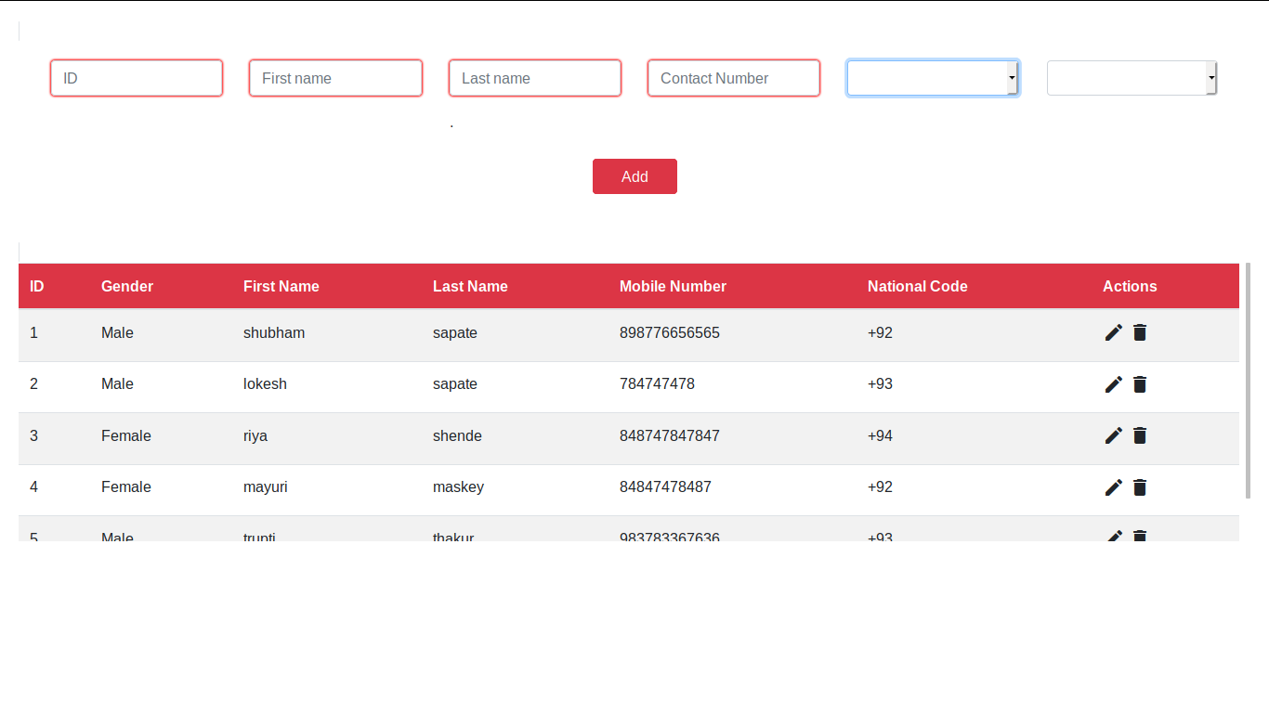

4. FUNCTIONALITY

In the Given Application, we can store data in local storage of browser.
User Enters the data and on click of ADD button we store data in the form of table by using CRUD operation

Any user can create,read,update and delete the data in tables.

To add data in the table user needs to fill all the fields.
Once user click add button, data will atomatically frames in the form of table by using crude operation.

For designing user-interface we use html,css and bootstrap.
For performing crud operation we use javascript.

Functionality vise this application can store the data in temporary manner and he can perform all the crud operation over it.

5. CODING

html code:

<!DOCTYPE html>
<html>

<head>
<meta charset="utf-8">
<meta name="viewport" content="width=device-width, initial-scale=1, shrink-to-fit=no">
<title>user detail</title>

<!-- Bootstrap core CSS -->
<link href="css/bootstrap.min.css" rel="stylesheet">
<link href="css/style.css" rel="stylesheet">
<link rel="stylesheet" href="https://fonts.googleapis.com/icon?family=Material+Icons">
</head>

<body>

<!-- form start -->

<form onsubmit="event.preventDefault();onFormSubmit();" autocomplete="off">
<span class="border rounded">

<div class="row">
<div class="col-md-2">

<input type="text" class="form-control" placeholder="ID" id="idinp" required>
<label class="validation-error hide" id="fullNameValidationError"><p class="text-danger" maxlength="20"></p></label>

</div>

<div class="col-md-2">

<input type="text" class="form-control" placeholder="First name" id="fname" required>
<label class="validation-error hide" id="fullNameValidationError"><p class="text-danger" maxlength="20"></p></label>

</div>
<div class="col-md-2">
<input type="text" class="form-control" placeholder="Last name" id="lname" required>
<label class="validation-error hide" id="fullNameValidationError"><p class="text-danger" maxlength="20"></p>.</label>

</div>
<div class="col-md-2">
<input type="text" class="form-control" placeholder="Contact Number" id="cnumber" maxlength="12" required>
<label class="validation-error hide" id="fullNameValidationError"><p class="text-danger"></p></label>
</div>
<div class="col-md-2">

<select id="genderinp" class="form-control" placeholder="Select Gender">
<option disabled selected>Select Gender</option>
<option selected>Male</option>
<option>Female</option>
<option>other</option>
</select>
<!--
<input type="text" class="form-control" placeholder="Gender" id="genderinp" required>
<label class="validation-error hide" id="fullNameValidationError"><p class="text-danger" maxlength="20" ></p></label> -->

</div>
<div class="col-md-2">

<select id="ncode" class="form-control">
<option disabled selected>National Code</option>
<option>+92</option>
<option>+93</option>
<option>+94</option>
</select>

<!-- <input type="text" class="form-control" placeholder="National Code" id="ncode" required> -->
</div>

</div>
<!-- button -->
<div class="row justify-content-center">

<button type="submit" class="btn btn-danger " style="margin-bottom: 30px;padding-left: 30px;padding-right: 30px">Add</button>

</div>
</span>
<div class="table-responsive">
<td>
<table class="table table-striped" id="userList">
<thead class="bg-danger text-white">
<tr>
<th scope="col">ID</th>
<th scope="col">Gender</th>
<th scope="col">First Name</th>
<th scope="col">Last Name</th>
<th scope="col">Mobile Number</th>
<th scope="col">National Code</th>
<th scope="col">Actions</th>
</tr>
</thead>
<tbody style="overflow-y: scroll">
</tbody>
</table>

</form>

</div>

<script src="https://code.jquery.com/jquery-3.3.1.js" crossorigin="anonymous"></script>
<script src="js/bootstrap.min.js"></script>
<script src="js/main.js"></script>
<!-- <script src="js/pagination.js"></script> -->
</body>

</html>

CSS Code:

.row {
margin: 20px;
}

form {
margin: 20px;
}

.table-responsive {
max-height: 300px;
}

Javascript Code:

var selectedRow = null

function onFormSubmit() {
if (validate()) {
var formData = readFormData();
if (selectedRow == null)
insertNewRecord(formData);
else
updateRecord(formData);
resetForm();
}
}

function readFormData() {
var formData = {};
formData["idinp"] = document.getElementById('idinp').value;
formData["genderinp"] = document.getElementById('genderinp').value;
formData["fname"] = document.getElementById('fname').value;
formData["lname"] = document.getElementById('lname').value;
formData["cnumber"] = document.getElementById('cnumber').value;
formData["ncode"] = document.getElementById('ncode').value;
return formData;

}

function insertNewRecord(data) {
var table = document.getElementById('userList').getElementsByTagName('tbody')[0];
var newRow = table.insertRow(table.length);
cell1 = newRow.insertCell(0);
cell1.innerHTML = data.idinp;
cell2 = newRow.insertCell(1);
cell2.innerHTML = data.genderinp;
cell3 = newRow.insertCell(2);
cell3.innerHTML = data.fname;
cell4 = newRow.insertCell(3);
cell4.innerHTML = data.lname;
cell5 = newRow.insertCell(4);
cell5.innerHTML = data.cnumber;
cell6 = newRow.insertCell(5);
cell6.innerHTML = data.ncode;
cell7 = newRow.insertCell(6);
cell7.innerHTML = `<a onClick="onEdit(this)"><i class="material-icons">edit</i></a>
<a onClick="onDelete(this)"><i class="material-icons">delete</i></a>`;

}

function resetForm() {
document.getElementById("fname").value = "";
document.getElementById("lname").value = "";
document.getElementById("cnumber").value = "";
document.getElementById("genderinp").value = "";
document.getElementById("idinp").value = "";
document.getElementById("ncode").value = "";
selectedRow = null;

}

function onEdit(td) {
selectedRow = td.parentElement.parentElement;
document.getElementById("idinp").value = selectedRow.cells[0].innerHTML;
document.getElementById("genderinp").value = selectedRow.cells[1].innerHTML;
document.getElementById("fname").value = selectedRow.cells[2].innerHTML;
document.getElementById("lname").value = selectedRow.cells[3].innerHTML;
document.getElementById("cnumber").value = selectedRow.cells[4].innerHTML;
document.getElementById("ncode").value = selectedRow.cells[5].innerHTML;

}

function updateRecord(formData) {
selectedRow.cells[0].innerHTML = formData.idinp;
selectedRow.cells[1].innerHTML = formData.genderinp;
selectedRow.cells[2].innerHTML = formData.fname;
selectedRow.cells[3].innerHTML = formData.lname;
selectedRow.cells[4].innerHTML = formData.cnumber;
selectedRow.cells[5].innerHTML = formData.ncode;
}

function onDelete(td) {
if (confirm('Are you sure to delete this record ?')) {
row = td.parentElement.parentElement;
document.getElementById("userList").deleteRow(row.rowIndex);
resetForm();
}
}

function validate() {
isValid = true;
if (document.getElementById("fname", "cnumber", "lname", "ncode").value == "") {
isValid = false;
document.getElementById("fullNameValidationError").classList.remove("hide");
} else {
isValid = true;
if (!document.getElementById("fullNameValidationError").classList.contains("hide"))
document.getElementById("fullNameValidationError").classList.add("hide");
}
return isValid;
}

var Cnum = document.querySelector('#cnumber');

Cnum.addEventListener('input', restrictNumber);

function restrictNumber(e) {
var newValue = this.value.replace(new RegExp(/[^\d]/, 'ig'), "");
this.value = newValue;
}
var IDinp = document.querySelector('#idinp');

IDinp.addEventListener('input', restrictNumber);

function restrictNumber(e) {
var newValue = this.value.replace(new RegExp(/[^\d]/, 'ig'), "");
this.value = newValue;
}

paginator({
table: document.getElementById("userList").getElementsByTagName("table")[0],
box: document.getElementById("box"),
});

crud operation code

1.Create function:

function insertNewRecord(data) {
var table = document.getElementById('userList').getElementsByTagName('tbody')[0];
var newRow = table.insertRow(table.length);
cell1 = newRow.insertCell(0);
cell1.innerHTML = data.idinp;
cell2 = newRow.insertCell(1);
cell2.innerHTML = data.genderinp;
cell3 = newRow.insertCell(2);
cell3.innerHTML = data.fname;
cell4 = newRow.insertCell(3);
cell4.innerHTML = data.lname;
cell5 = newRow.insertCell(4);
cell5.innerHTML = data.cnumber;
cell6 = newRow.insertCell(5);
cell6.innerHTML = data.ncode;
cell7 = newRow.insertCell(6);
cell7.innerHTML = `<a onClick="onEdit(this)"><i class="material-icons">edit</i></a>
<a onClick="onDelete(this)"><i class="material-icons">delete</i></a>`;

}

2.Read function:
function readFormData() {
var formData = {};
formData["idinp"] = document.getElementById('idinp').value;
formData["genderinp"] = document.getElementById('genderinp').value;
formData["fname"] = document.getElementById('fname').value;
formData["lname"] = document.getElementById('lname').value;
formData["cnumber"] = document.getElementById('cnumber').value;
formData["ncode"] = document.getElementById('ncode').value;
return formData;

}

3.Update Function:

function updateRecord(formData) {
selectedRow.cells[0].innerHTML = formData.idinp;
selectedRow.cells[1].innerHTML = formData.genderinp;
selectedRow.cells[2].innerHTML = formData.fname;
selectedRow.cells[3].innerHTML = formData.lname;
selectedRow.cells[4].innerHTML = formData.cnumber;
selectedRow.cells[5].innerHTML = formData.ncode;
}

4.Delete Function:

function onDelete(td) {
if (confirm('Are you sure to delete this record ?')) {
row = td.parentElement.parentElement;
document.getElementById("userList").deleteRow(row.rowIndex);
resetForm();
}
}

5.Edit Function:

function onEdit(td) {
selectedRow = td.parentElement.parentElement;
document.getElementById("idinp").value = selectedRow.cells[0].innerHTML;
document.getElementById("genderinp").value = selectedRow.cells[1].innerHTML;
document.getElementById("fname").value = selectedRow.cells[2].innerHTML;
document.getElementById("lname").value = selectedRow.cells[3].innerHTML;
document.getElementById("cnumber").value = selectedRow.cells[4].innerHTML;
document.getElementById("ncode").value = selectedRow.cells[5].innerHTML;

}

6.Validate Function:

function validate() {
isValid = true;
if (document.getElementById("fname", "cnumber", "lname", "ncode").value == "") {
isValid = false;
document.getElementById("fullNameValidationError").classList.remove("hide");
} else {
isValid = true;
if (!document.getElementById("fullNameValidationError").classList.contains("hide"))
document.getElementById("fullNameValidationError").classList.add("hide");
}
return isValid;
}

6.References

1. https://getbootstrap.com/

2. https://fonts.google.com/

3. https://stackoverflow.com/

4. https://www.w3schools.com/

5. https://stackify.com/what-are-crud-operations/

6. https://dribbble.com

Thank You.....

