**CHAPTER 1**

**INTRODUCTION**

* 1. **PROJECT DETAIL:**
     1. **DEFINITION:**

The definition of the project is Event Management System. This application leads for the handling and formation of the event and its schedule.

**1.1.2 PROJECT PROFILE:**

**Name of Project:** Event Database Management System

**Object Description:** The Application generally relates to a system and method to schedule events, and more particularly, to a system and method for scheduling technical events among entities such as organization.

**OS:** Windows

**Front End:** Php

**Back End:** MySQL Database

**Methodology:** Object Oriented Development

**Support Tools Used:** xampp

* 1. **PURPOSE:**

The purpose of making this application is to provide an easiness of finding the event schedule at one place. The user will find the technical event schedule in one application rather to visit different web pages. The invention satisfies the foregoing needs and avoids the drawbacks and limitations and frustrations of the prior art, and provides a better, more timely and effective process of communication to schedule and coordinate events by utilizing Internet-based application. The people may get fail to answer the call or would be unable to check the email so this Application will lead a better communication of the people about the event.

* 1. **PROJECT SCOPE:**

The scope of the project includes creating a user interface to Window system as well as a backend Event management is the application of management to the creation and development of technical festivals, events and conference. The Application generally relates to a system more particularly, to a system and method for scheduling technical events among entities such as organization that may have limitations for scheduling, such as geographical requirements, constraints by timing, conflicts, availability, or other factors. This Application leads to provide the user especially the student the reliability in finding the schedule of events at one place rather to go for each of the college websites. The college will just have to post the event in pdf file and that will be downloaded by students. By this Application the matter of time which go in informing each other for the event will also be solved out.

* 1. **OBJECTIVES:**

The people sending mail or message of technical event to other is wasting of time and memory. To overcome this problem our invention provides a medium where one can get the schedule of an event by just opening our application with the internet connection and refreshing it. Another thing our application provides is all in one characteristic. i.e., all technical event schedule in just one application.

**CHAPTER 2**

**SYSTEM REQUIREMENT SPECIFICATION**

A System Requirements Specification (SRS) (also known as Software Requirement Specification is a document or set of documentation that describes the features and behavior of a system or software application. It includes a variety of elements (see below) that attempts to define the intended functionality required by the customer to satisfy their different users.

In addition to specifying how the system should behave, the specification also defines at a high-level, the main business processes that will be supported, what simplifying assumptions have been made and what key performance parameters will need to be met by the system.

The hardware and software requirements of a computer system are required to install and use the software efficiency in the SRS. The minimum requirements need to be met for the program to run efficiently all the times on the system are as follows:

**2.1 SOFTWARE SPECIFICATION**

The software requirements are description of features and functionalities of the target system. Requirements convey the expectations of users from the software product. The requirements can be obvious or hidden, known or unknown, expected or unexpected from client’s point of view. The goal of requirement engineering is to develop and maintain sophisticated and descriptive ‘System Requirements Specification’ document.

The software requirements specify the pre-installed software needed to run the code being implemented in this project.

* Operating System: Windows 10, MacOS 10.15
* Backend Software: MySQL 8.0 command line client
* Frontend Software: Java APIs for graphics programming AWT (Abstract Windowing Toolkit) and Swing.

**2.2 HARDWARE REQUIREMENT**

Usage of CPU, RAM and storage space can vary significantly based on user behavior. These hardware recommendations are based on traditional deployments and may grow or shrink depending on how active users are. The hardware requirement specifies the necessary hardware which provides us the platform to implement our programs.

* Processor: Core i7 8750H.
* Processor Speed: 1.4 GHZ or above.
* RAM: 4 GB RAM or above.
* HARD DISK: 20 GB hard disk or above.

The hardware and software components of s computer system that are required to install and use software efficiently are specified in SRS. The minimum system requirements need to be met for the program to run all times on the system.

**2.3 INTRODUCTION:**

This Software Requirements Specification (SRS) document intended to give the complete overview of Event Database Management System (working tile), including the user interface and Event organization. The SRS document details all features upon which CTFEOA have currently decided with reference to the manner and importance of their implementation.

**Product Perspective**

This product and application is newer which provides the user a new utility in their role as a student. We give this application to the college so they can post their upcoming events in the database. The other person who will use this application will be student they will get the details of the upcoming technical events by just logging to the application and downloading the desired event details.

**Product Features**

**Functionality**

The invention satisfies the foregoing needs and avoids the drawbacks and limitations and frustration of the prior ant, and provides a better, more timely and effective process of communication to schedule and coordinate events by utilizing Internet-based application. This product contains three major Users. First the admin will allow the user for accessing this application by giving the permission rights and access control. Second The college login will can post their new schedule of a technical event as well. And third The End User i.e., Student, I they can see the list of the events and schedule of event.

**Other Non-Functional Requirements**

**Performance Requirements**

Better performance will lead to better operating environment. For better environment the user needs a high-speed internet so that the upload and download will be done better.

**Security Requirements**

The login details must be kept confidential so that other user may not login using other's id and password. Especially the college login details must be kept confidential so that other user may not post a fake event schedule.

**2.4 FEASIBILITY STUDY**

**Feasibility Analysis:**

A feasibility study is a short focused, which aims to answer a number of questions: Does the system contribute to the overall objective of the organization? Can the system be implemented using the current technology and within given cost and schedule constraints?

Can the system be integrated with system which is already in place?

**Economic Feasibility:**

The project is economically feasible as it only requires a mobile phone with Windows operating system.

The users should be able to connect to internet through mobile phone and this would be the only cost incurred on the project.

**Technical Feasibility:**

To develop this application, an internet connection, a database server, a web server and software are required.

**Behavioral Feasibility:**

The application is behaviorally feasible since it requires no technical guidance, all the modules are user friendly and execute in a manner they were designed to.

**CHAPTER 3**

**DESCRIPTION**

A database is a structured collection of data. Data refers to the characteristics of people things and events. A database management system gives the user access to their data and helps them transform the data into information. Such database management system includes dBase paradox, IMS, SQL server and MySQL. These systems allow users to create, update and extract information from their database. Different Tables are created for the various groups of information. Related tables are grouped together to form a database.

This project has been designed using MySQL as back end and Java graphics programming API’s as front end.

**3.1 My STRUCTURED QUERY LANGUAGE (MySQL)**

**MySQL** is an [open-source](https://en.wikipedia.org/wiki/Open-source_software) [relational database management system](https://en.wikipedia.org/wiki/Relational_database_management_system) (RDBMS). Its name is a combination of "My", the name of co-founder [Michael Widenius](https://en.wikipedia.org/wiki/Michael_Widenius)'s daughter, and "[SQL](https://en.wikipedia.org/wiki/SQL)", the abbreviation for [Structured Query Language](https://en.wikipedia.org/wiki/Structured_Query_Language). A [relational database](https://en.wikipedia.org/wiki/Relational_database) organizes data into one or more data tables in which data types may be related to each other; these relations help structure the data. SQL is a language programmers use to create, modify and extract data from the relational database, as well as control user access to the database. In addition to relational databases and SQL, an RDBMS like MySQL works with an [operating system](https://en.wikipedia.org/wiki/Operating_system) to implement a relational database in a computer's storage system, manages users, allows for network access and facilitates testing database integrity and creation of backups.

MySQL has stand-alone clients that allow users to interact directly with a MySQL database using SQL, but more often, MySQL is used with other programs to implement applications that need relational database capability. MySQL is a component of the [LAMP](https://en.wikipedia.org/wiki/LAMP_(software_bundle)) [web application](https://en.wikipedia.org/wiki/Web_application) [software stack](https://en.wikipedia.org/wiki/Software_stack) (and [others](https://en.wikipedia.org/wiki/List_of_AMP_packages)), which is an acronym for [*Linux*](https://en.wikipedia.org/wiki/Linux)*,*[*Apache*](https://en.wikipedia.org/wiki/Apache_HTTP_Server)*, MySQL,*[*Perl*](https://en.wikipedia.org/wiki/Perl)*/*[*PHP*](https://en.wikipedia.org/wiki/PHP)*/*[*Python*](https://en.wikipedia.org/wiki/Python_(programming_language)). MySQL is used by many database-driven web applications, including [Drupal](https://en.wikipedia.org/wiki/Drupal), [Joomla](https://en.wikipedia.org/wiki/Joomla), [phpBB](https://en.wikipedia.org/wiki/PhpBB), and [WordPress](https://en.wikipedia.org/wiki/WordPress). MySQL is also used by many popular [websites](https://en.wikipedia.org/wiki/Website), including [Facebook](https://en.wikipedia.org/wiki/Facebook), [Flickr](https://en.wikipedia.org/wiki/Flickr), [MediaWiki](https://en.wikipedia.org/wiki/MediaWiki), [Twitter](https://en.wikipedia.org/wiki/Twitter), and [YouTube](https://en.wikipedia.org/wiki/YouTube).

**3.2 MySQL 8.0 command line client**

MySQL command line client is a free version of the world's most capable relational database. With MySQL command line client, you use an intuitive, command-prompt based interface, to:

* Administer the database
* Create table, views, and other database object Import, export, and view table data
* Run queries and MySQL script.
* Generate reports

**3.3 ER DIAGRAM**

An entity-relationship model (ER model) is a data model for describing the data or information aspects of a business domain or its process requirements, in an abstract way that lends itself to ultimately being implemented in a database such as a relational database. The main components of ER models are entities (things) and the relationships that can exist among them. Entity-relationship modelling was developed by Peter Chen and published in a 1976 paper. The ER diagram is drawn to have a better understanding of the whole scenario, it is used to conceptualize the phenomena, actions and interactions between various entities and to arrive at the specific requirements in a comprehensive manner.

An entity-relationship model is the result of using a systematic process to describe and define a subject area of business data. The data is represented as components (entities) that are linked with each other by relationships that express the dependencies and requirements between them, such as: one building may be divided into zero or more apartments, but one apartment can only be located in one building. Entities may have various properties (attributes) that characterize them. Diagrams created to represent these entities, attributes, and relationships graphically are called entity relationship diagrams. An ER model is typically implemented as a database. In the case of a relational database, which stores data in tables, every row of each table represents one instance of an entity. Some data fields in these tables point to indexes in other tables, such pointers are the physical implementation of the relationship. The three-schema approach to software engineering uses three levels of ER models that may be developed.

A relationship captures how entities are related to one another. Relationships can be thought of as verbs, linking two or more nouns. Examples: An owns relationship between a company and a computer, a supervised relationship between an employee and a department, a performs relationship between an artist and a song relationship between a mathematician and a conjecture. Entities and relationships can both have attributes Examples: an employee entity might have a Social Security Number (SSN) attribute, the proved relationship may have a date attribute.

Entity-Relationship diagram is a detail & logical representation of entities and data elements for an organization. This technique is used in database that helps in an enterprise are related to each other. There are 3 types of E-R diagram:

**1. one to one:**

It is a one-to-one relationship is an association between 2 entities.

**2. one to many:**

One-to-many relationship exists when one entity related to one or more entity.

**3. Many to many:**

It describes entities that may have many relationships among each other. The basic symbols for E-R diagram are as described below:

This rectangle represents entity set.

This arrow is known as flow line. It links attributes to entity set &entity set to relationship.

This diamond represents relationship among entity set. The association among several entities in E-R diagram is known as Relationship.

This oval represents various types of data items that describes an entity are known as its attributes.



**3.4 RELATIONAL SCHEMA**

A database schema is the skeleton structure that represents the logical view of the entire database. It defines how the data is organized and how the relations among them are associated. It formulates all the constraints that are to be applied on the data.

A database schema defines its entities and the relationship among them. It contains a descriptive detail of the database, which can be depicted by means of schema diagrams. It's the database designers who design the schema to help programmers understand the database and make it useful.

A database schema can be divided broadly into two categories -

* **Physical Database Schema** - This schema pertains to the actual storage of data sand its form of storage like files, indices, etc. It defines how the data will be stored in a secondary storage.
* **Logical Database Schema** - This schema defines all the logical constraints that need to be applied on the data stored. It defines tables, views, and integrity constraints.

Database schema is the skeleton of database. It is designed when the database doesn't exist at all. Once the database is operational, it is very difficult to make any changes to it. A database schema does not contain any data that will be inserted in the database later.

**3.5 Entity :**

Basic object that the ER model represent in an entity, which is a thing in the real world with an independent existence. An entity may be an object with a physical existence (e.g. a company, a job or a universally course).

**3.6 Attribute :**

Each entity has attributes. It is a particular property that describes entity. For example, an employee entity maybe described by the employee’s name, age, address, salary and job. A particular entity will have a value for each of its attributes. The attribute value that describes each entity becomes a major part of the data stored in the database.

**Schema Diagram**

**EVENT**

|  |  |  |  |  |  |
| --- | --- | --- | --- | --- | --- |
| EVENT_ID | EVENT_NAME | EVENT_LOCATION | EVENT_DESCRIPTION | START_TIME | END_TIME |

**ORG**

|  |  |  |  |  |
| --- | --- | --- | --- | --- |
| ORG_ID | EVENT_ID | ORG_NAME | ORG_CONTACT | ORG_BRANCH |

**VOLUNTEER**

|  |  |  |  |
| --- | --- | --- | --- |
| VOLUNTEER_ID | ORG_ID | VOLUNTEER_NAME | VOLUNTEER_BRANCH |

**PARTICIPANT**

|  |  |  |  |  |
| --- | --- | --- | --- | --- |
| PARTICIPANT_ID | EVENT_ID | PARTICIPANT_NAME | PARTICIPANT_CONTACT | PARTICIPANT_BRANCH |

**WINNERS**

|  |  |  |
| --- | --- | --- |
| EVENT_ID | WINNER_NAME | WINNER_PRIZE |

**Figure 3.2: Relational Schema Model of Event Database Management System**

**CHAPTER 4**

**CODING**

**4.1 CREATION OF TABLE**

**EVENT**

create table event (

event_id int primary key,

event_name varchar2(25),

event_location varchar2(25),

event_description varchar2(25),

start_time varchar2(25),

end_time varchar2(25)

);

**ORG**

create table org

(

org_id int primary key,

org_name varchar2(25),

org_contact varchar2(25),

org_branch varchar2(24),

event_id references event

);

**VOLUNTEER**

create table volunteer (

volunteer_id int,

org_id references org,

volunteer_name varchar2(25),

volunteer_branch varchar2(25)

);

**PARTICIPANT**

Create table participant

(

participant_id int,

participant_name varchar2(30),

participant_contact varchar2(25),

participant_branch varchar2(50),

event_id references event

);

**WINNERS**

Create table winners(

winners_prize varchar2(25),

winners_name varchar2(225),

event_id references event

);

**4.2 INSERTION OF VALUES IN THE TABLE:**

**EVENT**

Insert into event values (1,’Fashion-show’, ‘Audi’, ‘Indian Outfit','9:00PM’, '10:00AM’);

Insert into event values (2, ‘Quiz’, ‘C102’, ‘Comics’,’9:00 AM’,’11:00 AM’);

Insert into event values (3, ‘Treasure Hunt’, ‘College campus’, ’Find the clues’,’9:00Am’,’12:00 PM’);

Insert into event values (4, ‘Singing’, ‘Audi’, ’band’, ‘5:00 PM’,’6:00 PM’);

Insert into event values (5, ‘Hackathon’, ‘D111’,’Creating web application’, ‘2:00 PM’,’4:00 PM’);

Insert into event values (6,’Break Code’, ‘D131’,’Crack Code Snippet’, ‘2:00 PM’,’9:00 PM’);

**ORG**

Insert into org values (101, ‘Kiran’,’2147483647’,’Computer science’, 1);

Insert into org values (102, ‘Nanda’, ‘9876543210’, ‘Electrical’, 2);

Insert into org values (103,’Sagar’, ‘6677552288’, ‘Computer science’,3);

Insert into org values (104, ‘Gagan’,’9871234560’, ‘Civil’,4);

Insert into org values (105, ‘Nisha’, ‘7711002233’, ‘Computer science’,5);

**VOLUNTEER**

Insert into volunteer values (201,101,’Kishore’, ‘Computer science’);

Insert into volunteer values (202,101,’Mansi', 'Information science');

Insert into volunteer values (203, 103, 'Sanjana', 'Information science');

Insert into volunteer values (204,103, 'Satish', 'Civil');

Insert into volunteer values (205,104,’Pavan','Electrical');

Insert into volunteer values (206,105, ‘Seema', 'Computer science');

Insert into volunteer values (207,105,'Sandesh', 'Mechanical');

**PARTICIPANT**

Insert into participant values (301, ‘Meghana','9987455210', 'CIVIL',1);

Insert into participant values (302, 'Sahana', 7896515673", Electronics', 1);

Insert into participant values (303,’Kushal', '789654276','Mechanical',2);

Insert into participant values (304,’Nikhil', '9988776655', 'Mechanical’ ,2);

Insert into participant values (305,’Nagesh', '8877665544',’Telecommunication', 2);

Insert into participant values (306, ‘Namitha', '6699448822', 'Civil’,3);

Insert into participant values (307,'Ramya', '6699440011','Computer science',3);

Insert into participant values (308,’Prashanth',’7755443300’,’Mechanical’ ,3);

Insert into participant values (309,'Smitha', '6633220099', ‘Computer science',3);

Insert into participant values (310,’Namratha', '7896541230’,’Computer science', 4); Insert into participant values (311,'Sandeep','8050909549','Mechanical, 4);

Insert into participant values (312,'Rajini','9035972152', 'Information science',5);

Insert into participant values (313, Rakesh', '8147370232', 'Electronics',5);

**WINNERS**

Insert into winners values (1,'Meghana', 1);

Insert into winners values (2, 'Nagesh', 1);

Insert into winners values (2, 'Nikhil',2);

Insert into winners values (2, 'Kushal',3);

Insert into winners values (3, ‘Namritha', 1);

Insert into winners values (3,'Prashanth', 2);

Insert into winners values (4,'Sandeep',1);

Insert into winners values (5, 'Rajini',1);

Insert into winners values (5,'Rakesh',2);

**CHAPTER 5**

**SNAPSHOTS**

**5.1 Back-end Snapshots**

select * from event;

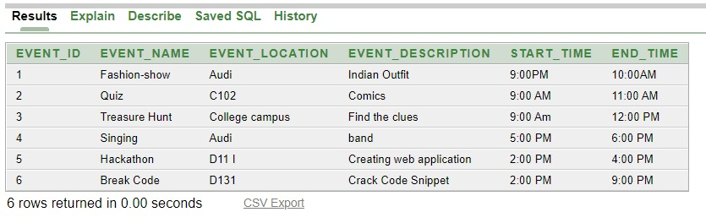

select * from org;

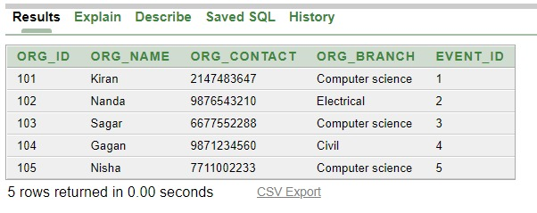

select * from volunteer;

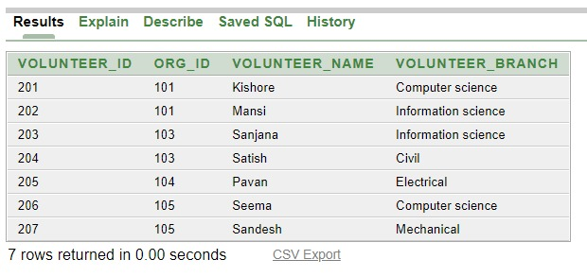

select * from winners;

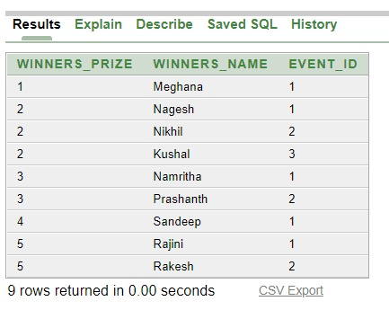

select * from participant;

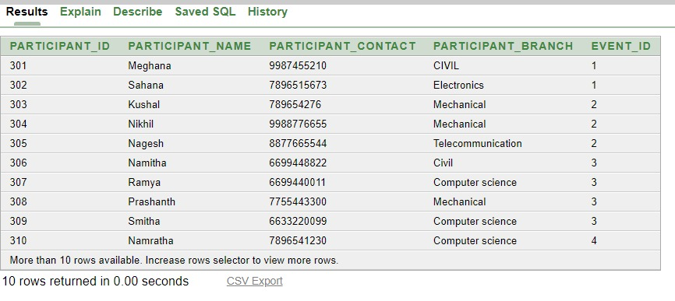

**5.2 Front-end Code**

<!DOCTYPE html>

<html lang="en">

<head>

<meta charset="UTF-8">

<meta name="viewport" content="width=device-width, initial-scale=1.0">

<link href="https://unpkg.com/tailwindcss@^2/dist/tailwind.min.css" rel="stylesheet">

<title>Event Management</title>

<body style="background-color:rgb(0, 0, 0);">

<style>

#hover:hover {

transition-duration: 1s;

transform: scale(1.07);

/* background-color: rgb(8, 8, 8); */

color: rgb(5, 5, 5);

}

#k1:hover {

transition-duration: 1.12s;

transform: scale(1.06);

/* background-color: rgb(175, 39, 39); */

color: rgb(5, 5, 5);

}

.body {

background-color: black;

}

@import url('https://fonts.googleapis.com/css?family=Roboto:300');

.aboutus {

text-align: right;

color: aliceblue;

font-family: 'Roboto';

font-weight: 300;

font-size: 50px;

padding-top: 0vh;

padding-left: 5ch;

height: 10vh;

overflow: hidden;

-webkit-backface-visibility: hidden;

-webkit-perspective: 1000;

-webkit-transform: translate3d(0, 0, 0);

}

.span1 {

size: larger;

size: 1000ch;

color: aliceblue;

}

.aboutus {

display: inline-block;

overflow: hidden;

white-space: nowrap;

size: 40px;

}

.aboutus:first-of-type {

animation: showup 4s infinite;

}

.aboutus:last-of-type {

width: 100px;

animation: reveal 4s infinite;

}

.aboutus:last-of-type span {

margin-left: -3500x;

animation: slidein 7s infinite;

}

.middle {

position: absolute;

top: 50%;

left: 50%;

transform: translate(-50%, -50%);

}

.btn {

position: relative;

display: block;

color: white;

font-size: 14px;

font-family: "montserrat";

text-decoration: none;

margin: 30px 100px;

border: 2px solid #ff7675;

padding: 14px 70px;

text-transform: uppercase;

overflow: hidden;

align-items: center;

transition: 1s all ease;

}

.btn::before {

background: #ff7675;

content: "";

position: absolute;

top: 50%;

left: 50%;

transform: translate(-50%, -50%);

z-index: -1;

transition: all 0.6s ease;

}

.btn1::before {

width: 0%;

height: 100%;

}

.btn1:hover::before {

width: 100%;

}

.form-control{

width: 200px;

background: transparent

border: 1px solid gray;

color: #fff;

font-size: 18px;

}

.button {

background-color: #4CAF50;

border: none;

color: white;

padding: 8px 4px;

text-align: center;

text-decoration: none;

display: inline-block;

font-size: 16px;

margin: 4px 2px;

cursor: pointer;

}

.container1 {

position: relative;

text-align: center;

color: black;

}

.bottom-left {

position: absolute;

bottom: 8px;

left: 16px;

}

.top-left {

position: absolute;

top: 8px;

left: 16px;

}

.top-right {

position: absolute;

top: 8px;

right: 16px;

}

.bottom-right {

position: absolute;

bottom: 8px;

right: 16px;

}

.centered {

position: absolute;

top: 30%;

left: 50%;

transform: translate(-50%, -50%);

font-size: 90px;

}

</style>

<div class="container">

<header class="text-gray-600 body-font">

<div class="container mx-auto flex flex-wrap p-5 flex-col md:flex-row items-center">

<a class="flex title-font font-medium items-center text-gray-900 mb-4 md:mb-0">

<svg xmlns="http://www.w3.org/2000/svg" fill="none" stroke="currentColor" stroke-linecap="round"

stroke-linejoin="round" stroke-width="2" class="w-10 h-10 text-white p-2 bg-indigo-500 rounded-full"

viewBox="0 0 24 24">

<path d="M12 2L2 7l10 5 10-5-10-5zM2 17l10 5 10-5M2 12l10 5 10-5"></path>

</svg>

<span style="color: blanchedalmond;" class="ml-3 text-xl">SaS Event Management</span>

</a>

<nav style="color: white;"

class="md:mr-auto md:ml-4 md:py-1 md:pl-4 md:border-l md:border-gray-400 flex flex-wrap items-center text-base justify-center">

<a href="#home" class="mr-5 hover:text-gray-300">Home</a>

<a href="#aboutus" class="mr-5 hover:text-gray-300">About Us</a>

<a href="registration.php" class="mr-5 hover:text-gray-300">Registration</a>

<a href="#events" class="mr-5 hover:text-gray-300">Events</a>

<a href="#information" class="mr-5 hover:text-gray-300">Information</a>

<a href="#contact" class="mr-5 hover:text-gray-300">Contact Us</a>

</nav>

<div class="container1">

<br/>

<img src="https://i.pinimg.com/originals/c1/35/8f/c1358f85ac108ec3fc702b969d291d30.jpg" alt="Trulli" width="2000" height="1000">

<div class="centered"><b>COLLEGE EVENTS</b></div>

</div>

</div>

</header>

<hr> <section id="home1" class="text-gray-600 body-font">

<div class="container mx-auto flex px-5 py-24 md:flex-row flex-col items-center">

<div style="color: white;"

class="lg:flex-grow md:w-1/2 lg:pr-24 md:pr-16 flex flex-col md:items-start md:text-left mb-16 md:mb-0 items-center text-center">

<h1 style="color: white; text-align: left; size: 100ch;" id="home"

class="title-font sm:text-3x2 text-3xl mb-4 font-medium text-gray-900">Life is an Event, Make it Memorable 🥰

<br class="hidden lg:inline-block">Our Bussiness is Making Memories

</h1>

<p class="mb-8 leading-relaxed sm:text-2x2 text-2xl ">An Event shouldn't be just an experimental thing, it should be an emotional thing.</p>

</div>

<div class="middle">

<!-- <div class="lg:max-w-lg lg:w-full md:w-1/2 w-5/6">

<img class="object-cover object-center rounded" alt="hero"

src="https://source.unsplash.com/720x600/?Event,Design">

</div> -->

</div>

<br>

<a href="" class="btn btn1">Join us ?</a>

</section>

</hr>

</div>

<hr>

<!-- component -->

<section class="text-blueGray-700 ">

<div class="container items-center px-5 py-8 mx-auto">

<div class="flex flex-col mb-12 text-left">

<div class="w-full mx-auto lg:w-1/3">

<div class="p-6">

<div style="text-align:left;" class="aboutus sm:text-6x2 text-5xl">About Us</div>

<div>

<p class="span1"> We not only organize extravagant event, we organize mesmerizing moments for you. Because events may be forgotten but moments will last a lifetime. We offers complete events planning and management solutions from theme events

</p>

</div>

</div>

</section>

</hr>

<hr>

<section id="events" class="text-gray-600 body-font">

<div class="container px-5 py-24 mx-auto">

<div class="flex flex-wrap w-full mb-20">

<div class="lg:w-1/2 w-full mb-6 lg:mb-0">

<h1 style="color: white;" class="sm:text-3xl text-2xl font-medium title-font mb-2 text-gray-900">Event Categories</h1>

<div class="h-1 w-20 bg-indigo-500 rounded"></div>

</div>

</div>

<div class="flex flex-wrap -m-4">

<div class="xl:w-1/4 md:w-1/2 p-4">

<div class="bg-gray-100 p-6 rounded-lg">

<img id="k1" class="h-40 rounded w-full object-cover object-center mb-6"

src="https://www.mandreel.com/wp-content/uploads/2019/01/event-organizer-in-jakarta-indonesia.jpg"

alt="content">

<h2 class="text-lg text-gray-900 font-medium title-font mb-4"><a href ="queryorg.php"> Organiser Details</a></h2>

</div>

</div>

<div class="xl:w-1/4 md:w-1/2 p-4">

<div class="bg-gray-100 p-6 rounded-lg">

<img id="k1" class="h-40 rounded w-full object-cover object-center mb-6"

src="https://cdn.raceroster.com/image_uploads/add9f4e425bfab4eaed2a92ef8627be2.jpg"

alt="content">

<h2 class="text-lg text-gray-900 font-medium title-font mb-4"><a href="queryvolunteer.php"> Volunteer Details </a></h2>

</div>

</div>

<div class="xl:w-1/4 md:w-1/2 p-4">

<div class="bg-gray-100 p-6 rounded-lg">

<img id="k1" class="h-40 rounded w-full object-cover object-center mb-6"

src="http://2.bp.blogspot.com/-WINdpmMSJAQ/T0zgPAVUuEI/AAAAAAAAAAM/jZ3t7hhjXvc/s1600/event+organizer.jpg" alt="content">

<h2 class="text-lg text-gray-900 font-medium title-font mb-4"><a href="queryevent.php">Event Details </a></h2>

</div>

</div>

<div class="xl:w-1/4 md:w-1/2 p-4">

<div class="bg-gray-100 p-6 rounded-lg">

<img id="k1" class="h-40 rounded w-full object-cover object-center mb-6" src="https://www.usertesting.com/sites/default/files/styles/opengraph_social_sharing/public/wp-uploads/participants_2-01.png?itok=BeqU1LnP" alt="content">

<h2 class="text-lg text-gray-900 font-medium title-font mb-4"><a href="queryparticipant.php">Participation Details</a></h2>

</div>

</div>

</div>

<div class="flex flex-wrap -m-4">

<div class="xl:w-1/4 md:w-1/2 p-4">

<div class="bg-gray-100 p-6 rounded-lg">

<img id="k1" class="h-40 rounded w-full object-cover object-center mb-6"

src="https://deow9bq0xqvbj.cloudfront.net/image-logo/2332469/winnerwinnerbanner.png"

alt="content">

<h2 class="text-lg text-gray-900 font-medium title-font mb-4"><a href="querywinner.php">Winner Details</a></h2>

</div>

</div>

</section>

<hr>

<section id="information" class="text-white-600 body-font relative">

<div class="container px-5 py-24 mx-auto">

<div class="flex flex-col text-center w-full mb-12">

<h1 style="font-size:300%" class="sm:text-3xl text-2xl font-medium title-font mb-4 text-gray-100">Information</h1>

</div>

<div class="container">

<div class="row">

<div class="col-sm">

<form action ="department.php" method ="post">

<h2 class="text-lg text-gray-100 font-medium title-font mb-4">Events BY Department</h2>

<input type = "text" name ="Departmentname" class="form-control"><br/>

<button type = "submit" class="button"> Submit </button>

</form>

</div>

<div class="container">

<div class="row">

<div class="col-sm">

<form action ="eventbytime.php" method ="post">

<h2 class="text-lg text-gray-100 font-medium title-font mb-4">Events BY Time</h2>

<input type = "text" name ="eventtime" class="form-control"><br/>

<button type = "submit" class="button"> Submit </button>

</form>

</div>

<form action ="locationevent.php" method ="post">

<h2 class="text-lg text-gray-100 font-medium title-font mb-4">EVENT LOCATION</h2>

<input type = "text" name ="eventlocation" class="form-control"><br/>

<button type = "submit" class="button"> Submit </button>

</form>

</section>

<hr>

<section id="contact" class="text-white-600 body-font relative">

<div class="container px-5 py-24 mx-auto">

<div class="flex flex-col text-center w-full mb-12">

<h1 style="font-size:300%" class="sm:text-3xl text-2xl font-medium title-font mb-4 text-gray-100">Contact Us</h1>

</div>

<div class="lg:w-1/2 md:w-2/3 mx-auto">

<div class="flex flex-wrap -m-2">

<div class="p-2 w-1/2">

<div class="relative">

<label style="color: white;" for="name" class="leading-7 text-sm text-gray-600 ">Name</label>

<input type="text" id="name" name="name"

class="w-full bg-gray-100 bg-opacity-50 rounded border border-gray-300 focus:border-indigo-500 focus:bg-white focus:ring-2 focus:ring-indigo-200 text-base outline-none text-gray-700 py-1 px-3 leading-8 transition-colors duration-200 ease-in-out"

required>

</div>

</div>

<div class="p-2 w-1/2">

<div class="relative">

<label style="color: white;" for="email" class="leading-7 text-sm text-gray-600">Email</label>

<input type="email" id="email" name="email"

class="w-full bg-gray-100 bg-opacity-50 rounded border border-gray-300 focus:border-indigo-500 focus:bg-white focus:ring-2 focus:ring-indigo-200 text-base outline-none text-gray-700 py-1 px-3 leading-8 transition-colors duration-200 ease-in-out" required>

</div>

</div>

<div class="p-2 w-full">

<div class="relative">

<label style="color: white;" for="message" class="leading-7 text-sm text-gray-600">Message</label>

<textarea id="message" name="message"

class="w-full bg-gray-100 bg-opacity-50 rounded border border-gray-300 focus:border-indigo-500 focus:bg-white focus:ring-2 focus:ring-indigo-200 h-32 text-base outline-none text-gray-700 py-1 px-3 resize-none leading-6 transition-colors duration-200 ease-in-out"></textarea>

</div>

</div>

<div class="p-2 w-full">

<button onclick="showAlert()"

class="flex mx-auto text-white bg-indigo-500 border-0 py-2 px-8 focus:outline-none hover:bg-indigo-600 rounded text-lg action:submit ">Submit</button>

</div>

<div class="p-2 w-full pt-8 mt-8 border-t border-gray-200 text-center">

<a href="asha:asha.cs@drait.edu.in">asha.cs@drait.edu.in</a>

<p class="leading-normal my-5">SaS Team Organiser

<br>Dr.AIT , Bangalore India

</p>

</div>

</section>

<div class="footer-2 bg-gray-800 pt-6 md:pt-12">

<div class="container px-4 mx-auto">

<div class="md:flex md:flex-wrap md:-mx-4 py-6 md:pb-12">

<div class="footer-info lg:w-1/3 md:px-4">

<h4 class="text-white text-2xl mb-4">The Project Handled by S3 Team</h4>

<p class="text-gray-400">Here is the public Website for Event Management 😍 </p>

<div class="mt-4">

</div>

</div>

<div class="md:w-2/3 lg:w-1/3 md:px-4 xl:pl-16 mt-12 lg:mt-0">

<div class="sm:flex">

<div class="sm:flex-1">

<h6 class="text-base font-medium text-white uppercase mb-2">About</h6>

<div>

<a href="#" class="text-gray-400 py-1 block hover:underline">Owner</a>

<a href="#" class="text-gray-400 py-1 block hover:underline">Events</a>

<a href="#" class="text-gray-400 py-1 block hover:underline">Our Team</a>

<a href="#" class="text-gray-400 py-1 block hover:underline">Opportunities</a>

</div>

</div>

<div class="sm:flex-1 mt-4 sm:mt-0">

<h6 class="text-base font-medium text-white uppercase mb-2">What we offer</h6>

<div>

<a href="#" class="text-gray-400 py-1 block hover:underline">Free Demo's</a>

<a href="#" class="text-gray-400 py-1 block hover:underline">Virtual Free Demo</a>

<a href="#" class="text-gray-400 py-1 block hover:underline">Events</a>

<a href="#" class="text-gray-400 py-1 block hover:underline">Internships</a>

<a href="#" class="text-gray-400 py-1 block hover:underline">Freebies</a>

</div>

</div>

</div>

<div class="border-t border-solid border-gray-900 mt-4 py-4">

<div class="container px-4 mx-auto">

<div class="md:flex md:-mx-4 md:items-center">

<div class="md:flex-1 md:px-4 text-center md:text-left">

<p class="text-white">&copy; <strong>FWR</strong></p>

</div>

<div class="md:flex-1 md:px-4 text-center md:text-right">

<a href="#" class="py-2 px-4 text-white inline-block hover:underline">Terms of Service</a>

<a href="#" class="py-2 px-4 text-white inline-block hover:underline">Privacy Policy</a>

</div>

</div>

<script>

function showAlert() {

alert("Thank you for reaching us !");

}const spans = document.querySelectorAll('.word span');

spans.forEach((span, idx) => {

span.addEventListener('click', (e) => {

e.target.classList.add('active');

});

span.addEventListener('animationend', (e) =>

{

e.target.classList.remove('active');}

);

// Initial animation

setTimeout(() => {

span.classList.add('active');

}, 750 * (idx + 1))

});

</script>

</body>

</html>

**5.3 Front-end Snapshots**

**ADMIN LOG-IN PAGE**

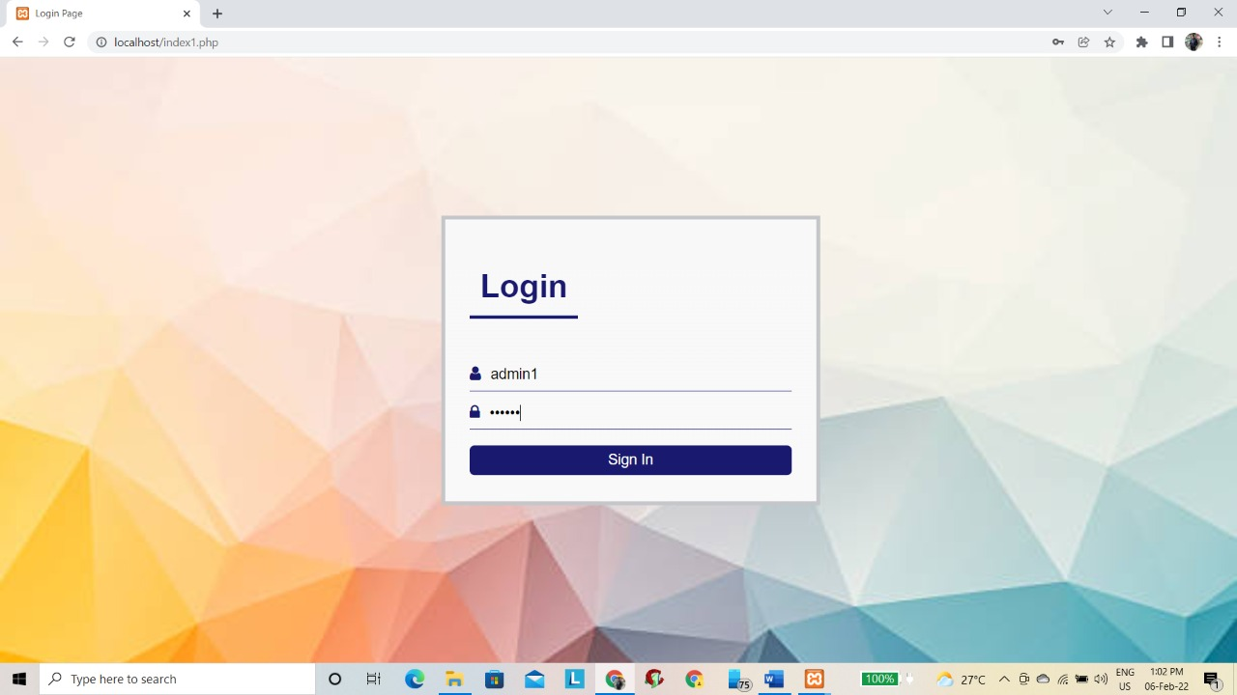Fig:5.1 Admin login page of the website “Event Management”

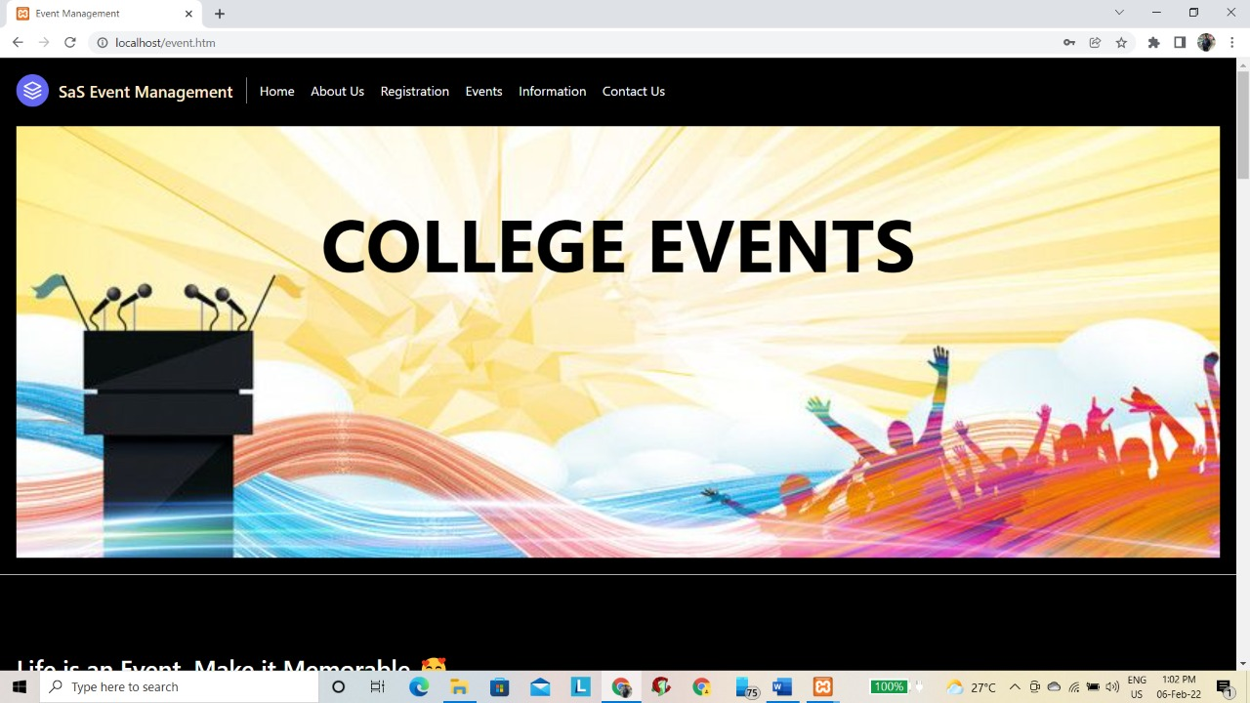

Fig:5.2 Home page of the website “Event Management”

**REGISTRATION FORM**

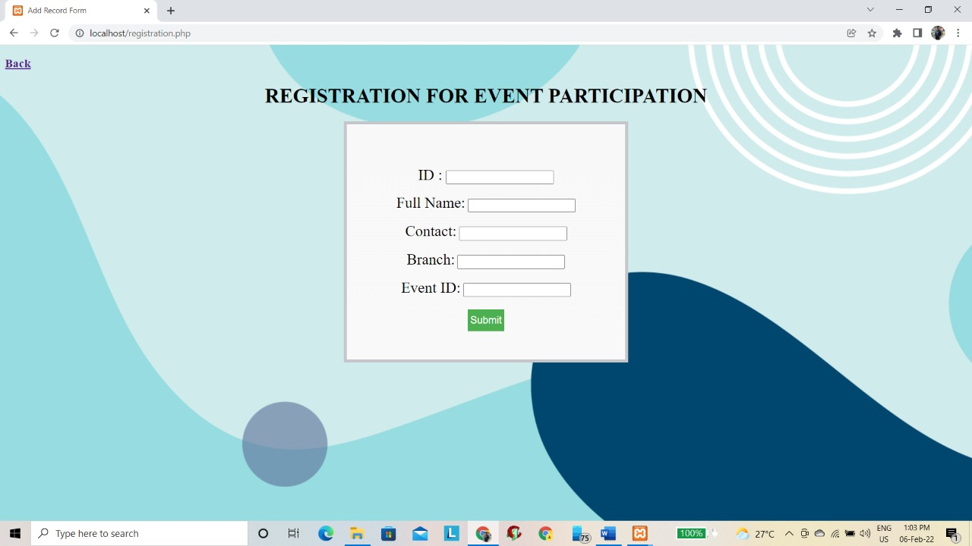

Figure : 5.3 Registration of the website “Event Management”

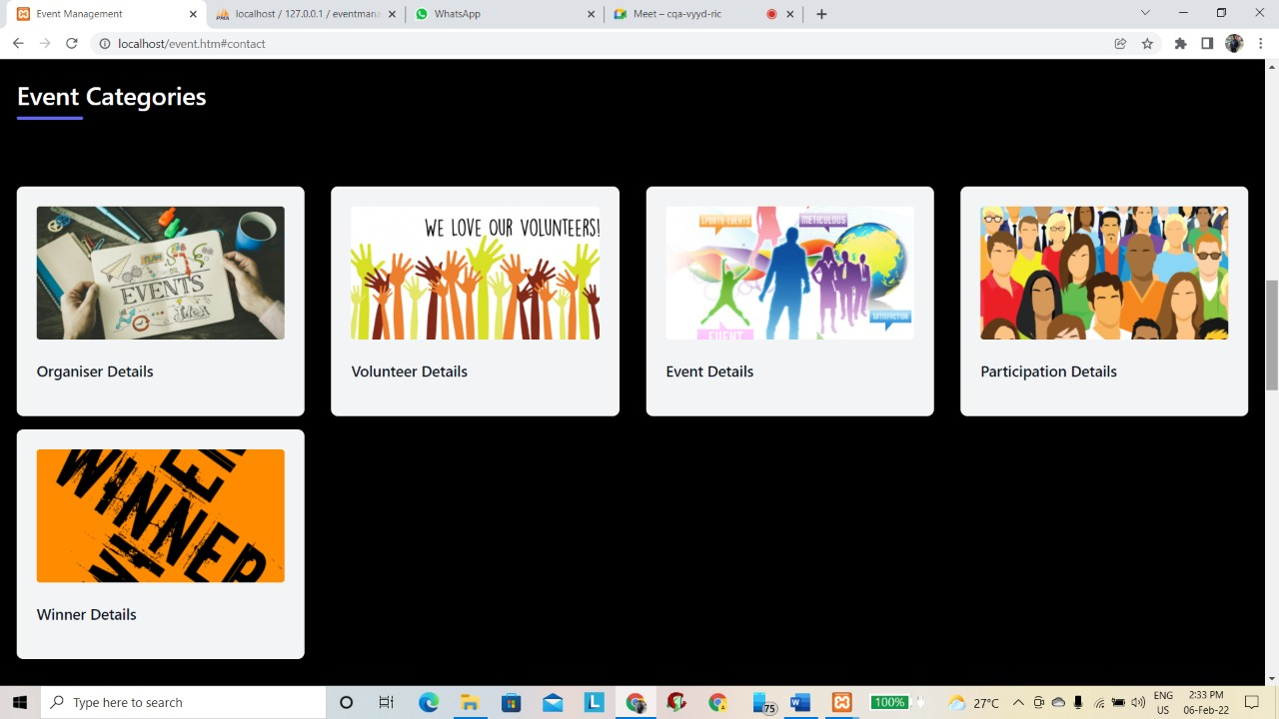

Figure : 5.4 Event categories details of the website “Event Management”

**EVENT DETAILS**

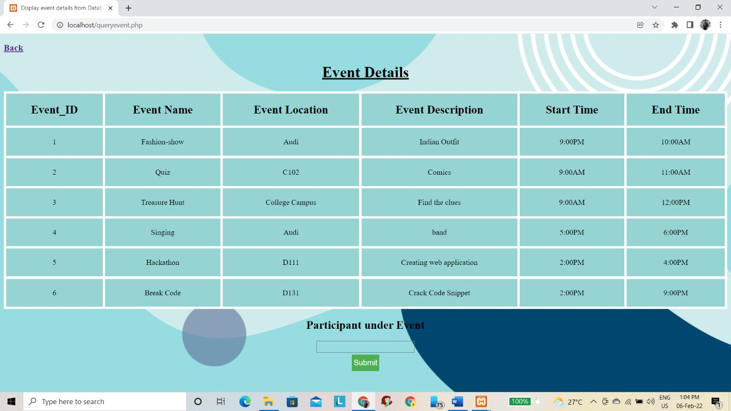

Figure : 5.5 Event details of the website “Event Management”

**ORGANISER DETAILS**

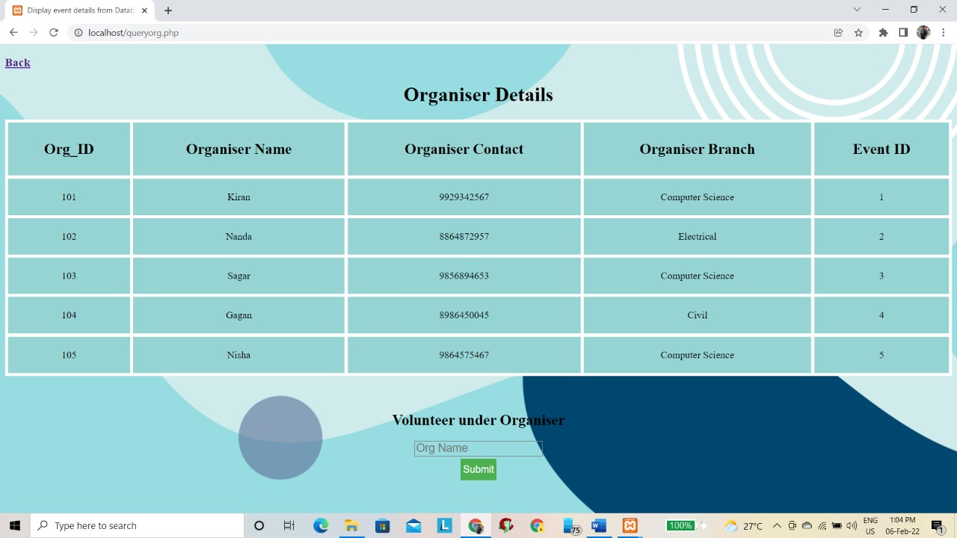

Figure : 5.6 Organiser details of the website “Event Management”

**VOLUNTEER DETAILS**

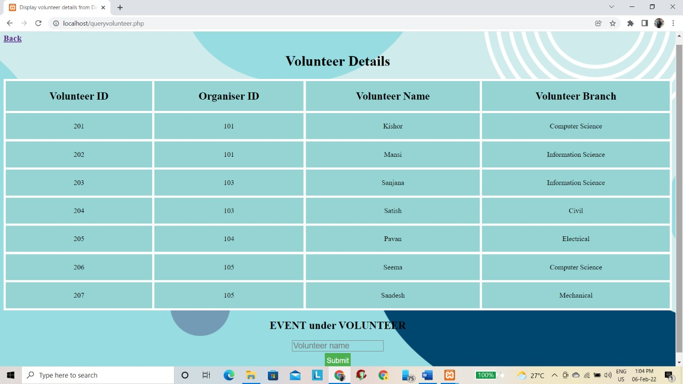

Figure : 5.7 Volunteer details of the website “Event Management”

**PARTICIPANT DETAILS**

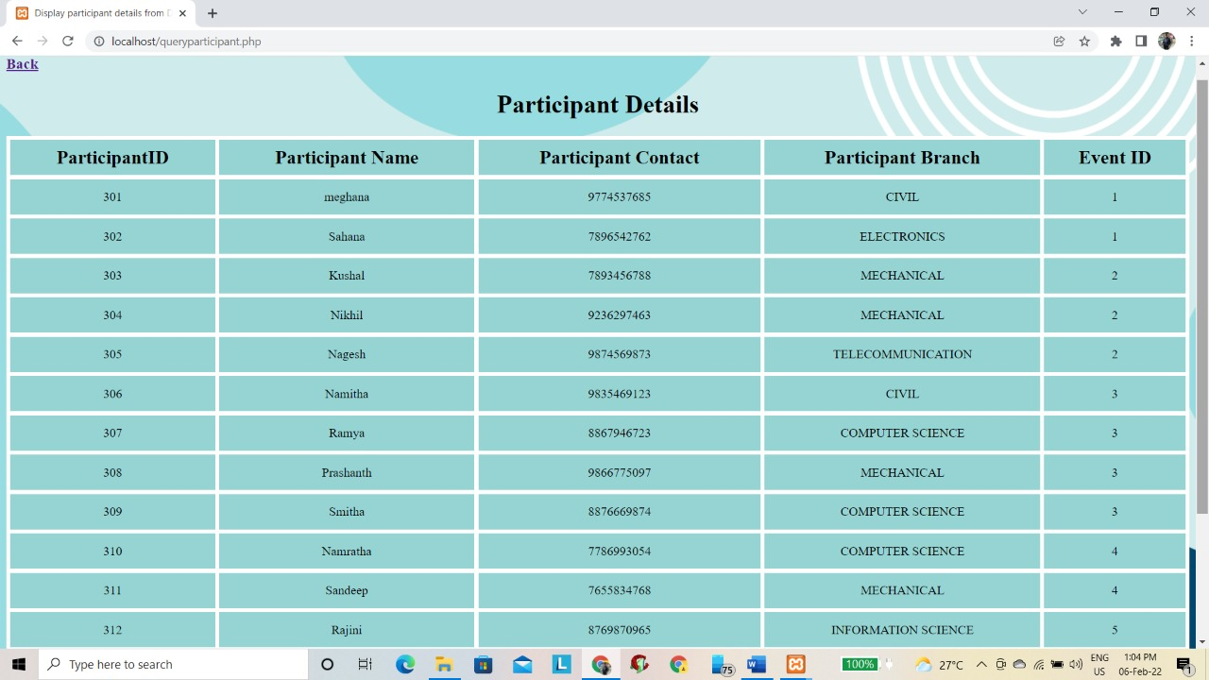

Figure : 5.8 Participant details of the website “Event Management”

**WINNERS DETAIL**

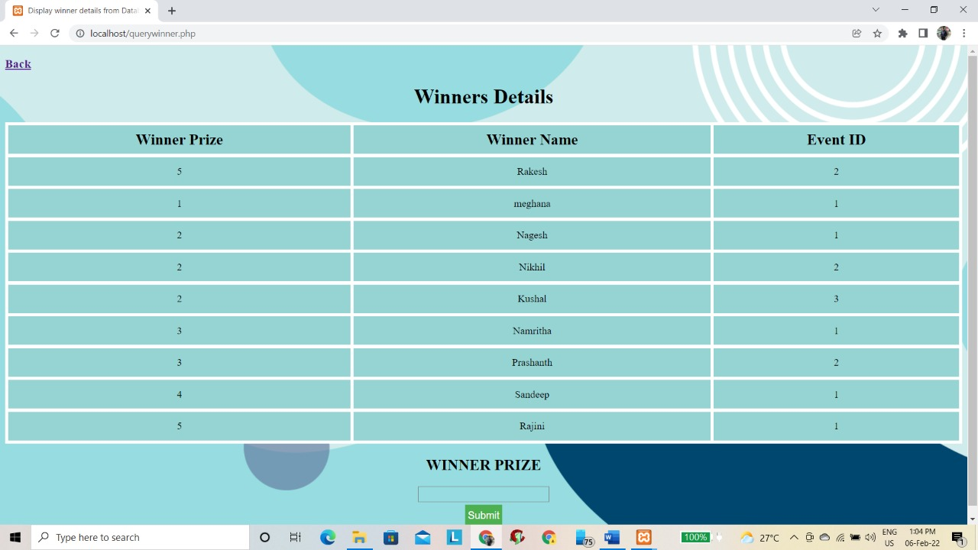

Figure : 5.9 Winners details of the website “Event Management”

**5.4 SQL QUERIES**

1. List all the events organized by various departments.

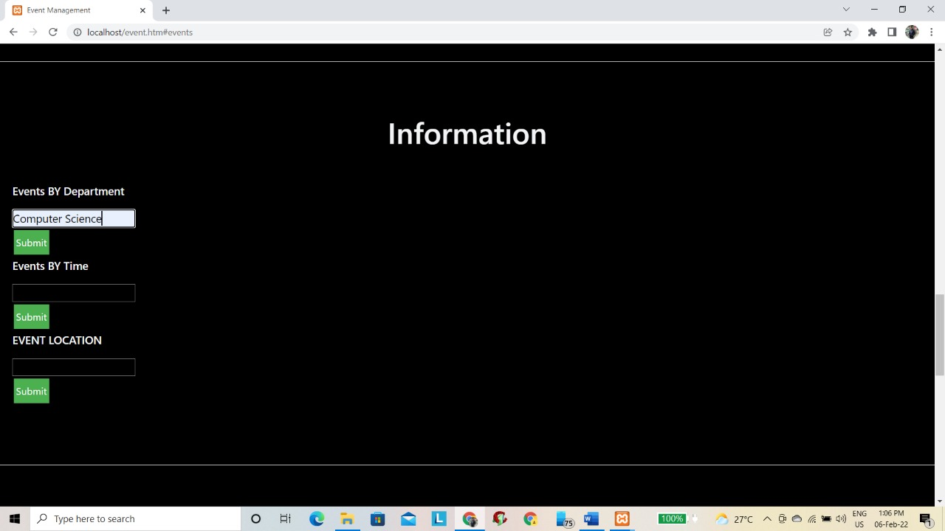

**Output**

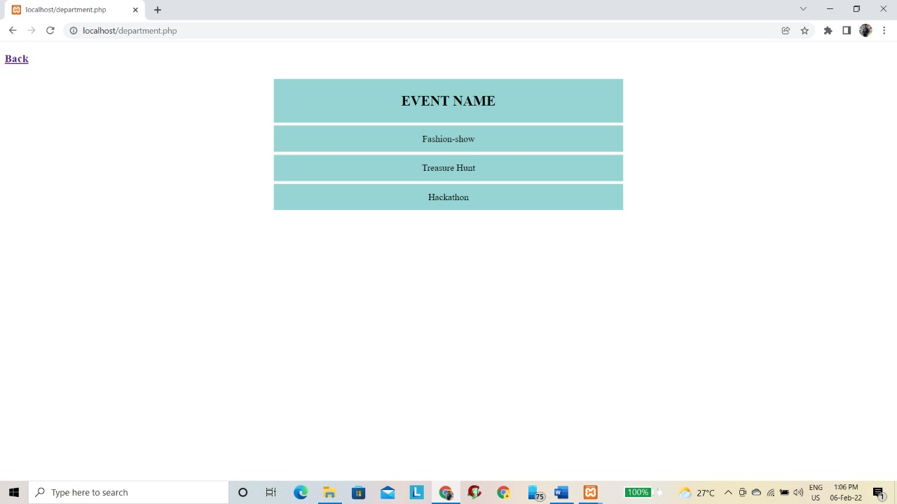

1. List the events and their occurrence time

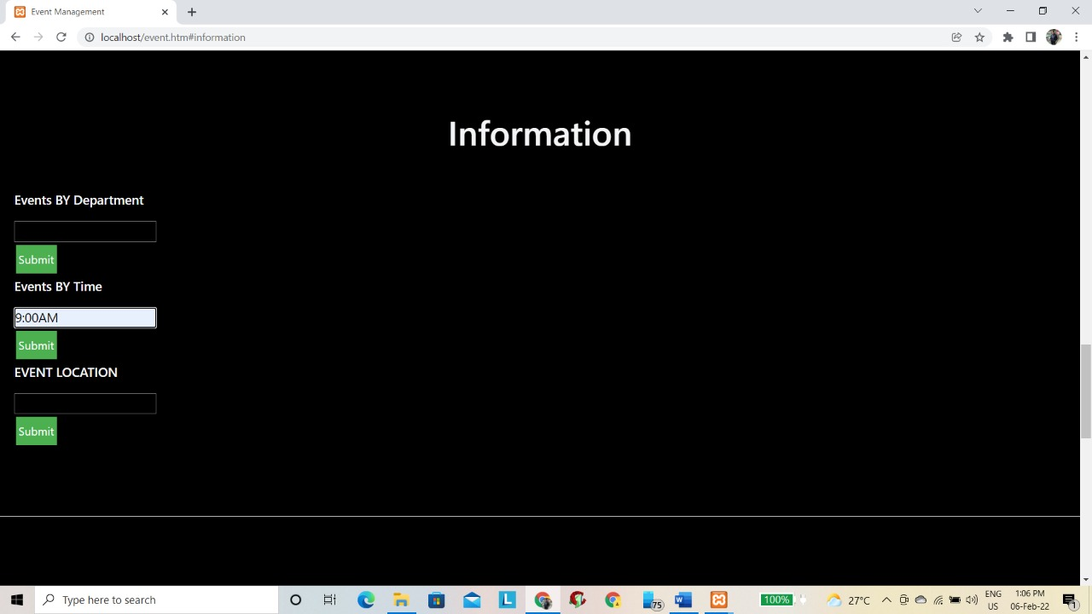

**Output:**

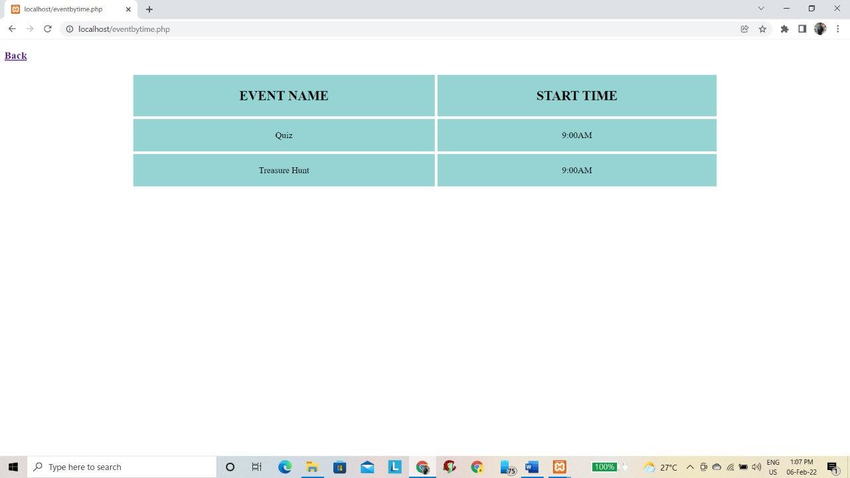

1. List of events occurring at the location.

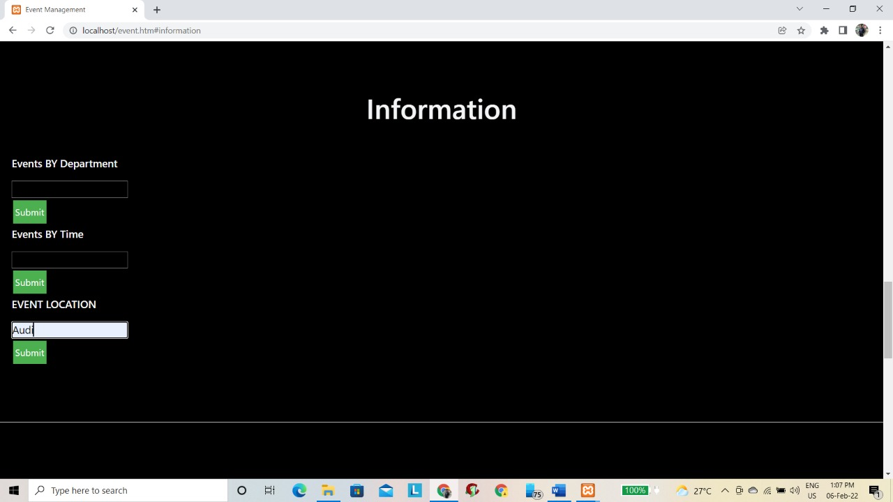

**Output:**

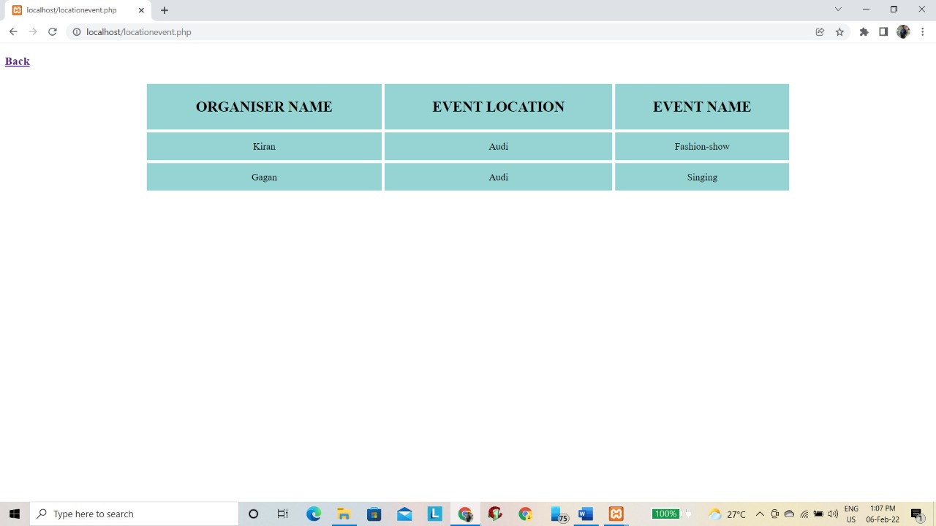

**5.5 Back-end Table Screenshots**

**Volunteer Table:**

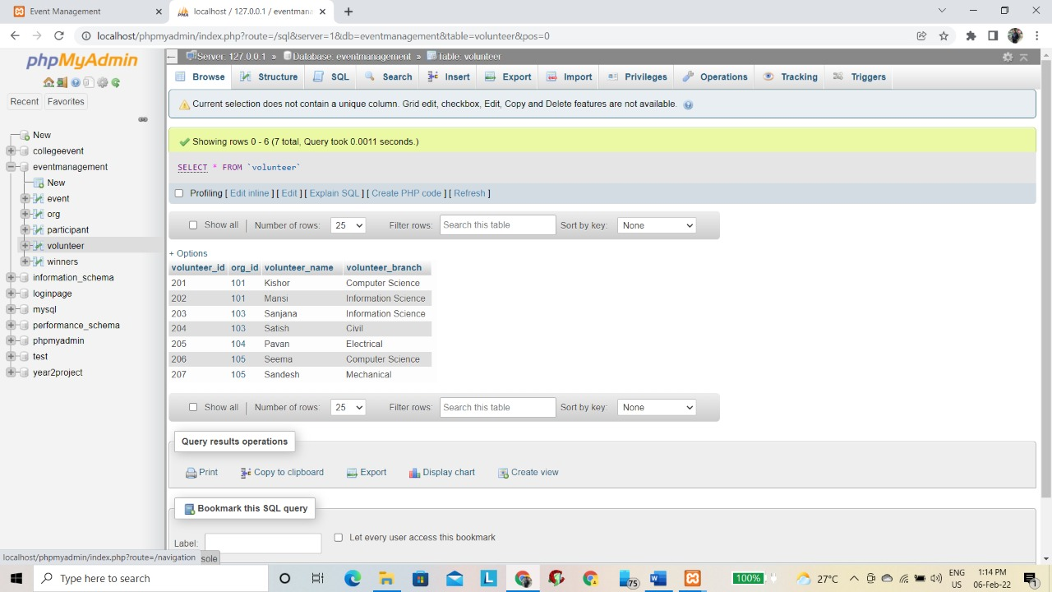

**Participant Table:**

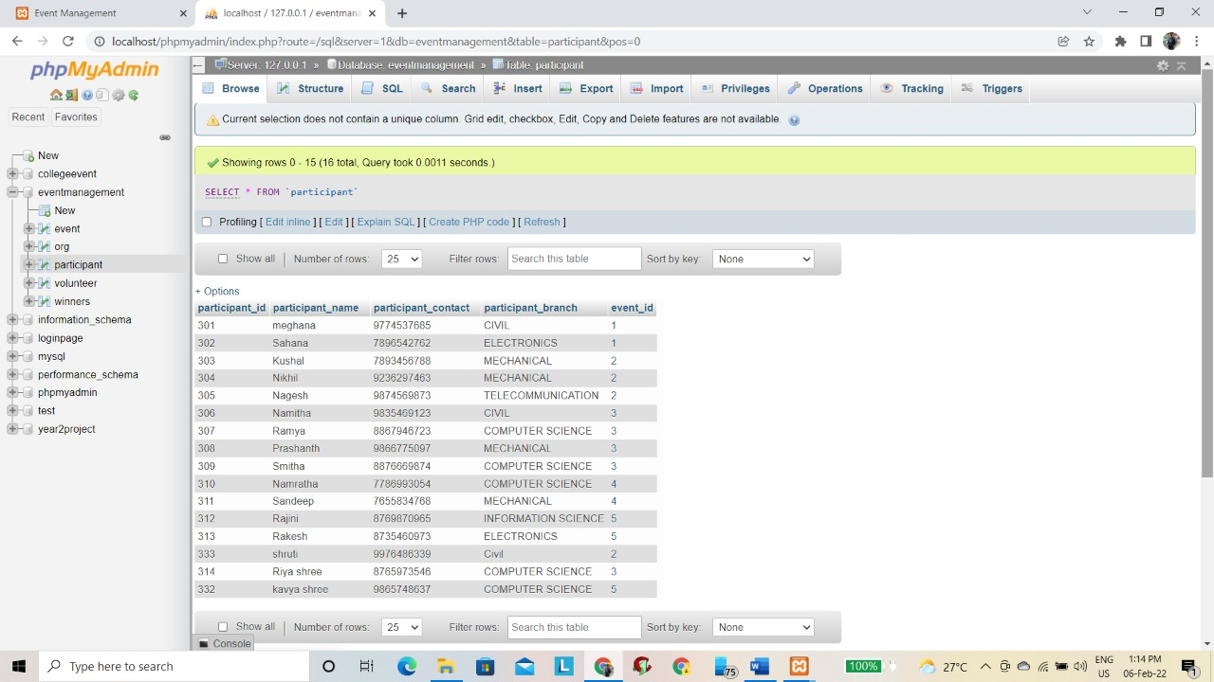

**Organize Table:**

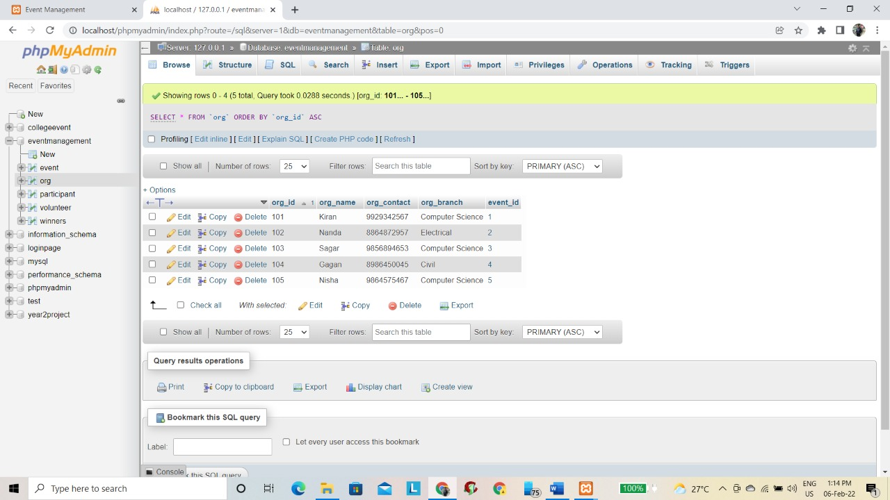

**Event Table :**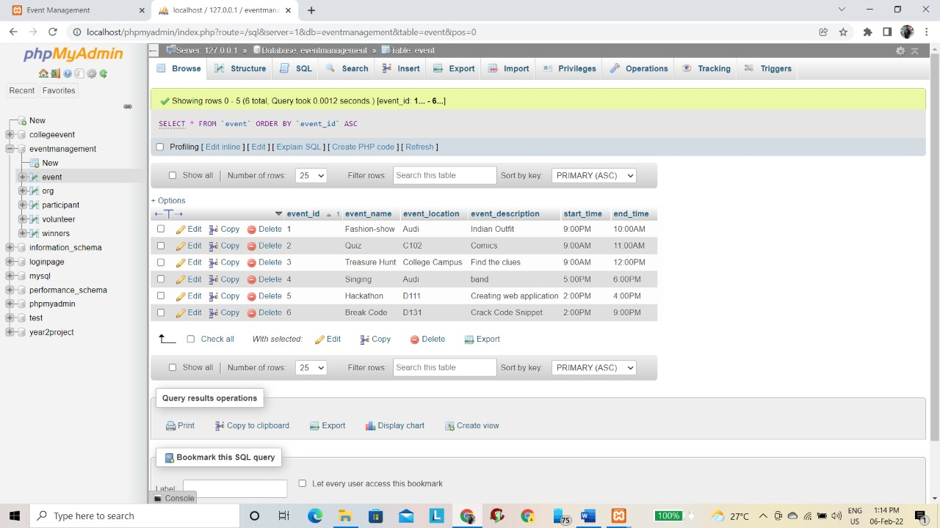

**Winner Table :**

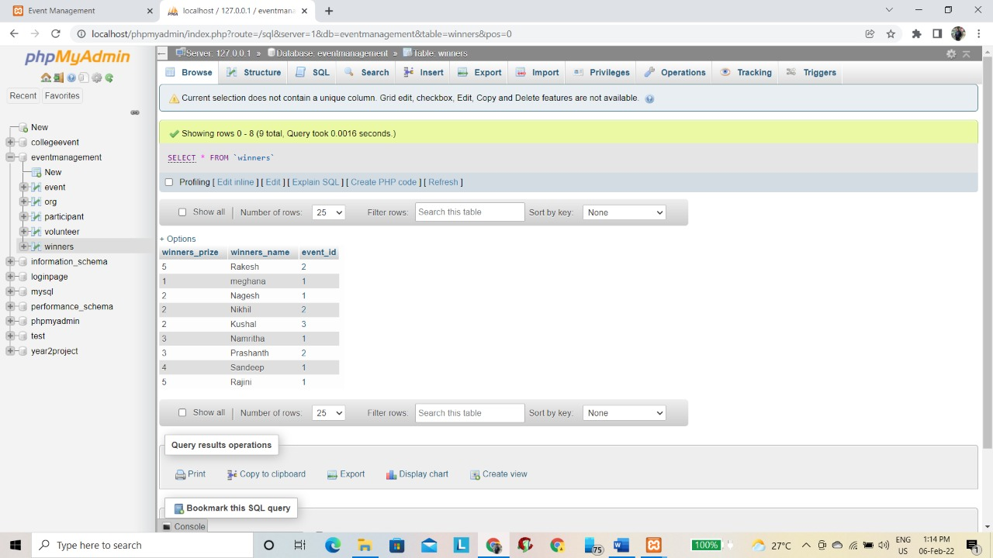

**QUERIES**

1. Retrieve all the winners names who received the first place in all events.

Query:

Select winners_name

from winners

where winners_prize='1';

Output:

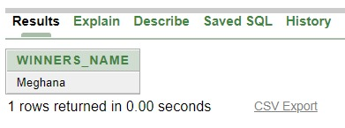

1. List all the events organized by computer science department

Query:

Select e.event_name

From event e

Where event_id in(select o.event_ id

from org o

where o.org_branch='Computer science');

Output:

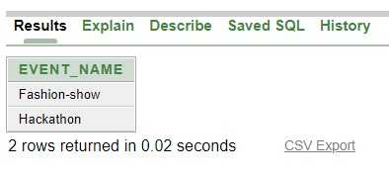

1. List the events happening at the same time

Query:

Select el.event_name

From event el

where exists

(select e2.event id

from event e2

where e2.event id <> el.event_id and el.start_time = e2.start_time);

Output:

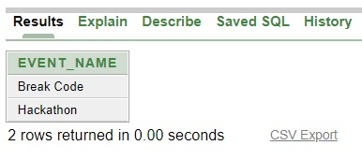

1. List the names of the volunteers volunteering for event Treasure Hunt

Query:

select v.volunteer_name

from volunteer V

where v.org_id in (select o.org_id

from org o.event e

where e.event_id=o.event_id

and e.event_name='Treasure Hunt');

Output:

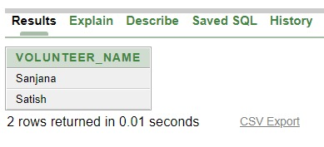

1. Retrieve the winners name and the event name in which the participants

Are from mechanical branch

Query:

select w.winners_name,e.event_name

from winners w,event e

where w.event_id=e.event_id

and e.event_id in(

select e.event_id

from event e,participant p

where e.event_id=p.event_id and p.participant_branch='Mechanical');

Output:

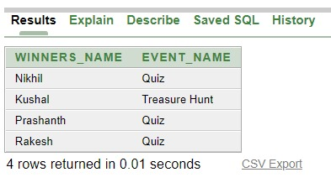

1. Retrieve the contact number of all organizers organizing an event with more

Then 3 participants

Query:

select o.org_contact,o.org_name,o.event_id

from org o

where o.event_id in(

select e.event_id

from event e,participant p

where e.event_id=p.event_id

GROUP BY e.event_id

having count(*)>2);

Output:

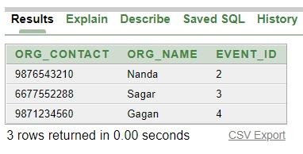

1. Retrieve the event id,event name and participant name which is organized by electrical branch with more than 2 participant enrolled

Query:

select e.event_id,e.event_name,p.participant_name

from event e,participant p,org o

where e.event_id=p.event_id

and e.event_id=o.event_id

and o.org_branch='Electrical’

and p.event_id in(select p.event_id

from event e, participant p

where e.event_id-p.event_id

group by p.event_id

having count (*) > 2)

order by p.participant_name;

Output:

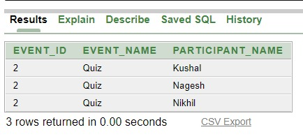

1. List the winners name who achieved 2nd place in the events organized by

Information science branch

Query:

select w.winners_name,e.event_name

from winners w,event e

where w.event_id=e.event_id

and w.winners_prize= ‘2’

and e.event_id in(

select e.event_id

from org o,event e

where o.event_id=e.event_id

and o.org_id in(

select o.org_id

from org o,volunteer v

where o.org_id=v.org_id

and v.volunteer_branch= ‘Information science’))

order by e.event_name;

Output:

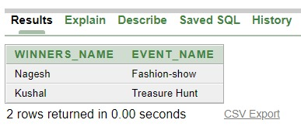

**CONCLUSION**

We are trying to achieve our target, to make possible to provide online information to all Events which is organized by colleges with their student details and college name it provides a user friendly, error free environment to manage large amount of data. System design is modular and structural system can be easily be enhanced. We know "write once Run anywhere "approach.so Electricity board application is 100% portable in any operating system. Consistent user interface with standard entry, information format and analysis of ease training.

**BIBLIOGRAPHY**

Few of the books and websites that were instrumental in helping us to complete this project are as mentioned below:

**BOOKS**

* Elmasri and Navathe, “Fundamental of Database System", Addison-Wesley,5th Edition 2007
* Database System Concepts, 6th Edition by Silberschatz, Korth and Sudarshan

**URL’s**

<https://www.wikipedia.com>

<https://w3schools.com>

<https://www.draw.io>

<https://www.php.net.com/manual>

<https://www.researchgate.net>

https://www.ecomputernotes.com