Adv-Devops Practical

Experiment No 1:-

**Step 1: Running a Python Script in CloudShell**

1. Log in to your **AWS Management Console** → https://aws.amazon.com/console
2. Open **CloudShell** from the top navigation bar.
3. Check if Python is installed:
4. python3 --version
5. Create a new Python file:
6. nano demo.py
7. Type the following code:
8. print("Hello from AWS CloudShell")
9. Save and exit (Press Ctrl + O, Enter, then Ctrl + X).
10. Run the Python file:
11. python3 demo.py

✅ Output: Hello from AWS CloudShell

**Step 2: Making an EC2 Instance**

1. From the AWS Console, go to **EC2 Service**.
2. Click on **Launch Instance**.
3. Give the instance a name, e.g., MyFirstInstance.
4. Choose **Amazon Linux 2** (Free-tier eligible).
5. Click **Launch Instance**.
6. Wait until the instance status becomes **Running**.

**Step 3: Connecting to the Instance**

1. Select your EC2 instance from the list.
2. Click on **Connect** at the top.
3. Choose **EC2 Instance Connect** → then click **Connect**.
4. The browser-based terminal will open.
5. Run the command below to verify the connection:

**Step 4: Running a Python Program**

1. Create a Python file:

nano test.py

1. Type this code:

name = input("Enter your name: ")

print(f"Hello {name}, welcome to AWS EC2!")

1. Save and exit (Ctrl + O, Enter, Ctrl + X).
2. Run the program:
3. python3 test.py

Output: Hello from EC2 Instance

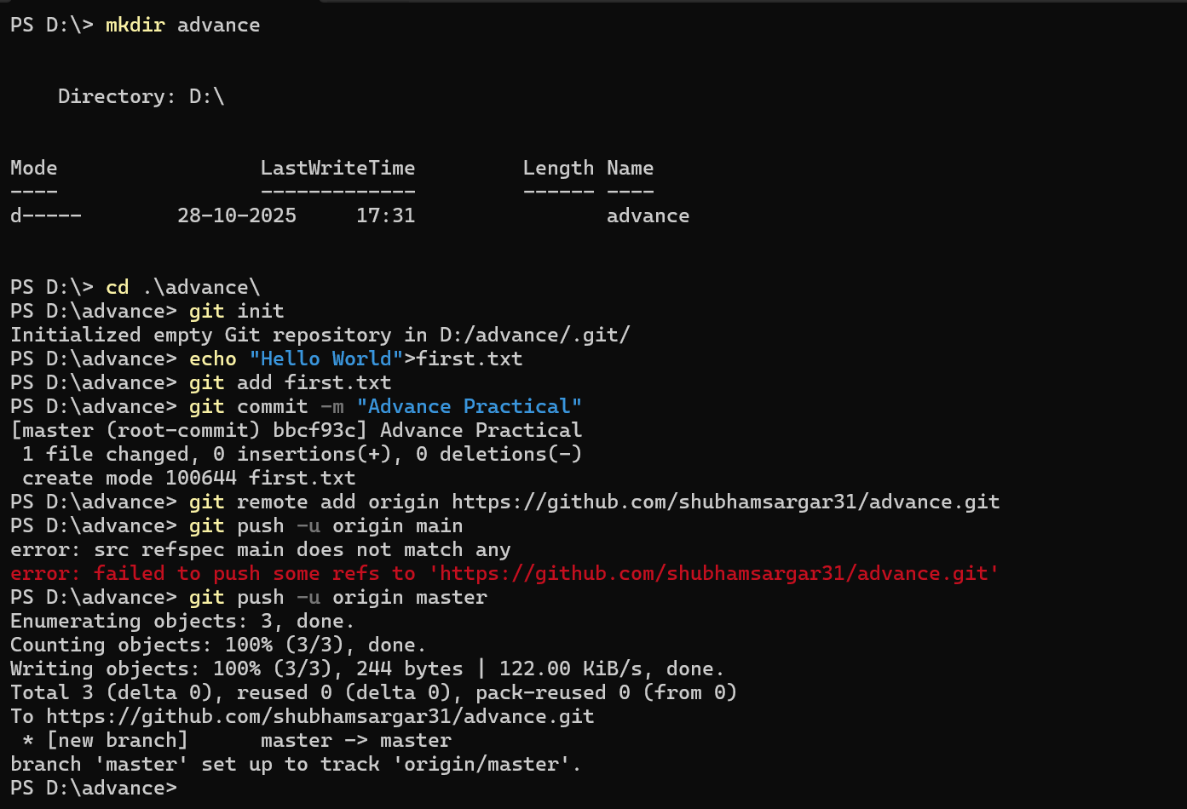Exp 2:-

Exp3:-

wsl –install

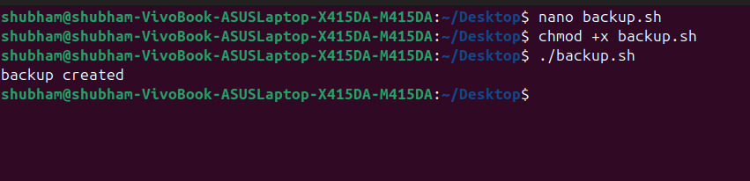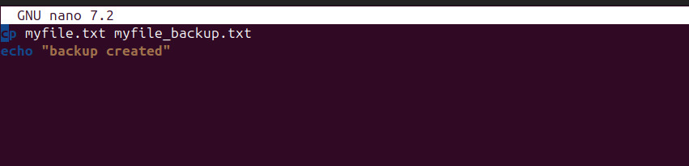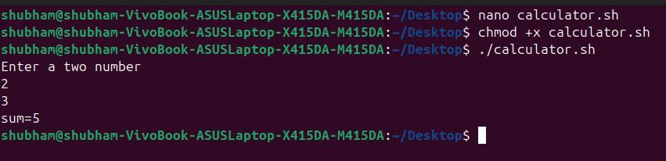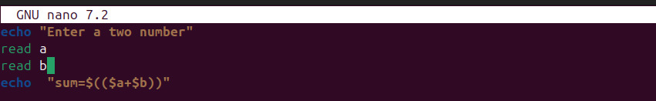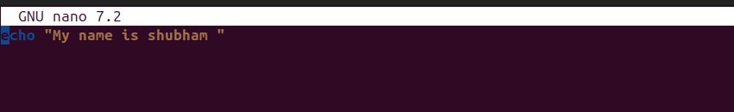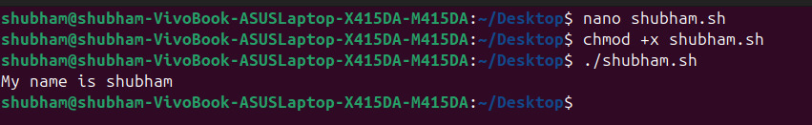

Experiment No 4:-