Business Recommendation:
Indian D2C True Profit Analysis

Prepared by | Shubham Sarkar | Category | Fashion (Kurta)
Dataset | 100 test orders | Tool | Microsoft Excel 2021

Executive Summary
The current workbook contains 100 test orders and shows a positive total CM2 of ₹21,821.62 when the observed return rate of 35.0% is applied. The earlier report used a 30% base-case return assumption; this updated report keeps that scenario for comparison while separating it from the actual dataset result.
The strongest channel on average CM2 per order is Own Website at ₹330.39, followed by Meesho at ₹242.50 and Myntra at ₹78.73. At product level, Premium Silk Kurta contributes the highest total CM2 at ₹10,200.93.
The clearest operational risk is returns: 35 of 100 orders are returned, producing a CM2 impact of -₹6,775.72. Reducing returns therefore has a direct and measurable effect on contribution margin.

Actual CM2 | Observed Returns | Avg Delivered CM2 | Best Channel | Top SKU
₹21,822 | 35.0% | ₹440 | Own Website | Premium Silk Kurta

1. Profitability: Positive, But Returns Reduce the Buffer
Using the observed order-status mix, 65 orders were delivered and 35 were returned. Delivered orders generated an average CM2 of ₹439.96 each, while returned orders generated an average CM2 impact of -₹193.59 each.
This produces an actual dataset CM2 of ₹21,821.62. The 30% base-case scenario remains useful for planning, where the model projects ₹24,989.38. The difference matters: the current dataset is running at a higher observed return rate than the base-case assumption.

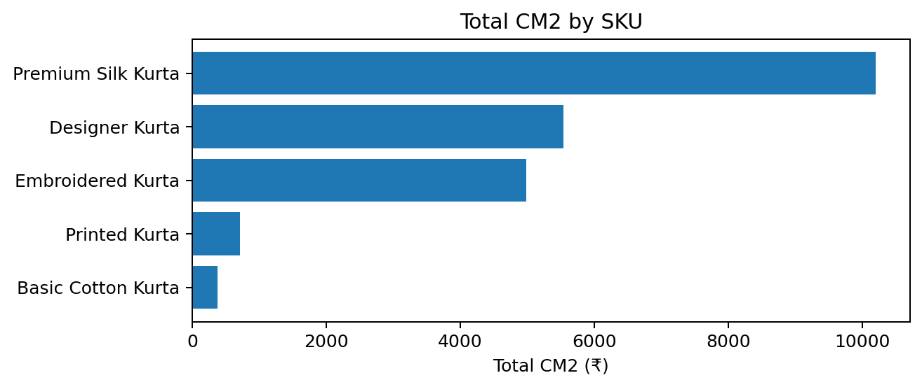

2. Channel Mix: Own Website Has the Strongest CM2 per Order
Own Website has the highest average CM2 per order at ₹330.39. Meesho averages ₹242.50, while Myntra averages only ₹78.73.
The previous report correctly identified channel economics as a structural issue rather than simply an operational performance issue. The workbook's rate assumptions show materially higher marketplace fees on Myntra, while the Own Website has the lowest commission burden.
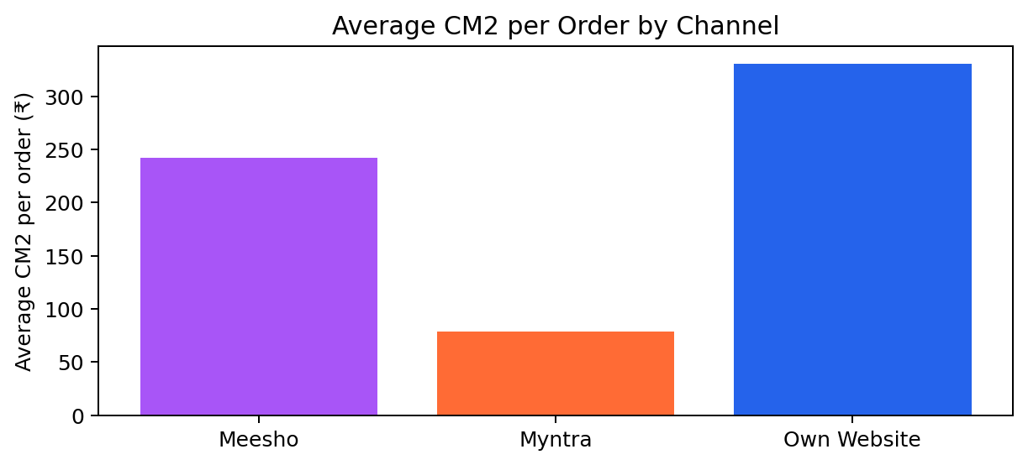

Channel | Avg CM2 / Order | Relative Position
Meesho | ₹242.50 | Middle
Myntra | ₹78.73 | Lowest
Own Website | ₹330.39 | Highest

3. Product Mix: Premium Silk Kurta Carries the Most CM2
Premium Silk Kurta is the strongest product by total CM2 at ₹10,200.93. Basic Cotton Kurta is the weakest at ₹373.15. This gap suggests that higher-value products have more room to absorb variable selling and fulfilment costs.
The earlier report recommended protecting and expanding Premium Silk Kurta while reviewing the economics of Basic Cotton Kurta. That recommendation remains consistent with the current workbook.

4. Returns: The Most Visible Business Risk
The overall observed return rate is 35.0%. At SKU level, Printed Kurta has the highest return rate at 45.0%, followed by Premium Silk Kurta at 42.3%. Designer Kurta has the lowest return rate at 20.0%.

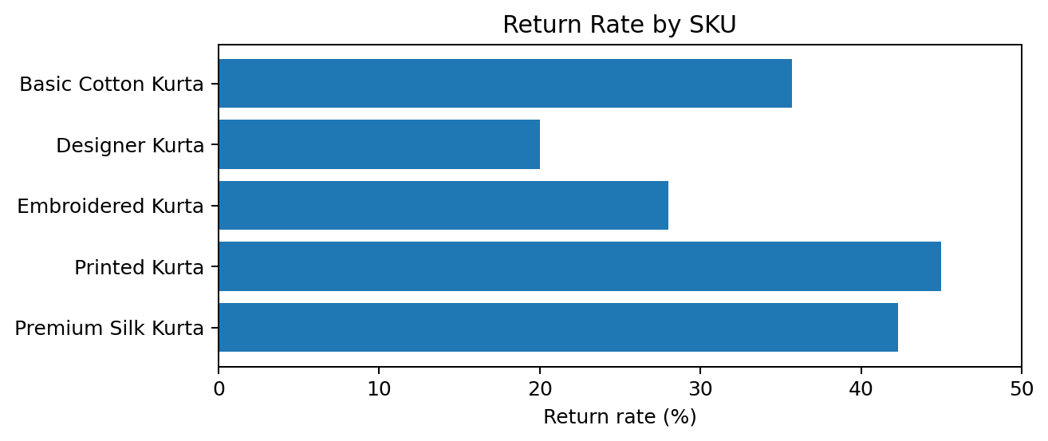

SKU | Delivered | Returned | Return Rate
Basic Cotton Kurta | 9 | 5 | 35.7%
Designer Kurta | 12 | 3 | 20.0%
Embroidered Kurta | 18 | 7 | 28.0%
Printed Kurta | 11 | 9 | 45.0%
Premium Silk Kurta | 15 | 11 | 42.3%

5. Scenario Analysis
The model shows a predictable relationship between return rate and CM2: lowering the return rate increases contribution margin because returned orders carry a negative CM2 impact.

Scenario | Return Rate | Projected CM2
Actual Dataset | 35.0% | ₹21,821.62
Base Case | 30.0% | ₹24,989.38
Optimistic | 20.0% | ₹31,324.89
Pessimistic | 40.0% | ₹18,653.86
Best Case | 10.0% | ₹37,660.40

Moving from the observed 35.0% return rate to 20% would increase projected CM2 by approximately ₹9,503.27 per 100 orders. Moving only to the 30% base case would add approximately ₹3,167.76 per 100 orders.

Recommendations
1. Reduce returns first. Prioritize size guidance, clearer product information, product demonstrations, and post-purchase communication. The model indicates a direct CM2 benefit from every reduction in the return rate.
2. Shift incremental acquisition toward Own Website. Own Website currently produces ₹330.39 average CM2 per order, substantially above Myntra's ₹78.73.
3. Protect and expand Premium Silk Kurta. It contributes ₹10,200.93 in total CM2, the highest among the five SKUs.
4. Review Basic Cotton Kurta economics. With only ₹373.15 total CM2, it has limited buffer. Test whether price, shipping, channel mix, or returns are eroding its economics.

Methodology & Source Reference
This updated report uses the current Excel workbook as the primary quantitative source and the previous 'profit_model_summary.docx' as the structural and narrative reference. The workbook contains 100 simulated orders, SKU pricing/cost assumptions, channel fee assumptions, order-status outcomes, and summary calculations.
The previous report's 30% return-rate scenario is retained as the Base Case for comparability. The observed dataset return rate is calculated directly from the workbook's 65 delivered and 35 returned orders, giving 35%. Where the two differ, this report labels the figures explicitly rather than treating the base-case assumption as the actual observed result.
The workbook's methodology uses RANDBETWEEN and CHOOSE also VLOOKUP based test data and includes assumptions for marketplace commissions, fixed fees, shipping, COD handling, and GST on platform fees. CM2 is used as the main contribution-margin measure.

