**OVERVIEW**

Human brain is one of the most complex mysteries of this universe that we still haven’t been able to decode and it's almost impossible to fully understand the neural architecture of our nervous system but we have somehow tried to replicate that function through artificial neural networks and the concept of our project **DEEP LEARNING** is all about artificial neural networks.

In this era of mass industrialization proper management of tasks become very important and hence automation in industry is required as it plays a very important role in easing our lives. The key component of this automation revolution is AI and our project is one small component of this gigantic concept of AI.

Our project's driving factor is the problem of classification of data(especially images) in any industry and as technology has advanced the amount of data has also increased and human workforce isn't capable enough to efficiently handle the segregation of data and hence we need a technological framework for it and deep learning is building block for this.

In this project we have used the concept of CNN on a very small level to classify images into one of 10 classes. The main idea used in this project is to train our model with a certain dataset containing large number of images to help our model to memorize it and then exposing our model to a new set of images to classify them using the features and patterns learnt by it during training.

We are using CIFAR-10 dataset in our project which consists of 60,000 images and associated labels (i.e. classifications of the images). We are using Jupyter notebook(a python IDE) to write our code and also using tensorflow library as it provides many in-built functions which are much easier to implement in comparison to user defined functions .We are also using pretty tensor as it provides much simpler ways of constructing Neural Networks in tensorflow, thus allowing us to focus on the idea we wish to implement and not worry so much about low-level implementation details. The activation function used in this project is ReLu.

The final concept that we are using in this project which increases learning speed of our model and the classification accuracy is transfer learning using a pre trained inception model.

**KEYWORDS:** AI, Deep Learning, CIFAR-10, CNN, Tensorflow, ReLu.

**OBJECTIVE**

The focus and objective of this project work lies on developing a precise convolutional neural network(CNN) architecture which will be able to classify a image and tell us to which class it belongs.

Not every task can be performed by humans and even if that’s possible it's not feasible to use man power for every task and hence the use of artificial intelligence becomes very important. The project that we are presenting here is a baby step in the field of computer vision.

Our main area of interest in developing this model is to achieve a classification accuracy much closer to what is achieved by our brain i.e. close to 100%. But this is still a long shot as there are infinite variances possible with one image and hence our model always cannot understand the image and can possibly give wrong predictions. The main reason for this is, that any deep neural network is trained in one type of environment and hence there is high probability of it failing when exposed to unknown territory.

Although this concept is already in use in many domains but still we have chosen this as our area of interest so as to learn about how image recognition works and hence we are developing this project to get the basic idea about such a complex topic.

Our main focus in this project is to understand about how to develop simple convolutional network using python language and tensorflow library and also learn about some concepts related with it . Some of these concepts are convolutional layers, pooling layers, activation layer( Relu) , fully connected layers, backpropagation, gradient descent and transfer learning.

After the training and testing of our deep learning model our next objective will be to upload these trained weights to raspberry pi to classify real time images.

At the end of this project we will be able to implement a CNN model and explain the basic idea of computer vision.

**PROCESS OF IMAGE CLASSIFICATION**

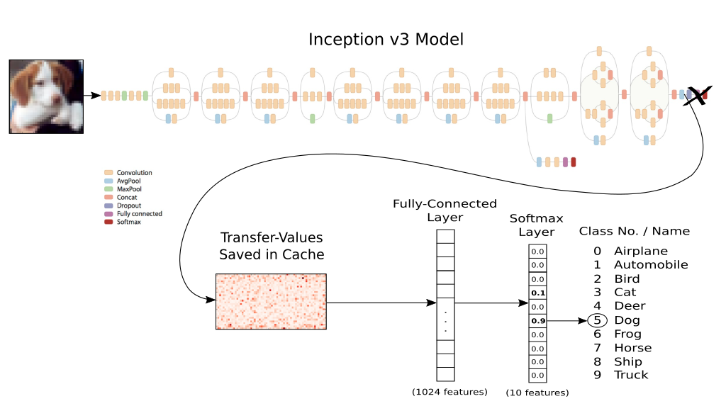

**This is the graphical representation of the process that we are carrying out in this project.**

**WORKING**

We are using a pre trained inception V3 model and implementing the concept of transfer learning . The Inception v3 model has nearly 25 million parameters and uses 5 billion multiply-add operations for classifying a single image and it is a very deep layered network having many convolutional layers and pooling layers. First we input and process an image with the Inception model. Just prior to the final classification layer of the Inception model, we save the so-called Transfer Values to a cache-file. When all the images in the new data-set have been processed through the Inception model and the resulting transfer-values saved to a cache file, then we can use those transfer-values as the input to another neural network consisting of a fully connected layer and a softmax layer. We will then train the second neural network using the classes from the new data-set, so that network learns how to classify images based on the transfer-values from the Inception model.

Transfer learning is a concept which makes use of the knowledge gained while solving one problem and applying it to a different but related problem. The whole training process involves training the model with small random batches of training dataset in numerous iterations which also involves checking the error between the predicted output and actual output and then according to the magnitude of difference we backpropagate our network and update the filter weights in each iteration to reduce the error, this is known as optimization . The mathematical approach that we are using to update weights is called gradient descent and backpropagation is as the term implies reverse to the direction of the network is a method used in artificial neural networks to calculate the gradients that is useful in updating weights using gradient descent.

Finally after the model is trained and weights are optimized we are checking the accuracy of our model on the test set images and the prediction is derived from the maximum of scores for 10 classes given after the softmax layer.

**ADVANTAGES**

* Classification not only limited to humans.
* Capacity to extrapolate new features from a limited set of features contained in a training set.
* Deep learning also enables to easily classify a complex data set or a combination of many images .
* Increased efficiency and accuracy.

**REFERENCES**

1. D. Ciresan, U. Meier and J. Schmidhuber, “Multi-column Deep Neural Networks for Image Classification”, IEEE Computer Society Conference on Computer Vision and Pattern Recognition, 2012.
2. X. Han and Y. Li, "The Application of Convolution Neural Networks in Handwritten Numeral Recognition", International Journal of Database Theory and Application, vol. 8, no. 3, pp. 367-376, 2015.
3. C. Szegedy, W. Liu, Y. Jia, P. Sermanet, S. Reed, D. Anguelov, D. Erhan, V. Vanhoucke, and A. Rabinovich., "Going deeper with convolutions", In Proceedings of the IEEE Conference on Computer Vision and Pattern Recognition, pp. 1–9, 2015.
4. E.Talvitie and S. Singh, "An experts algorithm for transfer learning", In International Joint Conference on Artificial Intelligence, 2007.
5. A. Krizhevsky, I. Sutskever and G. Hinton, "ImageNet classification with deep convolutional neural networks", Communications of the ACM, vol. 60, no. 6, pp. 84-90, 2017.
6. "Stanford University CS231n: Convolutional Neural Networks for Visual Recognition", Cs231n.stanford.edu, 2018. [Online]. Available: http://cs231n.stanford.edu/. [Accessed: 14- Jan- 2018].
7. "How to Make a Prediction - Intro to Deep Learning #1", YouTube, 2018. [Online]. Available: https://www.youtube.com/siraj. [Accessed: 03- Feb- 2018].
8. "Introduction to TensorFlow Tutorials", YouTube, 2018. [Online]. Available: https://www.youtube.com/Hvass_Labs. [Accessed: 20- Feb- 2018].