SERVERS CREATED

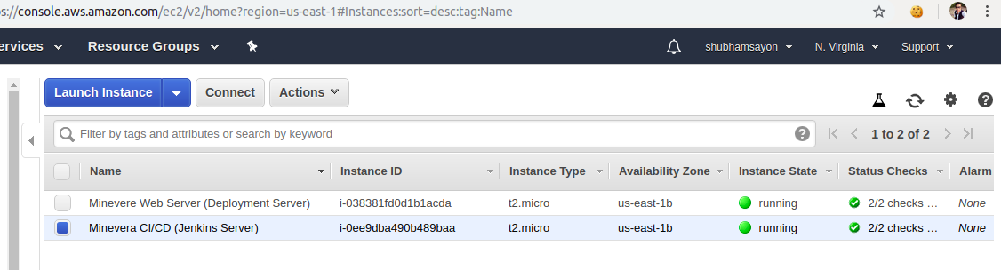
BUILD PIPELINE

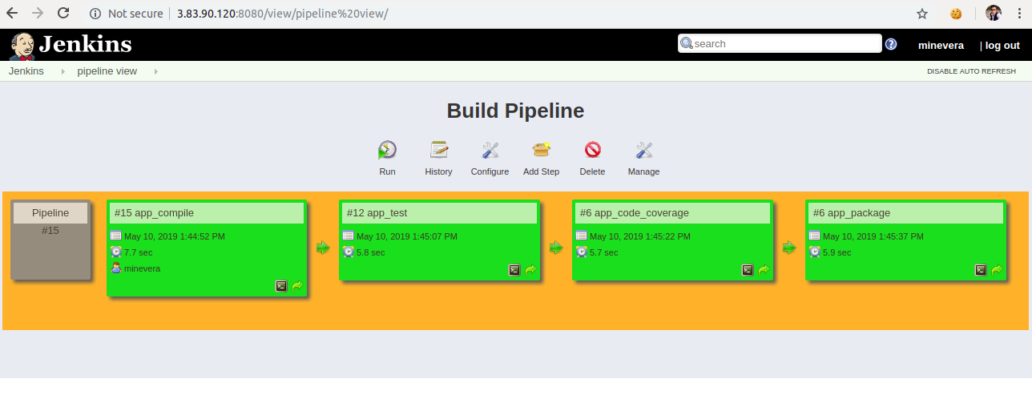
OUTPUT
