API’s

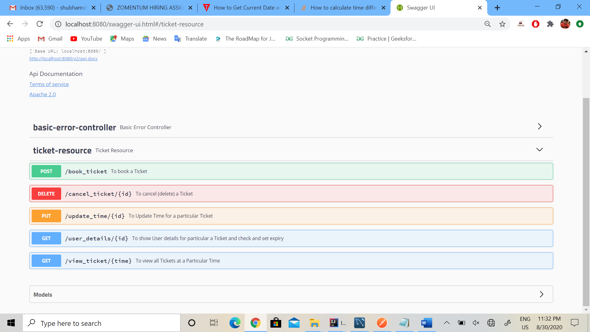

Models or Entities

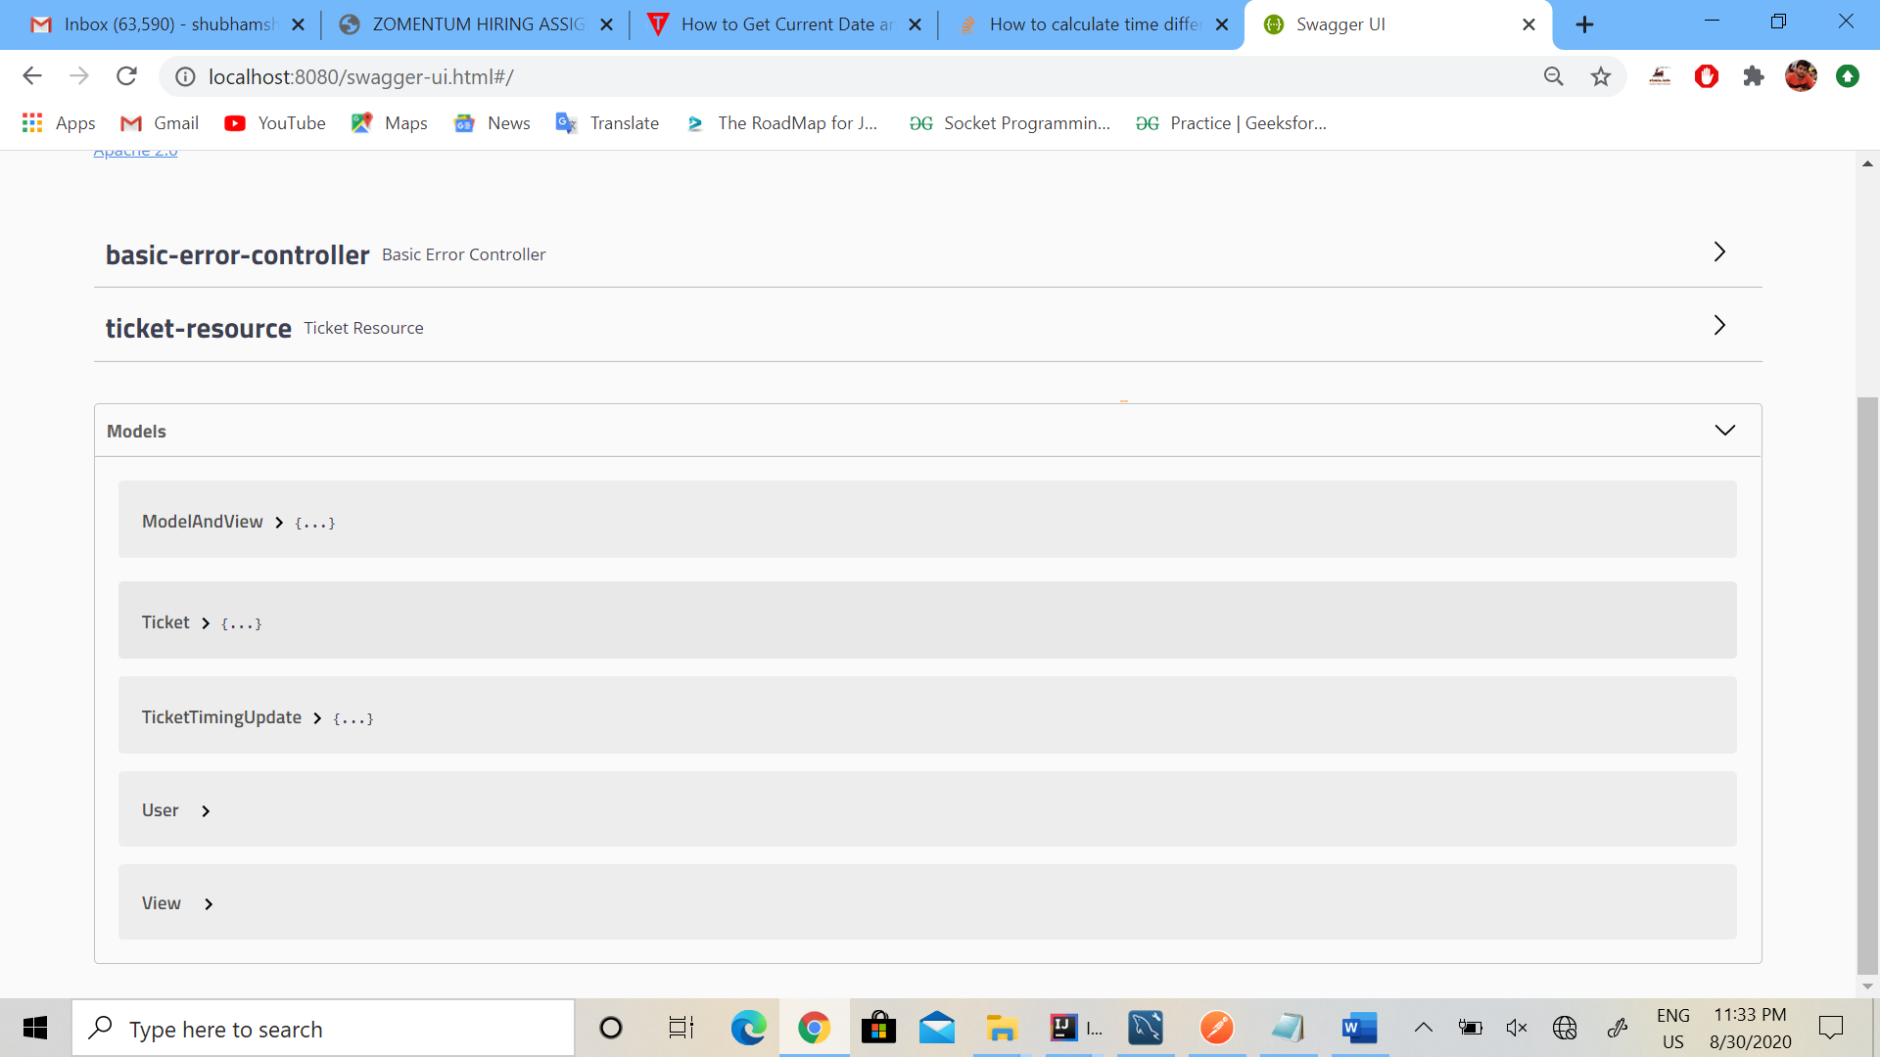

Tests

1. <http://localhost:8080/book_ticket>

Json data =

{

"id":1,

"user_name":"shubham",

"number":9997229979,

"time":"29-08-2020 21:00:00"

}

{

"id": 2,

"user_name":"Harsh",

"number":7412733821,

"time":"29-08-2020 18:00:00"

}

{

"id": 3,

"user_name":"Rahul",

"number":8279736552,

"time":"29-08-2020 18:00:00"

}

1. [http://localhost:8080/update_time/1](http://localhost:8080/update_time/15)

Json data =

{

     "time": "01-09-2020 09:00:00"

}

1. http://localhost:8080/view_ticket/2020-08-29 18:00:00
2. <http://localhost:8080/cancel_ticket/3>
3. <http://localhost:8080/user_details/2>

Swagger2 api - :

<http://localhost:8080/swagger-ui.html#/>