Endpoint 1 //Book a Ticket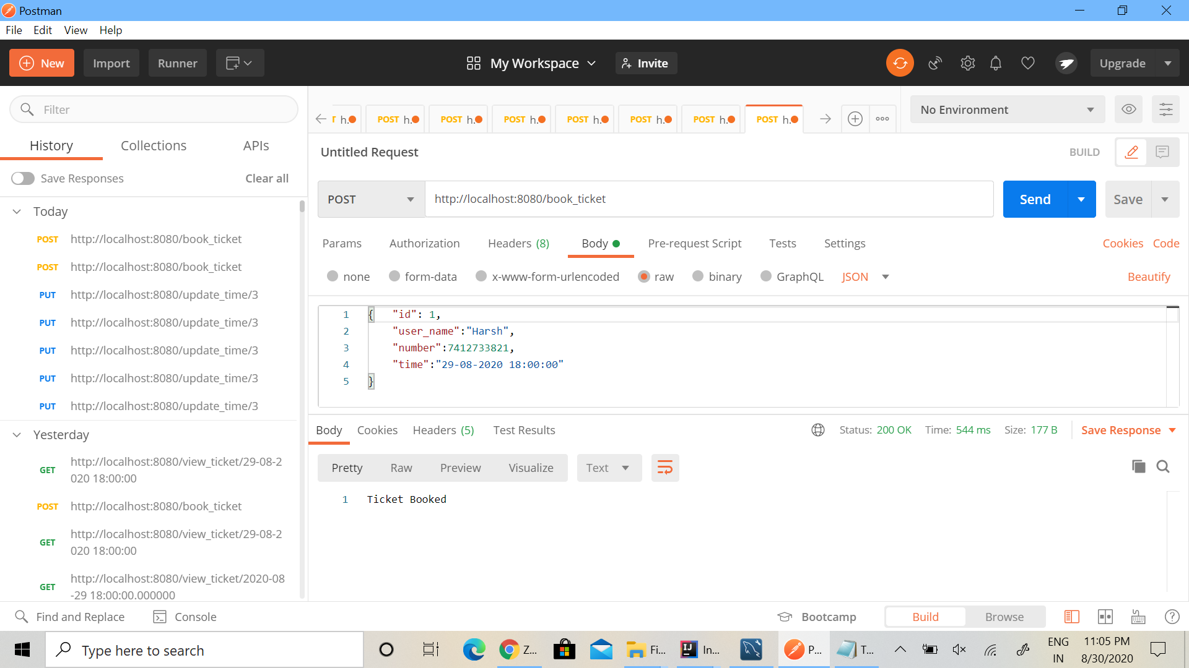

EndPoint 2 // Update Time of Ticket

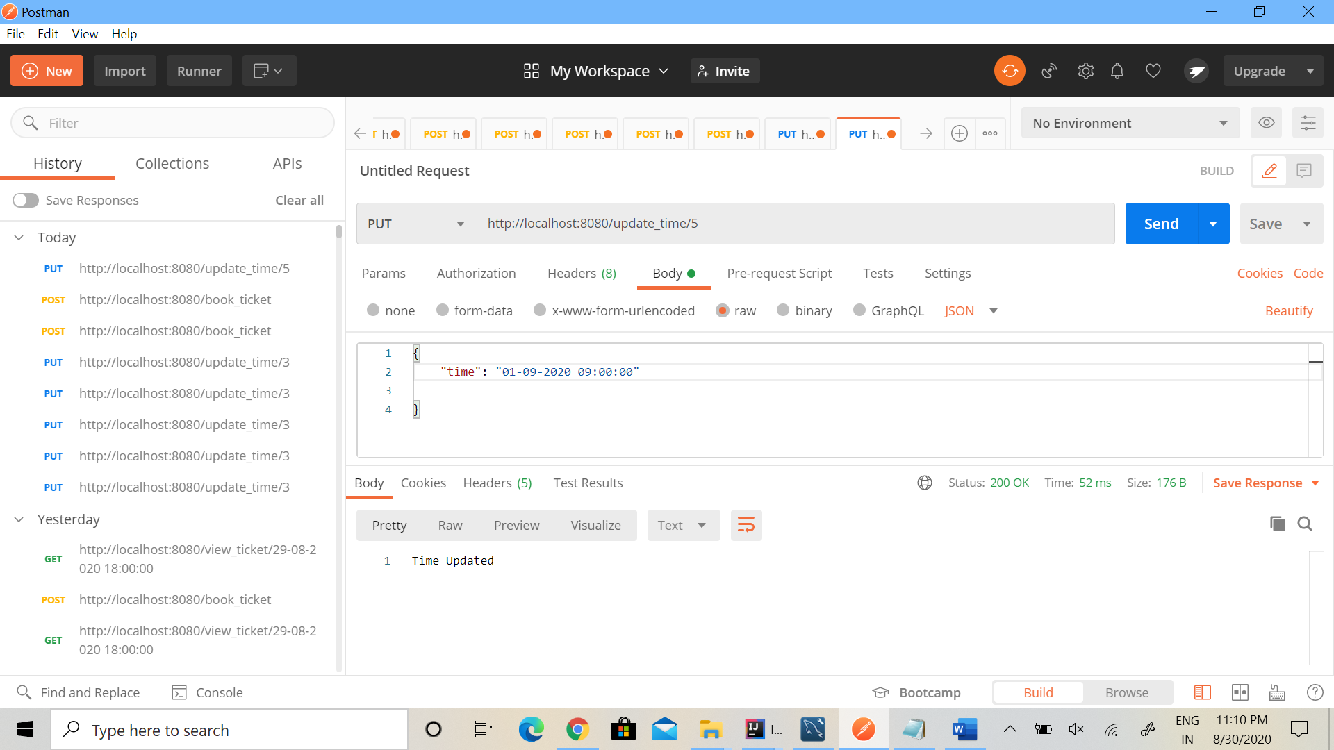

Endpoint 3 // View all Tickets AT particular time

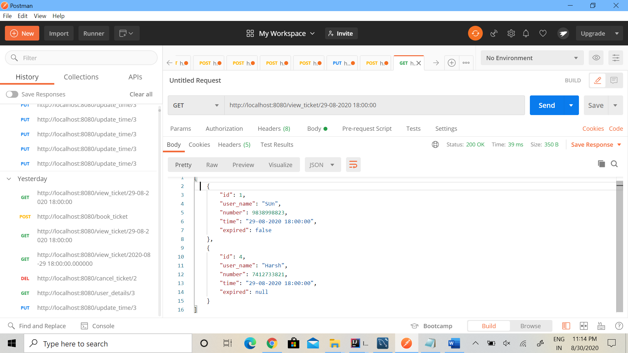

Endpoint 4 // Cancel(delete) A ticket

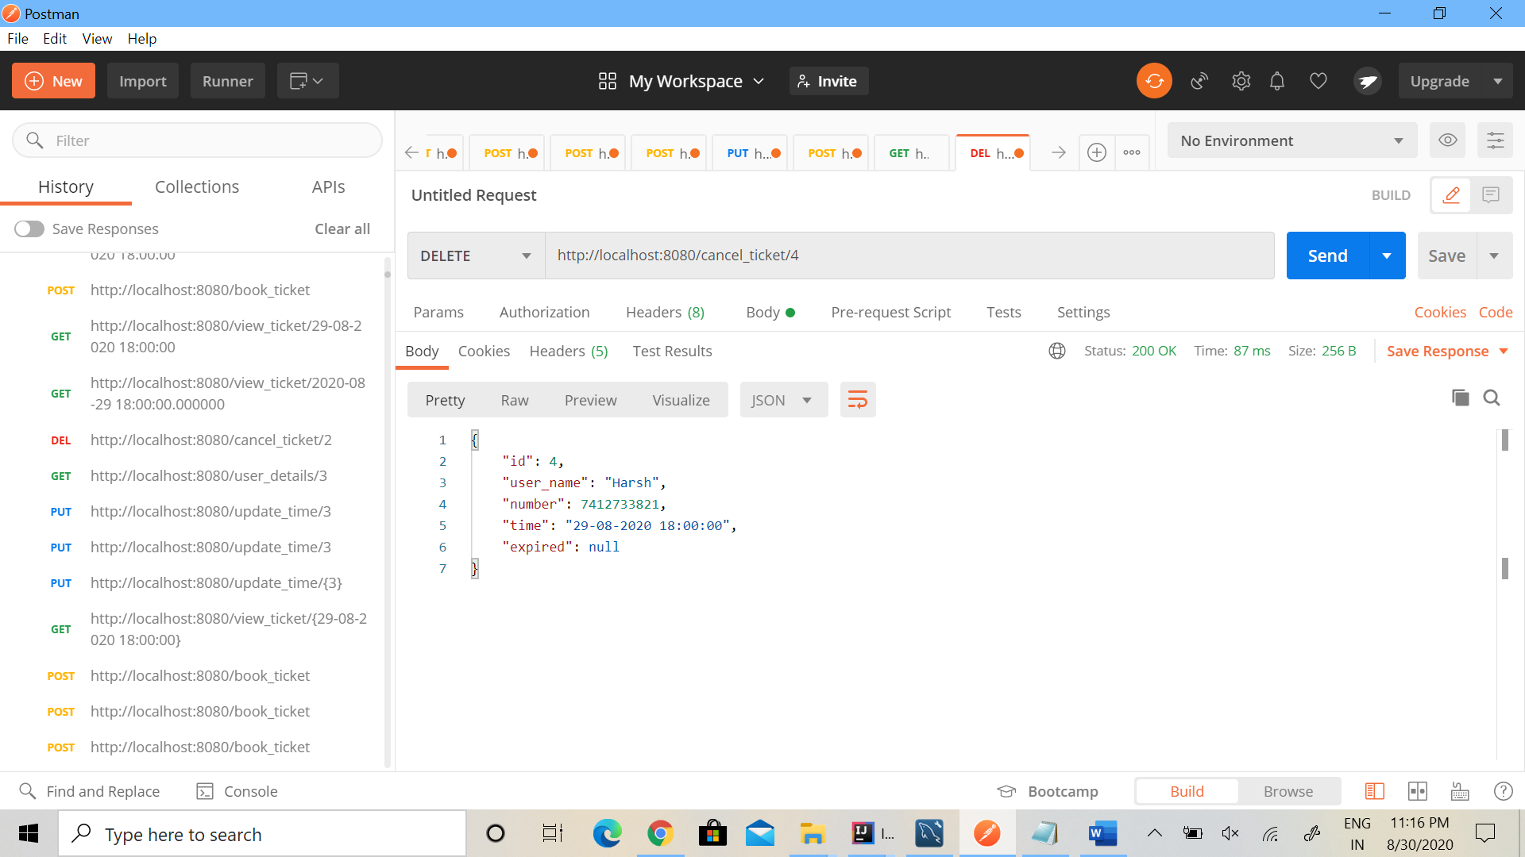

End Point 5 // View User Details For a specific Ticket Id and Mark Expired if time difference more than 8 hours

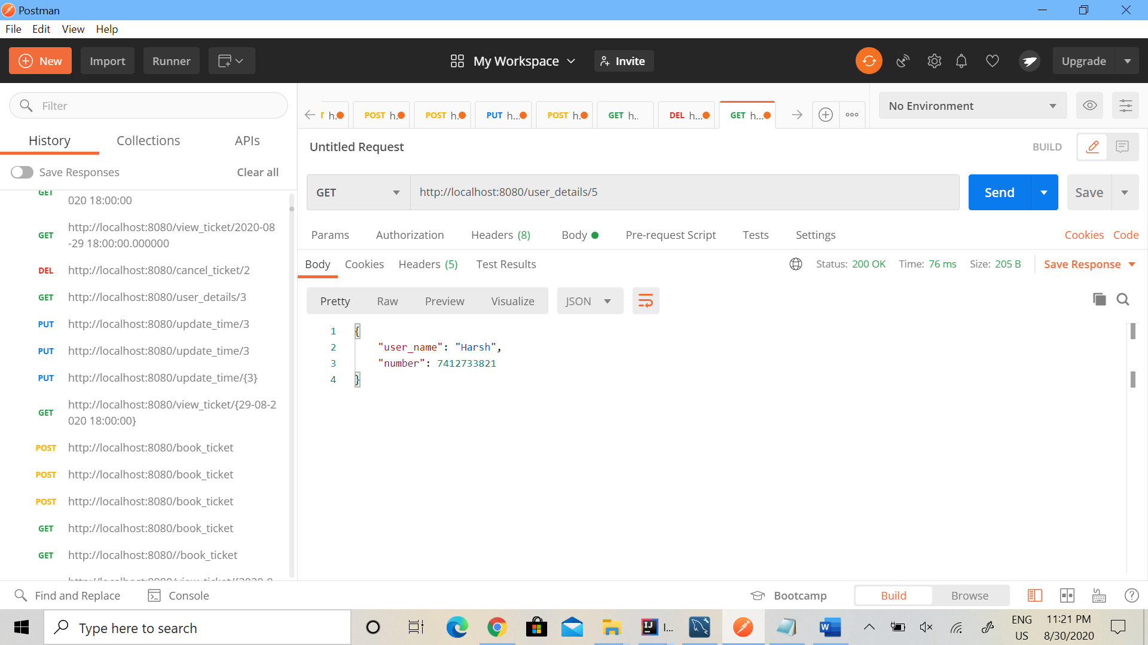

Data entry for expired changed to 1 ( id == 5)

