**Project 3**

**Name:** Shubham Shah

**Student Id:** 801257810

1. **Screenshot of the application’s home page displayed in your browser.**

* Index.ejs (home page)

 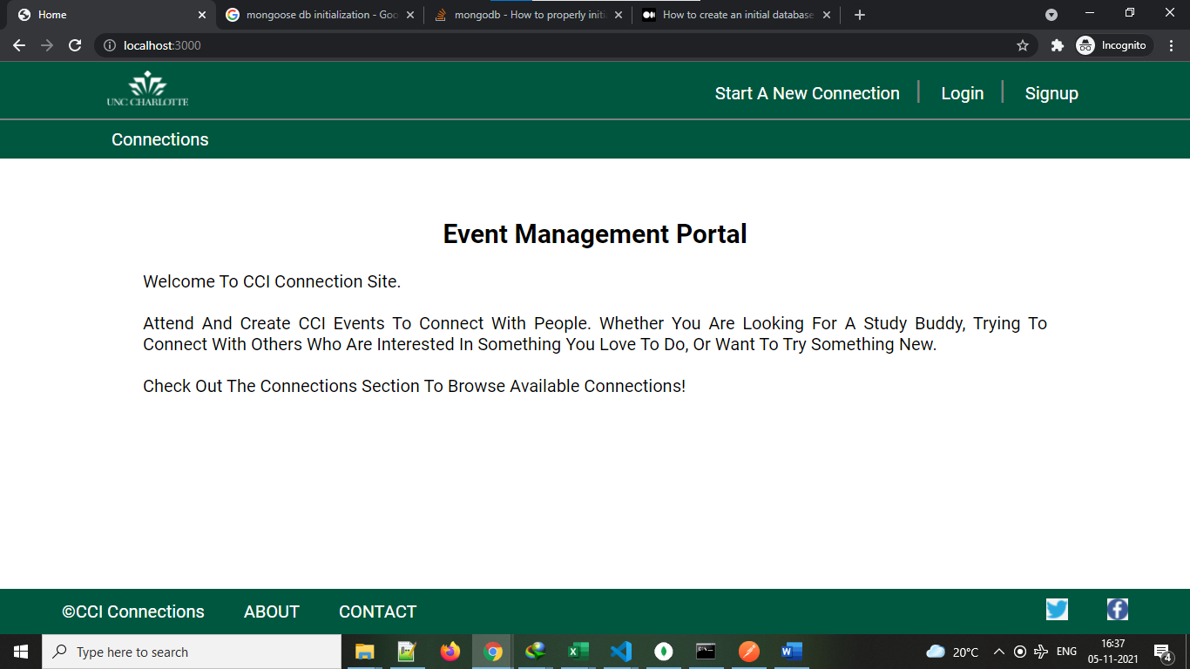

1. **Explanation of additional features, if any.**

* There are no additional features added as of now. But added some extra validations.
  + MinLenth of details = 10
  + It will show the day in connection page where the story details are given.

For an instance, Monday, 2021-10-21.

* + Added initialize.js script, which will be run when app is restarted or started. It contains the database and collection creation and then adding 6 documents.

1. **Explanation of status, stopping point, and issues if incomplete.**

* Status-Completed. I have implemented all the mentioned functionalities. There were some challenging situations but with the use of materials and because of enthusiasm to learn, completed the project.

1. **Discuss the easy and challenging parts of the assignment. How did you overcome all or some of the challenges?**

* MongoDb implementation was quite easy as already completed the exercises for the same.
* The challenging task was to create the initialize.js or (project3_createDB.txt), which I want to implement in a way it will be automatically executed when server restarts or server starts.
* I have gone through another module called child-process. With the use of exec method I ran the initialize.js script to initialize the database.
* For image url validation, I used Schema.path(‘imgUrl’).validate(arrow function) to validate the url pattern.

Project2 Comments:

No comments from project 2 as it was successfully implemented according to the description given.

* **Screenshots of all the pages with both view(laptop as well as mobile).**
* Connections.ejs (Connections with Topic)

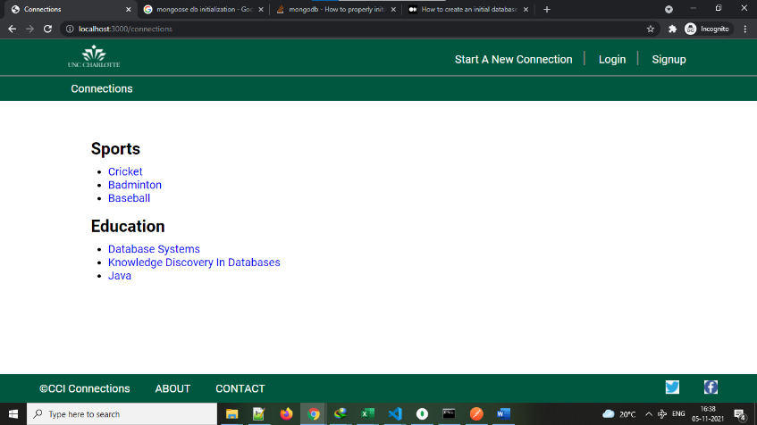

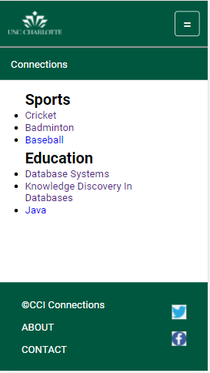

* newConnection.ejs(Adding new Connection form)

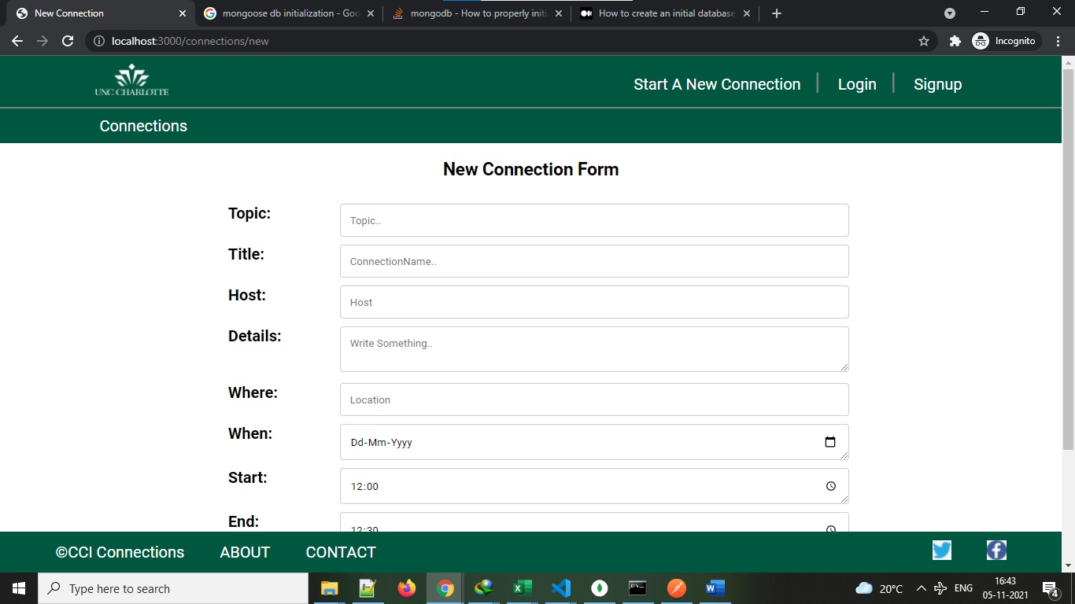

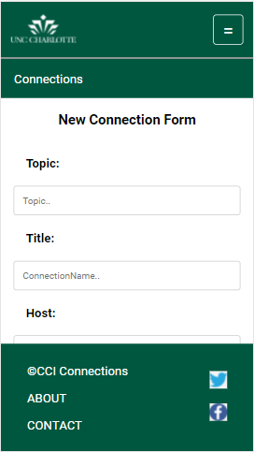

* connection.ejs (Check a particular connection)

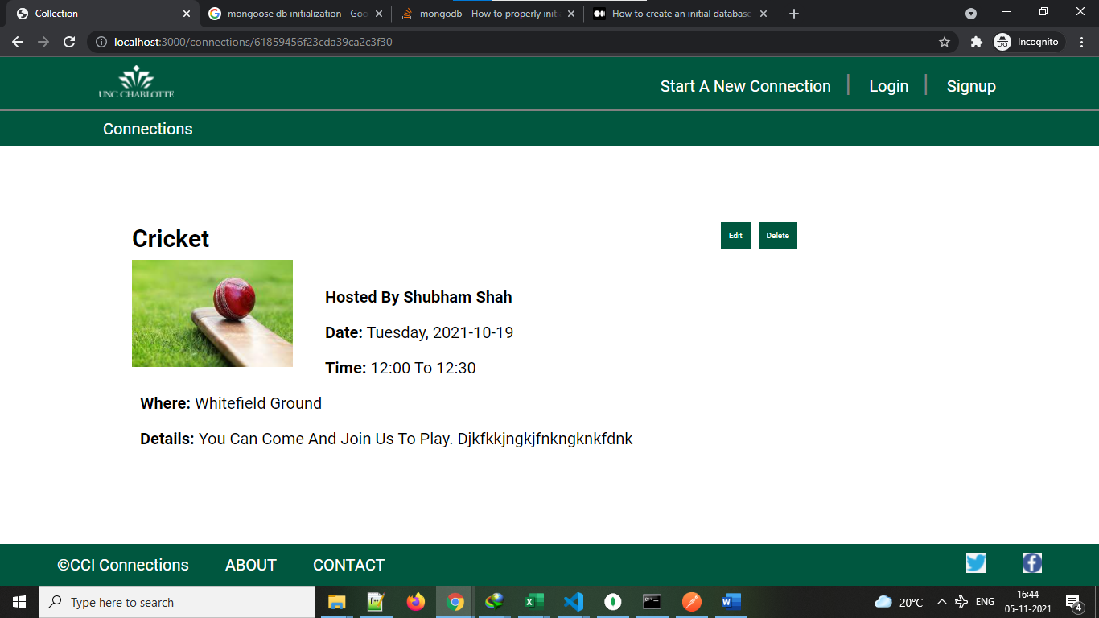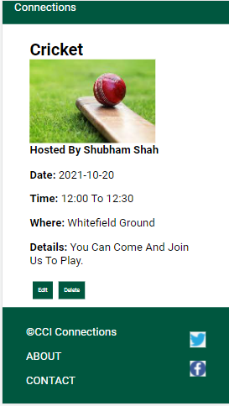

* edit.ejs (After clicking on edit button in connection)
* 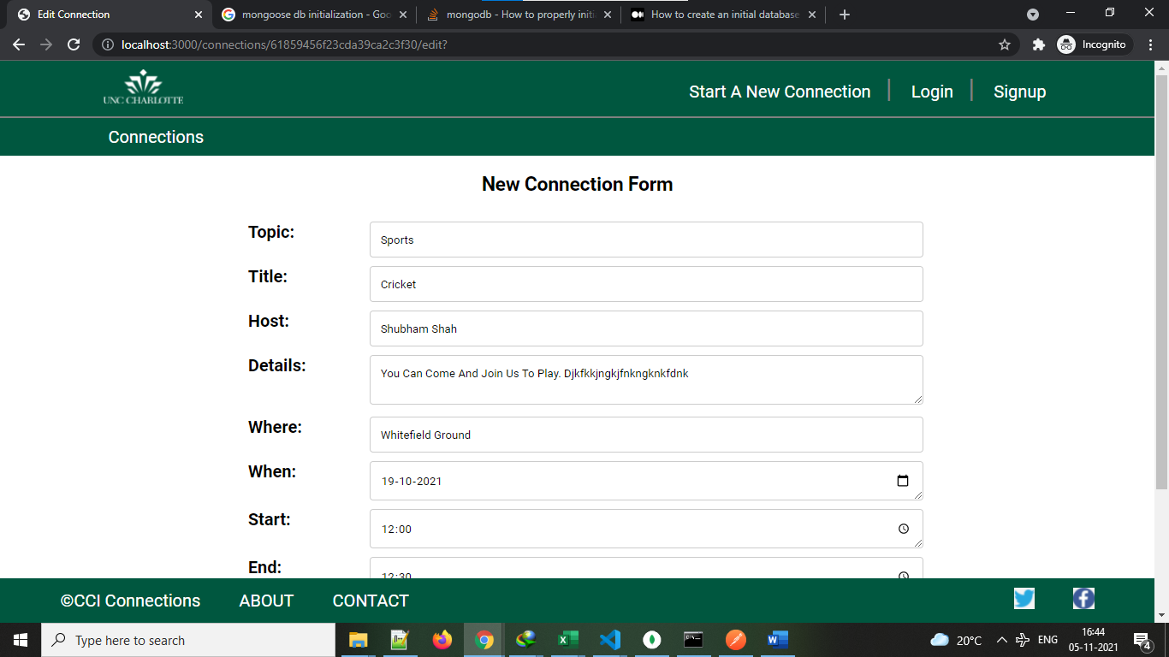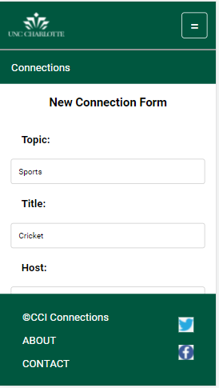
* About.ejs (About page)
* 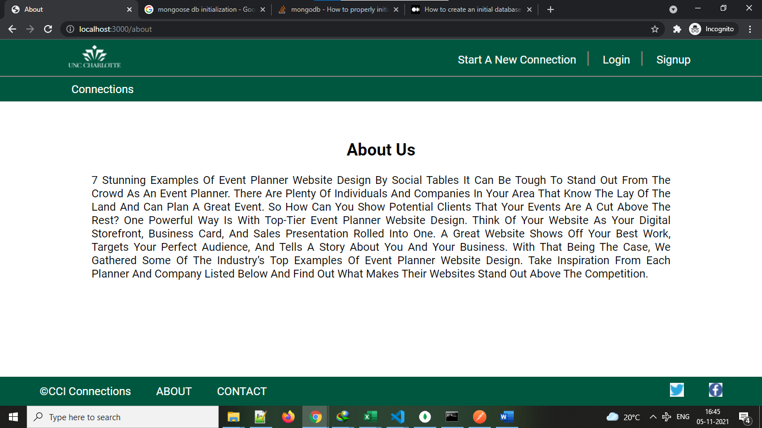
* Contact.ejs (Contact page)



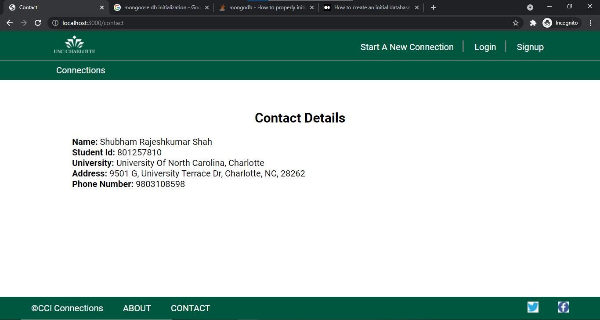

* Error page(error.ejs)

