Create 2 files -> File1 and File2

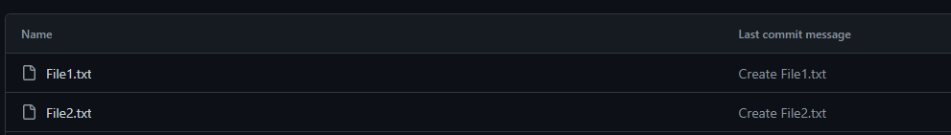

Create 2 branches -> B1 and B2

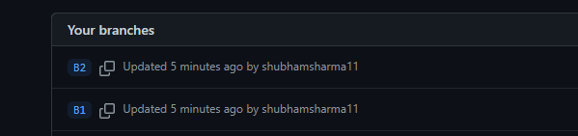

Checkout to B1, Add second line in File1, Commit the changes

Checkout to B2, Add second line in File 2, Commit the changes

Merge the branch B1 to master

Merge the branch B2 to master

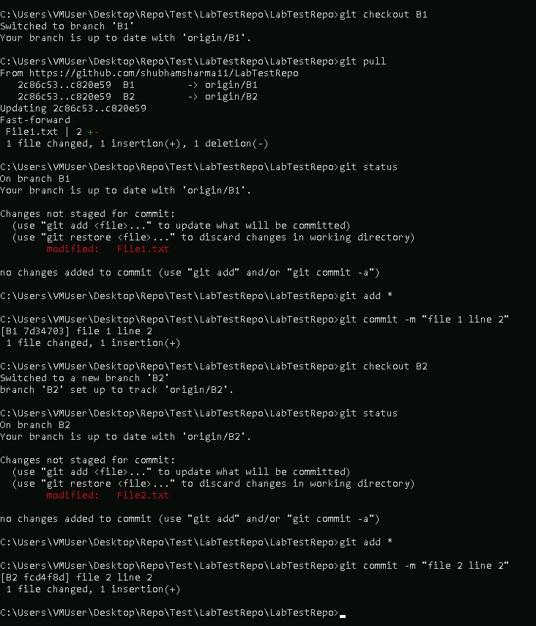

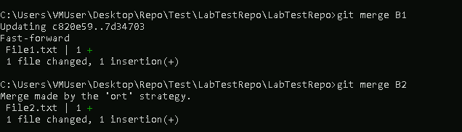

Pull the branch B1 to local repo

