Objective

Deploy website on linux machine using docker via the Azure pipeline.

Part-1: Using the Gui on the Azure pipeline for build and push of the docker image.

Steps:

1. Create Azure pipeline
   1. Build an image
   2. Push an image to ACR
2. Create Classic pipeline

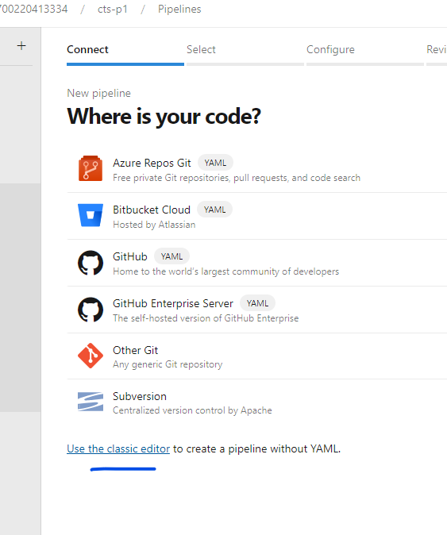

1. Select as mentioned

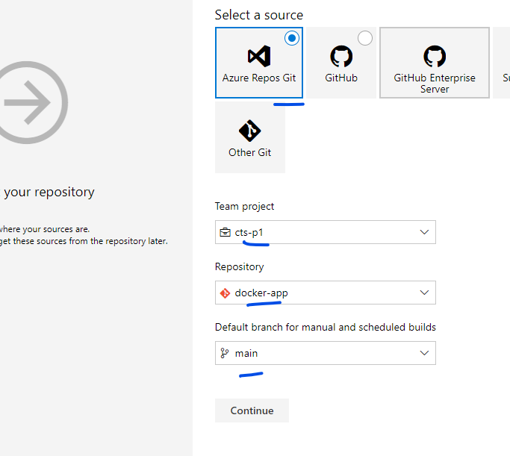

1. Select the Docker Container Template

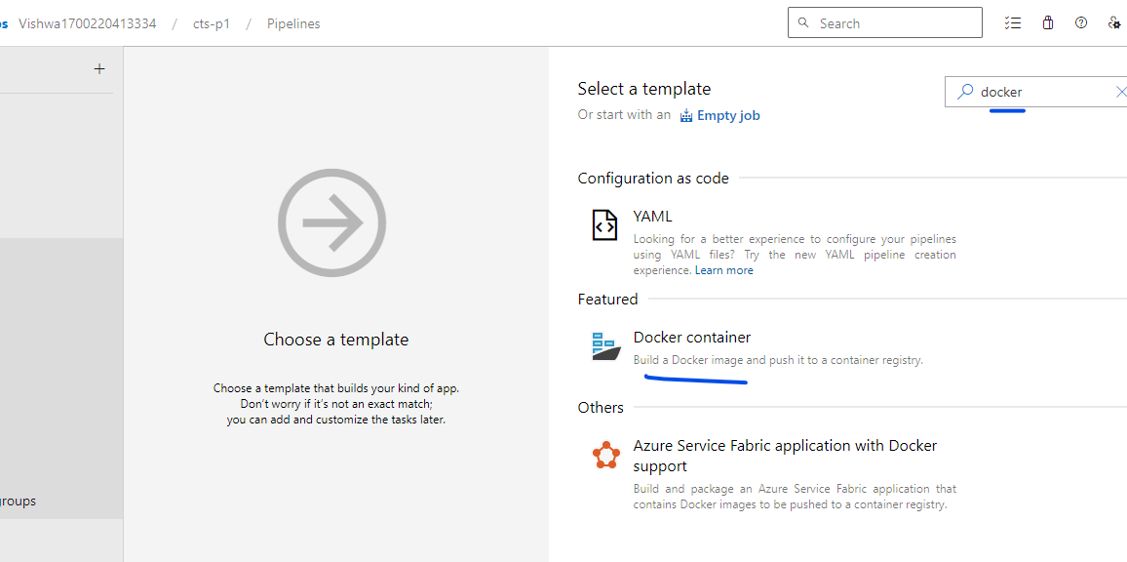

1. Select the Agent Pool

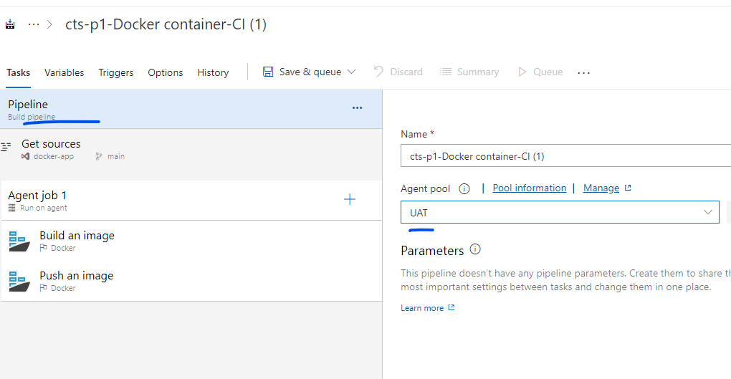

No Changes in the Agent Job option

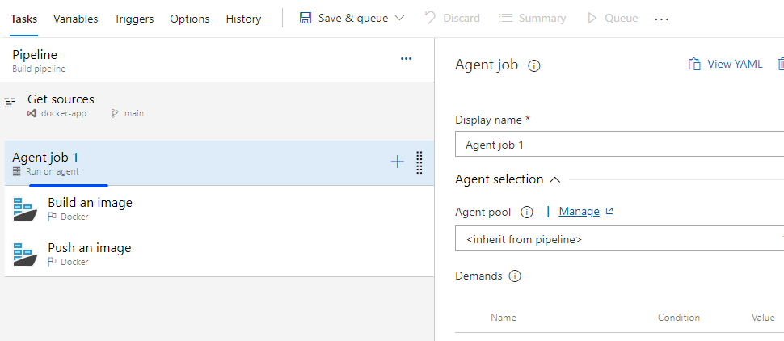

1. IN the “Build an image”

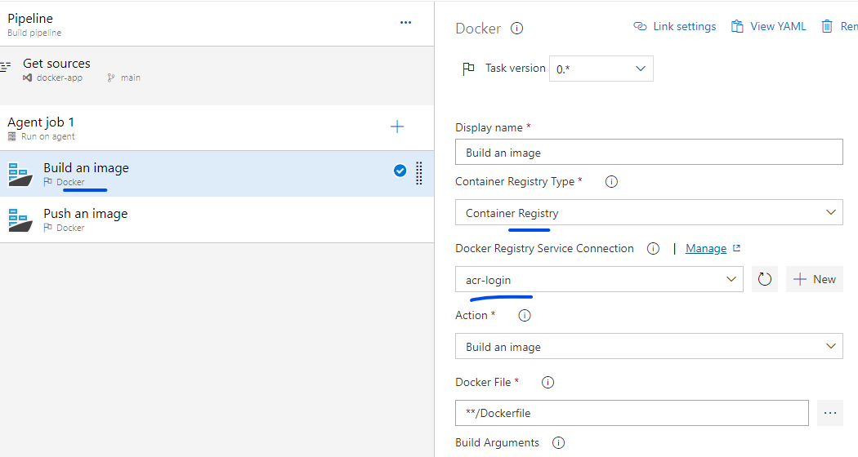

Update

Container Registry and Service connection

Image name as shown below

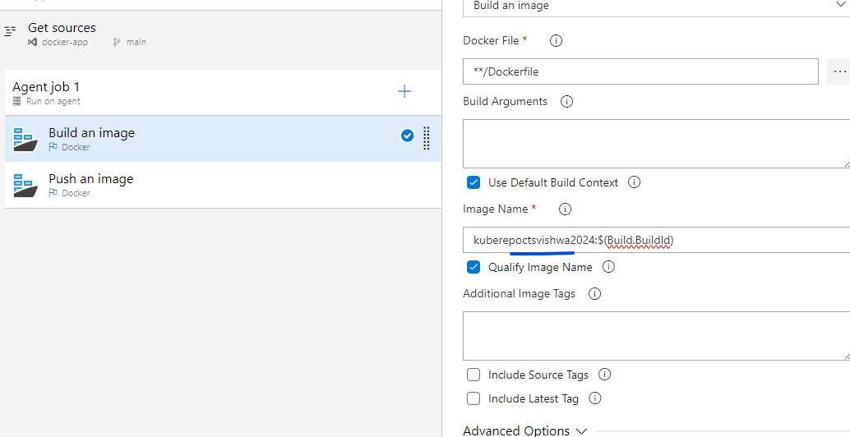

1. Update of “Push an Image” action

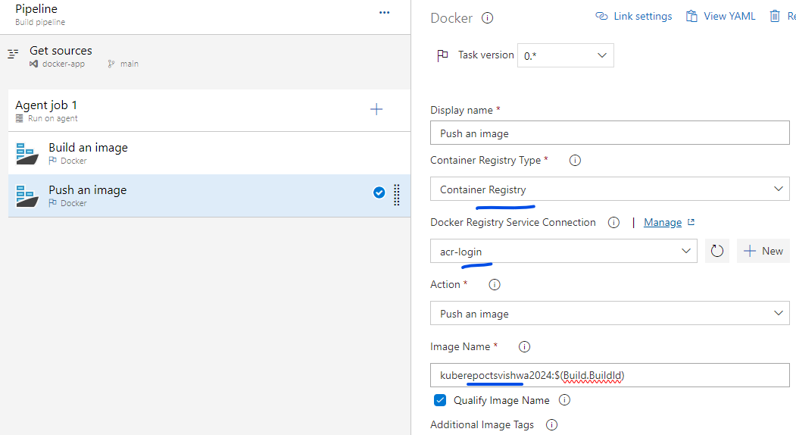

1. Save and queue

Finally check the ACR repo for the latest image upload.

Note: -- we do not have a proper template to run the container on the agent that is custom created.

So we will be using the YAML file in the next example.