Organ Donate



A project report submitted to

Rajiv Gandhi Proudyogiki Vishwavidhyalaya, Bhopal

towards partial fulfillment of

the degree of

**MASTER OF COMPUTER APPLICATION**

**{2020-21}**

**Submitted by:**

Shubham Sharma

0801CA191028

**Guided By:**

Mr Upendra Singh

*Department of Information*

*Technology*

Department of Information Technology

**SHRI G.S. INSTITUTE OF TECHNOLOGY AND SCIENCE**

**INDORE (M.P.)**

**SHRI G.S. INSTITUTE OF TECHNOLOGY AND SCIENCE**

**INDORE (M.P.)**



**Recommendation**

The project report entitled **“Book Shop”** submitted by **Shubham Sharma** students of Second year in the session 2020-21, towards partial fulfillment of the degree of **Master of Computer Applications** of Rajiv Gandhi Proudyogiki Vishwavidhyalaya, Bhopal, is a satisfactory account of his work and is recommended for the award of degree**.**

**Upendra Singh**

Project Guide

Department of IT

**Head**

Department of IT

**Dean(Academics)**

**S.G.S.I.T.S.,Indore**

**SHRI G.S. INSTITUTE OF TECHNOLOGY AND SCIENCE**

**INDORE (M.P.)**



**Certificate**

The project report entitled **“*Book Shop”*** submitted by **Shubham Sharma** students of Second year in the session 2020-21, towards partial fulfillment of the degree of **Master of Computer Applications** of Rajiv Gandhi Proudyogiki Vishwavidhyalaya, Bhopal, is a satisfactory account of their work and is approved for award of the degree.

**Internal Examiner External Examiner**

**Date**

**Acknowledgement**

I am heartily pleased to acknowledge all those people who have helped me in the successful completion of this project. With great pleasure i express my heartfelt gratitude to our esteemed guide, **Mr. Upendra Singh** Lecturer Department of information Technology, S.G.S.I.T.S. Indore. His persistent encouragement, perpetual motivation, everlasting patience and valuable technical inputs in discussions have enabled the successful completion of this project. His invaluable help, advice and constant encouragement helped us a lot and provide impetus to the progress of the project. We extend our profound indebtedness to the Head of the department **Ms. Sunita Varma,** the word loose their worth for her invaluable guidance, continuous encouragement and cooperation in every respect.

I sincerely wish to express our gratitude to all the members of staff of M.C.A.who have extended their cooperation at all times and have contributed in their own way in developing the project. Successful completion of a project is not an individual effort. It is an outcome of the cumulative effort of a number of persons, each having his own importance to the objective. We are thankful to our parents for being a constant source of encouragement in all our endeavors. Indeed it is their support that helps us through the ups and downs of life. The support and suggestion of our friends are worth appreciation and thankfulness. *A blend of gratitude, pleasure, great satisfaction and indebtedness is what, we feel to convey to all those who have directly or indirectly contributed to the successful completion of our project work.*

**Shubham Sharma**

***Table of Contents***

**Chapter 1.**

**Introduction**

1.1 Objective …1

1.2. Scope …1

1.3. Technologies used …1

**Coding 2-3**

**Output 4-5**

**References**

**Chapter 1**

**Introduction**

* 1. **Objective**

Aim of “**Book Shop**” to manage the details of books .

* 1. **Scope**

 To record the details variousbooks**.**

* 1. **Technology used**

1. Java

**Coding**

import java.util.*;  
class bookshopmethods  
{  
 Scanner in = new Scanner(System.in);  
 int n=2;  
 String[] title = new String[n];  
 String[] author = new String[n];  
 String[] publisher = new String[n];  
 int[] cost = new int[n];  
 int[] count = new int[n];  
 void setdata()  
 {  
 for(int i=0;i < n;i++)  
 {  
 System.out.println("Enter the title of the " + (i+1) +" book:");  
 title[i] = in.nextLine();  
 System.out.println("Enter the author of the " + (i+1) +" book:");  
 author[i] = in.nextLine();  
 System.out.println("Enter the publisher of the " + (i+1) +" book:");  
 publisher[i] = in.nextLine();  
 System.out.println("Enter the cost of the " + (i+1) + " book:");  
 cost[i]=in.nextInt();  
 System.out.println("Enter the number of books present in the Book shop:");  
 count[i]=in.nextInt();  
 in.nextLine();  
 }*//end of for loop* }*//end of setdata function* void search()  
 {  
 int i;  
 System.out.println("***********Books present in the Book shop are*************");   
 for(i=0;i<n;i++)  
 {  
 System.out.println((i+1) + ". Title of the book:" +title[i]);  
 }  
 System.out.println("Enter the title of the book needed:");  
 String titkey;  
 titkey = in.nextLine();   
 int flag=0;  
 for(i=0;i<n;i++)  
 {  
   
 if(titkey.equals(title[i]))  
 {  
 flag++;  
 break;  
 }*// end of if condition* }*// end of for loop* if(flag != 0)  
 {  
 System.out.println("******Details of the book you needed is*****");  
 System.out.println("Title of the book:"+title[i]);  
 System.out.println("Author of the book:"+author[i]);  
 System.out.println("Publisher of the book:"+publisher[i]);  
 System.out.println("Cost of the book:"+cost[i]);  
 System.out.println("Number of books presernt in the Book shop:"+count[i]);  
 }*//end of if condition* else  
 System.out.println("Book not present in the store");  
 }*//end of search function*}*//end of class*class bookshop  
{  
 public static void main(String arg[])  
 {  
 int ch;  
 bookshopmethods ob = new bookshopmethods();  
 Scanner in = new Scanner(System.in);  
 while(true)  
 {  
 System.out.println("********************MENU IS****************");  
 System.out.println("\t\t1.To enter the data\n\t\t2.To search a book\n\t\t3.Exit");   
   
 System.out.println("Enter your choice from the above menu:");  
 ch = in.nextInt();  
 switch(ch)  
 {  
 case 1: ob.setdata();  
 break;  
 case 2: ob.search();  
 break;  
 case 3: System.exit(0);  
 }*//end of switch case* }*// end of while loop* }*//end of main function*}*// end of class*

**Result**

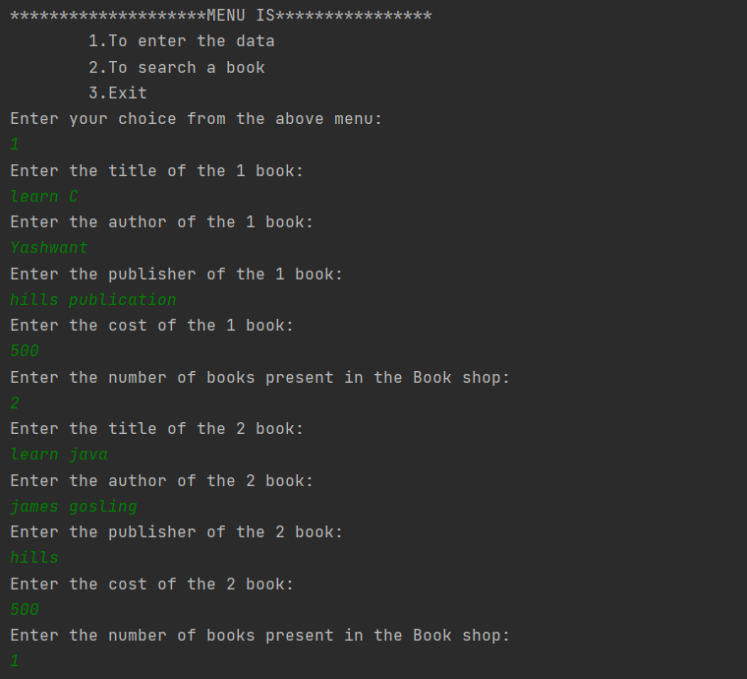

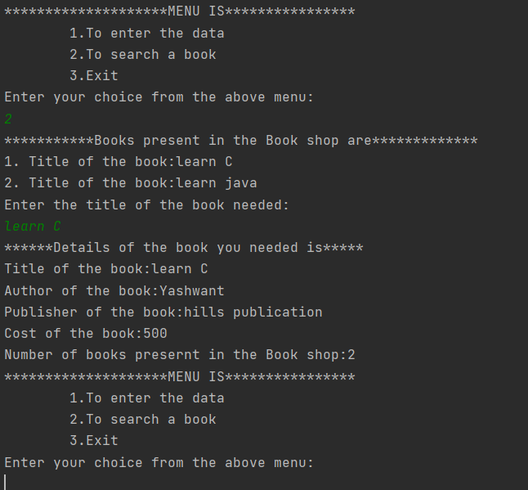

**References**

* [www.javatpoint.com](http://www.javatpoint.com)
* [www.geeksforgeeks.com](http://www.geeksforgeeks.com)