**Abstract**

Stock prediction has been one of the major target problems of the artificial intelligence domain. Since its beginning, people have tried to predict the share price values of stocks based on various parameters. However, predicting the exact value of any share is a near impossible task as it governed by infinitely many variables. Historical data, government policies, budgets, natural disturbances, to name a few of them. Hence, instead of predicting the exact value of a given share, we propose to predict the direction and intensity of change in the value of stock indices of India based on historical data. We propose to build a network of patterns seen in the 3 major stock indices of our country namely – SENSEX, NIFTY50 and NIFTY Consumption. After using the centrality measures of this network, we propose to use them as input variables to various classification methods such as KNN, K-means, SVM and certain deep learning strategies such as use of neural networks as well in order to classify the patterns of our test data. We also propose to combine the results of these techniques with some common trading strategies in order to enhance the results.

**Introduction**

Stock market prediction is a separate domain of research now. In the past, any study used to be centric towards manual data analysis and analysing figures of patterns in price variations which were used to determine how the market “might” behave in the future. However, with the advent of artificial intelligence, using AI tools has now become a common idea. Although the idea of applying machine learning and deep learning techniques on stock prices data feels like an easy task, the way in which it is applied can significantly change the results.

The research area in which we are going to delve is that of graphs and networks. The research in this domain is interesting in the sense that people find general classification strategies to be much more effective in terms of stock market. The motivation behind our study is not to accurately predict the stock market for next few days but rather predict the behaviour which it “might” show in the near future based on historical data. This becomes a classification task as one needs to only consider whether the market will go up or down. The best parameter to consider in this regard is the volatility parameter which calculates the dispersion of share price values. It is going to be the centre of this study and will significantly affect the results.

The major contributions of this research include –

* To experiment with various classification technqiues in machine learning to predict the pattern in which the market will behave.
* To combine the classification techniques with some common trading strategies to enhance the performance of the models.

**Literature Survey**

**Global stock market investment strategies based on financial network indicators using machine learning techniques**

This paper combines the varying markets around the world to form a network and use all of them to perform a time series forecasting on stock data using some simple machine learning algorithms such as regression, random forests and SVM. The paper uses the parameter of volatility for forecasting the Z-score of each stock indices and then applies two strategies to find out which one performs better with each algorithm.

**Forecasting stock crash risk with machine learning**

This paper experiments with various features in order to find out which feature is responsible towards the financial distress of a stock. It also sheds light on the use of NLP techniques in order to extract data from news articles and find the features of stock market which has the highest variability in its SHAP score. It also uses distance-to-default parameter. It mainly focuses on news articles and business news in order to predict the directions of stock market and look for crashes.

**Stock Price Pattern Prediction Based on Complex Network and Machine Learning**

This paper converts the problem of prediction into a classification one by not actually predicting the price but rather predicting the trend in the stock price. It considers 3 most popular stock indices of the US stock market. It finds the pattern of fluctuations in stock prices using returns and volatility and classifies them into 4 separate behaviours. It then constructs a graph for these parameters of 30 days for the entire training dataset. Centrality measures for these graphs are then calculated which act as input variables for KNN and SVM classification algorithms in order to perform prediction on testing data.

**Novel Method of Identifying Time Series Based on Network Graphs**

This study experiments with various types of time series data and then converts them into graph. Each time series results in a separate kind of graph. The constant time series turns into a complete graph. The periodic time series like a sine graph turns into a regular graph and so on. The properties of the graph such as their centrality measures, clustering coefficient etc. gives information about the time series.

**A hybrid supervised semi-supervised graph-based model to predict one-day ahead movement of global stock markets and commodity prices**

This paper uses a semi-supervised approach by building a network of stock indices in the same time zone. The supervised portion of the model predicts the movement of stock market which then sends these results into the network. The research compares its results with the traditional classification methods such as KNN, SVM and Random Forests etc. with their model of HyS3 and Kruskal based graph construction.

**Factors Affecting Stock Prices in the UAE Financial Markets**

This research focuses on the development of the stock market in the United Arab Emirates (UAE) and aims to identify the key factors influencing stock prices in this emerging market. Covering the period from 1990 to 2005 and based on data from 17 companies, the study employs regression analysis with five independent variables, excluding oil price and dividend per share due to multicollinearity issues. Notably, the findings align with previous research, revealing a strong and positive impact of earnings per share (EPS) on UAE stock prices. Money supply and GDP exhibit expected positive coefficients, albeit statistically insignificant, while the consumer price index demonstrates a significant negative relationship with stock prices, particularly at the 1% confidence level, unlike the interest rate, which remains statistically insignificant.

**A method for automatic stock trading combining technical analysis and nearest neighbour classification**

This paper uses a nearest neighbour classifier and checks whether considering only historical data can be feasible in analysis of stock market or not. It uses technical indicators such as stop loss, stop gain, RSI filter as parameters for its own trading strategy. It compares the results of the traditional buy-and-hold strategy with its own. The variable to analyse here was profit which turned out to be better than the buy-and-hold strategy’s profit.

**Applications of deep learning in stock market prediction: Recent progress**

A review paper which summarizes the latest progress in deep learning approaches towards stock market prediction. The research pays special attention to implementation and reproducibility. It points out future directions of research in similar domains. The major models considered are some of the time series models like ARIMA, LSTM etc. and classification models like KNN, SVM, K-means etc. The review also combined all the repositories from GitHub into one single repository.

**An innovative neural network approach for stock market prediction**

The paper proposes two models, one time series model of LSTM with an embedded layer and the other one with an automatic encoder. The models are applied to the Shanghai A-share composite index and Sinopec. The LSTM model with the encoder gives better performance than a stochastic forecast. This research is also closely related to IMMT (Internet of Multimedia of Things) for financial analysis.

**Problem Statement**

To classify stock price variation patterns using various machine learning techniques and evaluate them on real data.

**Methodology and Work Done**

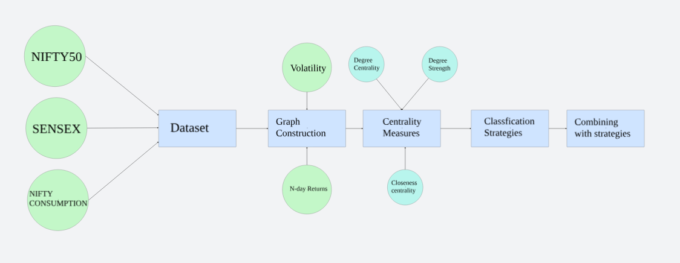

Figure 1: Workflow of research

1. **Dataset**

The dataset used in this research consists of the closing prices of 3 stock indices of India namely SENSEX, NIFTY50 and NIFTY Consumption every day from 01-01-2014 to 31-12-2023 (10 years). SENSEX is a free-float market capitalization consisting of 30 most traded and relatively liquid stocks which contribute towards the balance of the country’s equity market. NIFTY50 on the other hand is a benchmark index of 50 companies. NIFTY Consumption reflects the performance of companies in the domestic consumption sector. The data for SENSEX and NIFTY50 is taken from MarketWatch and NIFTY Consumption is taken from Yahoo Finance.

1. **Creation of graph**

The graph is constructed using the study of Cao, Lin et. al. who have used *N*-day volatility *V*, and *N*-day return *R* in order to divide the movement of stock index in 4 separate variations.

Here, *t* refers to the current day in consideration and *N* refers to the number of continuous trading days (generally a week if there is no national holiday) and *Close(t)* refers to the closing price of the stock index on *tth* day. In order to find out *V*, we need to find one-day return, r which is given by

After calculating *r*, we can calculate *V* for *N* days by,

Where refers to the standard deviation of

We can now calculate the average Volatility of entire stock index in question by simply averaging over the entire time series.

In addition to comparing with the entire time series, the volatilities will also be compared with an average of volatilities of a definite window size (30 days).

Now, in order to build the network using the two parameters mentioned earlier, we can devise 4 types of patterns. We can classify the changes in any stock index in the following way –

This classification is done for all the 3 indices and the combination of the patterns formed represents a node of a graph. Since the total number of combinations can be 43 = 64, we used a 4-base number system as nodes *u* and *v* for the graph.

The graph is constructed for 30 days although experimenting with other window sizes is still a future prospect of this research.

|  |  |  |  |  |
| --- | --- | --- | --- | --- |
| Index | SENSEX | NIFTY50 | NIFTY Consumption | Combined Pattern |
| 1 | P3 | P2 | P1 | P3P2P1 |
| 2 | P4 | P1 | P4 | P4P1P4 |
| 3 | P2 | P1 | P3 | P2P1P3 |
| 4 | P3 | P2 | P1 | P3P2P1 |
| 5 | P1 | P2 | P3 | P1P2P3 |
| 6 | P2 | P1 | P3 | P2P1P3 |
| 7 | P3 | P2 | P1 | P3P2P1 |
| … |  |  |  |  |
| 30 | P1 | P2 | P4 | P1P2P4 |
| 31 | P2 | P3 | P3 | P2P3P3 |

Table 1: Sample patterns for 7 days of data of SENSEX, NIFTY50 and NIFTY Consumption

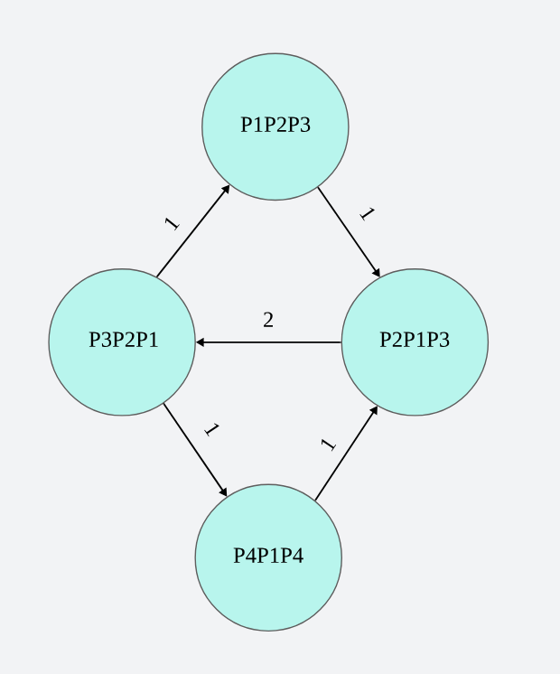

Figure 2: Example Weighted pattern graph for the data mentioned in Table 1 for the first 7 days

1. **Centrality measures as input variables**

The significance of this graph is that the denser this graph is, more is the dispersion and hence more care needs to be taken by investors while investing. Hence, we consider certain centrality measures in order to feed them as characteristics of our graph for classification on unseen data.

The measure we are considering for this research are degree centrality, strength (as described by Cao, Lin et. al.), closeness centrality and betweenness centrality. So far, we have applied the KNN algorithm for degree centrality and strength of the network.

The centrality measures considered for this research include –

* Degree centrality – Degree centrality is defined for a particular node of a graph which is equal to the total number of edges connected to it.

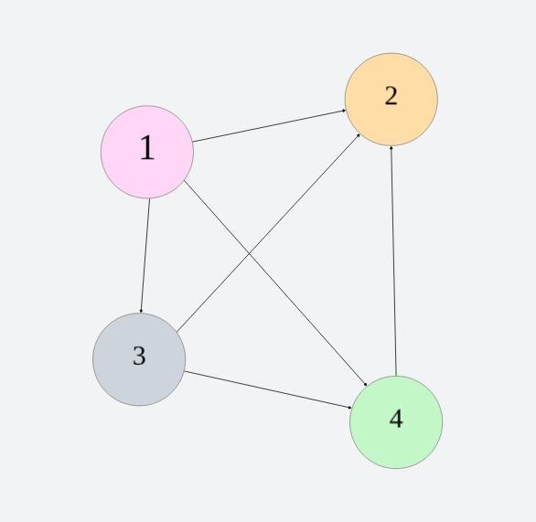

In the figure, the degree centrality of node labelled *2* is 3 as it has 3 edges.

* Closeness centrality – Closeness centrality denotes how “close” a particular node is to other nodes. Mathematically, it is calculated as the inverse of the summation of all closest distances of nodes from the node in consideration.

Here, *N* represents the total number of nodes in the graph and *dij* represents the shortest distance between nodes *i* and *j.*

* Degree strength – Although, not a very prominent centrality measure, it is very similar to the degree centrality but the difference is it considers weighted graph where instead of the number of edges connected to the node, it is the total weight of the edges connected to the node.

These three centrality measures will act as input variables to our classification algorithms with the closing price of the 30th day being our target variable.

Since this is a classification problem, we are going to focus on whether the closing price went up or down after a particular window period. If the price went up, the target variable is going to be 1 and if the price went down then the target variable is going to be 0.

After this the research is mainly divided into two parts –

* Pattern Recognition for One-day - In one phase of the project, we treat the window of *N* days as a training portion which we use to classify *Nth* day closing price. This generally corresponds to a “buy-and-hold” strategy in which the time period for which the share is being held corresponds to the window size of N days.
* Pattern Recognition for the entire graph - Second phase of the project will cater to the short-term investment where we classify the graphs constructed using these windows of *N* days and investors will look at the behavior of the market and will act according to the corresponding graph constructed.

**Pattern recognition for One-day**

**Future Work**

The following are the major contributions of this research which are yet to come in the future:

1. Applying various classification methods including SVM, random forest, deep learning strategies including neural networks in order to compare the strategies and find out the best one. We will also consider ensemble techniques by combining multiple classification strategies together.
2. Currently, we worked with only two centrality measures. In the future, we will work with more centrality measures such as betweenness centrality and closeness centrality in order to increase the input variables for classification algorithms.
3. We will also practically apply these machine learning techniques by using them through various investment strategies in trading simulators to better evaluate our results.
4. Currently, a window size of 60 days is only considered. However, graphs with other window sizes will also be considered on which these algorithms will be applied again. This will generate more results.

**References**

[1] Lucas Lacasa, Bartolo Luque, Fernando Ballesteros, Jordi Luque and Juan Carlos Nun. From time series to complex networks: The visibility graph

[2] Yung-Keun Kwon, Sung-Soon Choi and Byung-Ro Moon. Stock Prediction based on Financial Correlation.

[3] Ying Li, Hongduo Cao and Yong Tan. Novel Method of Identifying Time Series Based on Network Graphs. Department of Management Science, Business School, Sun Yat-Sen University, Guangzhou 510275, China

[4] Minggang Wang, Ying Chen, Lixin Tian, Shumin Jiang, Zihao Tian, Ruijin Du. Fluctuation behaviour analysis of international crude oil and gasoline price based on complex network perspective. Accepted at Elsevier, May 2016.

[5] Michel Ballings, Dirk Van den Poel, Nathalie Hespeels, Ruben Gryp. Evaluating multiple classifiers for stock price direction prediction. Accepted at Elsevier, May 2015.

[6] Lamartine Almeida Teixeira, Adriano Lorena Inácio de Oliveira. A method for automatic stock trading combining technical analysis and nearest neighbour classification. Accepted at Elsevier.

[7] Hongduo Cao, Tiantian Lin, Ying Li, and Hanyu Zhang. Stock Price Pattern Prediction Based on Complex Network and Machine Learning. Accepted at Wiley, May 2019

[8] Arash Negahdari Kiaa, Saman Haratizadeha, Saeed Bagheri Shourakib. A hybrid supervised semi-supervised graph-based model to predict one-day ahead movement of global stock markets and commodity prices. Accepted at Expert Systems with Applications, March 2018

[9] Jan Grudniewicz, Robert Slepaczuk. Application of machine learning in algorithmic investment strategies on global stock markets. Accepted at Elsevier, July 2023.

[10] Tae Kyun Leea, Joon Hyung Chob, Deuk Sin Kwonb, So Young Sohnb. Global stock market investment strategies based on financial network indicators using machine learning techniques. Accepted at Expert Systems with Applications, September 2018.

[11] Hussein A. Hassan Al-Tamimi, Ali Abdulla Alwan & A. A. Abdel Rahman. Factors Affecting Stock Prices in the UAE Financial Markets. Accepted at Transnational Management, March, 2011.