Creative Delivery
Web Application Platform v1.0
System Architecture & Application Flow
Technical Design Document • Client: A. Centauri Software
Version 1.0 • July 2026

1. Application Overview
A highly scalable, real-time courier service platform connecting customers who need packages delivered with independent contractor couriers. Deliveries are offered in multiple tiers (Express, Same-Day, Scheduled) with instant distance- and tier-based quotes. A real-time dispatch engine matches each booking to nearby online couriers, and live GPS tracking keeps customers, couriers, and operations synchronised from pickup to proof of delivery.

2. Technology Stack
- Frontend: React — customer app, courier/contractor app, and ops/admin console
- Core backend: Django + Django REST Framework (Python) — accounts, orders, pricing, payments, ratings
- Real-time service: FastAPI (async Python) — dispatch/matching engine, WebSocket live tracking, ETA/route service, courier presence
- Database: PostgreSQL + PostGIS — geo indexes, deliveries partitioned by month, read replicas for history/analytics
- Cache & messaging: Redis — GEO sets of online couriers, Pub/Sub for offers and tracking fan-out, offer locks, Celery broker
- Background jobs: Celery — invoices, payout batches, notification fan-out
- File storage: S3 + CDN — proof-of-delivery photos/signatures, KYC documents, invoices
- External: payment gateway (charges + contractor payout rails), maps/routing/geocoding API, push/SMS/email, KYC & background checks

3. Core Services
- Accounts & Onboarding — JWT auth; contractor KYC, vehicle documents, approval workflow
- Order & Booking Service — full delivery lifecycle state machine (booked → assigned → picked up → in transit → delivered)
- Pricing & Tier Engine — Express / Same-Day / Scheduled quotes from distance, tier rates, and surge factors
- Dispatch / Matching Engine (FastAPI) — Redis GEO nearest-courier search with ranked offer waves and offer locks
- Live Tracking (FastAPI WebSockets) — courier GPS in, customer map and ops fleet view out, live ETA refresh
- Payments & Payouts — authorise at booking, capture on delivery; batched contractor settlements
- Ratings & Disputes — two-way reviews and claims workflow

4. System Architecture Diagram
Three React surfaces connect through an NGINX gateway to a hybrid Python backend: Django/DRF owns the transactional core (accounts, bookings, pricing tiers, payments and payouts, ratings), while a FastAPI service owns everything real-time — the dispatch/matching engine, WebSocket live tracking, ETA/route computation, and courier presence — with the two sides talking over internal REST. Redis GEO sets hold live courier positions for sub-second nearest-courier matching; PostgreSQL + PostGIS is the durable source of truth with partitioned delivery history.
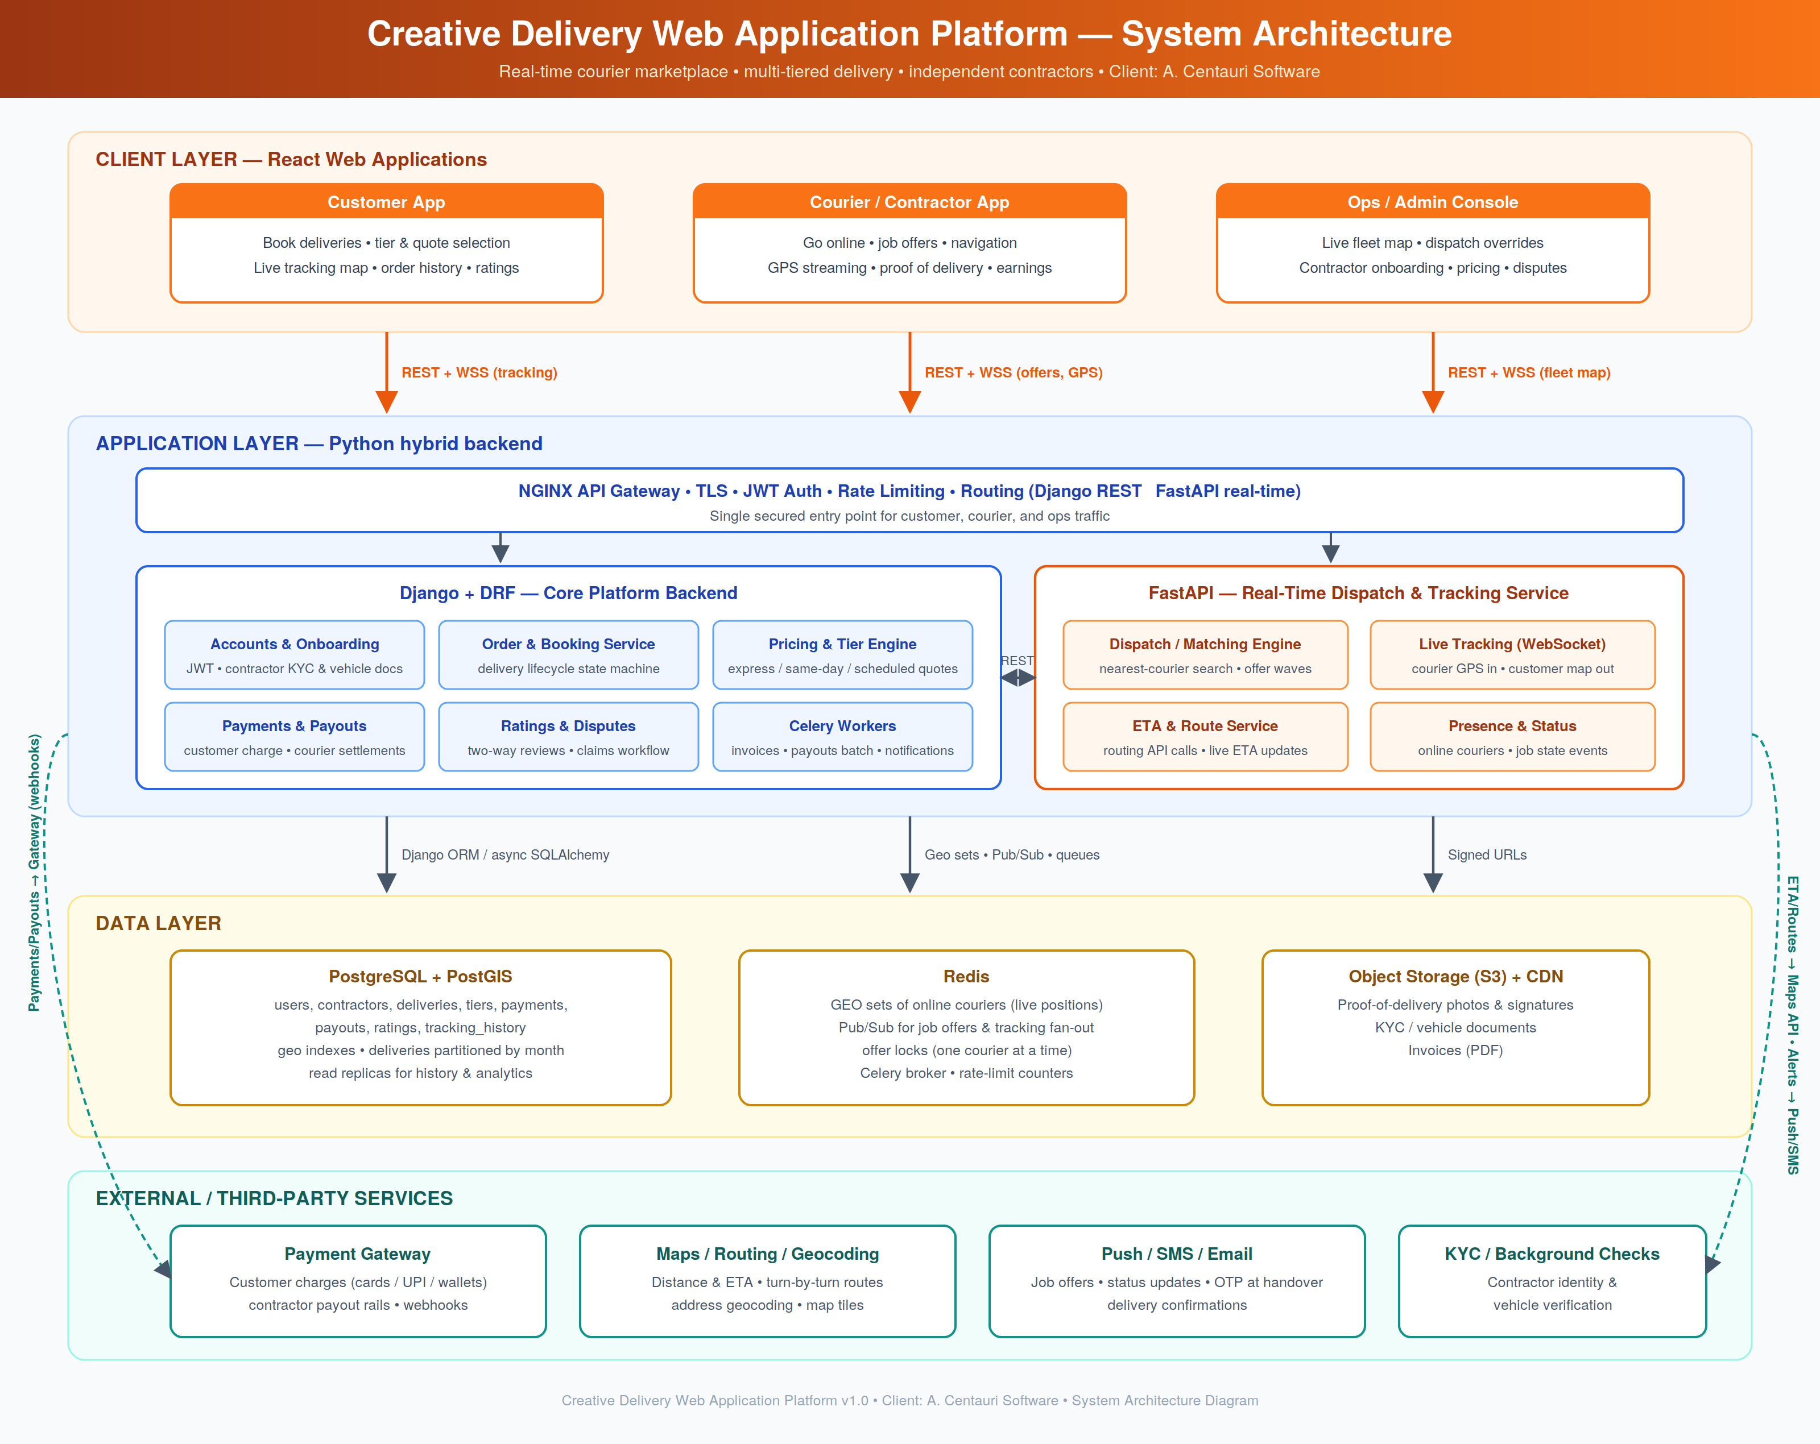

5. Application Flow Chart
The flow branches by user type. Customers enter pickup/drop details, choose a delivery tier, receive an instant quote, and confirm with an authorised payment. Couriers complete one-time KYC onboarding, then go online — streaming GPS into the Redis GEO presence set. The dispatch engine matches each booking to the best nearby courier with a locked, time-limited offer, rebroadcasting in waves on timeout. After OTP-verified pickup, live WebSocket tracking runs until handover; failed handovers route through an exception flow. Successful delivery captures proof of delivery, triggers payment capture and courier payout accrual, and requests two-way ratings — with loops for the customer's next booking and the courier's next job.
