Restaurant Online
Web Application v1.0
System Architecture & Application Flow
Technical Design Document • Client: A. Centauri Software
Version 1.0 • July 2026

1. Application Overview
A highly scalable restaurant management platform that unifies two customer journeys in one system: online food ordering with pickup and delivery fulfilment, and real-time table reservations. The customer web app, the restaurant dashboard with a live kitchen display (KDS) and floor plan, and the admin console all operate against a shared backend, so a table booked online, a walk-in seated by the host, and an order flowing through the kitchen all reflect one live state.

2. Technology Stack
- Frontend: Next.js (React) — customer web app, restaurant dashboard + KDS, admin console
- Core backend: Django + Django REST Framework (Python) — auth, menu/catalog, orders, payments, loyalty
- Real-time service: FastAPI (async Python) — table availability engine with seat holds, order-status WebSocket stream, prep-time/ETA engine, delivery tracking relay
- Database: PostgreSQL — orders partitioned by month; an exclusion constraint prevents double-booked tables; read replicas for reports
- Cache & messaging: Redis — per-slot availability cache, seat holds (TTL), Pub/Sub for KDS/status/tracking events, cart sessions, menu (86'ing) cache, Celery broker
- Background jobs: Celery — receipts, reservation reminders, daily reports
- File storage: S3 + CDN — dish photography, receipts/invoices
- External: payment gateway (orders + reservation deposits), delivery/logistics API, SMS/email/WhatsApp, maps/geocoding for delivery zones

3. Core Services
- Auth & Accounts — JWT for customers; staff roles (host, kitchen, manager) for the dashboard
- Menu & Catalog — items, modifiers, and live availability with instant 86'ing (sold-out) propagation
- Order Service — pickup/delivery lifecycle state machine feeding the KDS
- Table Availability Engine (FastAPI) — live slot computation, seat holds with TTL, no-show release
- Payments — order checkout, peak-slot reservation deposits, refunds, webhook confirmation
- Loyalty & Promotions — coupons, points, happy-hour pricing
- Order Status Stream & Delivery Tracking (FastAPI) — kitchen events to customer tracker; rider position to map

4. System Architecture Diagram
Three Next.js surfaces connect through an NGINX gateway to a hybrid Python backend: Django/DRF owns the transactional core (menu, orders, payments, loyalty) while a FastAPI service owns everything real-time — the table availability engine with TTL seat holds, the order-status WebSocket stream that links the kitchen display to the customer's tracker, dynamic prep-time ETAs, and delivery tracking. PostgreSQL guarantees reservation integrity with an exclusion constraint on table/time ranges; Redis carries the live world (availability cache, holds, event Pub/Sub).
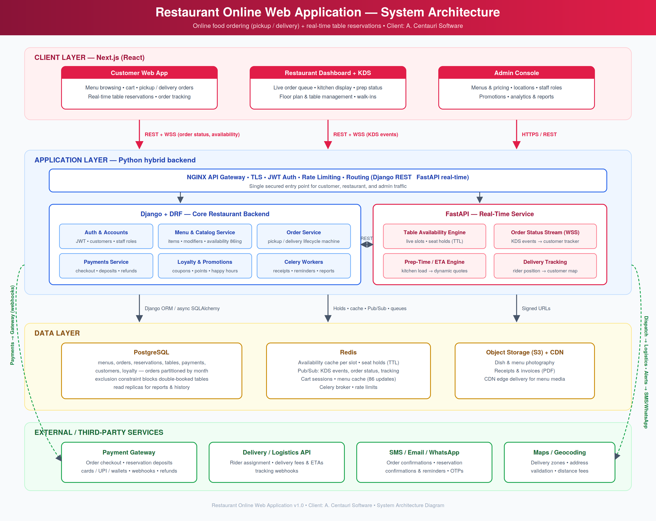

5. Application Flow Chart
The flow branches by customer intent. The ordering path runs: browse menu → pickup-or-delivery choice (zone check and fee for delivery, prep-time slot for pickup) → checkout with retry on payment failure → kitchen display (accepted → preparing → ready) → counter handover or rider dispatch with live tracking → completion with receipt and loyalty credit. The reservation path runs: pick date/time/party size → real-time availability check → alternate-slot suggestions when full → TTL seat hold → confirmation (optional deposit) with reminders → arrival check with a grace-window no-show release → seated → dine and settle, releasing the table. Both paths converge on feedback, with a loop for returning customers.
