Enterprise AI
Policy Chatbot
System Architecture & Application Flow
Technical Design Document
Version 1.0 • July 2026

1. Application Overview
A conversational agent that streamlines internal policy inquiries. Employees ask questions in natural language ('How many WFH days am I allowed?') and receive answers grounded in the company's actual policy documents, with citations to the source sections. Built with the Next.js framework — the chat UI and the API layer live in one codebase — using the OpenAI SDK for both embeddings and chat completions, and deployed on Netlify, where the frontend is served from the edge CDN and the API routes run as serverless functions.

2. Technology Stack
- Framework: Next.js (React) — employee chat interface + policy admin view, API routes as the backend
- AI: OpenAI SDK — embeddings for indexing and query, chat completions (streamed) for grounded answers
- Knowledge base: policy documents (HR, IT, compliance) chunked by section and stored as vectors with metadata (policy, section, version, effective date)
- Retrieval: top-k semantic search over the vector store with a relevance threshold; below-threshold questions get an honest 'not covered' response with HR escalation
- Auth: enterprise SSO (Okta / Azure AD) — session JWT; employee vs admin roles
- Deployment: Netlify — Git-triggered CI/CD builds, edge CDN for the app, serverless functions for /api/chat and /api/ingest, environment secrets (OPENAI_API_KEY, SSO config), deploy previews per PR, atomic deploys with instant rollback
- Feedback loop: 👍/👎 on every answer, unanswered-question queue, and escalation tickets — feeding admin analytics and policy-gap review

3. Core Components
- Auth Middleware — SSO session validation and role checks on every API call
- /api/chat RAG Pipeline — embed query → retrieve policy chunks → grounded completion with citations
- /api/ingest Knowledge Pipeline — parse, chunk, embed, and upsert policy documents on upload/update
- Guardrails — answers stay within policy scope, no legal/HR advice, low-confidence answers escalate
- Conversation & Feedback Logger — PII-minimised transcripts, feedback signals, unanswered-question queue
- OpenAI SDK Client — streaming completions with timeouts and retries

4. System Architecture Diagram
One Next.js codebase, two runtime surfaces on Netlify: the React app on the edge CDN and the API routes as serverless functions. The starred components define the product: the /api/chat RAG pipeline grounds every answer in retrieved policy chunks, and the Guardrails keep responses inside policy scope with escalation on low confidence. The data layer separates the vector store (embeddings + metadata for retrieval) from the versioned policy source documents and the transcript/feedback logs, and the bottom layer shows the Netlify CI/CD path from Git push to atomic deploy with instant rollback.
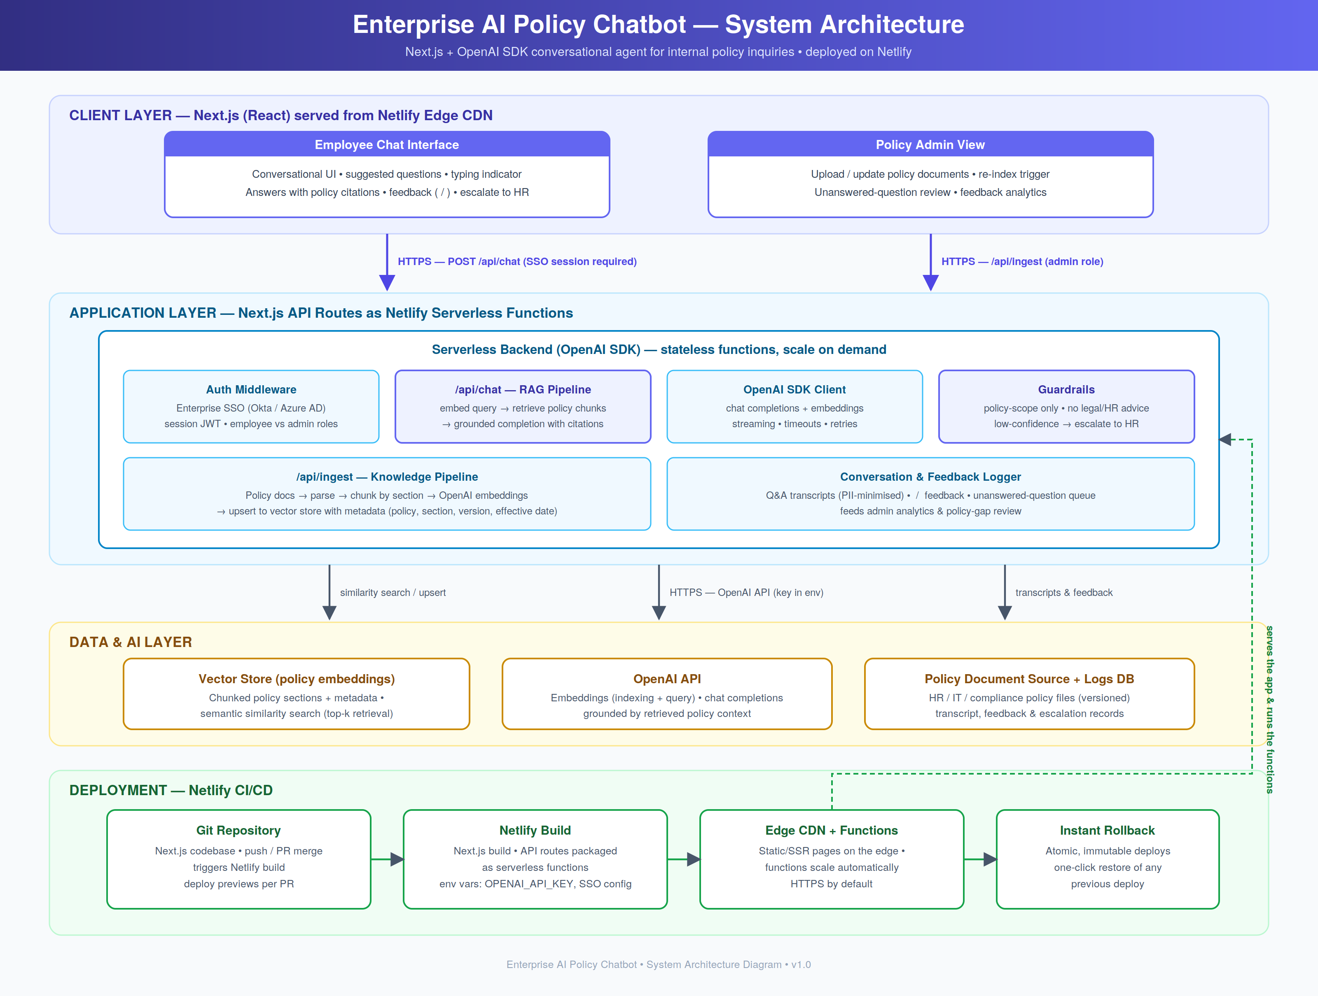

5. Application Flow Chart
The dashed strip shows the ingestion pipeline that runs whenever an admin uploads or updates policy documents: parse → chunk by section → OpenAI embeddings → vector store. The runtime loop below: an employee opens the chatbot (SSO-gated, with redirect to login), asks a question, and /api/chat embeds the query and retrieves policy chunks. Above-threshold matches flow into a streamed OpenAI completion and render as an answer with policy citations; below-threshold questions return an honest 'not covered' response with HR escalation and are logged for policy-gap review. Every answer collects 👍/👎 feedback — unhelpful answers open an escalation ticket — and the loop continues until the employee is done.
