Shopping Bags
E-commerce Platform
System Architecture & Application Flow
Technical Design Document
Version 1.0 • July 2026

1. Application Overview
The Shopping Bags E-commerce Platform is a dedicated B2B and B2C commerce solution for customizable shopping bags. Retail customers configure individual bags (size, material, colour, printed logo) through an interactive customizer, while verified business customers place bulk orders with tiered pricing, quote workflows, and purchase-order support. A dedicated real-time inventory service guarantees accurate stock availability at every step, including large-quantity B2B validation.

2. Technology Stack
- Frontend: Next.js (React) with SSR/ISR for an SEO-optimised storefront, B2B portal, and admin dashboard
- Core backend: Django + Django REST Framework — authentication, catalog, orders, quotes, pricing, customization
- Real-time microservice: FastAPI (async) — live stock APIs, WebSocket stock push, bulk availability checks, warehouse sync
- Database: PostgreSQL — users, products, variants, orders, quotes, and inventory with row-level locking for stock integrity
- Cache & messaging: Redis — hot stock cache, cart sessions, Celery task broker, Pub/Sub for inventory events
- Background jobs: Celery workers — transactional email, invoice generation, print-proof rendering
- File storage: S3-compatible object storage + CDN — product images, customer logo uploads, generated proofs and invoices
- External services: payment gateway (Stripe/Razorpay), shipping & logistics API, email/SMS service, GST/tax service

3. Key Capabilities
- B2C bag customizer with live print preview and logo/artwork uploads
- B2B bulk ordering: tiered pricing slabs, quote requests, negotiated rates, invoice payment terms, one-click reorder
- Real-time inventory: stock reservations at checkout, live WebSocket stock updates to storefront and admin, low-stock alerts
- Order lifecycle automation: payment capture, inventory decrement, print-proof generation, dispatch and shipment tracking

4. System Architecture Diagram
The platform uses a hybrid backend: Django/DRF handles core commerce (accounts, catalog, orders, pricing, customization) while a FastAPI microservice owns real-time inventory, communicating with Django over internal REST and pushing live stock changes to clients over WebSockets. An NGINX gateway routes and secures all traffic. PostgreSQL is the single source of truth, with Redis providing hot stock caching, cart sessions, Celery brokering, and inventory event Pub/Sub.
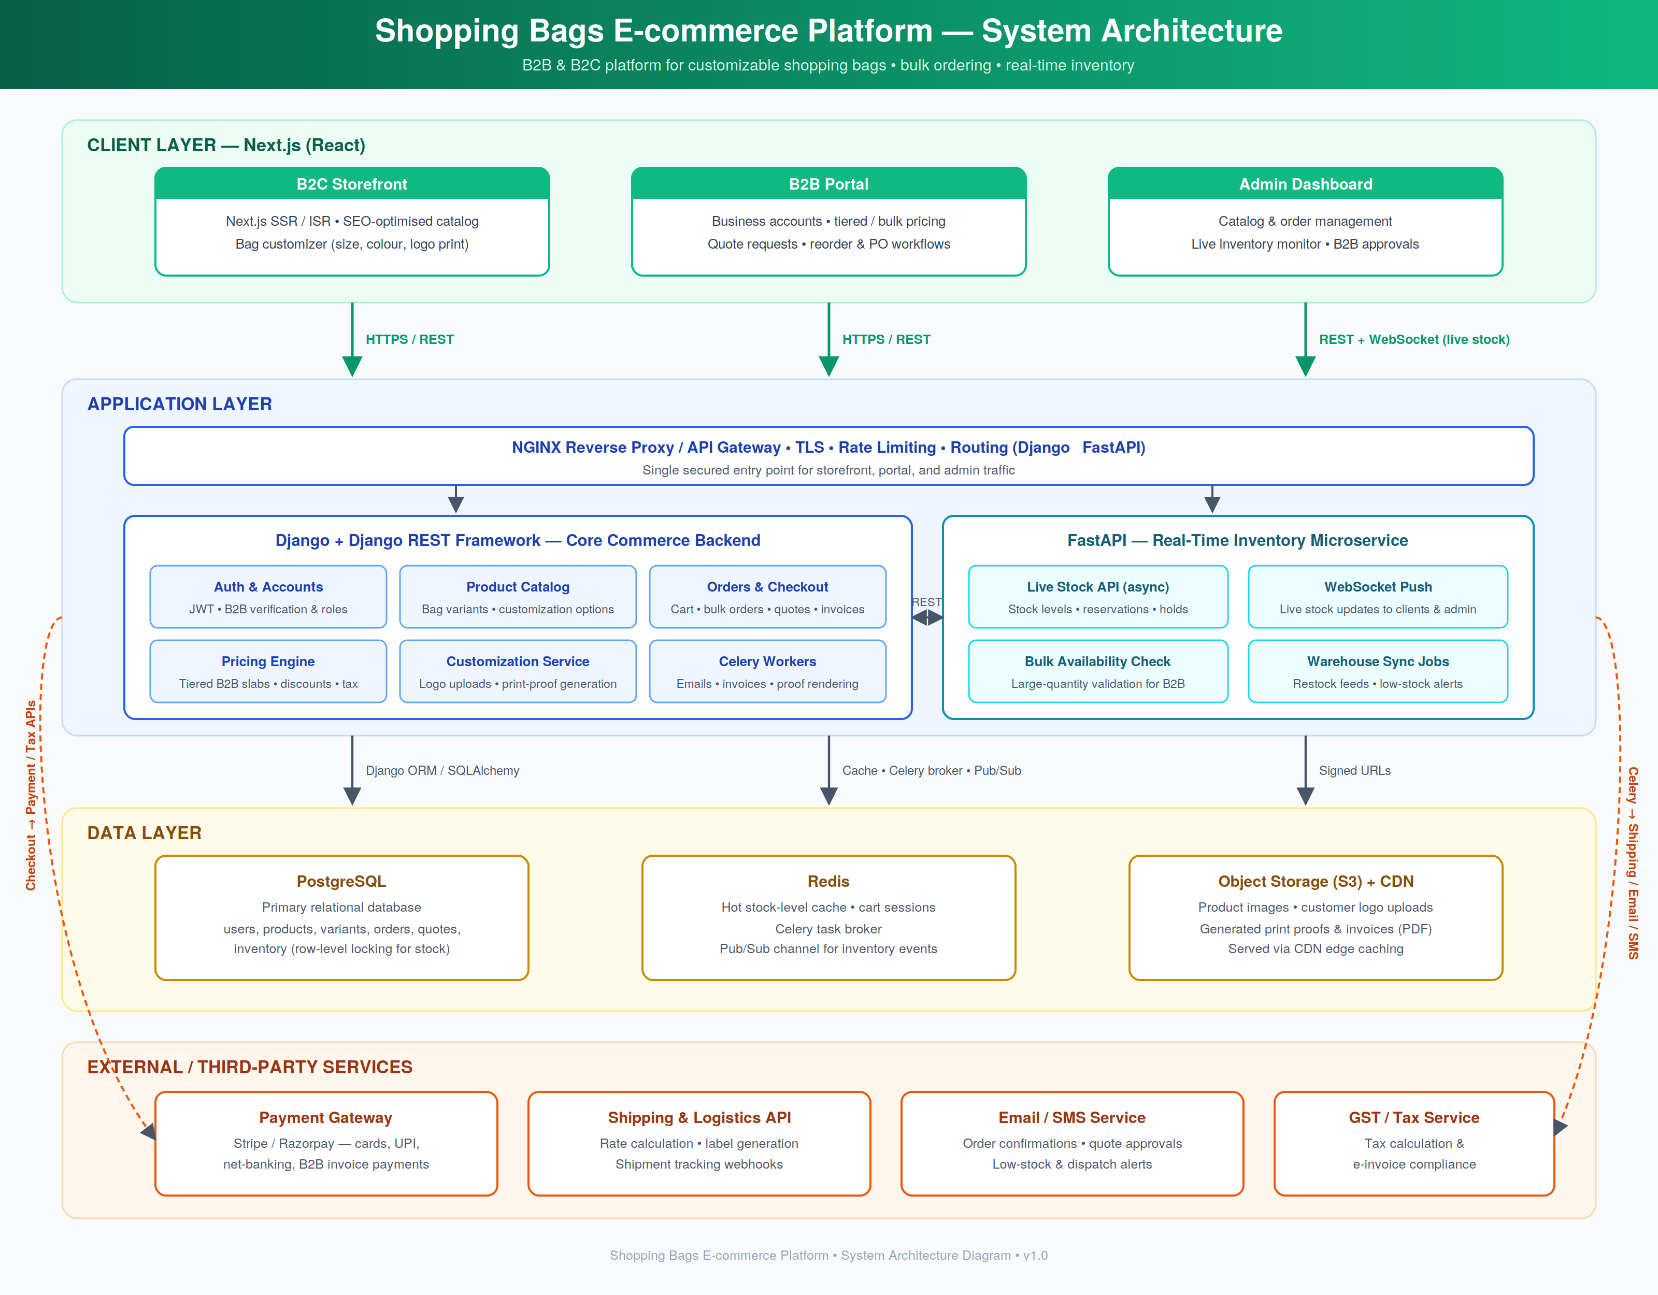

5. Application Flow Chart
The flow branches by customer type. B2C users customize a bag, upload artwork, and add to cart at retail pricing; B2B users configure bulk orders through the portal with tiered pricing. Both paths converge on a real-time FastAPI inventory check — in-stock quantities are reserved with a hold, while shortfalls trigger a lead-time/backorder negotiation. After successful payment (with retry on failure), the order is confirmed, inventory is decremented and broadcast live, and the order proceeds to print-proofing, production, and dispatch.
