Creative Marketplace
E-commerce Platform v2.0
System Architecture & Application Flow
Technical Design Document • Client: A. Centauri Software
Version 2.0 • July 2026

1. Application Overview
A multi-vendor digital marketplace connecting independent creators with global buyers. Creators onboard with KYC and a payout account, upload digital products (design assets, templates, fonts, audio, and similar), and publish through a moderation and malware-scan pipeline. Buyers discover products through faceted search, purchase in their own currency with region-correct tax, and receive secure digital delivery — license keys plus signed, time-limited, download-limited URLs. Every sale is split at payment time into the platform fee and the creator's earnings, settled through scheduled payout batches.

2. Technology Stack
- Frontend: Next.js (React) — buyer marketplace, creator studio, admin console
- Backend: FastAPI (async Python) — the entire service layer, behind NGINX + Uvicorn with JWT auth and Pydantic validation
- Database: PostgreSQL — vendors, products, orders (partitioned), licenses, earnings ledger, payouts; read replicas for analytics
- Search: OpenSearch — full-text + faceted product discovery with trending signals, fed by indexing workers
- Cache & queues: Redis — sessions, carts, hot product cache, download-limit counters, worker queues
- Background workers: ARQ/Celery — malware scanning of uploads, preview/thumbnail generation, search indexing, payout batches, email fan-out
- File storage: S3 (private digital-asset vault) + CDN (public previews and thumbnails)
- External: Stripe Connect (global checkout, split payments, creator payout rails), tax/VAT service for cross-border digital goods, email service, KYC/fraud & content scanning

3. Core Services
- Auth & Identity — JWT with OAuth social login; buyer, creator, and admin roles
- Vendor / Creator Service — onboarding, KYC, payout accounts, storefront profiles
- Product Catalog — digital assets with versions and license tiers; moderation workflow
- Search & Discovery — OpenSearch-backed ranking with facets and trending
- Checkout & Split Payments — multi-currency pricing, tax/VAT calculation, atomic fee/earnings split
- Digital Delivery & Licensing — license key issuance, signed time-limited URLs, download limits
- Payout Service — append-only earnings ledger, clawbacks on refunds, scheduled Stripe Connect transfers
- Reviews & Notifications — verified-purchase reviews feeding discovery ranking; sale and payout alerts

4. System Architecture Diagram
Three Next.js surfaces sit on a single async FastAPI backend. The two starred services carry the marketplace's commercial core: Checkout & Split Payments computes multi-currency totals with region tax and records the platform-fee/creator-earnings split at payment time, and Digital Delivery & Licensing turns a confirmed order into license keys and signed, expiring, download-limited URLs against the private S3 vault. OpenSearch powers discovery, PostgreSQL holds commercial truth including the append-only earnings ledger, and background workers handle upload scanning, preview generation, indexing, and payout batches.
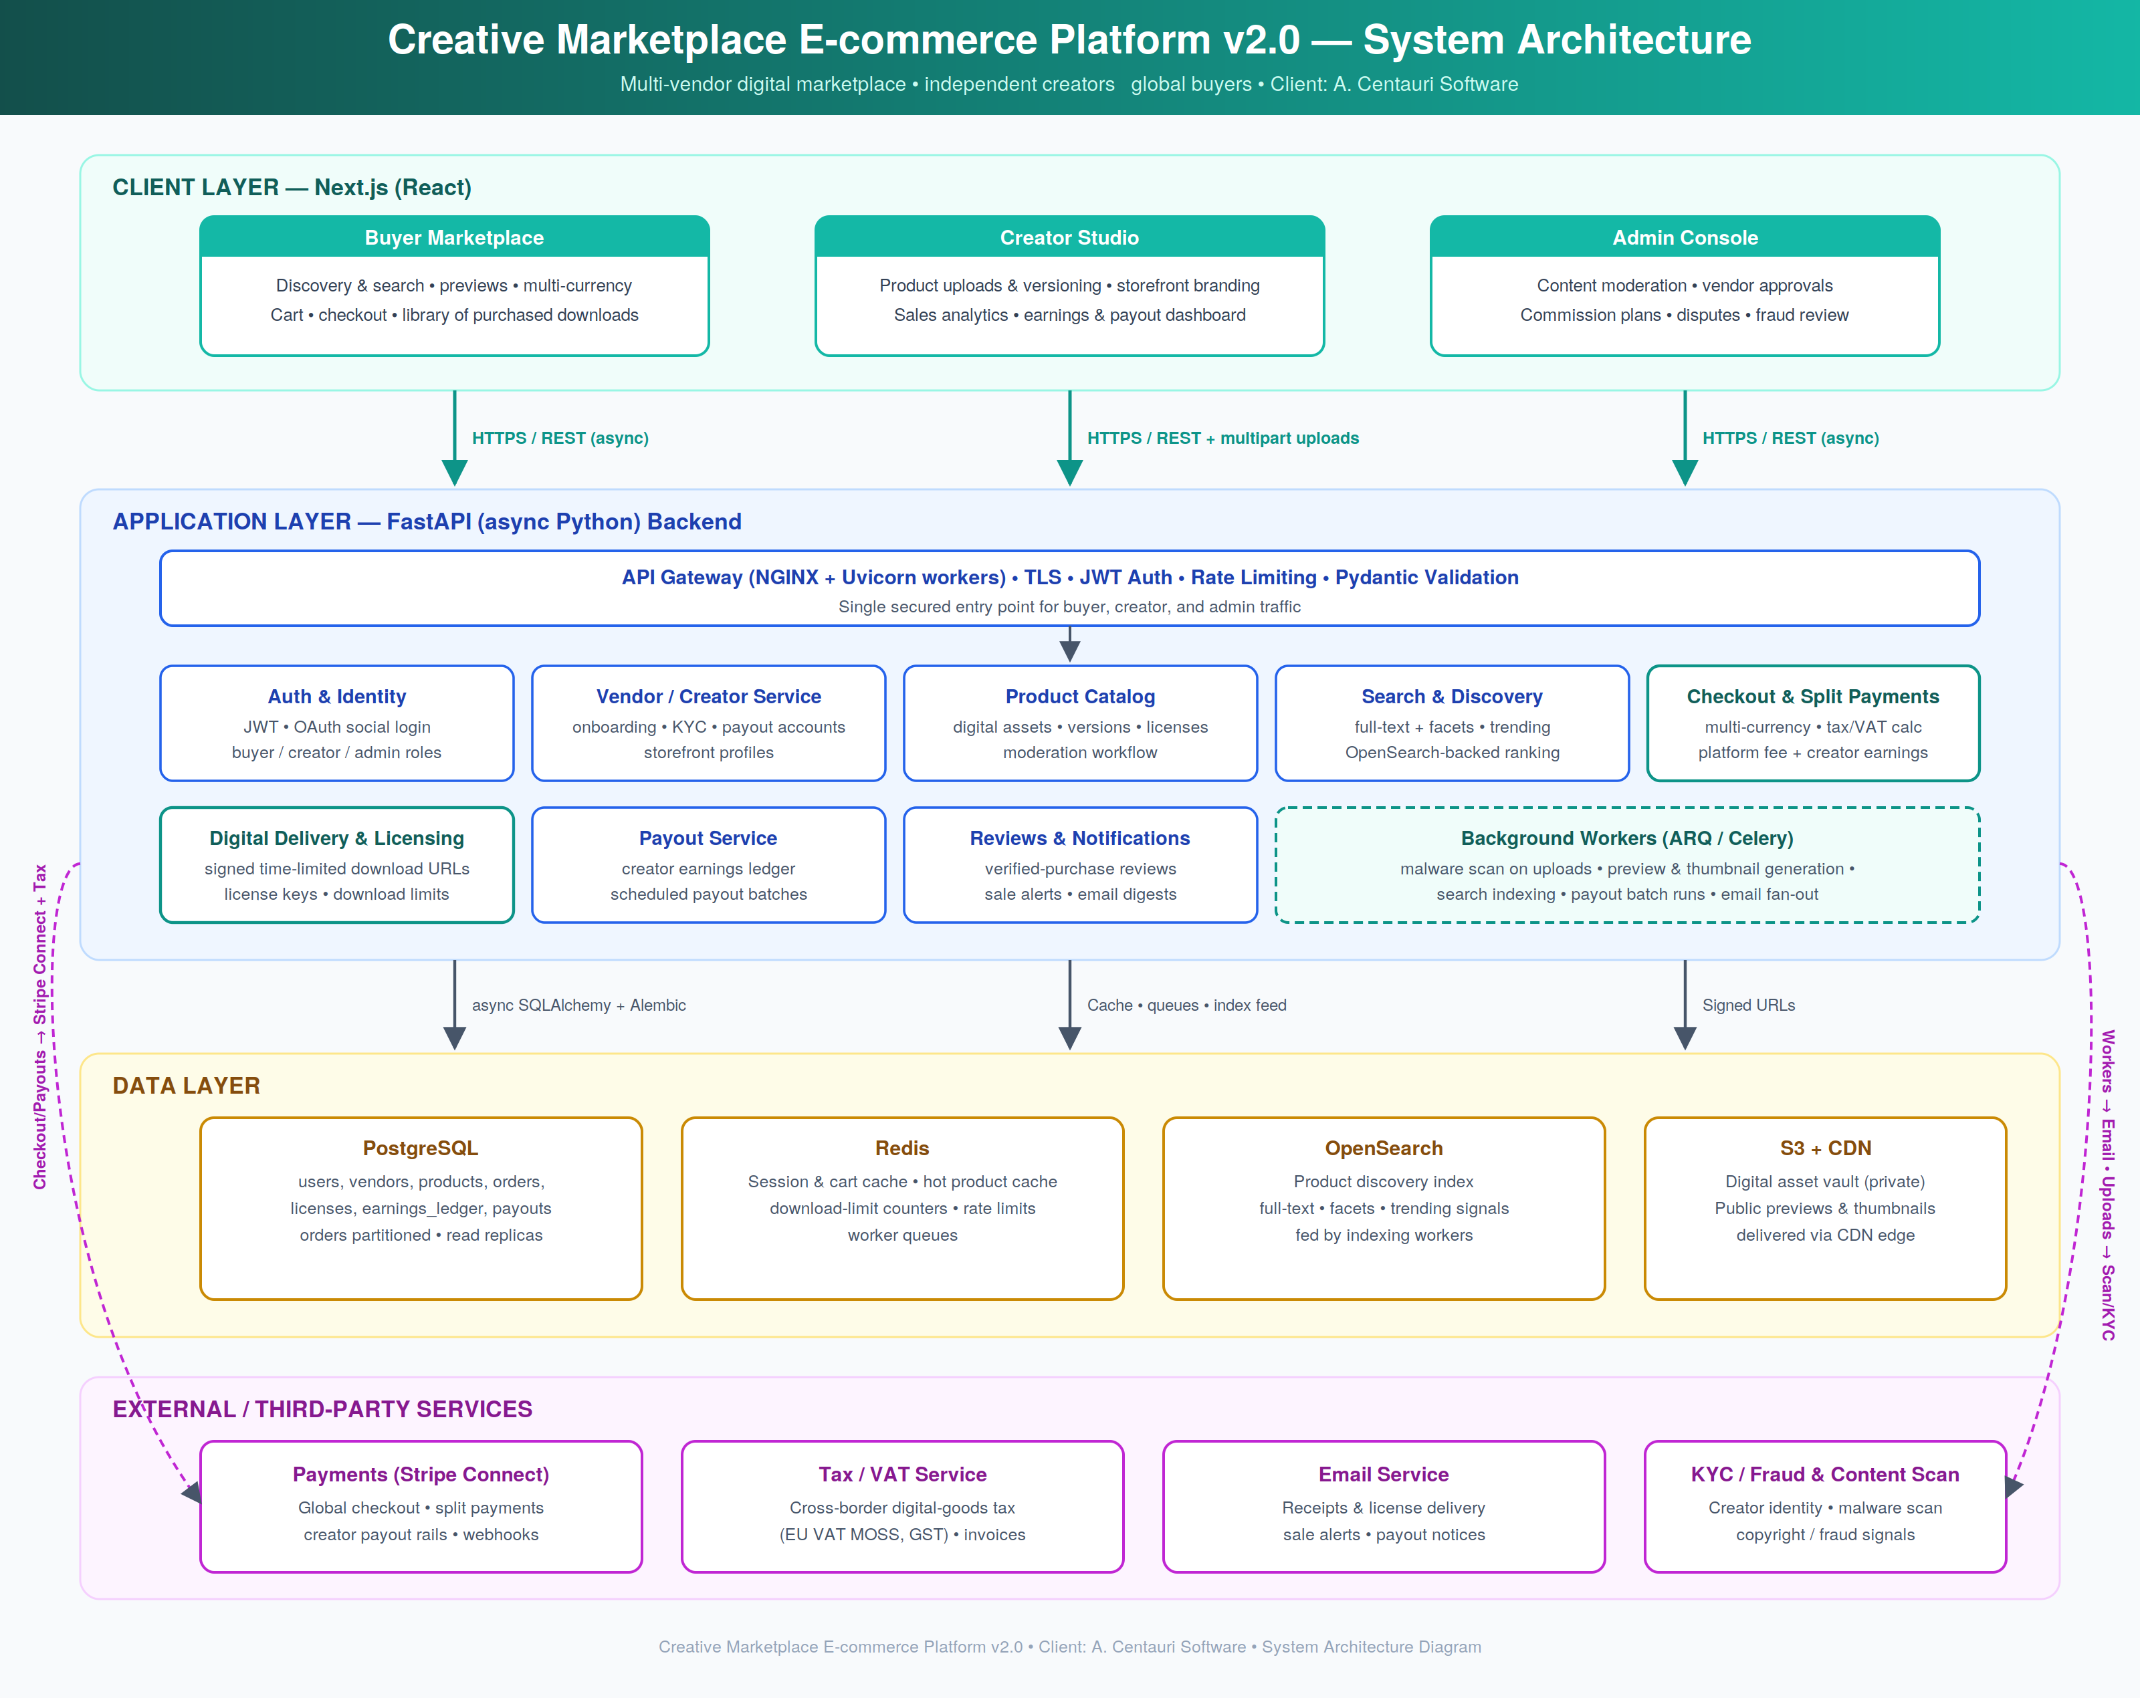

5. Application Flow Chart
The flow branches by role. Creators onboard once (KYC + payout account), upload products into the private vault, pass async malware scanning and moderation (with a fix-and-resubmit loop on rejection), and publish into the search index. Buyers search, preview, select a license tier, and check out in their currency with region tax; successful webhook-confirmed payment records the fee/earnings split, issues the license, and unlocks signed limited downloads from the buyer's library. Problems route to a dispute/refund flow with earnings clawback; happy paths invite a verified-purchase review that feeds ranking. Creator earnings settle in scheduled payout batches, and both roles loop — buyers browse again, creators upload the next product.
