Rent Property Listing
Web Application v1.0
System Architecture & Application Flow
Technical Design Document • Client: A. Centauri Software
Version 1.0 • July 2026

1. Application Overview
A high-volume property rental marketplace connecting renters with property listers (owners and agents). Its commercial core is a credit-based lead generation and consumption model: renter inquiries become leads with masked contact details, and listers spend wallet credits to unlock each lead. Credits are purchased through integrated payment gateways, and the data layer is explicitly optimised for marketplace-scale search and lead traffic.

2. Technology Stack
- Frontend: Next.js (React) web application — renter/seeker app, lister portal, and admin console
- Backend: FastAPI (async Python) behind NGINX + Uvicorn, with Pydantic validation and JWT/OTP auth
- Database: PostgreSQL with deliberate optimisation — PostGIS geo indexes, composite and partial indexes, monthly partitioning of the leads table, PgBouncer connection pooling, and read replicas for search traffic
- Cache & queues: Redis — hot search/listing cache, sessions, OTP store, rate-limit counters, worker queues, lead dedupe keys
- Background workers: Celery/ARQ — lead scoring, listing expiry, image processing, digests
- File storage: S3-compatible object storage + CDN for property photos and documents
- Payment integrations: Stripe / Razorpay for credit pack purchases with webhook confirmation, refunds, and GST invoices
- Other external services: maps & geocoding API, email/SMS/WhatsApp notifications, KYC/verification provider

3. Core Services
- Auth & Profiles — JWT + OTP login; roles for renter, lister, agent, admin
- Listing Service — listing CRUD, photos, amenities, moderation and expiry lifecycle
- Search Service — geo + filter queries with ranking, routed to read replicas and cached in Redis
- Lead Service — inquiry capture, deduplication, quality scoring, contact masking until unlocked
- Credit Wallet Service — balances, credit packs, atomic debit on lead unlock, append-only ledger
- Payment Service — credit pack checkout, idempotent gateway webhooks, refunds, invoicing
- Notification Service — new-lead alerts, low-credit nudges via email, SMS, and WhatsApp

4. System Architecture Diagram
Three Next.js surfaces sit on a single async FastAPI backend behind an NGINX/Uvicorn gateway. The Lead Service and Credit Wallet Service (starred) implement the platform's core monetisation loop: leads are captured with masked contacts, and an atomic, ledger-backed credit debit reveals them. PostgreSQL is tuned for high volume — PostGIS geo indexes, partitioned leads, read replicas for search, PgBouncer pooling, and row-level locking on wallet debits — with Redis absorbing hot reads.
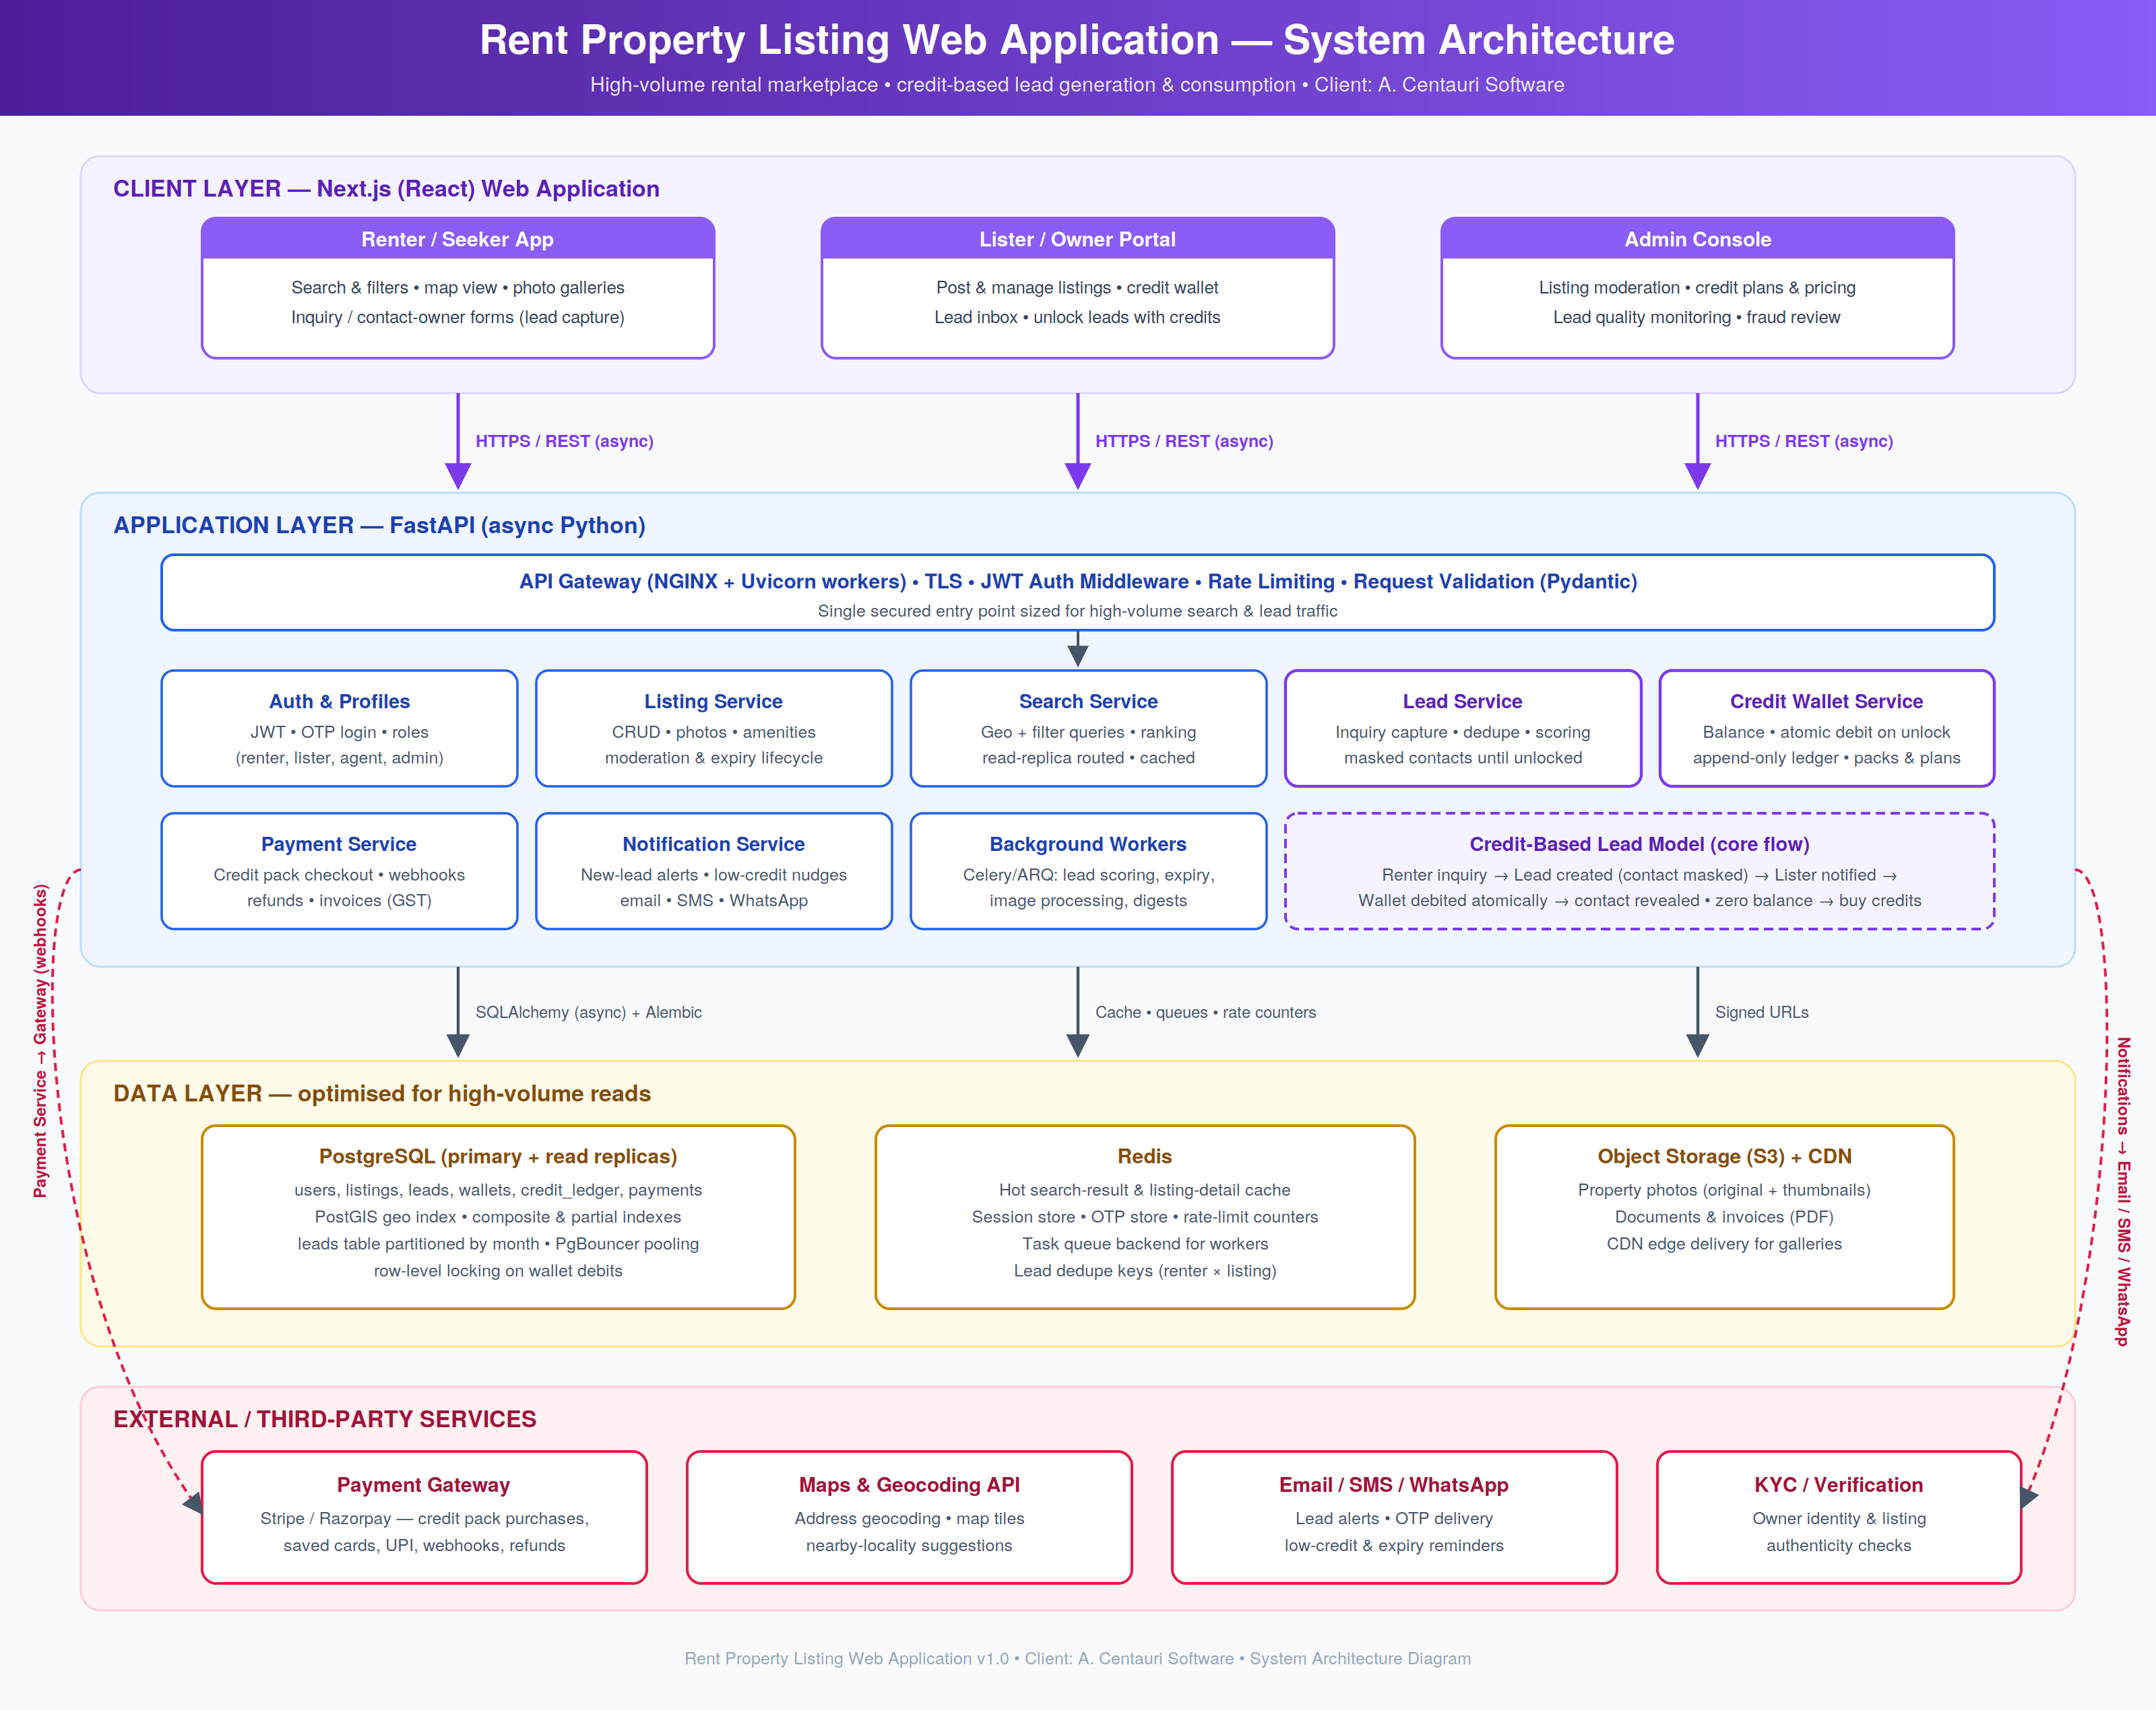

5. Application Flow Chart
The flow branches by user role. Renters search, view listings (with masked owner contacts), and submit inquiries that become deduplicated, scored leads. Listers post properties and hold a credit wallet. When a lead arrives, the lister is notified and decides whether to unlock it; a balance check either performs an atomic credit debit (revealing the renter's contact) or routes through the credit-pack purchase flow with payment retry. The loop closes when the property is rented and delisted — otherwise the listing stays live for the next lead.
