AI HR Exam
Application
System Architecture & Application Flow
Technical Design Document
Version 1.0 • July 2026

1. Application Overview
A multi-agent AI system built on Django that automates human-resources testing and reporting end to end. HR admins define an assessment (role, skills, difficulty, duration) for any of three audiences — current employees, freshers, or interview candidates — and a pipeline of five AI agents does the heavy lifting: generating questions, reviewing and calibrating them, grading submissions (including subjective and coding answers), analysing attempt integrity, and compiling insight-rich reports with hire/train recommendations. Enterprise user management with SSO (SAML/OIDC) governs employees, while external candidates enter through single-use tokenized exam links.

2. Technology Stack
- Backend framework: Django + Django REST Framework (Python) — the application backbone
- Multi-agent AI: five LLM-powered agents (Question Generator, Reviewer/Calibration, Evaluation, Integrity/Proctoring, Reporting & Insights) orchestrated as Celery pipelines over the LLM API (OpenAI / Claude)
- Enterprise identity: SSO via SAML/OIDC (Azure AD / Okta) with employee auto-provisioning; RBAC with org hierarchy (HR admin, manager, candidate); full audit trail
- External candidate access: single-use, expiring tokenized exam links for freshers and interview candidates
- Database: PostgreSQL — question bank, assessments, partitioned exam attempts, results, integrity events, audit log
- Cache & queues: Redis — live exam timers and session state, autosave buffer, Celery broker, token single-use locks
- File storage: S3 — generated report PDFs, code-answer artifacts, integrity evidence
- External: LLM API, enterprise IdP, email/notifications, HRIS/ATS integration (results pushed via webhooks)

3. The Five Agents
- Question Generator Agent — drafts MCQ, subjective, and coding items per role, skill, and difficulty from the blueprint
- Reviewer / Calibration Agent — validates correctness, screens for bias/ambiguity, calibrates difficulty, de-duplicates against the bank
- Evaluation Agent — auto-scores MCQs; grades subjective and code answers against LLM rubrics with per-criterion feedback
- Integrity / Proctoring Agent — analyses tab-switch and paste signals, answer similarity, and AI-generated-answer indicators; flags attempts for human review
- Reporting & Insights Agent — score analytics, rankings, skill-gap analysis, and hire/train recommendations compiled into PDF reports

4. System Architecture Diagram
Three client surfaces (exam portal, HR admin console, manager dashboard) sit on a Django/DRF core split into two halves: Enterprise Identity & User Management (SSO, RBAC/org hierarchy, tokenized external access) and the Assessment & Exam Session Engine (blueprints per audience, question bank, server-side timers with autosave and auto-submit). The amber band is the system's centrepiece — the Multi-Agent AI Orchestrator running five Celery-driven agent pipelines over the LLM API. PostgreSQL holds all commercial and audit truth, Redis carries live exam state and queues, and results flow out to email and HRIS/ATS integrations.
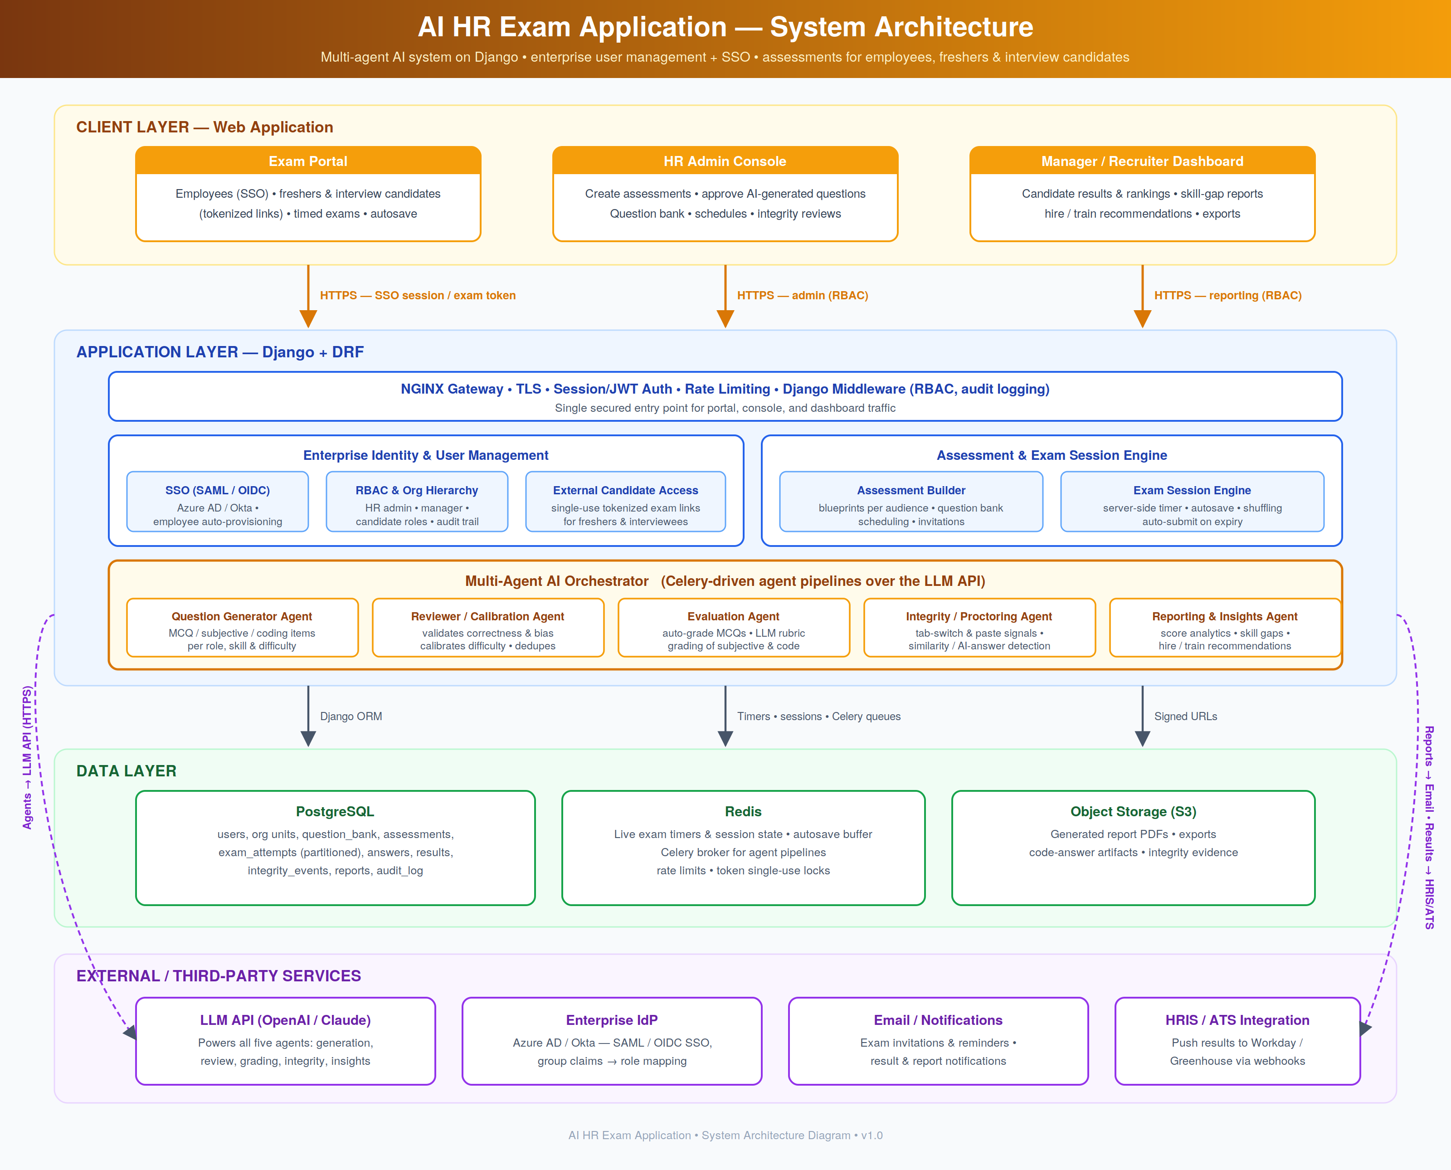

5. Application Flow Chart
The flow runs the full assessment lifecycle. HR creates an assessment and the audience decision selects the blueprint — employee (skills/compliance, SSO roster), fresher (aptitude + fundamentals, campus batches), or interview candidate (role-specific screening, per-candidate links). The amber agent stages then take over: the Question Generator drafts items, the Reviewer calibrates them, and HR approves (with an edit/regenerate loop). Publication sends SSO links to employees and single-use tokens to externals; the identity gate rejects used or expired tokens. The timed session runs with autosave and integrity logging until submission or auto-submit on expiry. The Evaluation Agent grades everything, the Integrity Agent's flags route suspicious attempts to HR review (accept or void), and the Reporting Agent compiles the final report delivered to dashboards and pushed to HRIS/ATS — with the loop returning for the next assessment cycle or candidate batch.
