LinkedIn Profile
Assistance Bot
System Architecture & Application Flow
Technical Design Document
Version 1.0 • July 2026

1. Application Overview
A LinkedIn Personal Info Bot: a chat assistant that answers visitors' questions about one person's professional profile. The React frontend provides the chat interface; the FastAPI backend exposes a single /chat endpoint. At startup the backend loads a local portfolio JSON file (profile, experience, projects, skills, education) and calls Google's Gemini with a strict system prompt so that every response is grounded exclusively in that JSON — questions outside the portfolio receive a polite, scoped refusal instead of an invented answer. Infrastructure is fully codified: Terraform builds and pushes the Docker image and deploys the backend to Google Cloud Run.

2. Technology Stack
- Frontend: React SPA — chat thread, input box, typing/loading indicator, client-side conversation history; deployed as a static build
- Backend: FastAPI (Python) — single POST /chat endpoint, Pydantic validation, CORS restricted to the frontend origin, basic rate limiting
- AI: Google Gemini via the google-generativeai SDK, with timeouts, retries, and safety settings
- Knowledge source: local portfolio.json bundled into the Docker image and loaded once at startup — the bot's only source of truth
- Grounding: a strict system prompt instructing Gemini to answer only from the supplied JSON and to decline anything else
- Infrastructure as Code: Terraform — enables GCP APIs, provisions Artifact Registry, Secret Manager, IAM, and the Cloud Run service
- Deployment: Docker image (FastAPI + portfolio.json) pushed to Artifact Registry; Cloud Run runs it with scale-to-zero autoscaling and the GEMINI_API_KEY injected from Secret Manager

3. Core Components
- Request Handling — Pydantic schemas, CORS policy, rate limiting, request logging
- Portfolio Data Loader — parses portfolio.json at startup into an in-memory structure
- Grounded Prompt Builder — composes system prompt + portfolio JSON + user question
- Gemini Client — SDK calls with timeout/retry and safety configuration
- Grounding Guardrails — enforces scope: out-of-portfolio questions get a polite refusal
- Response Composer — formats the model output into a clean { reply } JSON and maps SDK failures to friendly HTTP errors

4. System Architecture Diagram
A deliberately lean four-layer design. The React chat UI talks over HTTPS to a single FastAPI /chat endpoint running as a Docker container on Cloud Run. Inside the service, the two starred components carry the product's defining behaviour: the Grounded Prompt Builder injects the portfolio JSON with a strict system prompt, and the Grounding Guardrails ensure out-of-scope questions are politely declined rather than hallucinated. The Gemini API and Secret Manager sit outside the container boundary, and the bottom layer shows the Terraform pipeline that builds, pushes, and deploys everything reproducibly.
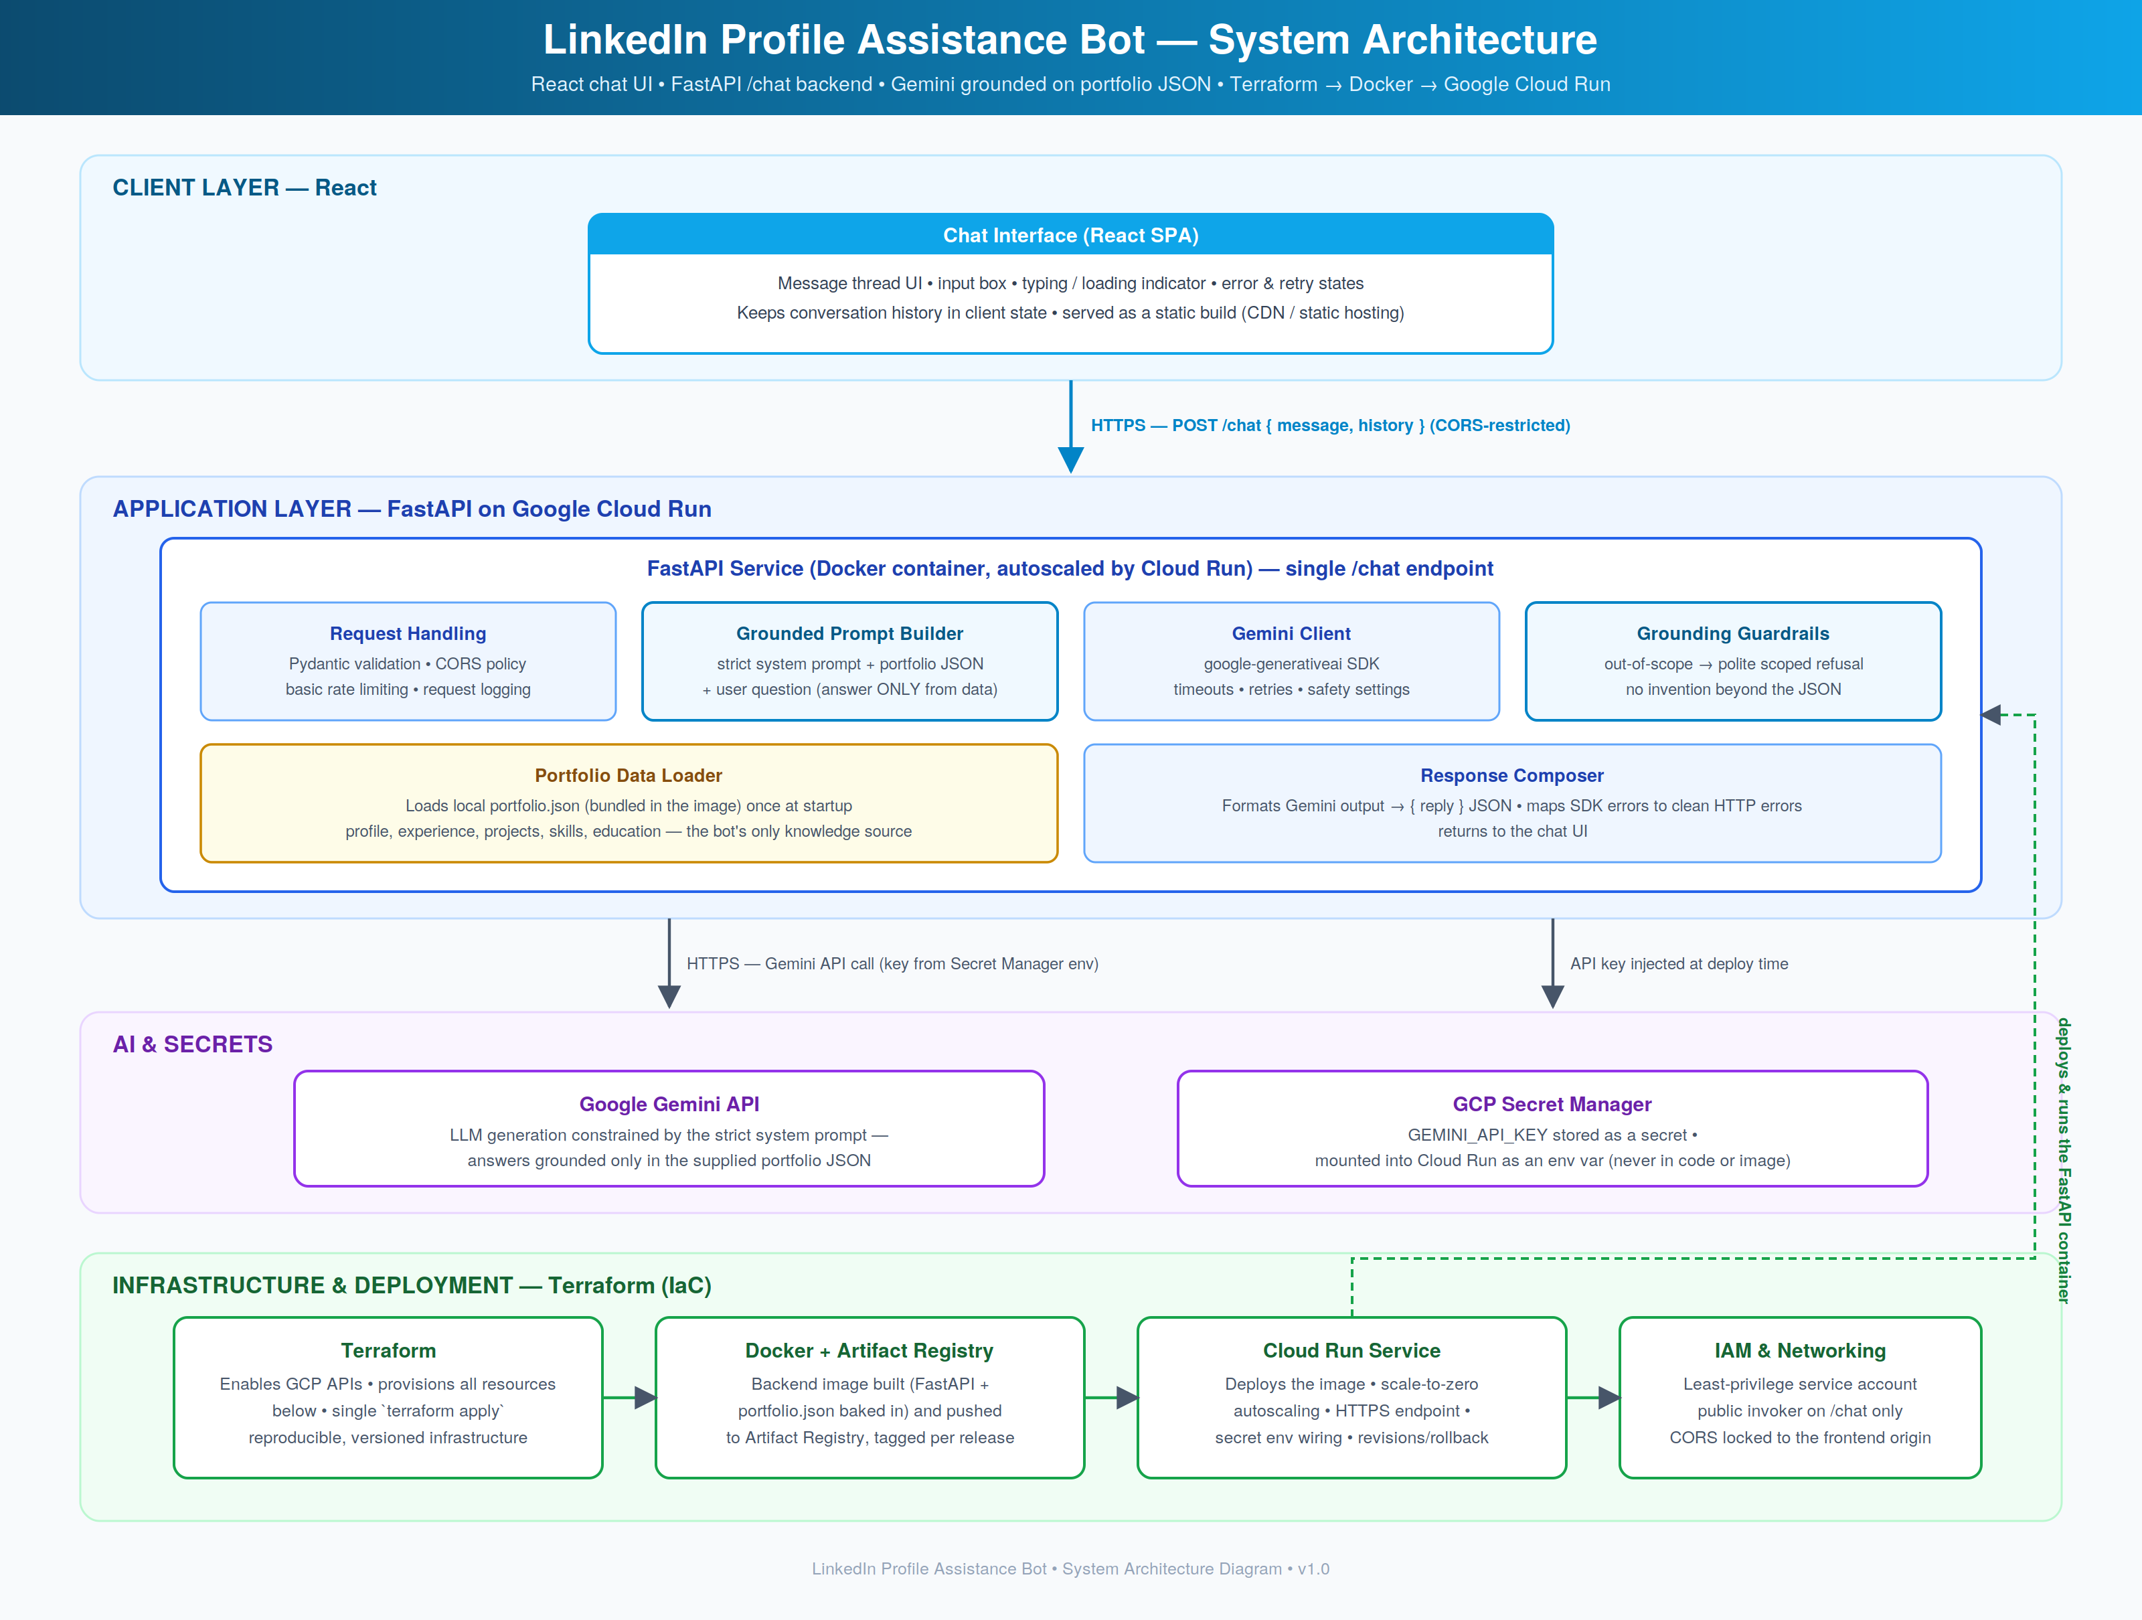

5. Application Flow Chart
The dashed strip at the top shows the one-time deployment pipeline: terraform apply provisions the infrastructure, the Docker image (FastAPI + portfolio.json) is built and pushed to Artifact Registry, Cloud Run deploys it with the Gemini key from Secret Manager, and the backend loads the portfolio at startup. The runtime loop below it: the visitor asks a question → POST /chat → validation (4xx errors return cleanly to the chat) → the grounded prompt is built → Gemini is called with timeout/retry (failures produce a graceful retryable error) → the grounding decision either composes an answer strictly from the portfolio JSON or returns a polite scoped refusal → the reply renders in the thread, and the loop continues until the visitor closes the chat.
